Name types of Energy:

All the “forms” of energy … Light, Nuclear, Mechanical, Heat, Chemical, Electrical, Magnetic, and Sound involve the interaction of _______ & _______.

Energy

* The capacity to do work (“_______” 🡪 KJ)
* Unlike matter, energy has neither mass nor volume. Energy is detected only by its effects.

_______ Energy (PE) 🡪 _______ energy

* Every chemical substance contains a certain amount of energy, called chemical potential energy, which is stored in the chemical _______ of its _______.
* The kinds of atoms and their arrangement in a substance, determine the amount of potential energy stored in that substance.

_______ Energy (KE) 🡪 energy of _______

* _______ is a measure of the _______ kinetic energy of the particles in a sample of matter. The greater the _______ of the particles in a sample, the hotter it feels.
* Celsius and Kelvin temperatures are related by the following equation:
* ___ = _______ + ⁰___

Energy *associated with chemical changes and with physical changes*

* _______ ΔH = ___
  + heat flows _______ the system from the surroundings
  + Exo_______ thermic ΔH = ___
    - heat flows _______ the system into the surroundings
  + _______ energy 🡪 The energy _______ before a chemical reaction can take place (e.g. Powder needs to be airbourne before it can explode.)

Energy Units

* _______ (J) 🡪 The joule (J) is the SI unit of energy. One joule of heat raises the temperature of 1 g of pure water 0.2390 ⁰C.
* _______ (C) 🡪 *The amount of energy required to raise 1 gram of water, one degree Celsius*.
* *1 calorie = 4.18 joules [Reference Table 1]*
* *1 J = 2.39 X 10-1 cal*

Heat

* A form of energy that takes into account the quantity of _______  
  Units: calories (Kcal) or joules (KJ)
* Calorimeter 🡪 instrument used to measure heat
* Physical and chemical changes involve changes in energy:
* Exothermic - _______ energy or heat
* Endothermic - _______ /_______ energy or heat
* _______ The measure of heat intensity: describes the average _______ energy (KE) of the molecules in a system
* Units: measured in degrees
  + Fahrenheit (°F)
  + Celsius (°C); also called centigrade
* _______ (K)
* “_______ temperature”
* Begins with ___ K (*theoretical temperature*)
* includes _______ and _______
* Conversions
  + Fahrenheit and Celsius

F = 9/5 C + 32

C = 5/9 (F - 32)

* Kelvin vs. Celsius

___ = ___ + _______

1 K increment = 1 C

Temperature versus Heat

* _______ involves the motion of molecules only
* Heat incorporates temperature and _______ (amount)
* Example: *burning a match verses a bonfire*
  + *Temperature for both is the same (~400-600 °C)*
  + *The bonfire contains MUCH more heat*

Heat flows from _______ to _______ 🡪 This represents K_______ E

Heating and Cooling Curves

Why doesn’t the temperature change as ice melts? As water boils?

What kind of energy relationships are occurring as ice melts and then boils?

What do we call the stages when ice melts and water boils?

Phase Change Diagrams

_______ ΔH = + _______ Curve

Heat flows _______ the system from the surroundings

Label KE/PE, phase, heat equation

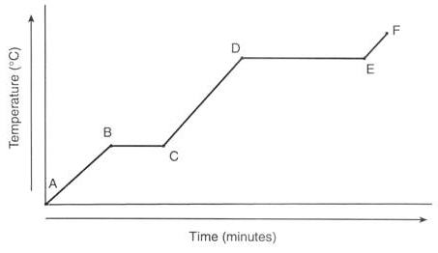

|  |  |  |  |  |  |
| --- | --- | --- | --- | --- | --- |
|  | Graph | Temp | Phase | KE | PE |
|  | A 🡪 B | -20 🡪 0 | s |  |  |
|  | B 🡪 C | 0 | s 🡪 l |  |  |
|  | C 🡪 D | 0 🡪 100 | l |  |  |
|  | D 🡪 E | 100 | l 🡪 g |  |  |
|  | E 🡪 F | 100 🡪 110 | g |  |  |

_______ ΔH = ─ _______ Curve

Heat flows _______ the system into the surroundings

Label KE/PE, phase, Heat equation

Heat

Temperature

°C

?

?

|  |  |  |  |  |
| --- | --- | --- | --- | --- |
|  | Temp | Phase | KE | PE |
|  | 120 🡪 100 | s |  |  |
|  | 100 | s 🡪 l |  |  |
|  | 100 🡪 0 | l |  |  |
|  | 0 | l 🡪 g |  |  |
|  | 0 🡪 -10 | g |  |  |

General Heating Curve

Fixed points (based on PE) … _______ is “fixed”

* _______ point ↔ _______ point (s ↔ l)
* _______ point ↔ _______ pt (l ↔ g)
* Sublimation ↔ Deposition (s ↔ g)

Quantitative Heat Measurements

Heat Equation: q = m c ∆T _______ (type of energy)

q: change in _______ energy for system or surroundings

m: _______ of substance

c: _______ heat of substance

cp (H20): 1.0 cal/g∙⁰C = 4.18 j/g∙⁰C

c (ice): 0.5cal/g∙⁰C = 2.09 j/g∙⁰C

c (steam): 0.5cal/g∙⁰C = 2.09 j/g∙⁰C

∆ T: change in _______ (closed system)

∆ T = _______ Temp – _______ Temp … ∆ T = Tf – Ti

Heat of _______ / Solidification (_______)

* The amount of energy gained or released when a substance _______ (s 🡪 l) or _______ (l 🡪 s)
* Melting (s 🡪 l): _______ ∆Hf = +
* Freezing (l 🡪 s): _______ ∆Hf = -

Heat of _______ / Condensation (PE)

* The amount of energy gained or released when a substance _______ (l 🡪 g) or _______ (g 🡪 l)
* vaporizing (l 🡪 g): _______ ∆Hv = +
* condensing (g 🡪 l): _______ ∆Hv = -

Specific Heat of Water

* The _______ heat capacity, or simply the specific heat (C) of a substance, is the amount of heat it takes to raise the temperature of 1 g of the substance 1⁰ C.
* _______ has the second highest specific heat of all liquids.
* Metals generally have _______ specific heats.
* Some things heat up or cool down faster than others.
  + _______ heats up and cools down faster than _______
  + e.g. Michigan stays warmer in the winter due to the heat from the lakes (*e.g. hot vegetables stay hot a long time because of their high water content*)
* Specific heat is ability of a substance to “_______” heat.
* A _______ is used to measure the specific heat of a substance.

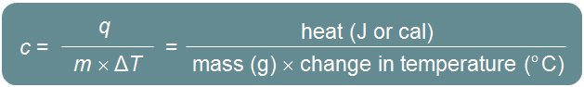

Place a hot metal (~ 75 C) in water (~25° C)

The metal _______ off (loses heat); q = ___ . The water _______ heat from the metal; q = ___

- q (metal) = q (water) _______ = _______

Thermochemical Equations

* Thermochemical equations are balanced stoichiometric chemical **equations** that include the _______ change (heat of _______ ΔH).
* Δ*Hrxn* = Δ*H*_______ – Δ*H*_______
* The _______ states (s, l, g) of reactants and products must always be included in thermochemical equations, because the states of reactants and products influence the overall amount of energy exchanged.
* In any chemical equation, the heat of reaction (∆H) is based on the enthalpy difference of the products and reactants. It is written as either a reactant or a product, depending on whether the reaction is _______ (+∆H) or _______ (-∆H).

In _______ processes, the chemical potential energy of the reactants is _______ than the chemical potential energy of the products. This is a “_______” reaction.

Because heat energy (enthalpy) is given off or _______. Therefore, the enthalpy change can be considered a _______.

In _______ processes, the chemical potential energy of the reactants is _______ than the chemical potential energy of the products. This is an “_______” reaction.

Because heat energy (enthalpy) is taken in or _______. Therefore, the enthalpy change can be considered a _______ .



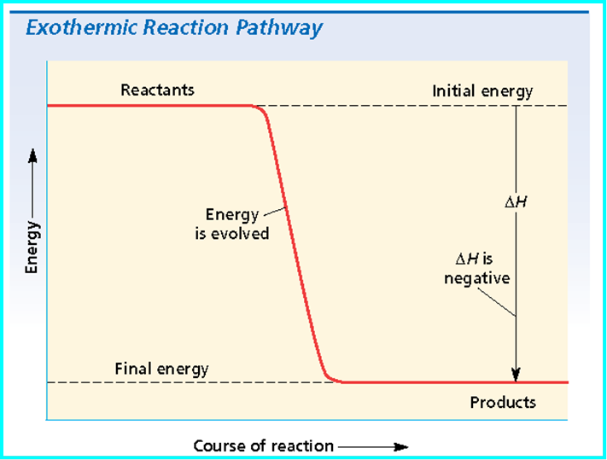

Heat (Enthalpy) of Reaction

* Heat of _______ refers to _______ Change (∆H), which is the Enthalpy or heat content of a system.
* For any reaction carried out directly at constant pressure, the heat flow (∆H = mc∆T) is exactly equal to the difference between the enthalpy of the products and the enthalpy of the reactants.

∆H = ∑[(∆H_______) × (_______ products)] – ∑[(Δ*H*_______) × (_______ reactants)]

Moles represents the _______ in a chemical equation.

Calculating Enthalpy of Reaction

Iron(III) oxide (Fe3O4(*s*), Δ*Hf* = –1117.1 kJ/mol) can react with aluminum powder to form aluminum oxide (Al2O3(*s*), Δ*Hf* = –1669.8 kJ/mol) and iron according to the equation below:

3Fe3O4(*s*) + 8Al(*s*) → 4Al2O3(*s*) + 9Fe(*s*)

What is Δ*Hrxn* for this reaction?

∆H = ∑[(∆Hproducts) × (molproducts)] – ∑[(Δ*H*reactants) × (molreactants)]

Δ*H*f (prod) = [___ mol Al2O3(*s*) × Δ*H*f⁰ Al2O3(*s*)] + [___ mol Fe(s) × Δ*H*f ⁰ Fe(s)]

= (___ x _______ kJ) + (___ x 0.00 KJ) = _______ kJ

Δ*H*f (react) = [___ mol Fe3O4(s) × Δ*H*f⁰ Fe3O4 (s)] + [___ mol Al × Δ*H*f⁰ Al(s)]

= (___ x _______ kJ) + (___ x 0.00 kJ) = _______ kJ

Δ*H*° = ∑Δ*H*f ⁰(products) – ∑Δ*H*f ⁰(reactants)

Δ*H*° = _______ kJ – (_______ kJ)

Δ*H*° = _______ kJ _______

Standard Heat of _______ Δ*H*f*⁰*

* Where do the values for ΔH originate?
* The standard heat of formation (Δ*H* f*⁰*) of a compound is the change in enthalpy that accompanies the _______ of one mole of a compound from its _______ with all substances in their standard states, those being the stable forms of the substances at 25 ⁰C and 101.3 kPa.
* The Δ*H*f⁰ of all _______ elements (including the “Professor _______” diatomic molecules is arbitrarily set at _______.
* Thus, Δ*H*f*⁰* = ___ for all elements and the diatomic molecules:

Enthalpy of Formation

* Compounds with a large _______ enthalpy of formation are very _______.
* Example: The ΔHf⁰ of CO2 is –393.5 kJ/mol of gas produced. This indicates that carbon dioxide is more stable than the elements from which it was formed.
* Compounds with _______ values of enthalpies of formation are typically _______.
* Example: Hydrogen iodide, HI, has a ΔHf⁰ of +26.5 kJ/mol. It decomposes at room temperature into violet iodine vapor, I2, and hydrogen, H2.

Standard Heats of Formation ΔH⁰

Δ*H*° = ∑Δ*H*f°_______ – ∑Δ*H*f°_______

Heat of _______

* A common ΔH, heat of reaction, is the heat of combustion, relating to the complete burning of one mole of a substance.
* All are _______.

_______’s Law

* The heat of reaction for many chemical processes cannot be _______ directly. (*Theoretically, diamond can be made into graphite.*)
* The heat released or absorbed in a chemical process is the _______ whether the process takes place in one or in several _______.
* Hess's lawshows that energy changes are “_______” functions, meaning that the amount of energy depends only on the states of the reactants and the state of the products, but not on the intermediate steps.
* “States” here refer to _______, _______, or _______.
* If a reaction can take place by more than _______ pathway and the initial and final conditions are the same, the total enthalpy change (∆Hx) is equal. Therefore, _______ the heats of reaction for the individual reactions (Intermediate pathway 🡪 ∆H1 + ∆H2).

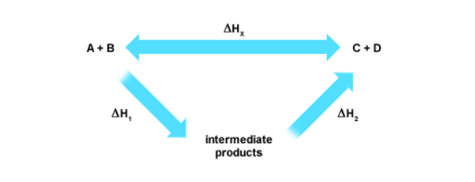

* The overall enthalpy change in a reaction is equal to the _______ of enthalpy changes for the _______ steps in the process.

Example: Tin and Chlorine synthesize Stannic Chloride

* SnCl4 (l) is not produced directly in nature. Hess’s law allows you to determine the heat of reaction indirectly, by using the known heats of reaction of 2 or more thermochemical equations.

Step 1: Sn (s) + Cl2 (g)  ⇌ SnCl2 (s) + 83.6 kcal

Step 2: SnCl2 (s) + Cl2 (g)  ⇌ SnCl4 (l) + 46.7 kcal

Determine the OVERALL Reaction

Step 1: Sn (s) + Cl2 (g)  ⇌ ~~SnCl~~~~2~~ (s) + 83.6 kcal

Step 2: ~~SnCl~~~~2~~ (s) + Cl2 (g)  ⇌ SnCl4 (l) + 46.7 kcal

∆H rxn = ∆H1 + ∆H2 = _______ kcal + _______ kcal = _______ kcal

OVERALL ___ (s) + 2 ___2 (g)  ⇌ ______4 (l) + _____ kcal

_______ Reaction