Refraction in Prisms Lab

### PURPOSE To investigate refraction using prisms.

### MATERIALS Protractor Light source (laser, cell phone beam)

### Prism (square, equilateral or right triangle, semi-circular)

2 pieces of unlined paper for drawings

<http://somup.com/cFfeq2Vp1T> Dispersion in Prisms (2:40)

Dispersion. Total Internal Reflection.

### PROCEDURES

1. You need a prism for this experiment. A drinking glass may work.

2. Obtain a protractor and two pieces of unlined paper.

3. Obtain the light source and prism.

4. Turn the unlined paper so that the longer side is horizontal on the lab counter. Place the light source at one end of the unlined paper.

5. Plug in the light source and make sure there is only one ray beam coming out.

6, Place the prism on the unlined paper so that the beam from the light source enters the prism and shows normal refraction as in one of the pictures below:

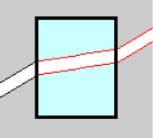

7. Draw and label the incident ray and refracted ray on your unlined paper, showing normal refraction (as above). Ignore the rays that are reflected, etc.

8. Trace the prism so it is part of your drawing.

**PART 2**

1. Obtain a new sheet of unlined paper for a new drawing.
2. Repeat the former procedures until you see the effect shown in ONE of the pictures below:

### CALCULATIONS AND DATA

1. For ALL of your drawings, LABEL the incident ray entering the prism and the refracted ray leaving the prism. Include arrows to show the direction of light travel.

2. For the “normal refraction” drawing in part 1, determine the angles of incidence (i**)** and refraction (t) for the light ray entering the prism and determine the angles of incidence and refraction for the light ray exiting the prism. Fill in the values you measured on your drawing.

NORMAL REFRACTION (part 1)

|  |  |  |  |  |
| --- | --- | --- | --- | --- |
|  | **i1** | **t1** | **i2** | **t2** |
| **Angle (degrees)** |  |  |  |  |

3. Hold any of the prisms up to the light. Move the prism until you see colors. Make a drawing of what you see, showing the incident light ray, the refracted ray inside the prism and the resulting color dispersion in the proper order of color.

### CONCLUSIONS AND QUESTIONS

1. What Phenomenon of light did you observe in PART 2 of the procedures?

2. Give two examples of instruments that we use that contain prisms.

3. What Phenomenon of light did you observe when holding the prism up to the light and seeing colors?

### Calculations and Data

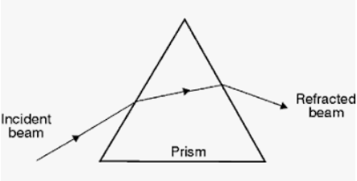

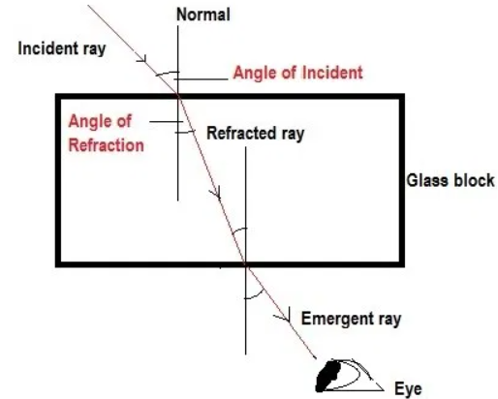

### CONCLUSIONS AND QUESTIONS

1. What Phenomenon of light did you observe in PART 2 of the procedures?

**Total internal reflection**

2. Give two examples of instruments that we use that contain prisms.

**Microscopes, telescopes, binoculars, spectroscope, periscopes**

3. What Phenomenon of light did you observe when holding the prism up to the light and seeing colors?

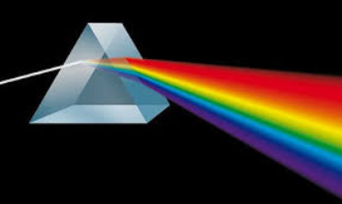 **Dispersion**