**Chapter 6**

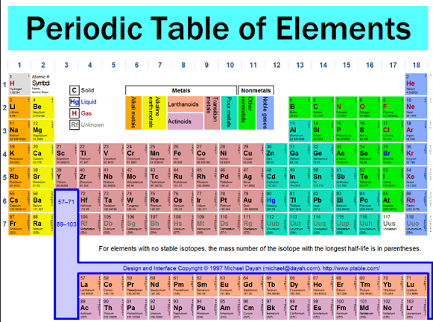

**See** [**https://www.learningctronline.com/courses**](https://www.learningctronline.com/courses) **for Materials and Resources.**

**Topics:**

1. The Periodic Table

**Objectives:**

1. Explain the history of the Periodic Table (Dobereiner, Newlands, Mendeleev, Moseley).
2. Describe the arrangement of the periodic table (periods, groups, periodic law, classes of elements).
3. Classify elements based on electron configuration for Valence (outer electrons that bond).
4. Explain periodic trends (electronegativity, atomic & ionic size, ionization energy)

TAKE NOTE [1 week unit]

1. Notes / Study Guide
2. Lesson Check/Sample problems or Alternative Worksheets
3. Density Lab Report Revisions
4. Test Corrections Atomic Structure & Modern Atomic Theory
5. Test Study Guide 🡪 Objectives, Major Points
6. Periodic Table Test
7. Week 8 Devotional (<https://www.learningctronline.com/devotional>)

**Text**: Chapter 6: Periodic Table pp. 158-191

Read the assigned pages in the text.

**Class Notes: PowerPoint or PDF**

**Notes/Study Guide:** Fill in the Chapter 5 worksheet to understand the class notes.

**Homework**: TEXT

(1) Answer the KEYED **"Lesson Check"** questions at the end of each of the chapter.

(2) Answer the **"Sample problems"** found in the "Sample Problem" boxes throughout the chapter. An answer KEY is provided for you to use to self-correct your homework problems.

* Put your answers into complete thoughts in a Word document. Do NOT just put the answer, but write a phrase or sentence that you can study from for your tests. Save your work in a WORD document and SAVE into your HOMEWORK folder in the Chemistry folder on the desktop.
* Assignments will be “spot checked” during class or submitted via email.

**Alternate Homework**:

1. Periodic Law Worksheet
2. Periodic Trends Review Worksheet

**Lab**: Revise the Density Lab Report

<http://somup.com/c06lYbBzq3> (8:55) ... video tutorial.

1. Revise your Density lab report as follows:
2. Leave your original lab content and place the corrections BELOW your original content IN EACH SECTION to show the revision. (e.g. If you made errors in the Calculations and Data section, leave those errors, but add the corrections below your content IN THE Calculations and Data section by using a **blue font color**.)
3. Refer to the sample density lab report, but Do NOT copy and paste the model density lab information. Retype in your own words and fill in tables for yourself.
4. Make all the major corrections needed, not just a partial revision (You are being offered an opportunity to learn from your mistakes and receive bonus points for doing so. Please use integrity and respect by doing your own work and using the Model only as a guide).
5. If you follow the designated format, you can earn 1/2 of the points deducted from your grade.
6. When completed, resubmit the lab.
7. The revised Density Lab Report is due before next week's class.

**TEST:** Periodic Table

1) the academic integrity policy

* Tests must be completed **WITHOUT** referring to books, notes, the internet, people, or any outside resources.
* Students **MAY** use the approved Periodic Tables, approved Reference Tables, or approved equation (formula) sheet (provided by the teacher) along with calculators and scratch paper.
* A guardian should be proctoring the test. Proctoring means to monitor the following:

2) The test is composed of 35 multiple choice questions and some written problems.

* The **multiple-choice test must be taken "in one sitting"**, meaning that once you start the test, you must complete it without interruption. (60 minutes)
* Take a short break (5-10 minutes)
* There is **NO** **written portion on this test.**

3) There is a **60-minute time limit** on this test. Please have the proctor write the time taken at the top of your answer sheet with their signature or initials.

4) Proctors should NOT be reading the test or engaging students during the test.

5) Do NOT use RED font. Black font is best.

Supplemental Resources (Optional)

1. Top Secret Agent Periodic Table
2. Chapter 6 Study Guide Pearson

[The Periodic Table Song](http://somup.com/cF6QFinnyQ) (2:44) ... over 100 elements.  
  
[Tom Lehrer's The Elements Song](http://somup.com/cFQ22hVSKJ) (1:26) 1970  
  
<http://somup.com/cr6o2a30ll>  Periodic Table Review Song (3:07) ... Periods, Groups, Valence, Electronegativity (Review).  
  
[As for Me & My House Joshua 24:15; Always](http://somup.com/cYhIDejrLq) (5:15)