**Acids & Bases Chapter 19A**

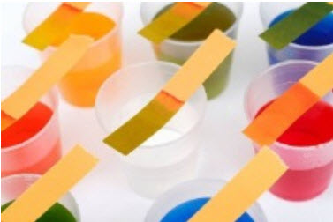

**See** [**https://www.learningctronline.com/courses**](https://www.learningctronline.com/courses) **for Materials and Resources.**

**Topics:**

1. Acids & Bases

**Objectives:**

1. Explain Arrhenius acids and bases based on the dissociation of water.
2. Define pH and pOH. Use the pH scale to characterize the acidity and basicity of solutions and properties of acids and bases.
3. Convert between pH, pOH, hydrogen ion concentration and hydroxide ion concentration.
4. Describe Bronsted-Lowry acids and bases.
5. Identify conjugate acids and conjugate bases as well as conjugate pairs in a Bronsted-Lowry acid–base reaction.
6. Describe Lewis acids and bases. [Honors]

TAKE NOTE

1. Notes/Study Guide [2 weeks]
2. Test Corrections (Reaction Rate, Equilibrium, Spontaneity)
3. Lesson Check/Sample problems or Alternative Worksheet [2 weeks]
4. Labs Acid Base Simulation & Natural Indicators
5. Class Song: “When a Man’s an Empty Vessel” (If I Had Reality)

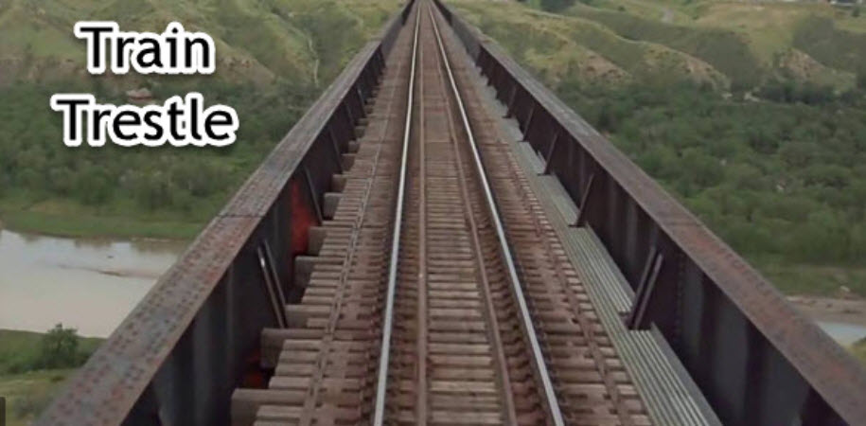

1. Week 29 Devotional (<https://www.learningctronline.com/devotional>)

**Text**: Chapter 19: Acids & Bases pp. 644-671; OMIT Sample Problem 19.4 (p. 658)

Read the assigned pages in the text. Skip the omitted problem.

**Class Notes: PowerPoint or PDF**

**Notes/Study Guide:** Fill in the Chapter 19 worksheet to understand the class notes.

**Homework**: Text

(1) Answer the KEYED **“Lesson Check”** questions at the end of each.

(2) Answer the **“Sample problems”** found in the “Sample Problem” boxes throughout the chapter. An answer KEY is provided for you to use to self-correct your homework problems.

* Put your answers into complete thoughts in a Word document. Do NOT just put the answer, but write a phrase or sentence that you can study from for your tests. Save your work in a WORD document and SAVE into your HOMEWORK folder in the Chemistry folder on the desktop.
* Assignments will be “spot checked” during class or submitted via email.

**Alternate Homework**:

1. Chapter 19 Review Exam (Acids & Bases)

**Lab**: Acids & Bases Simulation

1. Perform the " Acids & Bases Simulation" using the video and worksheet provided.  
     
   [Acid & Base Simulations](http://somup.com/cYfFlziX4l) (7:01)
2. Answers are provided at the end of the document for guidance. Do NOT copy and paste these answers, but write using your own words.

Save the document into your LAB folder in the Chemistry folder on your desktop.

**Lab Natural pH Indicators**

* Perform the lab using the worksheet provided.
* Answers are provided at the end of the document for guidance, but do NOT copy and paste. Use your own words.   
    
  [Red Cabbage As a Natural Indicator](http://somup.com/cFXXcXniZB) (1:02)

**TEST:** The test will be given after next week’s lesson.

Supplemental Resources (Optional)

1. pH, pOH, [H+] and [(OH)-] Practice Worksheet

[Rainbow Connection](http://somup.com/cFX603niZO) (4:04) Acid-Base Indicators  
  
You will hear a "special needs" student in the background who will brighten your day!  
  
[Bronsted-Lowry Acids & Bases](http://somup.com/cFX60CniZy) (5:39)  
  
[Eyes but Can't See, Ears but Can't Hear Matthew 13:14-15; Slow Fade](http://somup.com/cYhqbwjzUF) (5:59)