**Introduction**

**Purpose** To investigate and compare a simple series circuit with a simple parallel circuit.

**Background Information**

Series circuits are electric circuits in which electrical devices are connected in ONE loop, and the same electric current (I) exists in all resistors (R) or loads. The amount of current (amperage) that flows across each resistor is the same. Therefore, the more resistors you add, the dimmer each one gets. Series circuits work well for simple circuits (e.g. flashlights), but are not advantageous for industry and homes because if one resistor fails, the circuit stops.

Parallel circuits are electric circuits in which electrical devices are connected in such a way that the same voltage (V) acts across each electrical device and any one of electrical devices completes the circuit independently of all the others; 2 or more branches. Every unit that is connected in a parallel circuit gets equal amount of voltage (V). Parallel circuits are used in cases of multiple loads. It becomes easy to connect or disconnect a new element without affecting the working of other elements. If any one of those branches “goes down” the other branches continue to operate since the voltage (V) is equal everywhere in a parallel circuit.

**Hypothesis**

If an electric circuit is connected in series, then if one resistor is disconnected the other loops in the circuit will stop. If resistors are added to the series circuit, then the brightness will decrease since overall current remains constant.

If an electric circuit is connected in parallel, then if one resistor is disconnected the other loops in the circuit will not be affected. If another loop is added to the parallel circuit, then the other loops will not be affected.

**Materials** PHET Simulation 3 Switches 1 Battery (adjust voltage)

6 Light Bulbs Wire Non-contact ammeter

Voltmeter

**Procedures**

1. For the simulation, click on: <https://phet.colorado.edu/en/simulation/legacy/circuit-construction-kit-ac> or use the following video link: <http://somup.com/cbeoDuRtf> .

2. Click on the “Phet simulation” … click download. You may need to download java as well (it’s free).

* Find the “**Circuit Construction Kit**” in the Electricity Index

**Set up a SERIES circuit**

Use the PHET simulation or video link and the drawing below.

1. Connect the battery (30 V), switches and 6 bulbs together with wire to form a series circuit (*see diagram on the next page*).

2. Draw a sketch using SYMBOLS of your series circuit.

3. Remove one of the bulbs in the series circuit and observe what happens.

4. Use the non-contact ammeter to check the current at various points in the series circuit.

bulb

switch

battery

Series Circuit

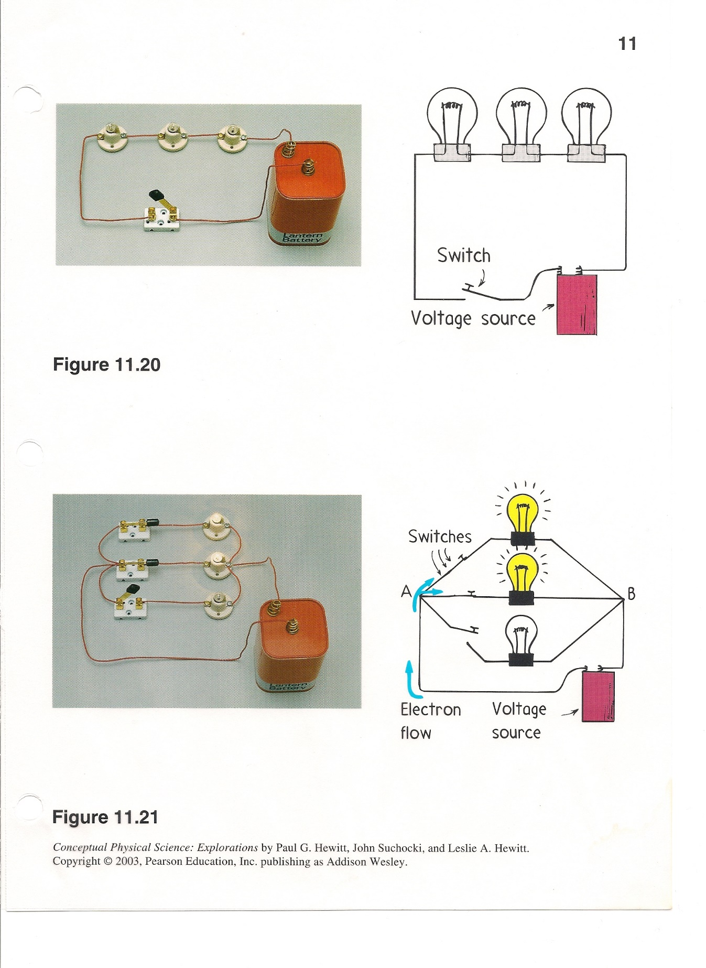

Series Circuit

**Set up a PARALLEL circuit**

1. Use the PHET simulation or video link and drawing below.

2. Connect the battery, switches and 6 light bulbs together using wire in order to form a parallel circuit (*see diagram on the next page*).

3. Draw a sketch using SYMBOLS of your parallel circuit.

4. Unscrew one of the bulbs in the parallel circuit and observe what happens.

5. Use the voltmeter to check the voltage across each path in the parallel circuit.

6. Observe the light intensity of each bulb when all 6 are lit.

bulb

switch

battery

Parallel Circuit

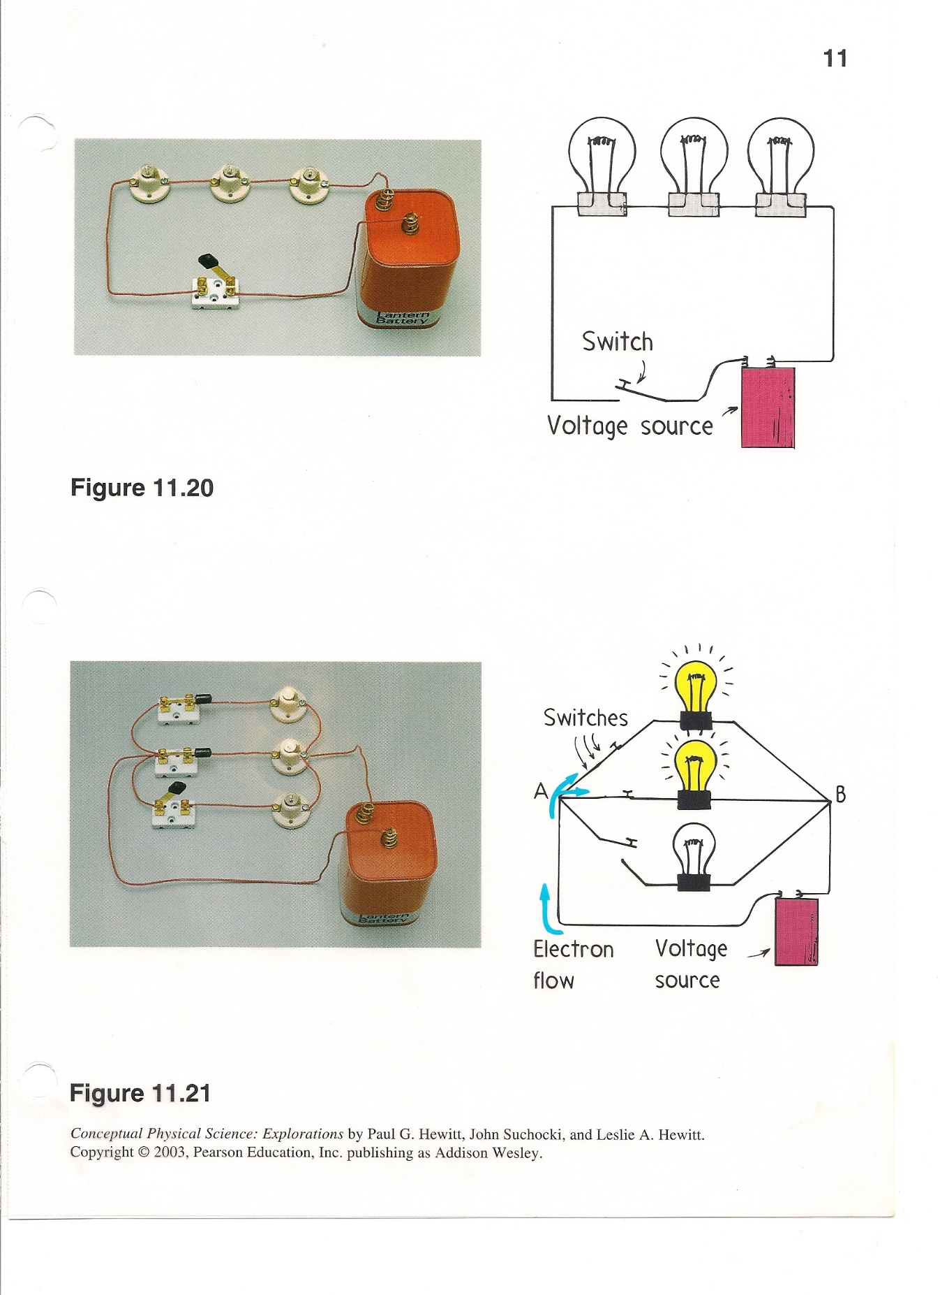

Parallel Circuit

## Calculations and Data

1. Label both of your drawings/sketches to distinguish all of the following: Series Circuit, Parallel Circuit, voltage source (*battery*), resistance (lamps), and switches.

2. What happened when you unscrewed one of the lamps in the series circuit?

3. What happened when you unscrewed one of the lamps in the parallel circuit?

4. For the parallel circuit, how did the light intensity vary throughout the circuit? Try changing the number of bulbs or turn one branch off, etc.

5. Set up a series circuit using 1 light bulb. Notice the light intensity. Now add 1 more bulb to the series circuit. Compare the intensity of the lamps with the series circuit you set up with only one bulb. Add another bulb into the series circuit. Notice the light intensity now. What does this show about the electric power going across the lamps in a series circuit?

## Conclusions and Questions

1. Which circuit is best to use for a normal household? Explain your answer.

2. What common household device would use a series circuit?

3. What element (*voltage, resistance, current*) remained constant in the series circuit?

4. What element (*voltage, resistance, current*) remained constant across each path of the parallel circuit?

## ANSWERS

## Calculations and Data

1. Label both of your drawings/sketches to distinguish all of the following: Series Circuit, Parallel Circuit, voltage source (*battery*), resistance (lamps), and switches.

*Both circuits are shown on the lab sheet.*

1. What happened when you unscrewed one of the lamps in the series circuit?

*If any resistor breaks or is unscrewed, the entire series circuit will shut down.*

1. What happened when you unscrewed one of the lamps in the parallel circuit?

*If any resistor breaks or is unscrewed only the loop containing the resistor will shut down, but the other loops in the parallel circuit will continue working.*

4. For the parallel circuit, how did the light intensity vary throughout the circuit? Try changing the number of bulbs or turn one branch off, etc.

*As long as the number of bulbs in each branch is the same, the light intensity will not vary because the voltage is the same for each resistor.*

5. Set up a series circuit using 1 light bulb. Notice the light intensity. Now add 1 more bulb to the series circuit. Compare the intensity of the lamps with the series circuit you set up with only one bulb. Add another bulb into the series circuit. Notice the light intensity now. What does this show about the electric power going across the lamps in a series circuit?

*The more light bulbs that are added, the dimmer the light in each bulb. This is because the current for each resistor (light bulb) is the same throughout the circuit. Therefore, if the circuit yields 5 A of current, one bulb would receive all 5A. However, add another bulb (2 total) and now each bulb would receive 2.5 A. Three bulbs would each get 1.67 A each.*

*Voltage is additive in a series circuit, meaning that the voltage across each resistor is added up to equal ONE total, which should match the voltage source (e.g. battery).*

## Conclusions and Questions

1. Which circuit (series of parallel) is best to use for a normal household? Explain your answer.

*A Parallel circuit works best because if any resistor breaks or is unscrewed only the loop containing the resistor will shut down, but the other loops in the parallel circuit will continue working.*

*In real life, most circuits in our homes and industry are “combination” circuits which contains a fuse or circuit breaker connected in series while the other loops are parallel.*

2. What common household device would use a series circuit?

*A flashlight is a common household device using a series circuit. Possibly some battery operated toys and tools also contain series circuit.*

3. What element (*voltage, resistance, current*) remained constant in the series circuit?

*Current remains constant in a series circuit, meaning that the overall current is the same. For instance, a series circuit with 10 amp will spread that amperage across all resistors. If there is one resistor, it receives 10 amps of current. If there are 2 resistors, each will get 5 amps (totaling 10 amps), if 3 resistors, each will get 3.3 amps (totaling 10 amps), etc..*

4. What element (*voltage, resistance, current*) remained constant across each path of the parallel circuit?

*Voltage remains constant across each loop or path in a parallel circuit, meaning that the electrical power remains constant across all loops.*