# Chapter 31 – Human Anatomy and Physiology

1. Endocrine System
   1. Overview
2. The endocrine system is made up of _____ that release their products into the _____.
3. These products deliver _____ throughout the body.
4. The chemicals released by the endocrine system can affect almost every _____ in the body.
5. Endocrine and Nervous Systems specialize in the inter-systemic communication needed to maintain body _____.
6. Nervous system acts faster and more locally than Endocrine System
7. Endocrine System includes:
   * 1. G_____
     2. H_____
   1. Glands
      1. An organ that produces and releases a _____.
      2. Two kinds of glands:
8. _____ glands 🡪 Release secretions through _____ directly to the organs that use them.
9. _____ glands 🡪 Release their secretions _____ into the _____.
   1. Endocrine system Control
10. In the endocrine system, _____ signals called _____ regulate body functions.
11. Hormones are chemicals released in _____ of the body that travel through the bloodstream and affect the activities of cells in _____ parts of the body.
12. Are released into the bloodstream by endocrine cells.
13. Are carried to _____ locations in the body.
14. Affect only _____ Cells that have receptors for that _____ hormone.
15. _____ travels everywhere via the bloodstream.
16. _____: Limited to cells that have the _____ for the signal.
    1. H_____
       1. Maintains the body at a balanced level.
       2. Produces and releases _____.
       3. Regulates many body _____, including sleep, memory, and appetite.
       4. Hypothalamus secretes hormones which make other _____ glands secrete hormones.

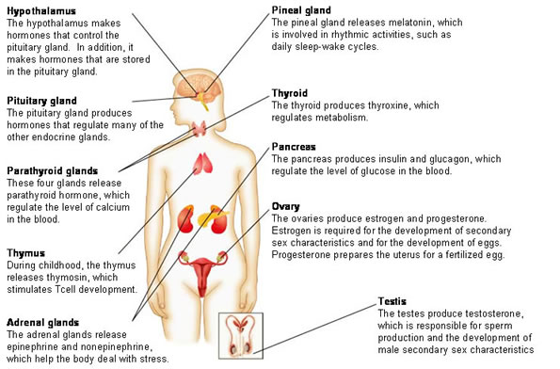

* 1. P_____ Gland

1. Secretes hormones which make other endocrine glands secrete hormones, “releasing hormones”; Releases FSH (menstrual cycle), LH (ovulation), ACTH (metabolism), TSH (thyroid), GH (growth).
2. The pituitary hormones help control some of the following body processes:
3. G_____.
4. _____ Pressure.
5. Some aspects of pregnancy and childbirth including stimulation of uterine contractions during childbirth.
6. Breast milk production.
7. _____ organ functions in both women and men.
8. _____ gland function.
9. The conversion of food into energy (_____).
10. _____ and osmolarity _____ in the body.
    1. P_____ Gland

* Releases _____, regulates rhythmic activities (_____ cycles, etc.).
  1. T_____ Gland

1. Produces _____ to regulate _____, involving iodine.
2. _____ reduced blood _____ levels (opposes parathyroid gland).
   1. P_____ Gland

* Controls _____ blood levels (nerves / muscles).
  1. Adrenal Glands

1. Adrenal _____ 🡪 _____, ___ hormones, _____ (stress & glucose levels).
2. Adrenal _____ 🡪 _____, norephinephrine, epinephrine; _____ reactions.
   1. P_____
3. Regulates _____ levels in the blood.
4. Produces _____ (causes glucose _____) & _____ (releases glucose into the blood.
   1. T_____ 🡪 produce testosterone
5. _____ production
6. development of male “_____ sex characteristics” (_____, _____ hair, voice box).
   1. O_____
      1. produce *estrogen* and *progesterone.*
      2. _____ is required for the development of female _____ sex characteristics (breasts, hips) and the development of _____.
      3. _____ prepares the _____ for a fertilized egg.

|  |  |  |
| --- | --- | --- |
| GLAND | HORMONE | ACTION |
| Pineal | Melatonin | Circadian Rhythm |
| Anterior Pituitary | Growth Hormone | Cell Growth |
| Posterior Pituitary | ADH (Antidiuretic Hormone) | Water Balance |
| Thyroid | T3/T4 | Metabolism |
|  | Calcitonin | Decreases Blood Calcium |
| Parathyroid | Parathyroid Hormone (PTH) | Increases Blood Calcium |
| Pancreas | Insulin | Decreases Blood Sugar |
|  | Glucagon | Increases Blood Sugar |
| Adrenal Cortex | Glucocorticoids | Anti-Inflammatory |
| Adrenal Medulla | Epinephrine (Adrenaline) | Fight or Flight |
| Ovary | Estrogen | Female Sex Characteristics |
| Testes | Testosterone | Male Sex Characteristics |

* 1. Control of the Endocrine System

1. The endocrine system is regulated by _____ mechanisms that function to maintain _____.
2. _____ feedback
   1. (more product sends the signal for even _____ _____)
   2. Alarm or panic can spread by positive feedback among a herd of animals to cause a stampede.
3. _____ feedback controls the rate of a process to _____ accumulation of a product.

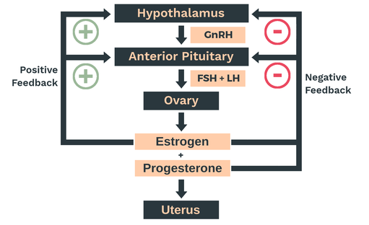

1. Immune System
   1. Overview
   2. _____ the body against _____ and _____ cells.
   3. The immune system recognizes, attacks, destroys, and “remembers” each type of pathogen that enters the body.
   4. _____ 🡪 The immune system fights infection by producing cells that inactivate foreign substances or cells.
   5. _____ Blood cells that play major roles in the _____.
      * 1. M_____ 🡪 Phagocytes – cells that _____ bacteria and debris.
      1. ___ Lymphocytes:
         1. Mature in the _____.
         2. When activated the turn into _____.
         3. They produce _____.
      2. ___ Lymphocytes:
         1. Mature in the _____.
         2. Two main kinds
   6. Helper (activate other parts of immune system).
   7. Cytotoxic (kill infected cells).
   8. Two General Categories
      1. Innate (nonspecific) Defenses 🡪 Provide _____ protection against all pathogens.
      2. _____ (_____) Immunity
2. Directed against specific pathogens.
3. Produces “memory” that protects against future exposure to a previously encountered pathogen.
   1. ___ Line of Defense
      * 1. ___specific
        2. Act Early (_____, mucous, _____, tears)
        3. Prevent pathogens from entering body.

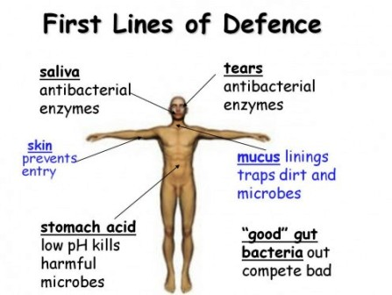

* 1. ___ Line of Defense
     1. _____, Destroy, or _____ _____ that have entered the body.
     2. Macrophages: consume pathogens, promote _____, and activate the immune response.
     3. Antimicrobial Proteins: communicate with immune system cells and stimulate _____.
     4. _____ (nonspecific response): _____, warmth, _____, pain.

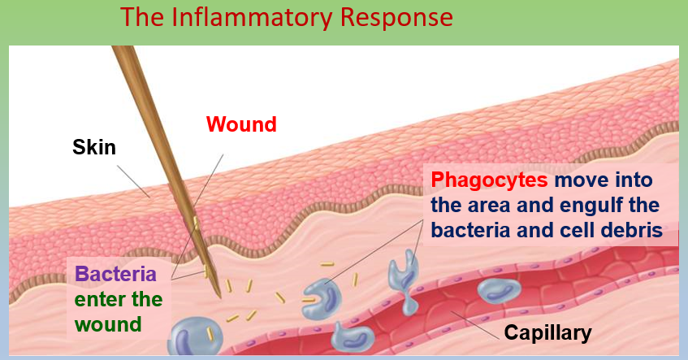

?

?

* + 1. Nonspecific Defenses 🡪 Fever:

1. The immune system releases chemicals, pyrogens (inflammatants), that _____ the core body _____.
2. This high temperature _____ or stops the growth of _____.
3. Increases heart rate, _____s get to the site of infection faster.
   1. Specific Defenses 🡪 ___ Line of Defense
4. Immune Response
   * + If a pathogen gets past the nonspecific defenses, the immune system reacts with a series of specific defenses.
5. _____ 🡪 substance that causes an immune response.
6. _____ 🡪 protein that tags/flags antigen.
7. _____ (WBC)
8. Made in bone _____.
9. B cells – produce _____ (target _____).
10. T cells – helper cells/killer cells (target _____ and abnormal cells).
    1. Acquired Immunity
11. _____ Immunity
    1. Body develops immunity after _____ to a microbe (antigen).
12. _____ – exposed to the disease organism
13. Artificial - _____

2. _____ Immunity

* 1. Body develops immunity after being given _____ to the antigen.
  2. _____
  3. Ex: Nursing infants receive antibodies from mom.
  4. Ex: Person bitten by raccoon gets antibodies to help defend against potential rabies infection.

* 1. Primary and Secondary Immune Responses
     + 1. _____ encounter with an antigen provokes the _____ immune response which is relatively slow.
       2. Its legacy is _____ Cells that greatly speed the _____ Immune Response on subsequent exposure to the _____ antigen

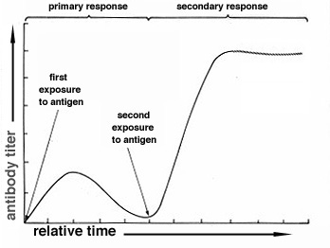

* + - 1. _____ Immune Response is _____ and _____.
      2. Primary Response:

1. _____ response after first exposure to an antigen.
2. begins about 5 -10 days after exposure.

5. Secondary Response:

1. Antibody response after second exposure to an antigen.
2. begins _____ and response is greater (than primary response).
   1. Immune Diseases
      1. _____ is cancer affecting the _____ and bone marrow.

* It occurs when the body produces abnormal _____ blood cells that don’t function properly and can’t fight off infection.
  + 1. _____ is an autoimmune deficiency (the body attacks itself by mistake), a chronic condition in which the _____ produces little or no _____.
    2. Rheumatoid _____ is an autoimmune deficiency (the body attacks its own tissue), including _____.
* A chronic inflammatory disorder affecting many joints, including those in the hands and feet.
  + 1. _____ usually occurs due to an overactive immune system, reacting to environmental triggers and causing inflammation in the _____ and symptoms such as coughing, wheezing, and shortness of _____.

# Human Anatomy and Physiology – Chapter 33

1. Digestive System
   1. _____ 🡪 Substances in food your body uses to produce energy and raw materials for growth and repair.
      1. Vitamins
   2. _____ **molecules** that are vital to maintaining a healthy body.
   3. Ex: _____ A, B, C ,D , E, K
   4. Sources: variety of foods
      1. _____
   5. _____ chemical elements needed for proper body function.
   6. Ex: iron, potassium, calcium, sodium, phosphorus, zinc, iodine
   7. Sources: variety of foods
   8. “You are What you Eat” – Food is processed in four stages:
      1. _____ is the act of eating.
      2. _____ is the breaking down of food into molecules small enough for the body to absorb.

a. M_____ (physical)

b. C_____

1) Intracellular

2) Extracellular

3) H_____

4) Enzymes

* + 1. _____ is the take-up of the products of digestion by the cells lining the digestive tract.
    2. _____ is the removal of _____ materials from the digestive tract.
  1. Two methods of Digestion
     1. _____ Digestion: involves grinding of food and mixing it with digestive juices.
* _____ and _____
  + 1. _____ Digestion: involves chemically breaking down the food into soluble substances that the body can use.
* _____ and Digestive Juices

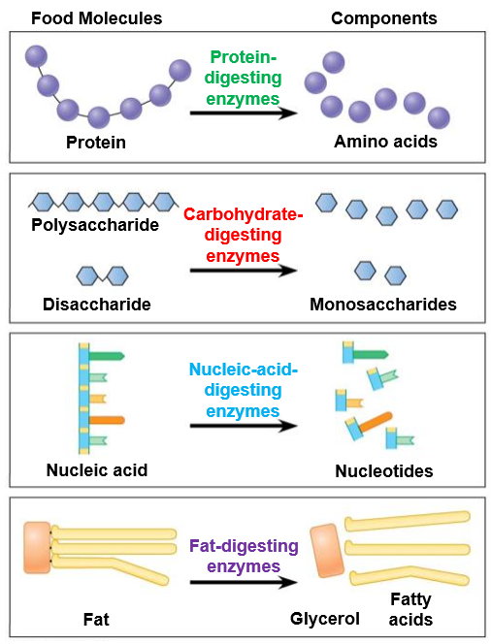

* 1. Organs of the Digestive System are divided in two groups:
     1. _____ Canal: tube about 9 m (30 feet) long that runs from the mouth to the anus.
        1. Mouth, Pharynx, Esophagus, Stomach, Intestines
        2. _____: type of _____ contractions by which food is moved along the alimentary canal.
     2. _____ Organs: organs attached to the alimentary canal by ducts (tubes).
* Salivary glands, gallbladder, Liver and Pancreas

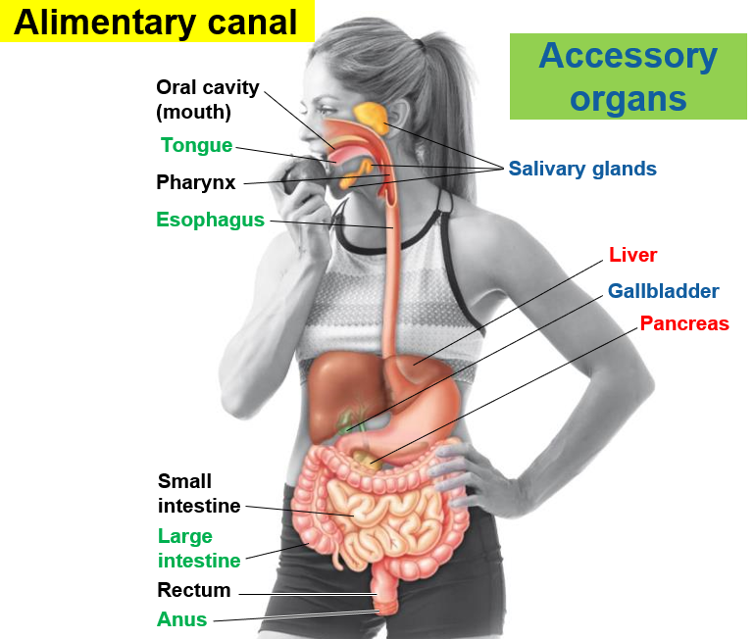

* 1. Path food takes in digestion
     1. M_____
        1. _____ (physical) digestion begins in the mouth as the tongue moves the food between the teeth for chewing
        2. _____ contains the enzyme _____ for chemically digesting Starch into maltose.
        3. Tongue forms a _____ for swallowing.

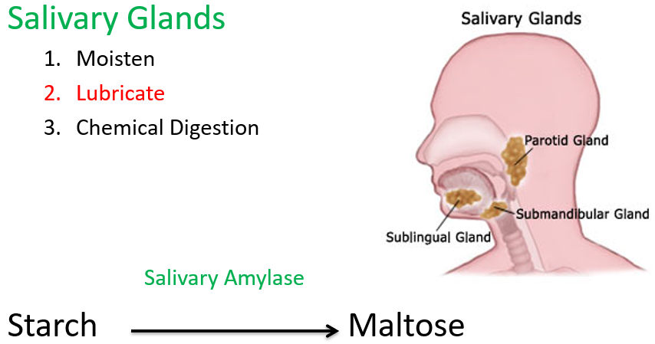

* + 1. E_____

1. The tongue moves the chewed food into the _____ at the back of the mouth where _____ starts.
2. Trachea is blocked by the Epiglottis
3. Swallowing begins the _____, wave-like _____ of _____ that pushes the food through the _____.
   * 1. S_____
        1. _____ digestion.
4. Closed _____ at each end of the stomach keep the food inside while _____ in the wall of the stomach carry on _____.
5. Food is churned for up to _____.
   * + 1. _____ Digestion
6. _____ in the stomach lining produce fluids that contain
7. _____: enzyme that digests _____.
8. _____ acid, which helps to _____ certain foods and also kills some _____ that enter the stomach.
9. _____ continue the digestive process.
10. Acid and enzymes do not digest the stomach itself because it is protected by a thick layer of _____.
11. In the stomach, the mixture of food, enzymes and acid becomes a semiliquid called _____.
    * 1. Small Intestine
         1. Materials from liver, gall- bladder and pancreas are delivered to small intestine.
         2. Liver and gallbladder
      2. _____ – produced by the _____ and stored in the _____.
         1. Bile contains _____, bile salts, broken down _____ blood cell pigments.
         2. Bile aids digestion by _____ (mechanical) digestion.
         3. _____ (break down of fat)
         4. Bile enters the small intestine through the _____ _____ duct.
      3. G_____
         1. are _____ deposits of _____ possibly caused by too much cholesterol (fatty diet) or bilirubin (which breaks down RBCs).
         2. Treated by surgery or medication to dissolve the gallstones.

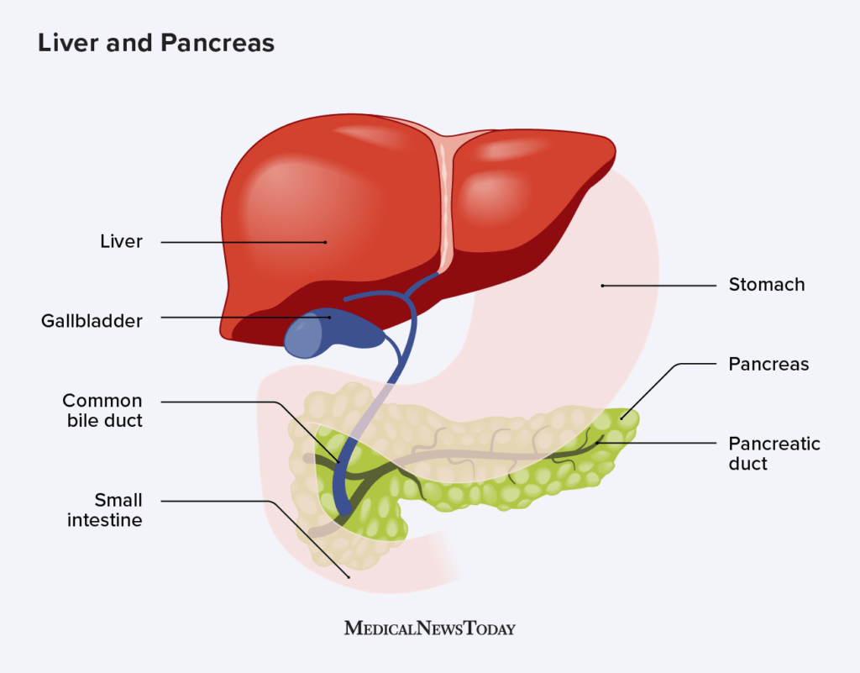

* + - 1. L_____
      2. The liver is an _____ digestive organ.
      3. The “Master Chemist of the Body” (>500 functions).
      4. Adjust the contents of the blood to meet the body’s needs.
      5. The liver receives blood from the Hepatic Portal Vein and various arteries.
      6. This blood carries food and other substances absorbed by the small intestine.
      7. The main function of the liver within the digestive system is to process the _____ _____ _____ the small intestine.
      8. _____ from the liver secreted into the small intestine also plays an important role in digesting _____ and some vitamins.
      9. The liver takes the raw materials absorbed by the intestine and makes all the various chemicals your body needs to function.
      10. Digested food in the small intestine is absorbed into the capillaries inside the _____.
      11. Blood then carries these absorbed molecules to the _____.
      12. P_____

1. The pancreas has two main functions: an _____ function that helps in digestion and an _____ function that regulates blood _____ (insulin & glucagon).
2. Releases _____ to neutralizes stomach _____.
3. Releases Pancreatic ‘Juice’ for digestion.
4. _____ (_____)
5. _____ & chymotrypsin (_____)
6. _____ (_____)

4) Pancreatic ‘juice’ enters the small intestine as the pancreatic duct joins the _____ _____ duct.

* + - 1. Small Intestine

1. Characteristics and function
2. Small _____ (up to 23 feet long!)
3. Among others, it releases sodium bicarbonate to neutralize acid in _____.
4. ____% of chemical digestion occurs there.
5. Absorption – _____ and microvilli increase Surface Area (SA).
6. Peristalsis
7. Three sections
8. _____ – absorbs _____, _____, and _____.
9. Jejunum – absorbs sugars, amino acids and fatty acids.
10. Ileum – absorbs nutrients (B-12) & bile. Connects to colon.
11. Duodenum receives
12. _____: from liver
13. _____ Juice: from Pancreas. Pancreatic Juice contains:
14. Trypsin and Chemotrypsin digest proteins.
15. Lipase digests fats.
16. Pancreatic Amylase digests starch.
17. Nucleases: digest nucleic acids.
    * 1. _____ Intestine
18. At the end of the small intestine, the remaining undigested foods and fluids enter the Large Intestine.

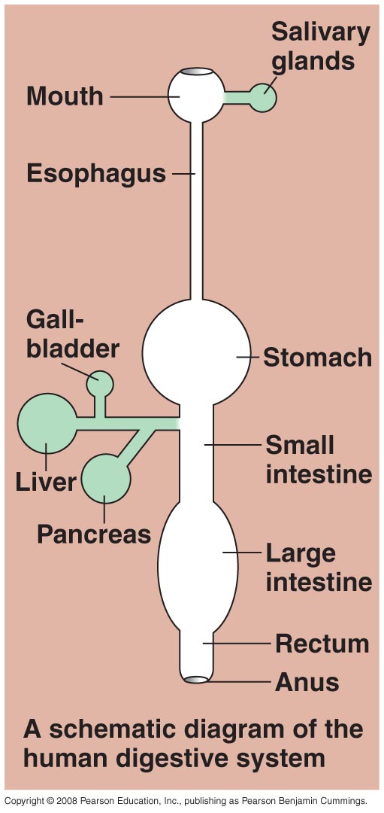

1. 1.5 m (5 ft.) long
2. Little or no digestion occurs here.
3. _____ _____, _____ and some vitamins.
4. Many friendly _____ live and reproduce in the large intestine (e. coli).
5. Usually, they do not cause disease.
6. They produce certain _____ (K) and digest food that humans cannot digest.
   * 1. Rectum and Anus
7. Material left after large intestine absorbs most of the water is called _____ (food debris and bacteria).
8. Peristalsis moves feces from the large intestine to the _____ through the _____, the last valve of the alimentary canal.
   * 1. _____ occurs when too little water is reclaimed from the contents of the large intestine.
     2. _____ occurs when too much water is reclaimed.

IV. Excretory (_____) System

* 1. Main Functions

1. _____ the body of _____ _____.
2. Types of waste in humans:
3. CO2
4. Excess water
5. _____
6. _____ – Nitrogenous waste formed from _____ of amino acids.
   1. Organs of the Excretory System
7. _____: excretes ‘sweat’ – excess water, salts and small amount of urea.
8. _____: excrete CO2
9. _____: detoxifies the blood and converts harmful substances into urea.
10. _____
11. The _____ excretory organ in humans (part of urinary system).
12. excrete water, urea, salts and other wastes from the blood.
13. maintain blood ___.
14. regulate _____ content and blood _____.
    1. Urinary System Anatomy
       1. Kidneys:

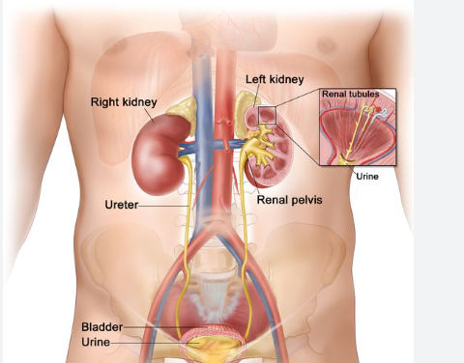

1. Primary excretory organ in humans.
2. produces urine.
   * 1. _____: tube that leaves each kidney, carrying urine to the bladder
     2. Urinary _____: saclike organ where _____ is stored before being excreted.
     3. _____: tube that leaves the bladder and delivers urine to the _____ environment.
   1. Kidney function
3. Blood enters the kidney through the _____ _____.
4. The kidney removes waste products and passes them to the _____.
5. The clean, filtered blood leaves the kidney through the _____ vein and returns to circulation.
6. Three parts:
7. Renal Cortex
8. Renal Medulla
9. Renal Pelvis
10. _____ – Functional unit of the kidney that _____ the _____.
11. _____ – Ball of capillaries

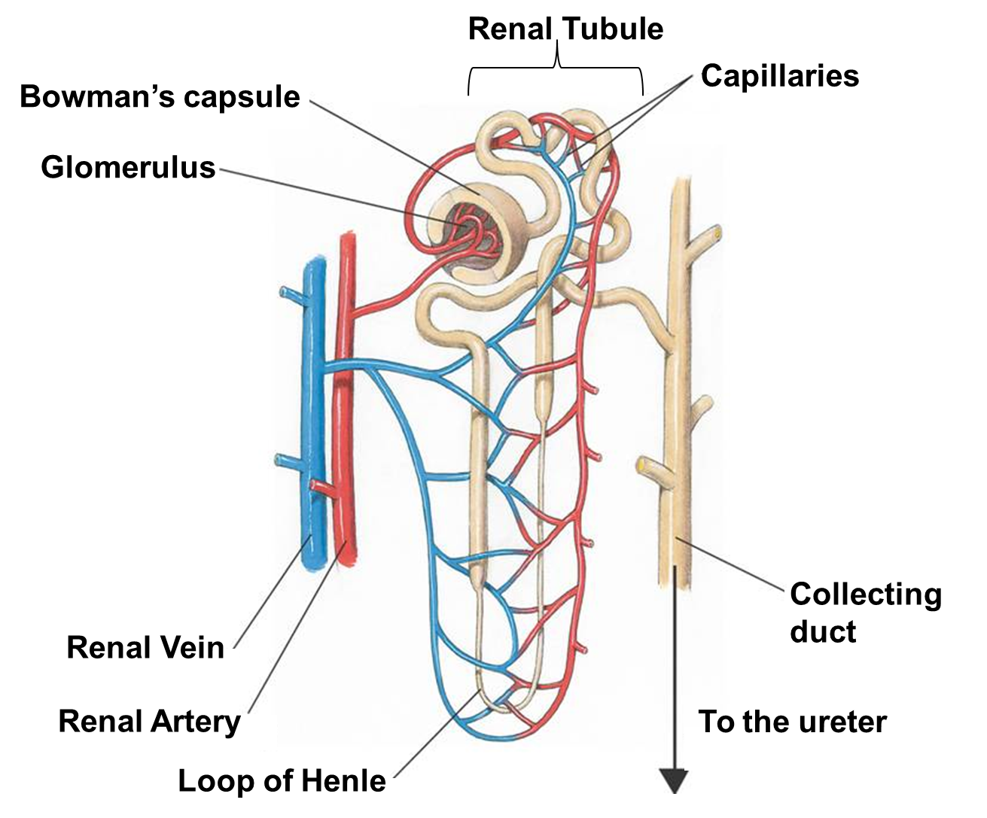

1. _____’s capsule – Cup-like structure that surrounds glomerulus.
2. Renal _____
3. Tube connecting Bowman’s capsule to collecting duct.
4. Includes _____ of _____ – site of _____.
5. Capillaries intertwined
6. _____ duct – collects _____ from several nephrons.
7. Nephrons are primarily located in the renal cortex except for their Loops of Henle, which descend into the renal medulla.
   1. Urine Formation
      1. _____ is formed by two key processes:
8. Filtration
9. Reabsorption
   * 1. F_____
10. ____-selective process of pushing fluid through the glomerulus into Bowman’s capsule.
11. Blood cells are too large to pass so they remain in the blood.
12. Filtered liquid is now called filtrate (_____, _____, glucose, _____, salts).
    * 1. R_____
13. _____ process of removing ‘good stuff’ from the _____.
14. Occurs in the _____ of _____.
15. ‘Good stuff’ moves from Loop of Henle back to capillaries.
    * 1. _____ = excess water + urea + excess salts
16. Collects in the _____ ducts, empties into renal pelvis then _____ the kidneys via the ureters.
17. _____ in the urinary _____ before exiting the body via the _____.

F. Summary: Pathway of Excretory (Cellular) Waste

1. Produced in _____.

2. Diffuses into blood stream.

3. Carried by blood to _____ of kidney.

4. Enters _____.

5. Filtered into bowman's _____ and passes to renal tubule.

6. Travels from renal tubule (including Loop of Henle) to collecting duct.

7. Enters renal pelvis from collecting duct.

8. _____ (in form of urine) then passes through _____.

9. Urine is stored in _____ until released by passing through _____.

G. Control of Kidney Function

1. When you drink a liquid, it is absorbed into the blood through the digestive system.
2. The concentration of _____ in the blood _____;
3. _____ the rate of kidney water _____.
4. Less water is returned to the blood.
5. Excess _____ is excreted as _____.
6. When the kidneys detect an increase in salt … they respond by returning less _____ to the blood by reabsorption.
7. The excess salt is excreted in urine, thus maintaining the composition of the blood.