Plant Physiology

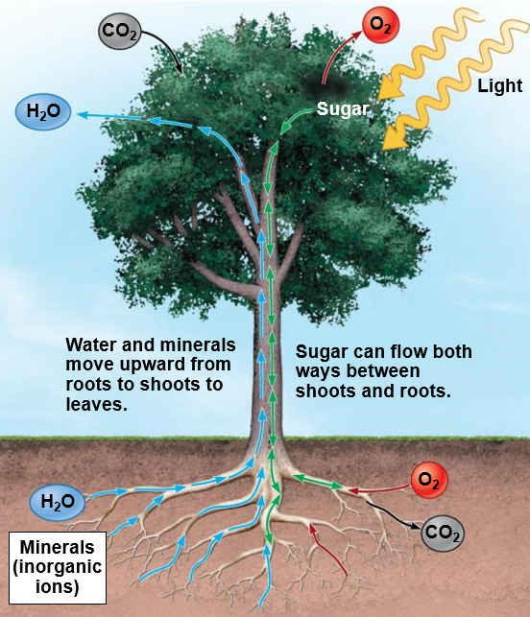

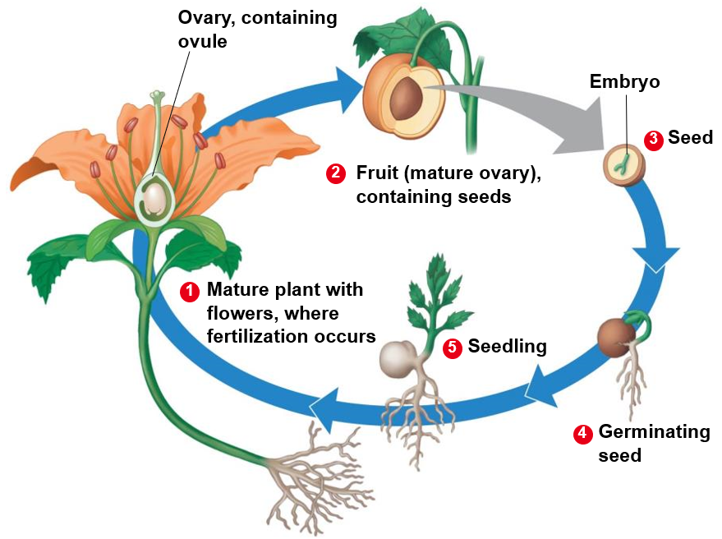



**See** [**https://www.learningctronline.com/courses**](https://www.learningctronline.com/courses) **for Materials and Resources.**

**Topics:**

1. Plant Physiology

**Objectives:**

1. Identify the major organs in plants, including the function and anatomy of each one?
2. Distinguish herbaceous & woody plants, monocots & dicots.
3. Explain the formation and aspects of secondary growth, including vascular tissue & bark.
4. Understand how plants acquire nutrients from air, water, and soil (root pressure, capillary action, transpiration), including light absorption and guard cells.
5. Identify Hormones and explain the process of germination.

HONORS

1. Understand and identify the structures and components of the reproduction of flowering plants.

TAKE NOTE

1. Notes/Study Guide (1 week)
2. Homework from Text (1 week)
3. Lab Quiz Keying Out Trees
4. HONORS or BONUS 🡪 Lab Seed Germination
5. Honors 🡪 Personalized Study Guide (2 weeks) & Flower Germination Notes
6. Chapter 24 – 25 Test … Plant Introduction & Physiology
7. Week 24 Devotional (<https://www.learningctronline.com/devotional>)

**Text**: Chapter 25: Plant Physiology pp. 530 – 550

Read the assigned pages in the text.

**Class Notes: PowerPoint or PDF**

**Notes/Study Guide:** Fill in the Chapter 25 Study Guide worksheet to understand the class notes.

**Homework**: (1 week)

* Study Questions (end of the chapter in the text) #6, 8, 11-12, 14-16
* Use a Word document format as follows:
  + Start on a new page of your document
  + Heading: Your name, Chapter in Text, Study Questions
  + Number the appropriate questions you are to answer
  + Write the answer in a complete sentence use the question as the template (do not copy the question, but reword it into a statement that answers the question).
* Use the same document each week by starting a new “Study Question” for a different chapter on the next page.
* Assignments will be “spot checked” during class or submitted via email.

**Lab**: Lab Quiz Keying Out Trees

* Use the Power Point Presentation for “Tree ID Quiz” to take the quiz.
* Place answers on the “Tree ID Quiz Answer Sheet”.
* You may use the "Dichotomous Tree Key" on the quiz.
* After completing the lab quiz, email it to [learningctronline@gmail.com](mailto:learningctronline@gmail.com) for grading.
* Save document into your LAB folder in the Biology folder on your desktop.

**TEST:** Plant Introduction & Physiology

1) the academic integrity policy

* Tests must be completed **WITHOUT** referring to books, notes, the internet, people, or any outside resources.
* A guardian should be proctoring the test as per Learning CTR Online policy: <https://www.learningctronline.com/test-proctor-policy>

2) This test is composed of 25 multiple choice and 3 essay questions.

* The **test must be taken "in one sitting"**, meaning that once you start the test, you must complete it without interruption.
* Take a short break (5 minutes) during the test.

3) There is a **60-minute time limit** on this test. Please have the proctor write the time taken at the top of your answer sheet with their signature or initials.

4) Honors students have an additional 20 minutes to answer the additional questions.

5) Proctors should NOT be reading the test or engaging students during the test.

5) Do NOT use RED font. Black font is best.

Supplemental Resources (Optional)

1. Plant Physiology Vocabulary Crossword

<https://youtu.be/HLYPm2idSTE> (8:00) The Amoeba Sisters Channel – **Plant Reproduction in Angiosperms**

<https://youtu.be/DGpPHrLF-5M> (8:26) The Amoeba Sisters Channel – **Plant Structure and Adaptations**

[**https://somup.com/c3QoY0UauC**](https://somup.com/c3QoY0UauC) **(1:30) Seed Germination**