**Introduction**

**Purpose** To investigate a physical principle that constitutes the modern theory of the atom.

**Discussion**

The electron in a Hydrogen atom can only have certain energies. Because the electron can only exist at discrete energy levels, they are said to be quantized. The word quantum comes from a Latin word meaning “how much.” The branch of physics that provides the current model of the Hydrogen atom is called quantum mechanics.

**Hypothesis**

Ifone observes various phenomenon which display the same physical principle, then one can better understand the nature of the atom.

**Part 1** You will observe four phenomena to determine the major physical principle that is apparent in all four.

**Activity 1** Emission Spectrum of a Gas Versus Fluorescent Light Spectrum

1. Watch the video to compare the types of lights used in terms of emission spectra.

<http://somup.com/cr1orUqpp6> Fluorescent Tube Versus Elemental Gas Spectra (1:04)

2. For fun, if you have a pair of diffraction glasses (3 D glasses) look at various types of light in your house and maybe in the video.

3. Compare the spectra:

**Activity 2** Tuning Forks (Scale) Versus Double Notes

1. Watch the video:

<http://somup.com/cr1oojqp6N> Interference Beats Tuning Forks (1:01)

2. Compare these sounds of identical tuning forks and those slightly different:

**Activity 3** Calculator Digits Versus Fractions

1. Punch the “1” and hit the “=” sign. Repeat with “2,” “3,” etc. up to “9.”

2. Now perform the following operations: 2/3, then 5/6, 6/7, and 8/9. Compare the numbers from step 2.

**Activity 4** Compare an analog tuner with a digital tuner

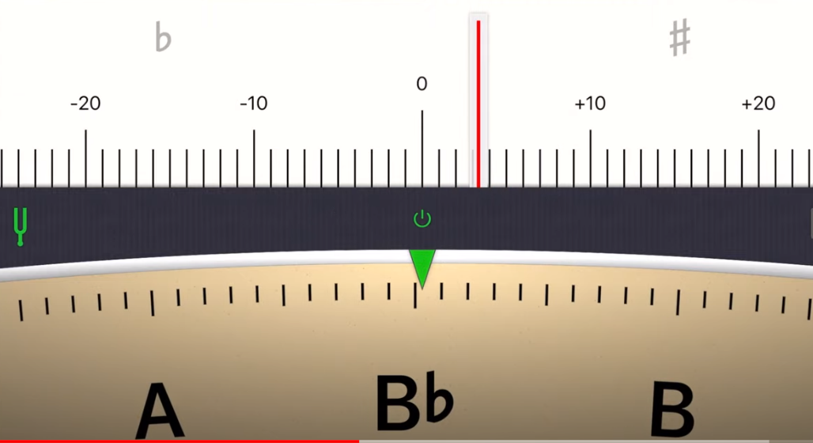 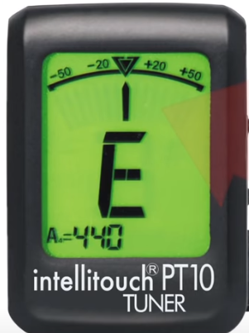

**Physical Principle: ??**

**Part 1 Physical Principle:**

**Part 2** Rutherford Experiment

**Materials** [The Nucleus: Atoms are mostly empty space](http://somup.com/cF6eVsnVyD) (0:48)  
  
[Rutherford's Experiment: Atom's center is a Nucleus](http://somup.com/cF6eVMnVyb) (0:47)

**Give evidence or make a sketch to illustrate the Physical Principle:**

**Part 1 Physical Principle:**

**Continuous versus Discrete Quanta of Energy (not gradual). All of the activities showed a definite quantity rather than a continuous or gradual quantity.**

**Part 2 Physical Principle:**

**Atoms are mostly empty space with a central mass called a nucleus, where positive charges exist.**