**Weather Patterns**

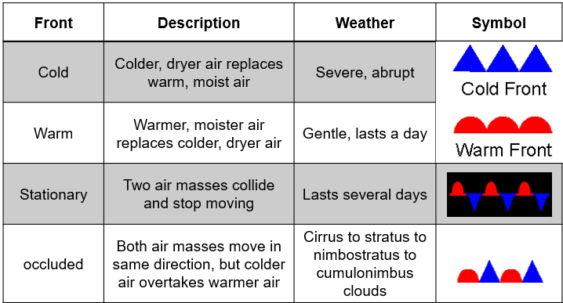

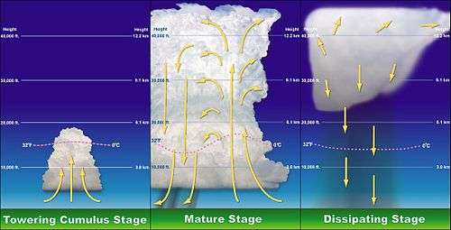

**See** [**https://www.learningctronline.com/courses**](https://www.learningctronline.com/courses) **for Materials and Resources.**

**Topics:** Weather Patterns

**Objectives:**

* List and define factors that affect wind. (Latitude, Frictional Forces, Coriolis Effect, Specific Heat of land versus water).
* What happens to air as it rises or sinks? (Describe wind patterns that exist around the globe.)
* Explain Pressure Centers (Low vs. High).
* Name & define Earth’s major air masses.
* Understand & describe the four major weather fronts.
* Define & describe thunderstorms (severe weather).

TAKE NOTE (All assignments are due by next week’s class.)

1. Weather Patterns PowerPoint Worksheet (class notes)
2. Lab Actual Weather (Track Weather for 3 days)
3. Weather Review Worksheet
4. Test Weather
5. Week 26 Devotional (<https://www.learningctronline.com/devotional>)

**Text**:

**Reference Material: Weather Patterns PowerPoint**

**Homework**:

* Weather Patterns PowerPoint Worksheet (class notes)
* Weather Review Worksheet

**Lab**: Actual Weather

* Perform the “Actual Weather” lab using the worksheet provided.
* You will track and record 3 days of weather.
* Save the document into your LAB folder in the Projects in Science folder on your desktop.

**TEST:** Test Weather

1) the academic integrity policy

* Tests must be completed **WITHOUT** referring to books, notes, the internet, people, or any outside resources.
* Students **MAY** use the approved Periodic Tables, approved Reference Tables, or approved equation (formula) sheet (provided by the teacher) along with calculators and scratch paper.
* A guardian should be proctoring the test. Proctoring means to monitor the following:

2) Take the **"in one sitting"**, meaning that once you start the test, you must complete it without interruption.

3) There is a **50-minute time limit** on this test. Please have the proctor write the time taken at the top of your answer sheet with their signature or initials.

4) Proctors should NOT be reading the test or engaging students during the test.

5) Do NOT use RED font. Black font is best.

Supplemental Resources (Optional)

1. Weather Vocabulary Crossword (Review)

Global Wind Circulation (2:05) <http://somup.com/cF6hoTnVWZ>

Specific Heat of Land Versus Water <http://somup.com/cFQ3lQVWWz> (0:38)

Occluded Front <https://screencast-o-matic.com/watch/cFlfIGrUZf> (0:51)

Weather Fronts <http://somup.com/cF6hodnVWH> (3:50)

Lightning Strike (0:28) <https://screenpal.com/watch/cF6h2RYoU7>