Name _____ Day, Time _____

Date _____

Directions Label the cloud diagrams on each page using the terms provided, your notes, and/or the internet.

*altocumulus altostratus cirrus cirrocumulus cumulus cumulonimbus stratus stratocumulus*

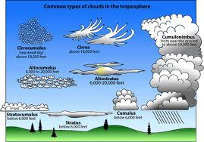

*altocumulus altostratus cirrus cirrocumulus cirrostratus*

*cumulus cumulonimbus nimbostratus stratus stratocumulus*

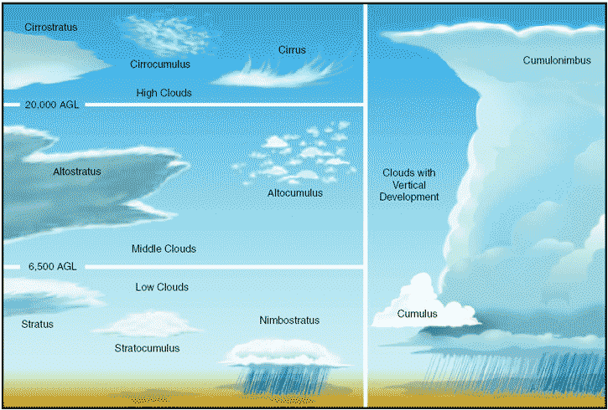

ANSWERS



