Heading

Title

**Introduction**

**Purpose** To investigate Meiosis in human cells, contrasting male and female cells.

**Discussion**

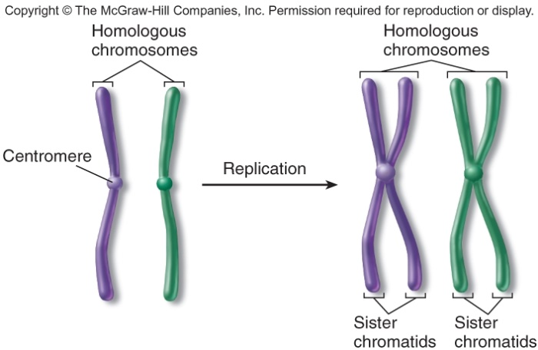

Meiosis is a type of cell division within the realm of sexual reproduction that produces haploid (n) gametes(sperm and egg) in diploid organisms. Humans and many animals and plants are diploid (2n), because all somatic cells contain pairs of homologous chromosomes. In humans, the diploid chromosome number is 46 (23 pairs of homologous Chromosomes) and the haploid (gamete) chromosome number is 23. Homologous chromosomes are chromosomes that share: The same structural features (e.g. same size, same banding patterns, same centromere positions) The same genes at the same loci positions.

MEIOSIS reduces the chromosome number by HALF. Daughter cells (n) contain half the number of chromosomes as the parent cell (2n), which is preceded by Replication and followed by two divisions: Meiosis I and Meiosis II. Meiosis must reduce the chromosome number by half, whereas, fertilization then restores the diploid (2n) number.

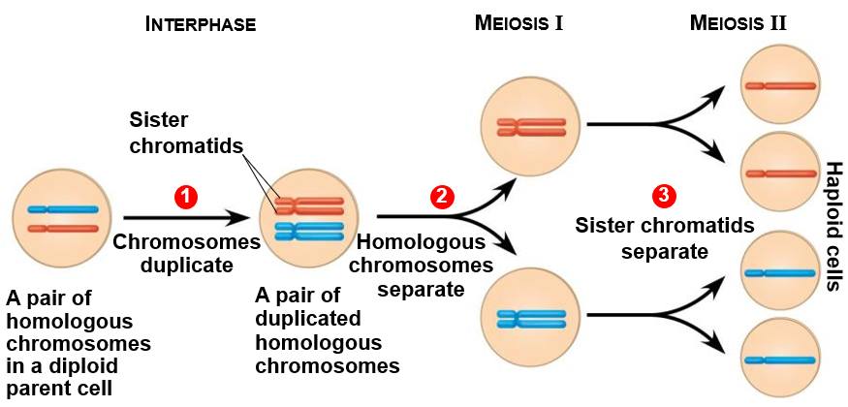

Mitosis, on the other hand, begins with diploid cells and ends with diploid (2n) daughter cells. Meiosis, begins with diploid cells and ends with haploid (n) daughter cells. This is because meiosis is followed by two consecutive cell divisions, while mitosis is followed by only one cell division. In meiosis, one duplication of chromosomes is followed by two divisions, producing four daughter cells with an haploid set (n) of chromosomes. During mitosis and meiosis, DNA replicates (chromosomes duplicate).

**Hypothesis**

If a diploid cell undergoes meiosis, then it will form 4 haploid daughter cells.

**Materials**

* <http://somup.com/c3fYb8OUJ8> (5:53) Meiosis Lab
  + Image of chromosomes (below) … 2 sets of homologous chromosomes

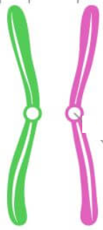





**Procedures**

A. Non-HONORs 🡪 Complete the phases of meiosis I and meiosis II on the next two pages using drawings. Explain the major events for each stage.

B. HONORS 🡪 Complete the phases of meiosis I and meiosis II as follows:

1. Use the four chromosomes above to fill in the diagrams on the appropriate pages. (*Skip the next two pages*)

2. Either copy and paste the images above to fill in the phases (preferred) OR copy all the pages necessary from this worksheet, then, cut the images of the chromosomes out to create diagrams. [*MAC users use “Text Wrap” … “arrange” … “none”*]

3. The diagrams may be done by hand as well. Be sure to take pictures of each stage of meiosis and insert the pictures into this lab worksheet.

4. Give explanation / definition of what happens at each phase.

**Calculations and Data**

A. NON-HONORS 🡪 Complete the phases of meiosis I and meiosis II. Draw the chromosomes in each phase beginning with ONE homologous pair. Explain the major events for each stage.

Meiosis I



**Interphase Prophase I Metaphase I**

- - -

- - -

-

-

**Anaphase I Telophase I**

- -

- -

-

-

**Cytokinesis I**

-

-

-

-

Non-Honors

Meiosis II [**THIS HAPPENS IN BOTH CELLS FROM CYTOKINESIS I**]

**Prophase II Metaphase II**

- -

- -

-

**Anaphase II Telophase II**

-

- -

-

-

-

**Cytokinesis II**

-

-

-

-

B. HONORS 🡪 Complete the phases of meiosis I and meiosis II. Place or draw chromosomes for each stage of meiosis and give explanation / definition of what happens at each phase. Start with the chromosomes shown in the materials section

Interphase

* G1 🡪
* S 🡪

Prophase I

Metaphase I

Anaphase I

Telophase I

Cytokinesis I

Meiosis II

Prophase II

Metaphase II

Anaphase II

Telophase II



Cytokinesis II

B. HONORS ONLY 🡪 **Contrast meiosis in human male versus female cells.**

* What are the names of the sex cells?
* What is produced in each case?

**Conclusions**

**Address Hypothesis**

The hypothesis, if a diploid cell undergoes meiosis, then it will form 4 haploid daughter cells, was confirmed. The cell underwent meiosis I and meiosis II as shown in the diagrams.

**Analysis**

Refer to the discussion section of the introduction.

**Questions**

*(Keep the numbers, but replace questions with statements that convey a complete thought.)*

1. Give two major similarities between mitosis and meiosis.

2. Give two major differences between mitosis and meiosis.

3. When and where do mitosis and meiosis take place?

4. Explain crossing over: what organisms have it, when does it occur, what is its function?

**Errors** *(List possible errors or suggest other ways to study meiosis)*

**Bibliography**

Meiosis. Class Notes. Biology Course Site, Week 12. Learning CTR Online, n.d. Web. 18 Nov. 2022. <[www.learningctronline.com](http://www.learningctronline.com)/biology-course-site-s1>.

Meiosis Lab. *Lab Worksheet*. Biology Course Site, Week 12. Learning CTR Online, n.d. Web. 18 Nov. 2022. <[www.learningctronline.com](http://www.learningctronline.com)/biology-course-site-s1>.

Meiosis Lab Video. *Week 12* *Overview*. Biology Course Site, Week 12. Learning CTR Online, n.d. Web. 18 Nov. 2022. <<http://somup.com/c3fYb8OUJ8>>.