# Scientific Method

Observation

* **Use the senses:** sight, hear, touch, taste, smell, pain/pressure (headache)
* **Ask questions**
* **Collect data**
* **Organize facts**

Hypothesis

* We make an **educated guess** … based on what we already know and what we’ve already **observed** (without accurate observation, one cannot have a solid hypothesis)
* This is **a possible solution to the problem** without “jumping to conclusions”

Experimentation (**Test the hypothesis)**

* **Collect more data and/or Compile more facts for further exploration** (graphs, charts, pictures, etc.)
* **Variables** (the part of the experiment being tested … a true experiment tests only ONE variable at a time)
* **Control** (the aspects of the experiment that do not change)
* **Conclusion:** a state whether the hypothesis was correct or not based on evidence / supporting data

Theory

* Establishes a **recognizable pattern** which can be repeated anywhere in which conditions are the same.
* Provides a **general explanation** for our observations.
* Can be **modified** (does not necessarily account for all factors). **Never proven.**

Law

* States a consistent, **unchanging relationship** between observed facts (under the same conditions).
* **Describes events in nature** … but does not explain them as a theory tries.
* There are **no exceptions** to the “rule” under the same conditions.

Create an experiment showing the scientific method for one of the following:

1. A string of 5 lights has one light that is not lit.

2. A person attempts to start their car, but only hears a clicking sound.

3. Does water freeze faster on its own or when salt is added to it?

4. A person comes home to discover their dog is missing. What is the reason?

Let’s Practice Science!

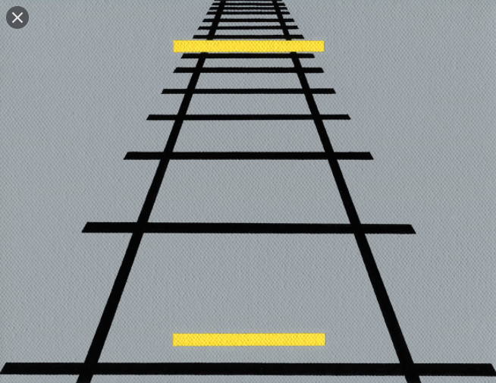



Which yellow line is longer?

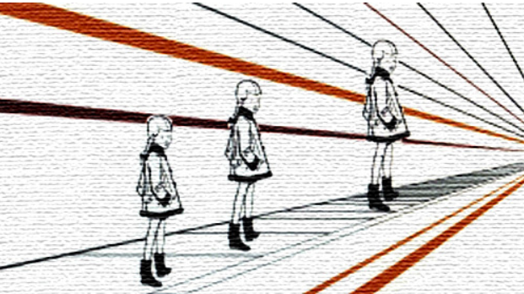

Which girl is tallest?

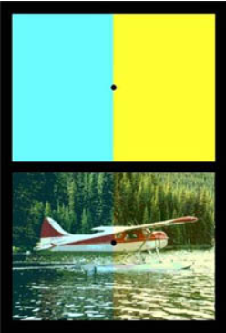

L**ook first at the airplane image**. Do you see that the two halves are differently colored? Now, **stare at the dot between the blue and yellow rectangles** for 20 seconds. Then **shift your gaze to the dot in the airplane image**. How do the two halves appear now? As you continue to watch, the effect will disappear.

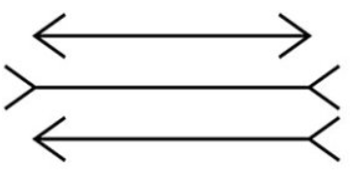

Which line is longest … are they staggered?

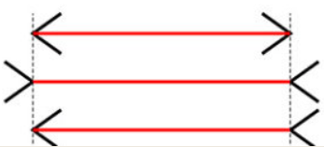

1. First, observation, question, use senses, etc.

2. Hypothesis: is one line longer than another.

3. Experiment: measure each line with the same metric unit.

4. Notice with all of these illusions, a measurement could solve the issue. (consistency)

5. Scientific practice also helps us recognize these illusions and solve them quicker. (Theories offer us recognizable patterns and explanations.)

6. A law means that there are no known exceptions in the natural world under the same conditions.