Name _____ Day, Time _____

Date _____

Composition of the **Atmosphere** 🡪 the most abundant elements are n_____ and o_____.

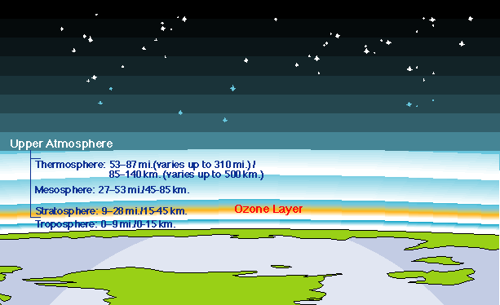

**W_____** – the state of the atmosphere at a given time and place.

C_____ – _____ term prevalent weather conditions for a given region, or location.

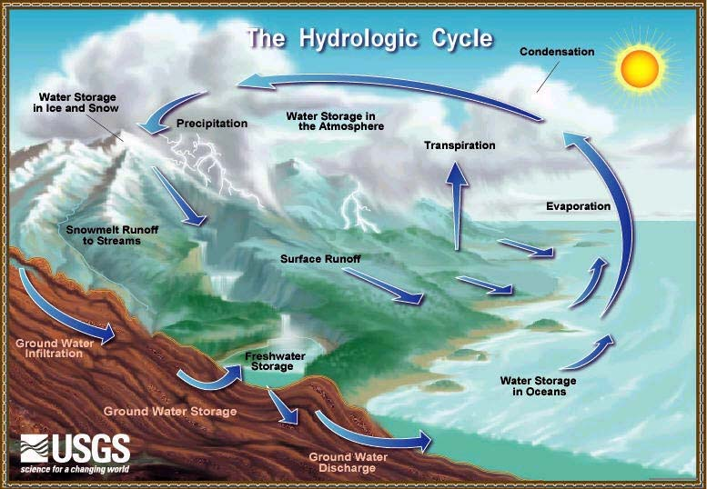

vapor

solid

liquid

E_____ is when water is changed to water ________. Energy must be _____. This process leaves the rest of the liquid a little bit _____.

C_____ 🡪 water vapor becomes _____ & releases energy as in cloud formation.

Label the phase changes to the right

and state if energy is gained or lost

**R_____ H_____**

* The ratio of _____ (water vapor) in the ____ compared to the amount of water vapor that can be ______ in the air at that temperature.
* A _____ measures the humidity of air.

The cooler air temperature holds _____ water, therefore, the _____ relative humidity.

The _____ air temperature holds much _____ water, therefore, the _____ relative humidity.

Example:

A cubic meter of air at 20º C can hold ____ grams of water vapor (see chart). This is called _____ at 20º C, meaning that the cubic meter of air has ____ grams of water vapor. This represents ______% relative humidity.

Any further cooling will cause condensation (fog, clouds, dew) to form. Thus, ___º C is the _____ for this situation.

If the temperature is _____ to 10º C, the air can only hold 9 grams of water vapor.

The other 8 grams of water vapor will _____ as water droplets forming clouds, fog or dew. The relative humidity is still _____% because the temperature is different.

If the same cubic meter of air _____ to 30º C, it can hold up to 30 grams of water vapor.

17 g / 30 g = _____ % This will produce a relative humidity of 56% and represents the amount of water vapor air can ____ at that _____.

**D___ P_____**

* The dew point is a water-to-air ____ temperature.
* The _____ the dew point, the more _____ is in the air.
* The dew point is associated with relative humidity
  + _____ relative humidity indicates that the dew point is ____ to the current air temperature.
  + _____% Relative humidity indicates the dew point is _____ to the current temperature and that the air is maximally _____ with water.
* At temperatures _____ the dew point, water will _____ the air.
* Water _____ to form _____, dew or _____.
* Condensed water on a solid surface is called _____.
* When frozen, it is called _____.

To determine the condition of the atmosphere in a given location, the following can be measured:

Temperature – _____ H_____ – psychrometer or hygrometer

Wind speed and direction – _____ Air pressure – _____

* As altitude (height) ____creases, air pressure ____creases.
* Temperature also ____creases.
* Air that is _____, holds _______ water vapor and will _____ easier.

_____ Temperature Change

* When the temperature of air changes due to a change in _____ it is referred to as an adiabatic temperature change
* This is what happens to air when it _____ in the atmosphere.

_____, _____ and _____ are forms of condensation

Clouds are groups of water droplets that form up in the atmosphere – _____ the ground.

Dew is condensation that occurs on objects ____ the ground.

Fog is cloud formation that occurs _____ the ground.

**Cloud Formation**

Air needs to be _____ to its _____ point (the point where it turns from _____ to liquid).

Water vapor needs condensation _____ to condense on. E.g. ______, salt in atmosphere, etc.

Air is most often cooled _____ in the atmosphere (a change in temperature due to a change in _____).

* Air rises due to it’s own _____ (heated air is less dense & will rise) 🡪 _____.
* Air is forced as it travels over mountains; this is called o_____ lifting.
* Air is forced up due to c_____ near low pressure zones.
* Air is forced up due to another air mass, this is called f_____ w_____.

There are 4 main types of Clouds

1. _____ 🡪

2. _____ 🡪

3. _____ 🡪

4. _____ 🡪

Cloud Formation Summary

* Air is _____ cooled, most often by being lifted in these four ways:
* Air rises due to it’s own _____ (heated air is less dense and will rise) this is known also as _____.
* Air is forced as it travels over _____; this is called _____ **lifting.**
* Air is forced up due to another air mass, this is called _____ _____.
* Air is forced up due to _____ near _____ pressure zones.

**What Causes Wind**?

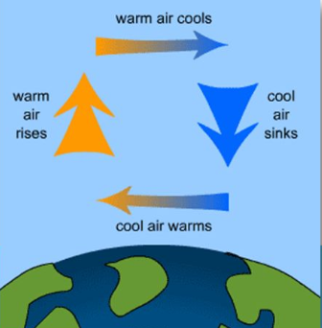

1. _____ Distribution of Thermal Energy (temperature)

* Warm air _____ (_____ dense), leaving a deficit of air and thereby lowering the air pressure – “___s”
* Cold air _____ (_____ dense), creating a buildup of air and thereby raising the air pressure – “___s”

1. Unequal Distribution of _____

* Pressure differences create a pressure _____ and causes the _____ to blow.
* The direction of wind motion is always from _____ pressure towards _____ pressure.
* The greater these differences, the greater the wind _____.

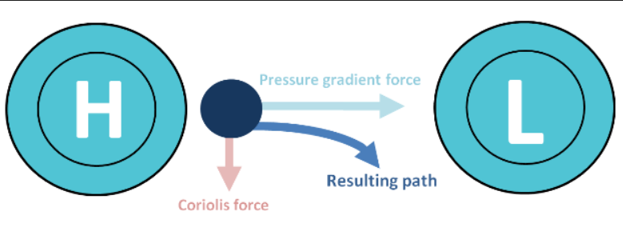

**I_____**

* _____ of constant or equal _____ on a weather map
* Air pressure is measured in millibars or mercury depending on the _____.
* Standard pressure 🡪 1013 millibars 101.3 kPa 760 mm Hg 29.92 in. Hg

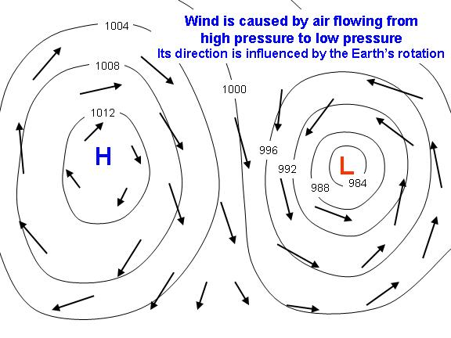

**Isobars**

**(The** _____ **circles)**

**Factors that affect Wind**

P_____ G_____ Force

* Pressure _____ create a pressure gradient and causes the _____ to blow.
* The _____ these differences, the greater the wind _____
* The direction of wind motion is always from _____ pressure towards _____ pressure.
* The velocity of wind can be estimated from the spacing of isobars on a weather chart.
  + The _____ the isobars the steeper the pressure gradient, and the _____ the wind

F_____ Force

* Frictional forces act to _____ wind movement and to _____ the wind direction.
* Winds in the _____ layers of atmosphere (at or _____ the earth's surface) are greatly influenced by the frictional force.
  + The effect of friction is to _____ the wind speed.
  + Friction is relatively _____ over the ocean surface.
  + Different layers of the atmosphere have different wind velocities and these winds can affect each other as they intersect.

**C_____ Force** (Effect) 🡪 due to the Earth’s _____

* Winds are curved or _____ to the _____ in the Northern Hemisphere.
* Winds are curved or deflected to the _____ in the Southern Hemisphere.
* When the wind swirls _____ in the northern hemisphere or clockwise in the southern hemisphere, it is called _____ flow.
* When the wind swirls _____ in the northern hemisphere or counter-clockwise in the southern hemisphere, it is called _____ flow.
* Winds blow _____ low pressure systems and swirl counterclockwise (in the Northern Hemisphere) around the _____ pressure center.

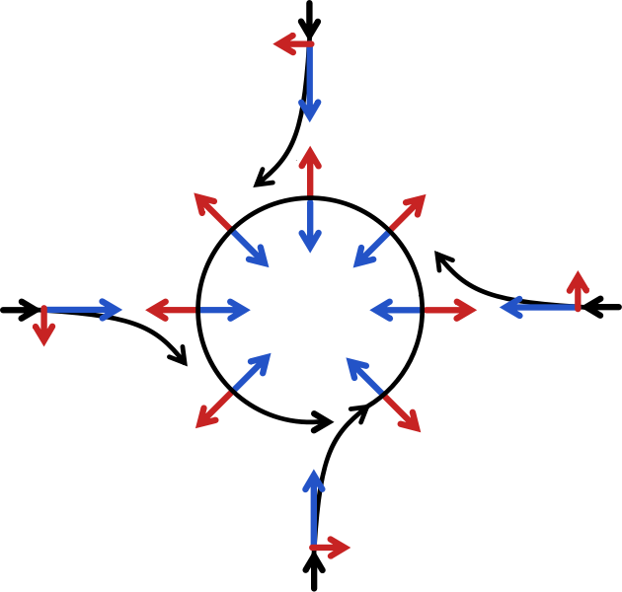

* Winds within high-pressure areas flow _____ and clockwise from the higher pressure areas near their centers towards the lower pressure areas further from their centers. In the Northern Hemisphere, winds blow _____.

**Global Wind Belts**

* Air moves from higher pressure to lower pressure. Pressure belts move air in a _____
* The Coriolis effect deflects wind, generating the _____ wind patterns.

