**Static Electricity & Magnetism (Week 2)**



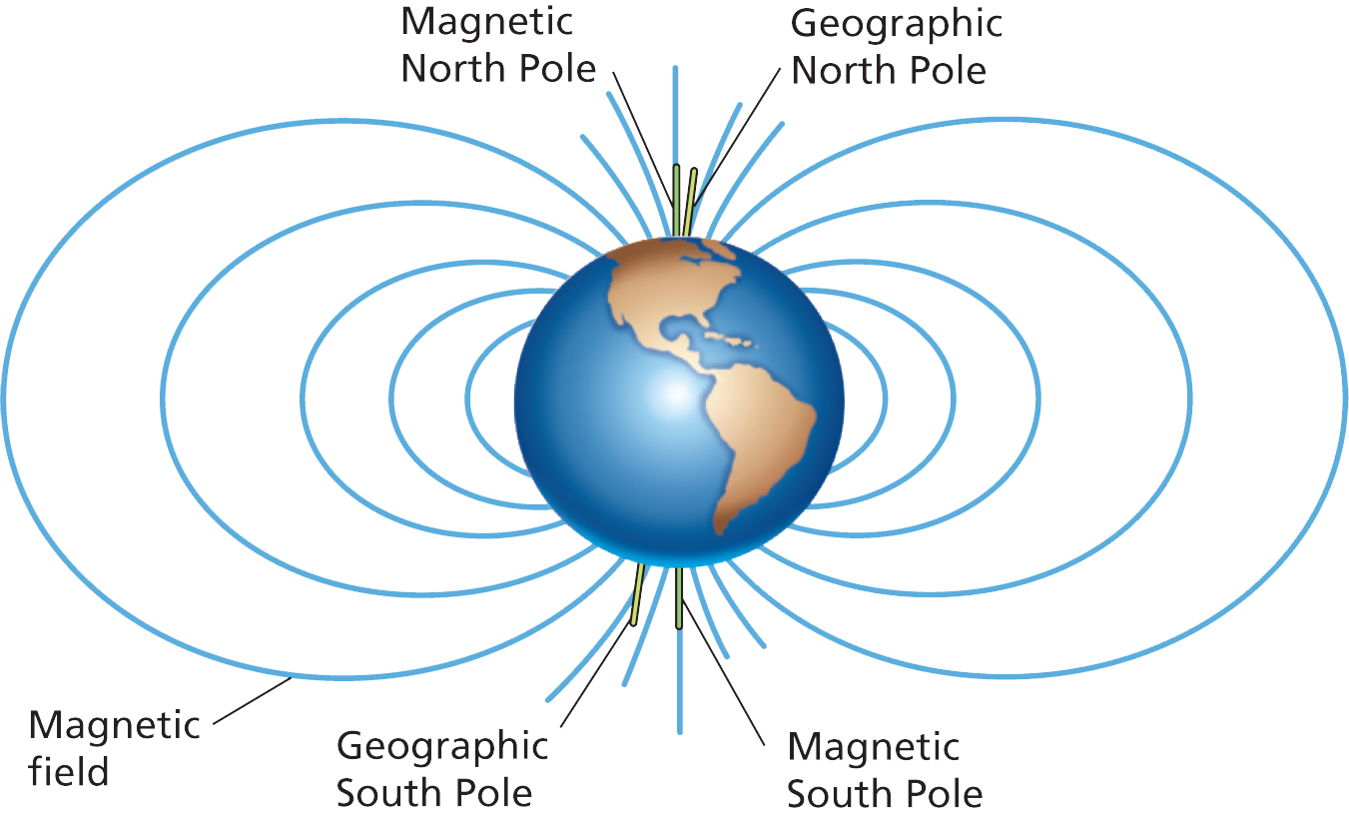

**See** [**https://www.learningctronline.com/courses**](https://www.learningctronline.com/courses) **for Materials and Resources.**

**Topics:**

1. Static Electricity & Magnetism (week 2 of 3)

**Objectives:**

* *Which particle is involved in transfer of charge between objects?*
* *Compare and contrast Static Electricity and Magnetism (similarities, differences).*
* *Explain the source of electrostatics and how objects are affected by it.*
* *Identify properties of magnetic objects.*
* Distinguish and draw electric field lines around charges and magnetic field lines around magnets, labelling the charges and the poles.
* Identify properties of electrified objects and magnetic objects (retention, strength).
* Understand how magnets are formed and sustained.
* Explain friction, induction and conduction related to electrostatics and magnetism.

TAKE NOTE

1. Reading (Hewitt Text)

2. Notes Static Electricity & Magnetism

3. Problem Set 1: Static Electricity (due before next week’s class)

4. Problem Set 2: Static Electricity (2 weeks: due before Test in two weeks)

5. Lab: Magnetism Field Lines

6. Lab: Magnetism Poles

7. Lab: Static Electricity Lab 2 Electrified Objects

8. Lab: Magnetism Nails

9. Class Song: Keep Pressing On

10. Open notes Quiz Static Electricity & Magnetism (due 8 days, noon EST)

11. Week 22 Devotional (<https://www.learningctronline.com/devotional>)

**Text**: Chapters 32 – 33, 36 Static Electricity & Magnetism (Hewitt)

**Class Notes: Use the Document provided**

**Homework**:

* Problem Set 1 Static Electricity
* Problem Set 2 Static Electricity (2 weeks)

**Lab**: Magnetic Field Lines

* Perform the lab as directed using the worksheet provided.
* Complete all calculations and data, showing work whenever appropriate.
* Conclusions should be answered in complete sentences that convey a complete thought.
* Save the documents into your LAB folder in the Physics folder on your desktop.

**Lab**: Magnetic Poles

* Perform the lab as directed using the worksheet provided.
* Complete all calculations and data, showing work whenever appropriate.
* Conclusions should be answered in complete sentences that convey a complete thought.
* Save the documents into your LAB folder in the Physics folder on your desktop.

**Lab**: Static Electricity 2 – Electrified Objects

* Perform the lab as directed using the worksheet provided.
* Complete all calculations and data, showing work whenever appropriate.
* Conclusions should be answered in complete sentences that convey a complete thought.
* Save the documents into your LAB folder in the Physics folder on your desktop.

**Lab**: Magnetism – Nails

* Perform the lab as directed using the worksheet provided.
* Complete all calculations and data, showing work whenever appropriate.
* Conclusions should be answered in complete sentences that convey a complete thought.
* Save the documents into your LAB folder in the Physics folder on your desktop.

**TEST:** Quiz Static Electricity & Magnetism

1) the academic integrity policy

* You may use your notes/lab on this quiz.
* The quiz is due by noon the day after next week’s class.
* Students **MAY** use the approved Periodic Tables, approved Reference Tables, or approved equation (formula) sheet (provided by the teacher) along with calculators and scratch paper.
* A guardian should be proctoring the test. Proctoring means to monitor the following:

2) This quiz contains short answer questions and problems.

3) There is a **45-minute time limit** on this test. Please have the proctor write the time taken at the top of your answer sheet with their signature or initials.

4) Proctors should NOT be reading the test or engaging students during the test.

5) Do NOT use RED font. Black font is best.

Supplemental Resources (Optional)

1. Big Ideas Static Electricity & Magnetism
2. Static Charges on Materials

<http://somup.com/cr10oOqsjp> Transfer of Charge & Charge by Induction (1:44)

<http://somup.com/cY1QFtQlBS> Components of Static Electricity (5:31)

<http://somup.com/cr10Dfqslf> Electric Forces Attraction & Repulsion (1:24)

<http://somup.com/cr10omqs6t> Charging an Insulator (Styrofoam) 1:12)

<http://somup.com/cr10DGqso6> Acrylic & Metal Transferring Charge (1:08)