# Chapter 14 – Genetic Variations

I. Introduction

A. Genes control _____ Traits through the Synthesis of _____

1. _____ specifies Traits by dictating Protein Synthesis.
2. Proteins are the links between genotype and phenotype.
3. The molecular chain of command is from
4. _____ in the nucleus to _____
5. _____ in the _____ to _____
6. where _____ acids 🡪 _____

B. _____ of Traits

1. _____ only determine potential capacities.
2. _____ factors play a large role in genetic expression.

_____ + _____ = Expression of Trait

C. Genetic _____

1. Normal and Abnormal types of genetic variation exist.
2. Variation is critical for the _____ of a population (e.g. _____).
3. Occurs as a result of different _____ for a trait.

D. Normal Genetic Variation

* 1. Occurs in _____ by
     1. Independent Assortment
     2. _____ _____ occurs when homologous chromosomes _____ pieces of the chromosomes as they are twisted around one another
     3. This results in an equal swap of the _____ involved.

E. _____ Genetic Variation – _____

1. May occur in _____ cells (are _____ passed to offspring).
2. May occur in _____ (germ cells) (eggs and sperm) and be passed to _____.
3. Can affect one _____ only or larger _____ of chromosomes.
4. A mutation is any _____ in structure or genetic material.
5. Any change in a cell can be considered a mutation and may NOT be inherited or passed on to offspring. Tumors, warts, moles.
6. A _____ mutation is a change in the _____ and will be _____ or passed onto offspring. However, many mutations involved _____ traits and are _____.

II. Gene Mutations

A. Introduction

1. Changes in the normal _____ sequence of a gene.
2. Almost all cause _____ or death to the organism.
3. They arise from a number of different mechanisms.

B. Types of Gene Mutations

1. Change in Chromosome _____
   * 1. _____ Non-disjunction
     2. Having more or less chromosomes
   1. _____
      1. _____ of the 2n (_____) number
   2. Somatic Cells (not inherited) vs Sex Cells (inherited)
2. Change in Chromosome _____
   1. Deletions, Translocations, Duplications, Inversions
   2. Point Mutations

C. _____ Mutations

1. _____
2. Silent
3. Missense – new protein (Amino Acid Substitutions)
4. Nonsense – stop codon
5. _____ and _____
6. Triplet Repeats
7. _____ Mutations
8. General Information
9. Change of a _____ nucleotide.
10. Includes the deletion, addition, or substitution of ONE nucleotide in a gene.
11. Occurs when _____ is replicated during _____ and _____, and a mistake occurs.

D. Point Mutations: _____

1. An incorrect nucleotide is inserted into the DNA instead of the correct one.
2. Example:

A-T-A-G-G-G-C

A-T-A-**A**-G-G-C

1. _____ Mutation
2. A substitution mutation that does _____ cause any observable change in the protein or the function of the protein that the gene codes for.
3. Example:
   * Both AAA and AAG code for phenylalanine.
   * If the third A in AAA undergoes a substitution mutation so that A is changed to a G, then it still codes for phenylalanine
4. A substitution mutation can occur that alters a group of nucleotides in such a way that the amino acid is changed.
5. But, if the new amino acid has similar _____ to the original amino acid, then the protein may still function normally.
6. _____ Mutation
7. Caused by Substitutions
8. It changes the group of nucleotides and results in the insertion of the _____ amino acid into the protein during protein synthesis.
9. The results could be _____ or silent.
10. Sickle Cell Disease is the result of one nucleotide substitution.

* Occurs in the hemoglobin gene.
* Hemoglobin is a protein that carries oxygen to our cells and carbon dioxide away from the cells. Exists inside our red blood cells.
* This mutation changes the “A” in “GAG” to a “T”.
* During translation, this results in the amino acid valine being inserted into the protein instead of the correct amino acid: glutamic acid.
* Because of this “minor” change a completely dysfunctional hemoglobin molecule is formed.
* Causes Sickle Cell Disease, a very severe blood disease that mainly affects people of African descent.

1. _____ Mutations
2. Caused by Substitutions
3. It alters an amino acid encoding group of nucleotides into a _____ signaling group.
4. When the message is read by the ribosome, the protein will stop being made too early.
5. It will be smaller and minimally functional.

E. Deletion and Addition Point Mutations

1. _____: occur when a nucleotide is _____ of its proper sequence
2. _____: occur when a single nucleotide is added during replication
3. Since RNA translates DNA 3 base sequences (_____), the exact sequence must be maintained = _____ _____.
4. _____ mutations DO _____ alter the reading frame.
5. _____ and _____ mutations alter the reading frame.

F. _____ shift mutations

1. Result from _____ or _____ point mutations.
2. These are usually more harmful than substitution mutations.
3. Example
4. Normal: THE DOG RAN AND ATE THE PIG
5. Mutated: THE DGR ANA NDA TET HEP IG
6. This is a _____ mutation (“O” in DOG)
7. Example
8. Original: THE FAT CAT ATE THE WEE RAT
9. Frame Shift (“a” added): THE FAT CAA TET HEW EER AT
10. This was due to an _____ point mutation.

III. Chromosome _____ Mutations

1. General Information
2. May Involve changing the STRUCTURE of a chromosome.
3. The _____ or _____ of part of a chromosome.
4. Most occur during mitosis and _____.
5. Five types exist:

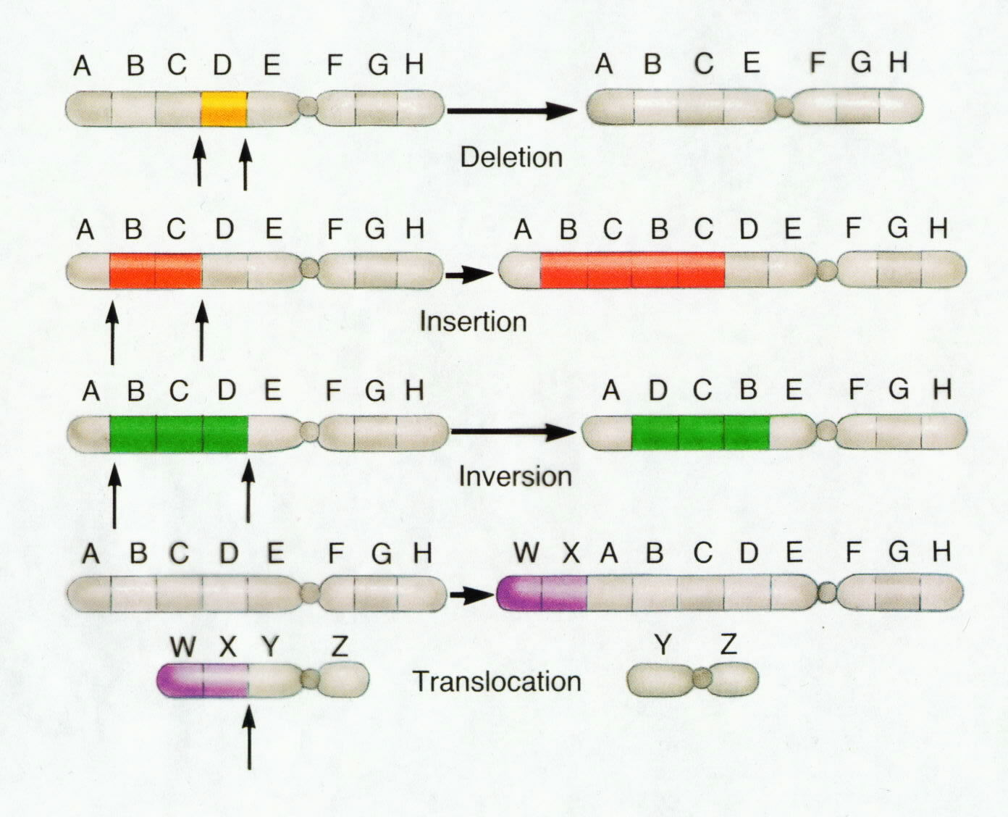

1. Deletion
2. Inversion
3. Duplication
4. Translocation
5. Nondisjunction
6. Structural _____ Mutation
7. Due to _____.
8. A piece of a chromosome is lost.
9. Usually results in _____ of organism.
10. Structural _____ Mutation
11. Chromosome segment breaks off.
12. Segment _____ around backwards.
13. Segment _____ into the same chromosome.
14. Structural _____ Mutation
15. Occurs when a piece of one homologous chromosome breaks off and is inserted into the other _____ chromosome.
16. Since the chromosomes are homologues, the chromosome that donated the segment has undergone a deletion mutation and the chromosome that receives the segment has duplication of genes.
17. Structural _____ Mutation
18. Involves two chromosomes that aren’t homologous.
19. A _____ of a chromosome breaks off of one chromosome and inserts into a _____-_____ chromosome.
20. _____ Chromosomal Mutation
21. _____ of chromosomes to _____ during _____
22. Causes gamete to have too many or too few chromosomes
23. E.g. Down Syndrome (_____ -21)

IV. M_____

1. Factors that are known to cause mutations (changes in DNA which lead to cancer)
2. _____ conditions might trigger a cell to become cancerous.
3. R_____
4. D_____ & M_____
5. V_____
6. C_____
7. Materials (e.g. asbestos)

V. How is genetics used to produce desired traits in an organism?

A. _____ Breeding & Society

1. The world food supply has been greatly enhanced by selective breeding and _____ engineering.
2. Hybridization is very important in producing new varieties of organisms.
3. Selective _____ produced many kinds of flowers, pets, and other organisms.
4. _____ selection
5. Selective breeding is the same as artificial selection.
6. Human intervention in animal or plant reproduction to _____ that certain _____ traits or combinations of traits are _____ on to future generations.
7. Artificial selection is goal-directed and purposeful.
8. Natural selection is directed by survival in the environment.
9. Selective Breeding of Organisms for Food
10. Plants:
11. Faster _____
12. Higher _____
13. Disease _____
14. Higher _____ value
15. Animals:
16. Faster growth
17. Greater _____ (less aggression)
18. Higher milk, egg, honey, or meat production
19. Process of Selective Breeding
20. Step 1 Choose which _____ to breed for.
21. Step 2 _____ individuals having those characteristics.
22. Step 3 Choose which characteristics to breed for.
23. Step 4 Breed individuals having those characteristics.
24. Selective Breeding
25. Selective breeding is a form of _____ selection to produce plants and animals with more _____ traits.
26. Selective breeding is goal-directed, not _____ like natural selection.
27. The process involves choosing the best parents to breed, then breeding offspring to build up traits in a population.
28. Some problems include _____ — buildup of _____ genes — and decreased population _____.
29. Wild mustard and wild cattle have been extensively selected.
30. H_____
31. Breeding between individual organisms with different parentage; reproduction between organisms that are _____ _____.
32. Mendel is the best-known early plant hybridizer.
33. Many crops are hybrids, combining good traits from different sources to restore “hybrid _____.”
34. Potential Problems with Artificial Selection – _____
35. Breeding between individual organisms who share _____ genetic makeup or parentage; reproduction between organisms that are _____ _____.
36. Inbreeding causes unintended _____:
37. Negative, _____ traits build up in the population.
38. The population becomes weaker and has less _____.
39. _____ decreases in populations.
40. E.g. hemophilia
41. Identifying Future Traits for Breeding
42. _____ to pesticides
43. addition of genes to make animal protein
44. resistance to insects, fungi, and other pests
45. addition of genes to _____ color and taste
46. _____ for specific climates (heat, cold, drought)
47. addition of genes to _____ concentrations of essential vitamins
48. modification of food’s appearance to make it more _____ to consumers