**Activity 1 The Medium Through Which Sound Waves Travel**

**Purpose** To investigate what the medium is for sound waves and to associate this to human hearing.

**Background Information**

Sound is a form of energy made by vibrations that can be heard. When an object vibrates (moves back and forth quickly … oscillation) it causes the air particles around it to move.

These particles collide with particles close to them (air pressure) and this continues until they run out of energy.

Sound travels in waves. Take a moment to sit quiet and just listen. You can identify sounds without seeing them because sound waves carry information to your ears. Sound waves must have a medium through which to travel. In other words, they must cause something to oscillate. What is the medium through which sound waves travel?

**Hypothesis**

If sound can be heard, then it must travel through some kind of medium (air, plastic wrap).

**Materials** Plastic Wrap Scissors Tape or Rubber Band

Candle w/ stand Match Large Pot

Wooden spoon Large bowl Rice

Plastic 1-liter or 2-liter bottle (e.g. soda pop)

**Procedures**

<https://screencast-o-matic.com/watch/cFX20vrh6t> Sound Moving Air (2:32)

1. Cut away the base of the plastic bottle so there is a large hole at the bottom.

2. Use the plastic wrap to cover the hole that was created when you cut away the bottle’s base.

a. You need to stretch the wrap tightly across the open base of the bottle (e.g. like making a drum).

b. Use tape to secure the plastic wrap on one side of the bottle, and then stretch the plastic wrap over the entire hole tightly. This will probably deform the bottle some. This is okay.

c. Once the wrap is tightly stretched over the opening, secure it with tape or a large rubber band all around the base of the bottle.

d. You have a makeshift drum on the bottom of the bottle.

3. Flick the wrap with your finger. You should hear a dull thump. If not, the plastic wrap is not tight enough. Rework it to make it tighter.

4. Hold the bottle so the opening from which you drink is pointed toward your ear. Flick the plastic wrap (“drum”) again and hear the sound as it comes through the bottle. Record your observations in the Calculations and Data section.

5. Light the candle on its stand.

6. Hold the bottle so that the opening from which you pour is pointed right at the flame.

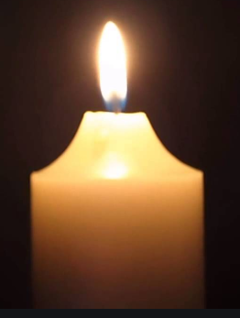



a. Hold the bottle opening as close to the flame as possible without melting it or letting it catch on fire!

b. See diagram.

7. When the bottle is positioned properly (#6), flick the plastic wrap at the other end (“drum”) so you hear the dull thump, and observe the candle flame.

8. What happened to the candle flame? Record your observations in the Calculations and Data section.

9. Take the large bowl and stretch plastic wrap over the top (open end) of the bowl tightly … as if storing food in the bowl.

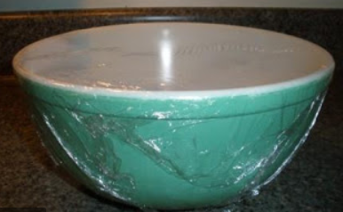

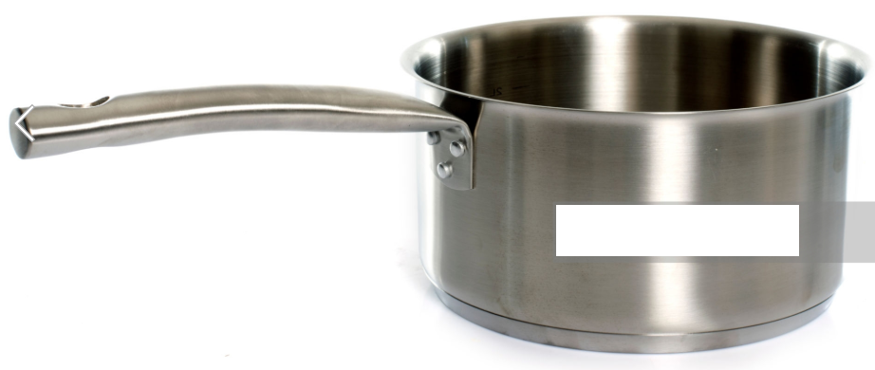

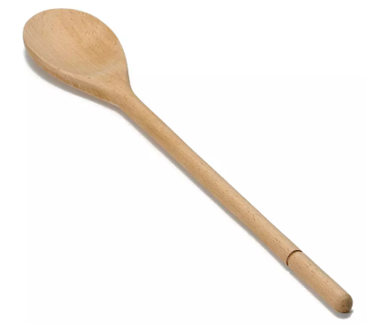

a. Make sure the plastic wrap is tight (like a drum).

b. If the plastic wrap stays on its own, you do not need to secure it with tape. Otherwise, use the tape or large rubber band to secure the wrap to the bowl.

10. Spread some rice over the plastic wrap that is stretched across the top of the bowl.

11. Bring the large pot near the bowl, holding it so the top of the pot (the open end) points towards the bowl.

12. Use the large wooden spoon and bang on the bottom of the pot.

13. Observe and record what happens to the rice (in the Calculations and Data section).

## **Calculations and Data**

4. Record the sound you heard when you flicked the plastic wrap (“drum”) to test for sound BEFORE holding the bottle to the candle.

8. Record what happened to the candle when you flicked the plastic wrap (“drum”) WHEN holding the bottle to the candle.

13. What happens to the rice on top of the plastic wrap when the large pot is hit with the wooden spoon?

## **Conclusions and Questions**

1. What does the fact that flicking the plastic wrap on the bottle that “blew” out the candle suggest about sound?

2. What does the fact that the pan being struck with the wooden spoon so the rice grains bounce suggest about sound?

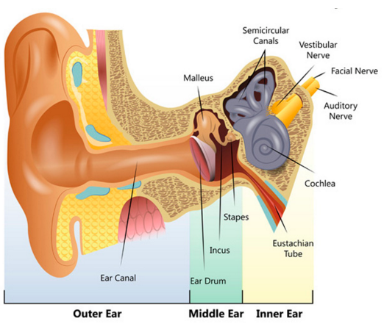

3. Use the class notes or section 17.4 in your textbook to fill in the blanks:

The bowl in this experiment is a pretty good illustration of the sound-sensing mechanism in the human ear. Each ear has a thin layer of tissue, called the _____ membrane (ear _____), that is tightly stretched across the ear canal.

When sound waves enter the ear, they cause the ear _____ (tympanic membrane) to _____, much like the sound waves in this experiment caused the plastic wrap to vibrate. Those vibrations are then transmitted to the brain and the brain interprets them as sound.

When sound waves reach the inner part of the ear, they cause the ear drum to oscillate. This vibration causes tiny bones called ossicles to _____. The _____ strikes the _____, which in turn moves the _____ back and forth. The three bones act as a lever system to amplify the motion of the eardrum. These transfer oscillations to the _____ (the inner ear), which converts them into electrical signals that are sent to the _____ and interpreted as sound.

**Activity 2 Wavelength and Frequency of Sound Waves**

**Purpose** To investigate two properties of sound waves, wavelength and frequency.

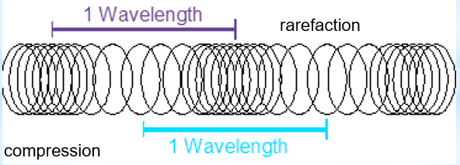

**Background Information**

Sound is a longitudinal wave, meaning the vibration of the medium is parallel to the direction the wave travels. An area where the particles in a medium are pushed close together is called a compression, and the area where the particles are spread out is called a rarefaction.

There are many properties of waves, but this lab focuses on two: wavelength and frequency. Wavelength is the distance between a point on one wave and the corresponding (same) point on the next cycle of the wave. Since sound is a longitudinal wave, the wavelength is the distance between adjacent compressions or rarefactions. Frequency is the number of cycles (waves) that pass a particular point in a given time, measured in Hertz (Hz). Frequency and wavelength are inversely proportional, meaning that a longer wavelength possesses lower frequency (e.g. radio waves), and a shorter wavelength possess higher frequency (e.g. gamma rays).

**Hypothesis**

If the wavelength of sound is shorter, then the frequency will be higher, and if the wavelength of sound is longer, then the frequency will be lower.

**Materials** Water 2-liter Glass or plastic bottle (narrow opening)

**Procedures**

<https://screencast-o-matic.com/watch/cFXoqlr13x> Blowing Across Bottles (0:35)

1. Empty the bottle and rinse it out with water. It should be clean.

2. Hold the bottle up to your mouth so that the top edge of the bottle opening just touches your bottom lip.

3. Pursing your lips, blow across the top of the bottle. It may take some practice, but you will eventually produce a sound that sounds like it is coming from a horn. Blow a few times to get an idea of what that sound sounds like.

4. Fill the bottle ¾ full of water and repeat steps 2 and 3. Blow the same way as before a few times to get a good idea of what the sound sounds like.

5. Record in the Calculations and Data section how the second sound (3/4 full bottle) differed from the first (empty bottle).

6. Empty some of the water out of the bottle so that the bottle is now half full. Repeat steps 2 and 3 again.

7. Record in the Calculations and Data section how this sound (1/2 full bottle) differed from the previous two sounds (3/4 full, empty bottle).

8. Empty some of the water out of the bottle so that the bottle is now ¼ full. Repeat steps 2 and 3 again.

9. Record in the Calculations and Data section how this sound (1/4 full bottle) differed from the previous three sounds (3/4 full, ½ full, empty bottle).

## **Calculations and Data**

5. How did the second sound (3/4 full bottle) differ from the first (empty bottle)?

7. How did the third sound (1/2 full bottle) differ from the first (procedures #2-3)?

9. How did the second sound (1/4 full bottle) differ from the first (procedures #2-3)?

## **Conclusions and Questions**

1. What property of sound accounts for the difference in sounds heard in activity 2?

2. What accounts for the difference in pitch when the bottle had different levels of water?

3. What relationship was observed between wavelength and frequency in this lab?

**Activity 3 The Doppler Effect**

**Purpose** To investigate how frequency of sound is affected by motion.

**Background Information**

The apparent change in the frequency of a sound caused by the motion of either the listener or the source of the sound is called the Doppler Effect. When an object is not moving, sound spread out evenly in all directions from the source of the sound. However, if the source of the sound is moving, an observer will hear higher and lower pitched sounds.

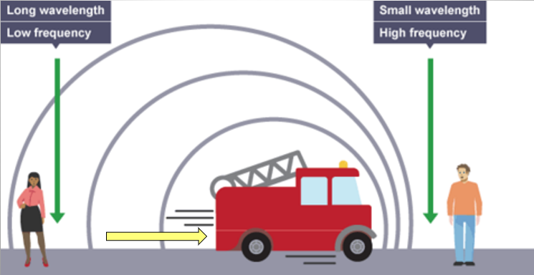

**Hypothesis**

If a car horn is approaching the listener, then the pitch becomes higher. If the sound is moving away from the listener, the pitch becomes lower.

**Materials** Car with a horn Parent Driver Straight Street

**Procedures**

<https://screencast-o-matic.com/watch/cFXoILrhRT> Car Horn Doppler Effect (0:12)

1. Have your parent drive to the end of a non-busy street.

2. Stand approximately mid-way down the street (between the ends of the street). Be careful!! Do not get too close to the street!

3. Signal your parent to start driving down the street towards you at least 20 miles per hour. Have your parent blow the horn as they drive towards you and for at least 50 yards past you.

4. If it is not too irritating to the neighbors, repeat 1-2 more times.

5. For comparison, have your parent stop the car and blow the horn.

## **Calculations and Data**

1. Describe the pitch as the car horn approached you.

2. Describe the pitch as the car horn moved away from you.

3. How did the car horn sound when the car was NOT moving compared to the other two sounds?

## **Conclusions and Questions**

1. What property of sound accounts for the difference in sounds heard in activity 3?

2. Explain how the frequency and wavelength could change by the movement of the sound.

**ANSWERS**

**Activity 1 The Medium Through Which Sound Waves** Travel

## **Calculations and Data**

4. Record the sound you heard when you flicked the plastic wrap (“drum”) to test for sound BEFORE holding the bottle to the candle.

*Dull “thump”*

8. Record what happened to the candle when you flicked the plastic wrap (“drum”) WHEN holding the bottle to the candle.

## *The candle may have been blown out completely.*

13. What happens to the rice on top of the plastic wrap when the large pot is hit with the wooden spoon?

*The rice grains bounced up and down on the plastic wrap.*

## **Conclusions and Questions**

1. What does the fact that flicking the plastic wrap on the bottle that “blew” out the candle suggest about sound?

*Sound travels through air (a medium). Therefore, sound waves cause the air to oscillate (vibrate up and down) when it travels. As a result, the sound that came out of the bottle caused the air to oscillate (vibrate) enough so that the candle’s flame was blown out.*

2. What does the fact that the pan being struck with the wooden spoon so the rice grains bounce suggest about sound?

*Sound travels through air (a medium). Therefore, the sound waves from the pot caused the air to oscillate (vibrate up and down) when it travels and when reaching the plastic wrap, the wrap vibrated up and down. As a result, the rice grains bounced up and down.*

3. Use the class notes or section 17.4 in your textbook to fill in the blanks:

The bowl in this experiment is a pretty good illustration of the sound-sensing mechanism in the human ear. Each ear has a thin layer of tissue, called the tympanic membrane (ear drum), that is tightly stretched across the ear canal.



When sound waves enter the ear, they cause the ear drum (tympanic membrane) to vibrate, much like the sound waves in this experiment caused the plastic wrap to vibrate. Those vibrations are then transmitted to the brain and the brain interprets them as sound.

When sound waves reach the inner part of the ear, they cause the ear drum to oscillate. This vibration causes tiny bones called ossicles to vibrate. The hammer strikes the anvil, which in turn moves the stirrup back and forth. The three bones act as a lever system to amplify the motion of the eardrum. These transfer oscillations to the cochlea (the inner ear), which converts them into electrical signals that are sent to the brain and interpreted as sound.

**Activity 2 Wavelength and Frequency of Sound Waves & The Doppler Effect**

## **Calculations and Data**

5. How did the second sound (3/4 full bottle) differ from the first (empty bottle)?

*Low pitched sound*

7. How did the third sound (1/2 full bottle) differ from the first (procedures #2-3)?

*higher pitched sound*

9. How did the second sound (1/4 full bottle) differ from the first (procedures #2-3)?

*Highest pitched sound*

## **Conclusions and Questions**

1. What property of sound accounts for the difference in sounds heard in activity 2?

*The difference in sound is due to pitch (the scientific term is frequency). There were “high” pitches (3/4 full bottle) and “low” pitches (empty bottle).*

2. What accounts for the difference in pitch when the bottle had different levels of water?

*The difference in water levels inside the bottle would cause the wavelength of sound to change. When the bottle was empty, the wavelength of sound would be longest and the pitch (frequency) was lowest. When the bottle was ¾ full, the wavelength of sound would be shortest and the pitch (frequency) was highest.*

3. What relationship was observed between wavelength and frequency in this lab?

*Wavelength and frequency are inversely related, meaning that a longer wavelength possesses lower frequency (e.g. empty bottle), and a shorter wavelength possess higher frequency (e.g. ¾ full bottle).*

**Activity 3 The Doppler Effect**

## **Calculations and Data**

1. Describe the pitch as the car horn approached you.

*The pitch sounded higher.*

2. Describe the pitch as the car horn moved away from you.

*The pitch becomes lower.*

3. How did the car horn sound when the car was NOT moving compared to the other two sounds?

*The car horn pitch did NOT change the entire time, but only “seemed” to sound higher in pitch, then, lower in pitch.*

## **Conclusions and Questions**

1. What property of sound accounts for the difference in sounds heard in activity 3?

*The Doppler effect accounts for the difference in sounds heard in activity 3.*

2. Explain how the frequency and wavelength could change by the movement of the sound.

*When the car moved towards the listener, the sound waves bunched up so the wavelength is shorter and the frequency is higher (pitch is higher). When the car moved away from the listener, the sound waves stretched out so the wavelength is longer and the frequency is lower (pitch is lower).*