Measuring Current & Voltage in Circuits

## *You will set up simple circuits, measuring current and voltage, and calculating resistance. Perform all the instructions given, complete charts or drawings asked for and answer questions in complete sentences. Be sure to include equations, worked out problems and appropriate units for all measurements and readings requested.*

**PHET Simulation**: <https://phet.colorado.edu/en/simulation/legacy/circuit-construction-kit-ac>

**OR**

<http://somup.com/criVDVYcEj> Measuring Current & Voltage in Circuits (7:46)

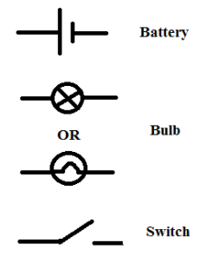 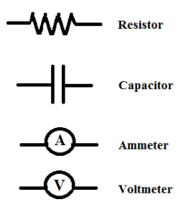

## Part 1 Measuring Current

Set up a simple parallel circuit with 2 resistors and measure amperage.

Materials: Battery Clips/wires 2 Resistors Ammeter

1. Make a schematic electrical drawing of the circuit using symbols.

a. Label the voltage of the battery and the readings on the ammeter.

b. Label the battery terminals (+ and -) and indicate the direction of current flow based on the electron flow.

2. Calculate the resistance (R total) of the circuit.

## Part 2 Measuring Voltage

Set up a simple series circuit (1 resistor) and measure the voltage of the resistor.

# Materials: Battery Alligator Clips/wires Voltmeter

1. Make a schematic electrical drawing of the circuit using symbols.

a. Label the voltage of the battery and the reading of the voltmeter.

b. Label the battery terminals (+ and -) and indicate the direction of current flow based on the electron flow.

2. Compare the voltage of the battery to the voltage measured across the resistor. Are they exactly the same? Why or why not?

3. Label the resistance of the resistor (bulb) from the simulation. Calculate the current in the circuit based on the voltage and resistance.

## Part 3 Measuring Current in a Combination Circuit

Set up a combination circuit with 3 resistors and measure amperage and voltage in each section of the circuit.

Materials: Battery Alligator Clips Ammeter 3 resistors

1. Make a schematic electrical drawing of the circuit using symbols.

a. Label the voltage of the battery and the readings on the voltmeter and ammeter across each resistor of the circuit.

b. Label the battery terminals (+ and -) and indicate the direction of current flow based on the electron flow.

2. Determine the resistance over each bulb in this circuit and label on your diagram.

3. Calculate the resistance (R total) of circuit.

4. How do the voltage measurements of the branches compare with that of the battery? Explain any discrepancy.

## Part 4 Identifying the Circuit & Measuring Voltage & Current

In Part 3, you measured the amperage and voltage as shown below in the circuit diagram. The measurements were done ONE at a time rather than connecting 3 ammeters and 2 voltmeters in the circuit simultaneously.

V

A

A

A

V

Consider and give an explanation as to why only one electrical device is measuring at a time.

**Conclusions & Questions**

1. How are ammeters set up in a circuit?

2. How are voltmeters set up in a circuit?

3. What type of electrical devices is often set up in series for a combination circuit? Explain.

4. Compare the total resistance calculation in a series circuit to a parallel circuit.

## ANSWERS

## Part 1 Measuring Current

Set up a simple parallel circuit with 2 resistors and measure amperage.

1. Make a schematic electrical drawing of the circuit using symbols.

a. Label the voltage of the battery and the readings on the ammeter.

b. Label the battery terminals (+ and -) and indicate the direction of current flow based on the electron flow.

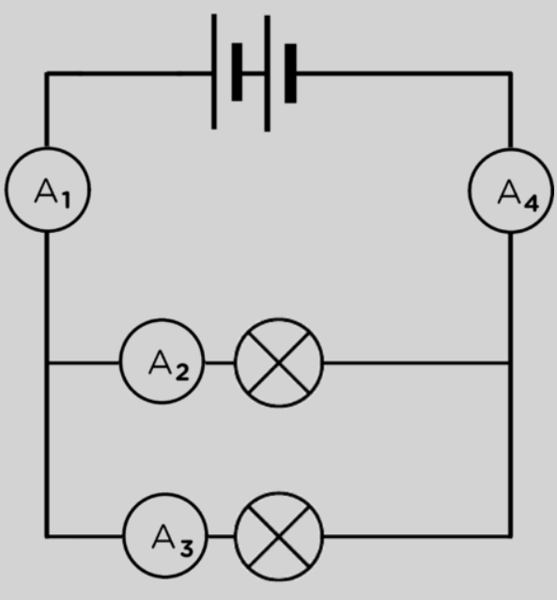

20 V

10 Ω

10 Ω

-

+

4 A

2 A

2 A

4 A

2. Calculate the resistance (R total) of the circuit.

**1/R total = 1/R1 + 1/R2 = 1/10 Ω + 1/10 Ω = 2/10 Ω … therefore, R total = 1/0.2 Ω = 5 Ω**

**The total resistance of a Parallel Circuit is NOT equal to the sum of the resistors (like in a series circuit). The total resistance in a parallel circuit is always less than any of the branch resistances. Adding more parallel resistances to the paths causes the total resistance in the circuit to decrease. As you add more and more branches to the circuit the total current will increase because Ohm's Law states that the lower the resistance, the higher the current.**

## Part 2 Measuring Voltage

Set up a simple series circuit (1 resistor) and measure the voltage of the resistor.

1. Make a schematic electrical drawing of the circuit using symbols.

a. Label the voltage of the battery and the reading of the voltmeter.

b. Label the battery terminals (+ and -) and indicate the direction of current flow based on the electron flow.

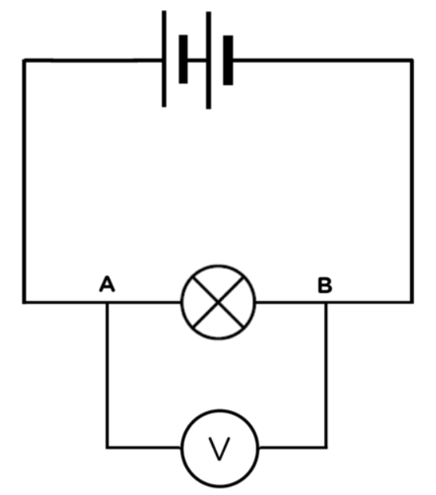

9 V

10 Ω

8.998 V

-

+

2. Compare the voltage of the battery to the voltage measured across the resistor. Are they exactly the same? Why or why not?

**The voltage across the resistor is slightly less than the battery voltage due to resistance.**

3. Label the resistance of the resistor (bulb) from the simulation. Calculate the current in the circuit based on the voltage and resistance.

**V = I R … I = V / R = 9 V / 10** Ω **= 0.9 A**

## Part 3 Measuring Current in a Combination Circuit

Set up a combination circuit with 3 resistors and measure amperage and voltage in each section of the circuit.

1. Make a schematic electrical drawing of the circuit using symbols.

a. Label the voltage of the battery and the readings on the voltmeter and ammeter across each resistor of the circuit.

b. Label the battery terminals (+ and -) and indicate the direction of current flow based on the electron flow.

2. Determine the resistance over each bulb in this circuit and label on your diagram.

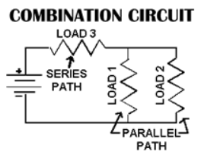

30 V

10 Ω

1A

9.999 V

1 A

2 A

1 A

10 Ω

1A

9.999 V

10 Ω

2A

19.997 V

3. Calculate the resistance (R) of circuit and label on your diagram.

**1/R total = 1/R1 + 1/R2 + 1/R3 = 1/10 Ω + 1/10 Ω + 1/10 Ω = 3/10 Ω … therefore,**

**R total = 1/0.3 Ω = 3.33 Ω**

4. How do the voltage measurements of the branches compare with that of the battery? Explain any discrepancy.

**The voltmeter readings are slightly less than the voltage of the battery. Ammeters and voltmeters do incur resistance when installed in a circuit.**

## Part 4 Identifying the Circuit & Measuring Voltage & Current

In Part 3, you measured the amperage and voltage as shown below in the circuit diagram. The measurements were done ONE at a time rather than connecting 3 ammeters and 2 voltmeters in the circuit simultaneously.

V

A

A

A

V

Consider and give an explanation as to why only one electrical device is measuring at a time.

**Ammeters and voltmeters do incur resistance when installed in a circuit. One device does not alter the resistance very much in a circuit so it does not affect the current or voltage much either. However, multiple devices would have some impact on the voltage, resistance, and current in a circuit.**

**Note: Ammeters have the lowest resistance of the electrical devices (ammeter, voltmeter, ohmmeter). This is because ammeters measure the current flow.**

**Conclusions & Questions**

1. How are ammeters set up in a circuit? Explain.

**Ammeters are set up in series because series circuits keep the same current throughout the circuit.**

2. How are voltmeters set up in a circuit? Explain.

**Voltmeters are set up in parallel because parallel circuits keep the same voltage across each branch of the circuit.**

3. What type of electrical devices is often set up in series for a combination circuit? Explain.

**Fuses or circuit breakers are installed near the power source (e.g. battery) of a combination circuit to prevent overloading or short circuiting. If the circuit bears too much load (resistance) or current, the fuse or breaker will “break” the circuit to stop the current flow.**

4. Compare the total resistance calculation in a series circuit to a parallel circuit.

**The total resistance of a Parallel Circuit is NOT equal to the sum of the resistors (like in a series circuit). The total resistance in a parallel circuit is always less than any of the branch resistances. Adding more parallel resistances to the paths causes the total resistance in the circuit to decrease. As you add more and more branches to the circuit the total current will increase because Ohm's Law states that the lower the resistance, the higher the current.**