***Gas Laws: Boyle’s Law & Charles’ Law***

<https://screencast-o-matic.com/watch/cYVn2GvZur>

**Purpose**

This experiment investigates two different Gas Laws, Boyle’s Law and Charles’ Law, confirming the relationship between variables of pressure and volume when temperature and moles are held constant (Boyle’s Law), and between temperature and volume when pressure and moles are held constant (Charles’ Law).



Background Information

(*Fill in the blanks*)

As a diver ascends, the water pressure _____ and the air trapped in the lungs _____. The diver has to avoid trapping air in the lungs to prevent overstretching of the lungs that can lead to pulmonary barotrauma. In addition to continuous breathing, divers also have to be careful to ascent _____. If they ascend too fast, there will not be enough time for the air to safely exit the lungs and some of the air will get trapped inside. The recommended ascent rate is 30 feet (9.1 m) per minute. This and other safety rules have been established to compensate for the air expansion and compression due to changes in water pressure.

Boyle’s Law

Robert Boyle, a 17th century scientist, investigated the relationship between the _____ of an ideal gas and its _____. Gases are different from liquids and solids in that they have neither a _____ volume nor a _____ shape. The behavior of gases depends on four variables: _____ (V), _____ (P), temperature (T), and amount (number of moles in the sample, n).

To investigate how two of the variables affect each other, the other variables must remain constant.

The number of _____ in a gas sample is related to the number of molecules by Avogadro’s number. The temperature of a gas will affect the _____ of the gas molecules. _____ temperatures provide more energy and lead to more movement of gas molecules within a given volume. Because gases do not have a fixed volume or shape, they will take the _____ and fill the _____ of their surroundings. For instance, gas placed in a container will fill the entire volume of the container. The pressure that a gas exerts on its surroundings is due to the gas molecules _____ with the boundaries of the surroundings. For instance, the pressure from a gas inside of an Erlenmeyer flask is due to the gas molecules colliding with the walls of the flask. It is important to note that a smaller volume will lead to more _____ due to the molecules having less room to move around.

Boyle held the amount of gas and its temperature constant during his investigation. He found that when he changed the pressure, the volume changed proportionally in the opposite direction. For example, when he doubled the _____, the _____ decreased by one half.

The results of Boyle’s experiments were published in 1662 and it became the first gas law to be published. Boyle’s Law states that at constant _____, the volume occupied by a fixed amount of gas is _____ proportional to the applied pressure. In other words, as the pressure _____ the volume _____ proportionally and vice versa. This is expressed mathematically using the equations below:

_____ = constant _____ = _____

where V is the volume of the gas, P is its pressure.

Hypothesis

Boyle’s Law

When temperature and number of moles is held constant, if the volume of a gas increases, then the pressure of the gas should decrease in the system. This will show a negative curve slope when volume and pressure are graphed.

**Equipment**

**Boyle’s Law**

* 30 mL Syringe
* Pressure Gauge (psi)
* Air
* Data Table

**Procedures**

Boyle’s Law (Using Air)

1. Move the syringe to volume: 5 ml. Allow the system to calibrate (black arrows appear).

2. Read the Pressure gauge and volume in the data table provided in the video.

3. Repeat procedures 1-2 for volumes near 10, 15, 20, 25, and 30 ml.

4. Record all data in the data tables provided in the Calculations and Data section.

*Refer to “Boyle’s Law Lab Video” for detailed procedures.*

**Calculations and Data**

1. Continue watching the video to collect data for the Boyle’s Law experiment.

2. Record the data for volume (mL) and pressure (psi) in the Boyle’s Law experiment.

Boyle’s Law (Air)

|  |  |  |
| --- | --- | --- |
| **Experiment Data** | | |
| **Volume (mL)** | **Pressure (psi)** | **Constant (mL∙psi)** |
|  |  |  |
|  |  |  |
|  |  |  |
|  |  |  |
|  |  |  |

3. Calculate the PV = constant value and record that in the “Constant (mL∙psi) column.

Show work for one calculation of the PV = constant.

Charles’ Law

Why do balloons shrink in the cold?

Have you ever left a balloon outside when it got cold? If you have, then you probably noticed that balloons _____ or deflate in _____ weather if they were inflated at a warmer temperature. This is due to the _____ of air in the balloons _____ when the balloons get _____. Bringing the balloons inside the house, where it is warmer, will re-inflate them.

_____ are different from liquids and solids in that they have neither a fixed volume nor a fixed shape. The behavior of gases depends on four variables:

pressure (P), _____ (V), _____ (T), and amount (number of moles, n).

There are three key laws that express the relationship between these variables: Boyle’s, Charles’, and Avogadro’s Law. These laws express the effect of one variable on another, whereas the other two variables remain constant. Because _____ is relatively easy to measure compared to the other variables, the gas laws are expressed as the effect of one of the other variables on gas volume.

Jacques Charles was a physics professor at Sorbonne University in France as well as a hot air balloon enthusiast. _____ air balloons rise when the gas inside is heated, which causes the gas to _____ in volume and become _____ dense. Charles decided to investigate the relationship between gas volume and temperature at constant pressure in his laboratory.

Charles’s law states that at constant _____ the volume occupied by a fixed amount of gas is _____ proportional to its temperature. In other words, as the temperature _____ the volume _____ proportionally and vice versa. This is expressed mathematically using the equations below:

_____ = constant _____ = _____

where V is the volume of the gas, T is its temperature in _____ (not degrees Celsius).

The relationship between the Kelvin and Celsius scales is shown below:

___ = ⁰___ + ___ .

Hypothesis

Charles’s Law

When pressure and number of moles is held constant, if the volume of a gas decreases, then the temperature of that gas should also decrease. This will show a positive, linear slope when volume and temperature are graphed.

**Equipment**

**Charles’ Law**

* 40 mL Piston Chamber
* Butane (C4H10­)
* Thermometer (K)
* Graph

**Procedures**

Charles’ Law (Using Butane)

1. Move the piston chamber volume to 40 ml (cm3).

2. Read the thermometer at that volume.

3. Repeat procedures 1-2 for volumes near 35, 30, 25, and 20 ml.

4. Record all data in the data tables provided in the Calculations and Data section.

*Refer to “Charles’ Law Lab Video” for detailed procedures.*

**Calculations and Data**

1. Continue watching the video to collect data for the Charles’s Law experiment.

2. Record the data for volume (mL) and pressure (psi) in the Boyle’s Law experiment.

|  |  |  |
| --- | --- | --- |
| Volume (mL) | Temperature (K) | V/T Constant |
|  |  |  |
|  |  |  |
|  |  |  |
|  |  |  |
|  |  |  |

3. Calculate the V/T = k value and record that in the “Constant (mL/K) column.

Show work for one calculation of the V/T = constant.

**Conclusions**

Hypothesis

Boyle’s Law

The hypothesis stated that when temperature and number of moles is held constant, if the volume of a gas increases, then the pressure of the gas should decrease in the system. This will show a negative curve slope when volume and pressure are graphed. This experiment confirmed the hypothesis because the volume increased from 9.75 ml to 29.78 ml and the pressure decreased from 52.77 psi to 17.28 psi. The graph of pressure versus volume showed the expected inverse relationship with a negative curve slope.

Charles’s Law

The hypothesis stated that when pressure and number of moles is held constant, If the temperature of a gas increases, the volume of that gas should also increase. This will show a positive, linear slope when volume and temperature are graphed. This experiment confirmed the hypothesis that at a volume of 39.9 ml, the temperature is 453.15 K and as the volume decreased to 20.2 ml, the temperature also decreased to 230.15 K. The graph of volume versus temperature showed the expected direct relationship with a positive, linear slope.

Analysis: *Refer to the graph analyses in the Calculations and Data section as well as to the questions below.*

Questions

1. What is the relationship of pressure and volume in the Boyle’s Law experiment?

2. What factor was held constant in the Boyle’s law experiment?

3. Create a general graph of Volume versus Pressure (Boyle’s Law) (refer to page 78):

1. Title the graph.
2. Label the vertical axis “Volume (ml)”.
3. Label the horizontal axis “Pressure (psi)”.
4. Draw a solid, CURVE-line that represents Boyle’s Law.

0

|  |  |  |  |  |  |  |  |  |  |  |  |
| --- | --- | --- | --- | --- | --- | --- | --- | --- | --- | --- | --- |
|  |  |  |  |  |  |  |  |  |  |  |  |
|  |  |  |  |  |  |  |  |  |  |  |  |
|  |  |  |  |  |  |  |  |  |  |  |  |
|  |  |  |  |  |  |  |  |  |  |  |  |
|  |  |  |  |  |  |  |  |  |  |  |  |
|  |  |  |  |  |  |  |  |  |  |  |  |
|  |  |  |  |  |  |  |  |  |  |  |  |
|  |  |  |  |  |  |  |  |  |  |  |  |
|  |  |  |  |  |  |  |  |  |  |  |  |
| 0 |  |  |  |  |  |  |  |  |  |  |  |

5. What is the relationship of temperature and volume in the Charles’s Law experiment?

6. Create a general graph of “Volume ∞ Temperature” (Charles’s Law) (refer to page 78):

a. Title the graph.

b. Label the vertical axis “Volume (ml)”.

c. Label the horizontal axis “Temperature (K)”.

d. Draw a solid, straight-line that best represents Charles’s Law.

0

0

|  |  |  |  |  |  |  |  |  |  |
| --- | --- | --- | --- | --- | --- | --- | --- | --- | --- |
|  |  |  |  |  |  |  |  |  |  |
|  |  |  |  |  |  |  |  |  |  |
|  |  |  |  |  |  |  |  |  |  |
|  |  |  |  |  |  |  |  |  |  |
|  |  |  |  |  |  |  |  |  |  |
|  |  |  |  |  |  |  |  |  |  |
|  |  |  |  |  |  |  |  |  |  |
|  |  |  |  |  |  |  |  |  |  |
|  |  |  |  |  |  |  |  |  |  |
|  |  |  |  |  |  |  |  |  |  |

7.  What variables are constant during the Charles’s Law experiment?

**Errors**

Because the experiments were both done using a simulated, virtual lab with near perfect results, there were no measurement errors. This is theoretical and not realistic. If the experiment were done in a real lab setting, errors would include human error in measurements, accuracy, and gas leakage when transferring. It would be valuable to create experiments that could measure Boyle’s and Charles’ laws in the laboratory. Then, we would need to consider percent error, which is a much more valid experimentation.

**Bibliography:**

Chemistry, Weeks 21-22. *Boyle’s Law video* and *Charles’ Law Lab Video,* Learning CTR Online, n.d. Web. 22 Feb. 2019. [www.learningctronline.com](http://www.learningctronline.com).

Chemistry, Weeks 21-22. *Class Notes, Gas Laws*. *Riesen, C*. Learning CTR Online, n.d. Web. 22 Feb. 2019. [www.learningctronline.com](http://www.learningctronline.com).

Chemistry, Week 21. *“Gas Laws Lab”, Directions*. Learning CTR Online, n.d. Web. 22 Feb. 2019. [www.learningctronline.com](http://www.learningctronline.com).

Chemistry, Week 21. *“Gas Laws Lab”, Riesen, C, Lab handout*. Learning CTR Online, n.d. Web. 22 Feb. 2019. [www.learningctronline.com](http://www.learningctronline.com).

Wilbraham, Antony, Denis Staley, Michael Matt, and Edward Waterman. “The Behavior of Gases.” *Pearson chemistry*. Boston: Pearson Education, 2012. Print.

**ANSWERS**

As a diver ascends, the water pressure decreases and the air trapped in the lungs increases. The diver has to avoid trapping air in the lungs to prevent overstretching of the lungs that can lead to pulmonary barotrauma. In addition to continuous breathing, divers also have to be careful to ascent gradually. If they ascend too fast, there will not be enough time for the air to safely exit the lungs and some of the air will get trapped inside. The recommended ascent rate is 30 feet (9.1 m) per minute. This and other safety rules have been established to compensate for the air expansion and compression due to changes in water pressure.

Boyle’s Law

Robert Boyle, a 17th century scientist, investigated the relationship between the volume of an ideal gas and its pressure. Gases are different from liquids and solids in that they have neither a fixed volume nor a fixed shape. The behavior of gases depends on four variables: volume (V), pressure (P), temperature (T), and amount (number of moles in the sample, n).

To investigate how two of the variables affect each other, the other variables must remain constant.

The number of moles in a gas sample is related to the number of molecules by Avogadro’s number. The temperature of a gas will affect the movement of the gas molecules. Higher temperatures provide more energy and lead to more movement of gas molecules within a given volume. Because gases do not have a fixed volume or shape, they will take the form and fill the volume of their surroundings. For instance, gas placed in a container will fill the entire volume of the container. The pressure that a gas exerts on its surroundings is due to the gas molecules colliding with the boundaries of the surroundings. For instance, the pressure from a gas inside of an Erlenmeyer flask is due to the gas molecules colliding with the walls of the flask. It is important to note that a smaller volume will lead to more collisions due to the molecules having less room to move around.

Boyle held the amount of gas and its temperature constant during his investigation. He found that when he changed the pressure, the volume changed proportionally in the opposite direction. For example, when he doubled the pressure, the volume decreased by one half.

The results of Boyle’s experiments were published in 1662 and it became the first gas law to be published. Boyle’s Law states that at constant temperature, the volume occupied by a fixed amount of gas is inversely proportional to the applied pressure. In other words, as the pressure increases the volume decreases proportionally and vice versa. This is expressed mathematically using the equations below:

PV = constant P1V1 = P2V2

where V is the volume of the gas, P is its pressure, and “k” is a constant.

**Calculations and Data**

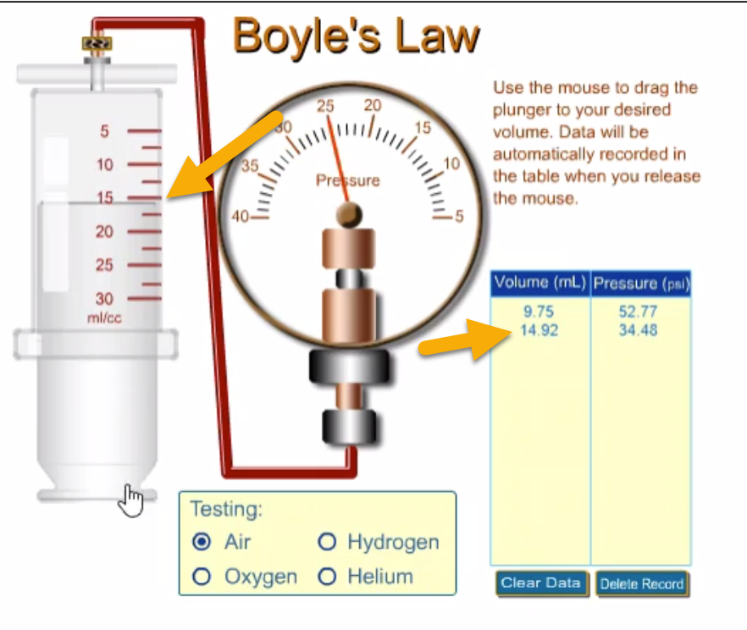

The image above shows the Boyle’s Law set up. The volume of the syringe is 14.92 ml and the pressure gauge is reading 34.48 psi.

Boyle’s Law (Air)

**Calculations of the Boyle’s Law Constant:**

PV = k

9.75 mL x 52.77 psi = 514.5 mL**∙**psi

14.92 mL x 34.48 psi = 514.4 mL**∙**psi

19.84 mL x 25.93 psi = 514.5 mL**∙**psi

25.24 mL x 20.38 psi = 514.5 mL**∙**psi

29.78 mL x 17.28 psi = 514.6 mL**∙**psi

|  |  |  |
| --- | --- | --- |
| **Volume (mL)** | **Pressure (psi)** | **Constant**  **mL∙psi** |
| **9.75** | **52.77** | 514.5 |
| **14.92** | **34.48** | 514.4 |
| **19.84** | **25.93** | 514.5 |
| **25.24** | **20.38** | 514.4 |
| **29.78** | **17.28** | 514.6 |

Calculating the PV constant provides evidence that Boyle’s Law worked because the values are close. As volume increased, pressure decreased (inverse proportion), but PV = k.

Charles’s Law

Why do balloons shrink in the cold?

Have you ever left a balloon outside when it got cold? If you have, then you probably noticed that balloons shrink or deflate in cold weather if they were inflated at a warmer temperature. This is due to the volume of air in the balloons decreasing when the balloons get colder. Bringing the balloons inside the house, where it is warmer, will re-inflate them.

Gases are different from liquids and solids in that they have neither a fixed volume nor a fixed shape. The behavior of gases depends on four variables:

pressure (P), volume (V), temperature (T), and amount (number of moles, n).

There are three key laws that express the relationship between these variables: Boyle’s, Charles’, and Avogadro’s Law. These laws express the effect of one variable on another, whereas the other two variables remain constant. Because volume is relatively easy to measure compared to the other variables, the gas laws are expressed as the effect of one of the other variables on gas volume.

Jacques Charles was a physics professor at Sorbonne University in France as well as a hot air balloon enthusiast. Hot air balloons rise when the gas inside is heated, which causes the gas to expand in volume and become less dense. Charles decided to investigate the relationship between gas volume and temperature at constant pressure in his laboratory.

Charles’s law states that at constant pressure the volume occupied by a fixed amount of gas is directly proportional to its temperature. In other words, as the temperature increases the volume increases proportionally and vice versa. This is expressed mathematically using the equations below:

V / T = constant V1 / T1 = V2 / T2

where V is the volume of the gas, T is its temperature in kelvins (not degrees Celsius). The relationship between the Kelvin and Celsius scales is shown below:

K = ⁰C + 273 .

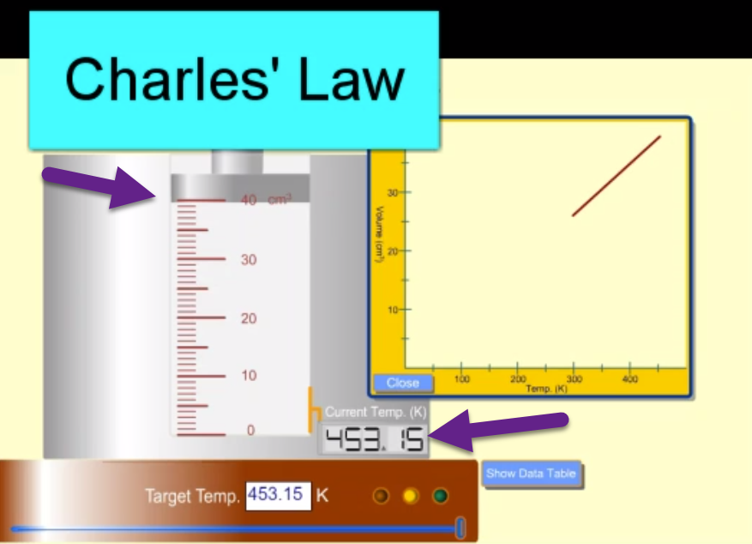

The image above shows the Charles’ Law Set Up. The piston chamber volume is 40 cm3 or 40 mL, and the corresponding temperature is 453.15 K.

Charles’ Law (Butane)

|  |  |  |
| --- | --- | --- |
| **Volume (cm3)** | **Temperature (K)** | **V/T Constant**  **mL/K** |
| **39.9** | **453.15** | 0.0881 |
| **34.0** | **385.15** | 0.0883 |
| **29.5** | **335.15** | 0.0880 |
| **23.8** | **269.15** | 0.0884 |
| **20.2** | **230.15** | 0.0878 |

Show work for the calculation of the V/T = k constant (use K temperatures):

V/T = k

Calculating the V/T constant provides evidence that Charles’ Law worked because the values are close. As volume decreased, temperature decreased (direct proportion), but V/T = k.

39.9 mL / 453.15 K = 0.0881 mL/K

34.0 mL / 385.15 K = 0.0883 mL/K

29.5 mL / 335.15 K = 0.0880 mL/K

23.8 mL / 269.15 K = 0.0884 mL/K

20.2 mL / 230.15 K = 0.0878 mL/K

**Conclusion Questions**

1. The relationship between Pressure and Volume in the Boyle’s law experiment is inverse. This assumes that temperature and the number of moles were held constant. The experimental data showed that as volume increased, the pressure of the gas decreased. The volume increased from 9.75 ml to 29.78 ml and the pressure decreased from 52.77 psi to 17.28 psi. The PV = k values were all close to 514.5 ml∙psi, supporting our data.

2. The factors that were held constant in Boyle’s Law were Temperature and the number of moles. Therefore, from the ideal gas law, PV = nRT, Boyle’s law becomes PV = k.

3. Create a general graph of Volume versus Pressure (Boyle’s Law) (refer to page 78):

Boyle’s Law: Volume Versus Pressure at Constant Temperature

0

0

10

10

40

30

20

50

40

30

20

50

X

X

X

X

X

**Volume**

**mL**

|  |
| --- |
| **Pressure (psi)** |

|  |  |  |  |  |  |  |  |  |  |  |  |
| --- | --- | --- | --- | --- | --- | --- | --- | --- | --- | --- | --- |
|  |  |  |  |  |  |  |  |  |  |  |  |
|  |  |  |  |  |  |  |  |  |  |  |  |
|  |  |  |  |  |  |  |  |  |  |  |  |
|  |  |  |  |  |  |  |  |  |  |  |  |
|  |  |  |  |  |  |  |  |  |  |  |  |
|  |  |  |  |  |  |  |  |  |  |  |  |
|  |  |  |  |  |  |  |  |  |  |  |  |
|  |  |  |  |  |  |  |  |  |  |  |  |
|  |  |  |  |  |  |  |  |  |  |  |  |
|  |  |  |  |  |  |  |  |  |  |  |  |

When the data points were plotted of the second experiment for Boyle’s Law, the graph shows an inverse the relationship between Volume and Pressure with temperature and moles held constant. The volume increased from 9.75 ml to 29.78 ml and the pressure decreased from 52.77 psi to 17.28 psi. This represents an inverse relationship (proportion).

5. The relationship between Temperature and Volume in Charles’ Law is direct which was confirmed in this experiment. At a volume of 39.9 ml, the temperature is 453.15 K and as the volume decreased to 20.2 ml, the temperature also decreased to 230.15 K. The V/T = k values were all very close to 0.0880 ml/K, supporting our data.

6. Create a general graph of “Volume ∞ Temperature” (Charles’s Law) (refer to page 78):

Charles’ Law: Volume Versus Temperature at Constant Pressure

|  |  |  |  |  |  |  |  |  |  |
| --- | --- | --- | --- | --- | --- | --- | --- | --- | --- |
|  |  |  |  |  |  |  |  |  |  |
|  |  |  |  |  |  |  |  |  |  |
|  |  |  |  |  |  |  |  |  |  |
|  |  |  |  |  |  |  |  |  |  |
|  |  |  |  |  |  |  |  |  |  |
|  |  |  |  |  |  |  |  |  |  |
|  |  |  |  |  |  |  |  |  |  |
|  |  |  | 0  0  50  40  30  20  10  100  500  400  300  200  X  X  X  X  X |  |  |  |  |  |  |
|  |  |  |  |  |  |  |  |  |  |
|  |  |  |  |  |  |  |  |  |  |

**Volume**

**mL**

|  |
| --- |
| **Temperature (K)** |

When the data points were plotted for the second experiment for Charles’s Law, the graph shows a direct relationship between Volume and Temperature, when Pressure and moles are held constant. Notice, temperature is kelvin. At a volume of 39.9 ml, the temperature is 453.15 K and as the volume decreased to 20.2 ml, the temperature also decreased to 230.15 K. The reason the line below the last data-point is dashed is that it is theoretical extension. No data points were taken from there. Also, when a gas approaches Absolute Zero (0 K), it has no volume, as the graph indicates. However, that is impossible and thus the line is dashed. This represents a direct relationship (proportion).

7.  In Charles’ Law Pressure and the number of moles is held constant. Therefore, from the ideal gas law, PV = nRT, Charles’s law becomes V/T = k.