**Electrochemistry (Voltaic Cells)**

**Purpose**

What kind of chemistry exists in a battery? Students discover that a lemon can create electricity (as in a household battery) based on a chemical reaction (redox reaction).

**Materials**

One lemon or lime 0 – 3 Volt Voltmeter or 1 amp LED electrode

5 cm piece of copper wire 5 cm piece of various Metal Electrodes

Pointed knife (*magnesium, aluminum, zinc, iron*)

One Red Alligator clip One Black Alligator clip

*(low guage copper wire works to connect the electrodes to the voltmeter.)*

**Real-World Connections**

Everything on earth stores and uses energy to stay alive. The ultimate source of energy is the sun. Basically this means that the sun produces all the energy used in our lives on planet earth. However, we also produce and store energy. By what process does life collect and store its energy? In this experiment, students will see how the process of energy storage (*and use*) in living things is described by “electrochemistry.” Our bodies, and the lemon used in this activity, are both sources of energy that can be stored or used to supply energy to operate something else. In other words, we and the lemon are both living batteries!

A battery operates because reduction and oxidation are occurring simultaneously inside. Oxidation takes place at the electrode with the more active metal (*producing electrons*) while reduction takes place at the electrode with the less active metal (*using up the electrons*). Batteries are rated according to voltage (i.e. 9 V battery). Voltage is the measure of the difference in potential between the two electrodes used and is very similar to the difference in height of a ledge and the ground for a waterfall. Therefore, voltage is often referred to as “Potential Difference.” When one uses the Standard Reduction Potentials of two metals used as electrodes, we determine the DIFFERENCE in potential between these electrodes. This is known as the theoretical voltage.

**Procedures**

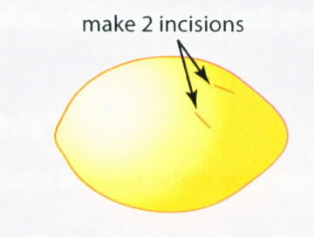

1. Roll the lemon on the table using your palm so that the juice can flow easily.

2. Make two 1 cm incisions in the lemon about 2 cm apart from one another.

3. Insert the copper electrode piece in one of the incision holes.

4. Insert another electrode piece in the other incision hole.

5. Attach the RED alligator clip to the copper electrode and to the RED side of the voltmeter.

6. Attach the Black alligator clip to the other electrode and to the BLACK side of the voltmeter.

* + *If the voltmeter does not register, switch the way that the alligator leads are connected to the copper wire and the other metal electrode*. (see diagram next page)

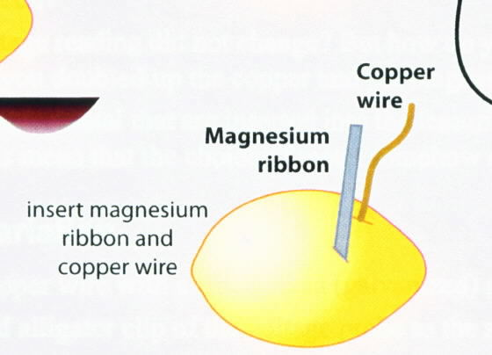 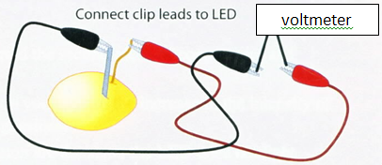

7. Record the potential difference (voltage) registered on the voltmeter.

8. Exchange the non-copper electrode with another electrode (*leave the copper electrode in the lemon*). Record the voltage in your calculations and data.

9. Continue to exchange electrodes until you have tested and recorded the voltage using the following electrodes: magnesium, aluminum, zinc, and iron electrodes.

**Calculations and Data**

1. Complete the table below and record the electrode potentials. *If you do not have electrodes or a voltmeter, use the pictures provided below the chart.*

|  |  |  |  |  |
| --- | --- | --- | --- | --- |
| Actual Voltage Readings using Copper | | | | |
| Electrode | Magnesium | Aluminum | Zinc | Iron |
| Voltage Reading |  |  |  |  |

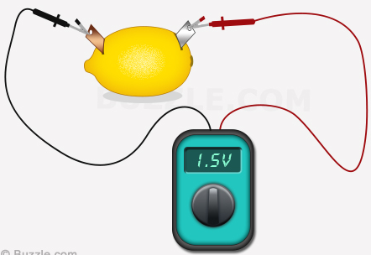 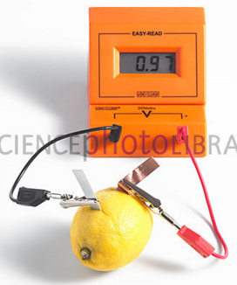 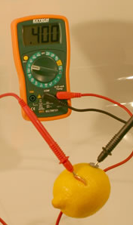

Magnesium & Copper Copper & Aluminum Zinc & Copper

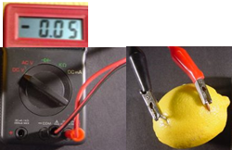

Iron & Copper

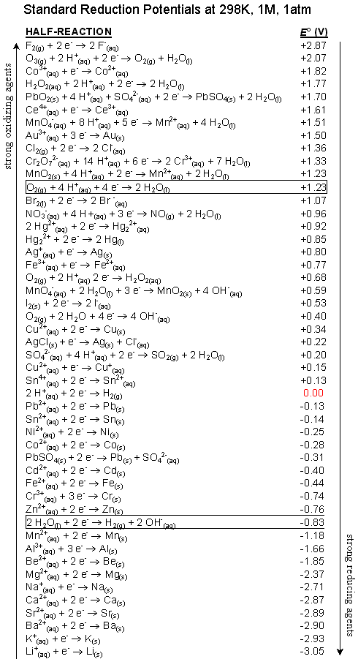

2. Use the SRP Reference Table on the previous page to determine the Standard Electrode Potential of each metal used in this experiment.

|  |  |  |  |  |
| --- | --- | --- | --- | --- |
| Standard Electrode Potential (Voltage) | | | | |
| Copper SRP Value: ______V | | | | |
| Electrode | Magnesium | Aluminum | Zinc | Iron |
| *SRP Values |  |  |  |  |

3. Subtract the Standard Electrode Potentials (Voltages) of each metal FROM Copper to find the theoretical Potential Difference (voltage) using Copper as the standard electrode.

e.g. Copper & magnesium: +0.34 V – (-2.37 V) = +2.71 V

|  |  |  |  |  |
| --- | --- | --- | --- | --- |
| Theoretical Potential Difference (Voltage) using Copper | | | | |
| Copper SRP Value: ______V | | | | |
| Electrode | Magnesium | Aluminum | Zinc | Iron |
| Expected Voltage |  |  |  |  |

**Conclusions and Questions**

1. What happened to the voltmeter when the lemon “battery” was connected properly?

2. What must be produced from the lemon to yield voltage in the voltmeter?

3. Where did the electricity come from?

4. How do you know which electrode has reduction occurring and which electrode has the oxidation occurring?

5. Write the reduction half reaction (*copper*) and the oxidation half reactions (*magnesium, aluminum, zinc, and iron*) in this lab.

6. Compare the ACTUAL voltage for each “battery” with the Theoretical (expected) voltage. Why the difference?

**Calculations and Data Answer Key**

1. Copy the table below on a piece of paper and record all electrode potentials.

|  |  |  |  |  |
| --- | --- | --- | --- | --- |
| Actual Voltage Readings using Copper | | | | |
| Electrode | Magnesium | Aluminum | Zinc | Iron |
| Voltage Reading | **1.5 V** | **0.97 V** | **0.40 V** | **0.05 V** |

2. Use the SRP Reference Table (N) to determine the Standard Electrode Potential of each metal used in this experiment.

|  |  |  |  |  |
| --- | --- | --- | --- | --- |
| Standard Electrode Potential (Voltage) | | | | |
| Copper SRP Value: **+0.34V** | | | | |
| Electrode | Magnesium | Aluminum | Zinc | Iron |
| *SRP Values | **-2.37 V** | **-1.66 V** | **-0.76 V** | **-0.44 V** |

3. Subtract the Standard Electrode Potentials (Voltages) of each metal FROM Copper to find the theoretical Potential Difference (voltage) using Copper as the standard electrode.

e.g. Copper & magnesium: +0.34 V – (-2.37 V) = 2.71 V

|  |  |  |  |  |
| --- | --- | --- | --- | --- |
| Theoretical Potential Difference (Voltage) using Copper | | | | |
| Copper SRP Value: +0.34V | | | | |
| Electrode | Magnesium | Aluminum | Zinc | Iron |
| Expected Voltage | **2.71 V** | **2.00 V** | **1.10 V** | **0.78 V** |

* + Expected Voltage is actually the SUM of the half reaction potentials. This represents the overall potential (voltage) of the electrochemical cell. Since Magnesium, aluminum, zinc, and iron are oxidized, their SRP values must be reversed (e.g. magnesium’s SRP was -2.37 V … when oxidized it becomes +2.37 V. When added to copper’s SRP (0.34 V), the total potential voltage is 2.71 V).

**Conclusions and Questions**

1. What happened to the voltmeter when the lemon “battery” was connected properly?

***The voltmeter registered voltage.***

2. What must be produced from the lemon to yield voltage in the voltmeter?

***Electricity is produced.***

3. Where did the electricity come from?

***The electricity came from the oxidation / reduction reactions of the electrodes in the lemon.***

4. How do you know which electrode has reduction occurring and which electrode has the oxidation occurring?

***The more active metal will be oxidized producing electrons which will reduce the copper.***



Electrons are given off by the oxidized metal to yield voltage, reducing the copper.

e-

e-

e-

5. Write the reduction half reaction (*copper*) and the oxidation half reactions (*magnesium, aluminum, zinc, and iron*) in this lab.

***Reduction: Cu+2 + 2 e- 🡪 Cu0 +0.34 V***

***Oxidation: Mg0 🡪 Mg+2 + 2 e- +2.37 V***

***Al0 🡪 Al+3 + 3 e- +1.66 V***

***Zn0 🡪 Zn+2 + 2 e- +0.76 V***

***Fe0 🡪 Fe+2 + 2 e- +0.44 V***

***\*The SRP values for the oxidation half reactions must be “reversed” … change to the opposite sign.***

6. Compare the ACTUAL voltage for each “battery” with the Theoretical (expected) voltage. Why the difference?

|  |  |  |  |  |
| --- | --- | --- | --- | --- |
| Theoretical Potential Difference (Voltage) using Copper | | | | |
| Copper SRP Value: +0.34V | | | | |
| Electrode | Magnesium | Aluminum | Zinc | Iron |
| Expected Voltage | **2.71 V** | **2.00 V** | **1.10 V** | **0.78 V** |
| Actual Voltage | **1.5 V** | **0.97 V** | **0.40 V** | **0.05 V** |

**The actual voltages observed for each battery was far below the expected (theoretical) voltage. This happens for many reasons. Some of the reasons are:**

**1) The loss of voltage as electrons are transferred from the oxidation electrode (e.g. magnesium, aluminum, zinc, or iron) through the alligator clips (wiring) to the voltmeter.**

**2) The theoretical potential difference (voltage) assumes that 100% of the possible voltage that can be produced is produced. That virtually never happens even in our best batteries. Lemons are a crude source of electricity and do not produce anywhere near the potential voltage.**

**3) Resistance in the wiring will reduce the potential voltage.**