**Deviations in the Name of Science**

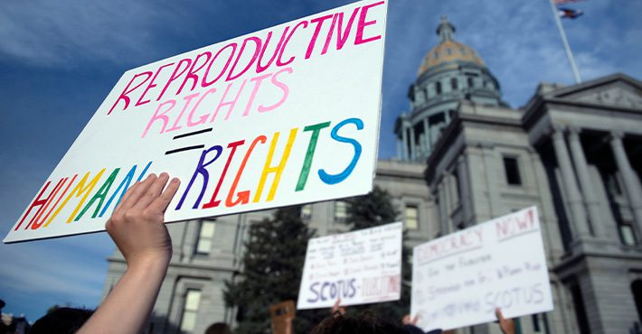

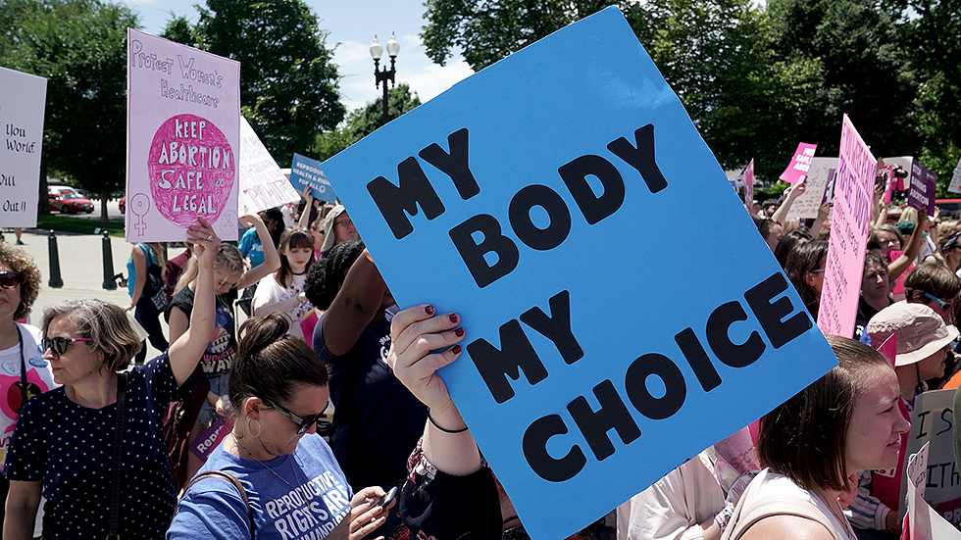

**See** [**https://www.learningctronline.com/courses**](https://www.learningctronline.com/courses) **for Materials and Resources.**

**Topics:**

1. Deviations in the Name of Science

**Objectives:**

* + Consider why people feel they have reproductive rights and bodily autonomy.
    - Contrast with a Biblical view of life originating with God, the Creator.
    - Emphasize the steps of true listening in order to speak the truth in love especially to those who deny, diminish or oppose God’s authority.
  + Analyze reproductive rights, homosexuality, and transgender issues (cross dressing, transvestite, changing gender) and compare to scripture.
  + Reflect upon and understand why viewpoints can deviate so far from scripture.

TAKE NOTE (1 week)

1. Article Summary: Biblical References Related to Life, Sexuality, and Gender
2. Article Summary: Abortion Versus Morality
3. Article Summary: Inside the Transgender Empire
4. Create a timeline representing the history of women’s rights
5. Lab: Listening to an Opposing Viewpoint
6. OPTIONAL Film Review “I am Woman” [2019] (Tilda Cobham-Hervey, Danielle MacDonald, Evan Peters) … 1h 56m
7. Week 19 Devotional (<https://www.learningctronline.com/devotional>)

**Reference Materials:**

* **Biblical References Related to Life, Sexuality, and Gender**
* **Abortion Versus Morality**
* **Inside the Transgender Empire**

**Homework**:

* Complete the THREE article summary worksheets.

**Lab**: Create a timeline representing the history of women’s rights.

* Use the worksheet provided.
* Research the internet and other resources to determine the evolution of women’s rights in the world and in the United States.
* Give dates and events with brief explanations.
* Offer positives and negatives related to women’s suffrage.
* Save the document into your LAB folder in the Projects in Science folder on your desktop.

**Lab**: Listening to an Opposing Viewpoint

* Use the worksheet provided.
* Find a friend, peer, classmate or adult with whom you have established a respectful relationship.
* Discuss and find a topic which you disagree at least somewhat strongly to.
  + If possible, choose one of the following as the topic: abortion, homosexuality, or transgender.
  + If not possible, find a Christian who holds to different Biblical interpretation than you do and discuss one topic. For example:
    - Infant vs adult baptism
    - Speaking in tongues, healing, miracles vs only in the apostolic age
    - Young earth vs old earth (between Christians)
    - Mega church format vs traditional liturgy
    - Rapture (pre-tribulation, mid-tribulation, post-tribulation or not at all)
    - Eternal security versus losing one’s salvation
    - Celebrating holidays (Easter, Halloween, Christmas) versus not
* Interview your “contrarian” by asking questions and listening as prescribed below:
* Do **NOT** become contentious or allow an argument. The main goal is to listen:
  + Listening does NOT mean you agree!
  + Focus on what the other persons is saying.
  + Acknowledge the other person by eye contact and gestures.
  + Clarify by asking questions and restating what the other person is trying to convey.
* Write a summary of your discussion. Include in your summary a statement or rating of 1-5 (5 is great, 1 is poor) from the OTHER person about how they felt you listened or not.
* Save the document into your LAB folder in the Projects in Science folder on your desktop.

**Lab**: Film Review [OPTIONAL]

* Obtain the movie “I am Woman” [2019] (Tida Cobham-Hervey; Danielle Macdonald; Evan Peters) … 1h 56m.
  + Complete the **I am Woman** film review.
* Save the document into your LAB folder in the Projects in Science folder on your desktop.

**TEST:** noQuiz

Supplemental Resources (Optional)