**Science & Data**

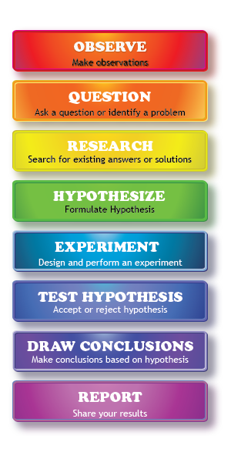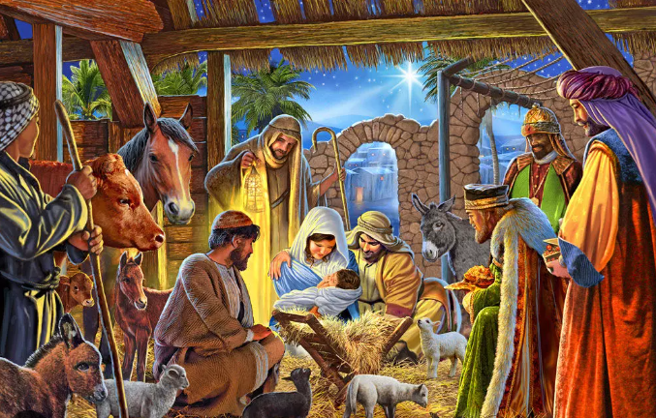 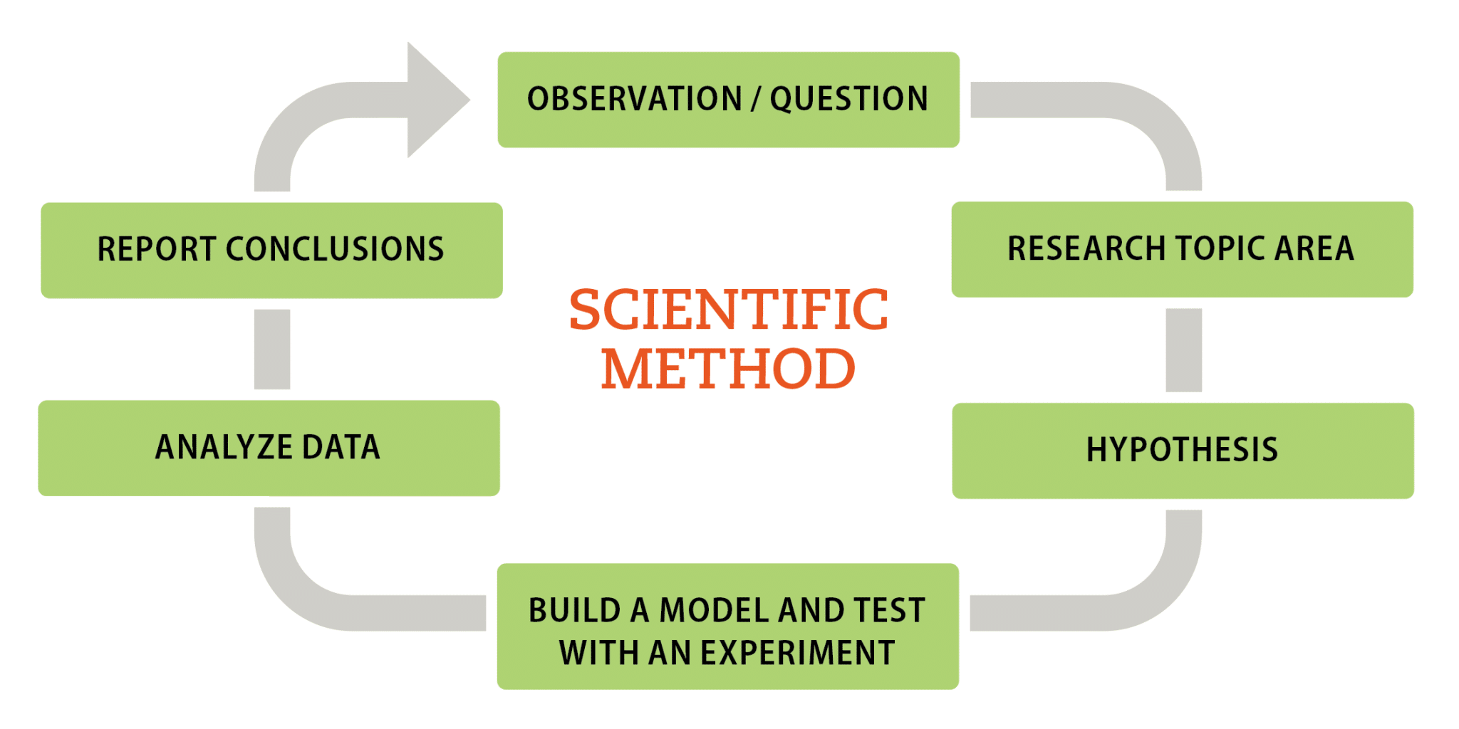

**See** [**https://www.learningctronline.com/courses**](https://www.learningctronline.com/courses) **for Materials and Resources.**

**Topics:**

1. Science & Data

**Objectives:**

* + Understand the importance of proper scientific process.
    - Contrast with the science of fake news.
    - Define fake news and explain ways to deal with it.
  + Recognize a scientific approach to Bible study.
  + Analyze scripture to evaluate the Nativity Scene as an example of proper scientific process, contrasting Bible understanding with public opinion.

TAKE NOTE (1 week)

1. Read “Scientific Method – Cornell Notes
2. Read Scientific Process Reference Material
3. Science of Fake News Worksheet
4. How to Study the Bible Worksheet
5. Project: Analyze Matthew 2 with Luke 2 regarding the Nativity Scene
6. Quiz Science & Data
7. Week 17 Devotional (<https://www.learningctronline.com/devotional>)

**Text**:

**Reference Material:**

**Homework**:

* Scientific Process Reference Material
* Science of Fake News Worksheet [based on reference material]
* How to Study the Bible Worksheet [based on reference material]

**Project**: Analyze Matthew 2 with Luke 2 regarding the Nativity Scene

* Complete the worksheet provided.
* Save the document into your LAB folder in the Projects in Science folder on your desktop.

**TEST:** Science & Data

1) the academic integrity policy

* Tests must be completed **WITHOUT** referring to books, notes, the internet, people, or any outside resources.
* Students **MAY** use the approved Periodic Tables, approved Reference Tables, or approved equation (formula) sheet (provided by the teacher) along with calculators and scratch paper.
* A guardian should be proctoring the test. Proctoring means to monitor the following:

2) Take the **"in one sitting"**, meaning that once you start the test, you must complete it without interruption.

3) There is a **30-minute time limit** on this test. Please have the proctor write the time taken at the top of your answer sheet with their signature or initials.

4) Proctors should NOT be reading the test or engaging students during the test.

5) Do NOT use RED font. Black font is best.

Supplemental Resources (Optional)

1. Birthdate of Jesus Article