**Simple Maps**

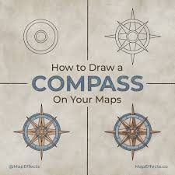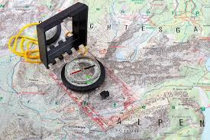



**See** [**https://www.learningctronline.com/courses**](https://www.learningctronline.com/courses) **for Materials and Resources.**

**Topics:**

1. Compass Bearings

**Objectives:**

* + Learn the components of and how to make a simple map.
    - Finding field bearings and distances (compass work)
    - Starting the map
    - Drawing the map
    - Protractor use.
  + Understand the concept of a contour (topographical) map and be able to draw one or decipher one.

TAKE NOTE

1. Film Review of “Cast Away” (Survival scenes).
2. Simple Maps Worksheet
3. Quiz 1 Simple Maps
4. Lab: Contour Mapping
5. Survival Essay OR Mapping Project
6. Quiz 2 Compass Mapping
7. Week 9 Devotional (<https://www.learningctronline.com/devotional>)

**Text**:

**Reference Material:** Simple Maps

**Homework**:

* Simple Maps Worksheet using the reference material.
* Survival Essay or Mapping Project [Complete the worksheet provided].

**Lab**: Film Review

* Obtain the movie “Cast Away” with Tom Hanks [2000 2h 24m]
  + You only need to watch the survival scenes beginning with the plane crash until his rescue.
  + Complete the **generic** film review in the course Resources folder for ONE of the two movies.
* Save the document into your LAB folder in the Projects in Science folder on your desktop.

**Lab**: Contour Mapping

* Complete the worksheet provided.
* Save the document into your LAB folder in the Projects in Science folder on your desktop.

**TEST: Quiz 1 Simple Mapping**

1. Complete the quiz and email it to [LearningCTROnline@gmail.com](mailto:LearningCTROnline@gmail.com)

**TEST: Quiz 2 Compass Mapping**

1. The quiz is open notes.
2. Complete the quiz and email it to LearningCTROnline@gmail.com

Supplemental Resources (Optional)

1. Use the internet to watch videos of making a simple compass map.
2. Crossword Review Compass Orienteering.
3. Watch a survival video online.