**The Atom & Quantum**

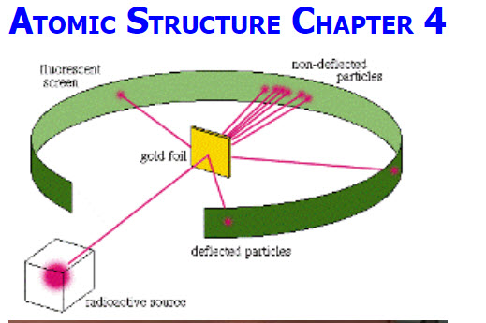

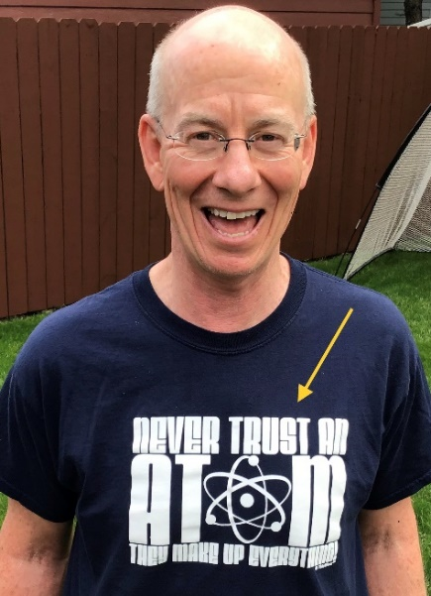

**“Never Trust an Atom … They make up everything!”**

**See** [**https://www.learningctronline.com/courses**](https://www.learningctronline.com/courses) **for Materials and Resources.**

**Topics:** The Atom

**Objectives:**

1. Explain the energy levels of atoms.
2. Understand that atoms are mostly empty space (Rutherford) and energy is quantized (Bohr).
3. Calculate energy, frequency, and wavelength of light absorbed or released by electrons when excited (absorption spectra) or returning to the ground state (emission spectra).
4. Recognize the color or portion of the light spectrum relating to electron energy, frequency and wavelength and where it fits in the electromagnetic spectrum.

TAKE NOTE – expect to spend 8-10 hours/week on Physics (Honors 10-12 hours/week)

1. Reading (Hewitt Text)

1. Notes Energy Levels of the Atom
2. Atom Inquiry Activities (1 week)
3. Problem Set: The Atom (2 weeks)
4. Lab: Emission Spectra (Up to Follow Up)
5. Lab: Circular Motion (Bohr Model of the Atom) [1 week]
6. HONORS 🡪 Flame Tests Lab
7. Class Song: The Minute You Came to This Class
8. Week 17 Devotional (<https://www.learningctronline.com/devotional>)

**Text**: Chapters 17 & 38 The Atom & Quantum (Hewitt)

**Class Notes: Energy Levels of the Atom**

**Homework**:

* Atom Inquiry Activities
* Problem Set: The Atom

**Lab**: Circular Motion (Bohr Model of the Atom)

* Perform the lab as directed using the worksheet provided.
* Complete all calculations and data, showing work whenever appropriate.
* Conclusions should be answered in complete sentences that convey a complete thought.
* Save the documents into your LAB folder in the Physics folder on your desktop.

**Lab**: Emission Spectra (Up to Follow Up)

* Perform the lab as directed using the worksheet provided.
* Complete all calculations and data, showing work whenever appropriate.
* Conclusions should be answered in complete sentences that convey a complete thought.
* Save the documents into your LAB folder in the Physics folder on your desktop.

**TEST:** The test will be given after next week’s lesson.

Supplemental Resources (Optional)

1. Flame Test Lab
2. Modern Atomic Theory Notes

[Van Der Graaf Demo [Charges Exist]](http://somup.com/cFQ22DVSKM) (1:15)  
  
[The Atom: Electrostatic Force Demonstrations ctr](http://somup.com/cF6elPnVza) (2:59) ... first 1:30 minutes is the Acrylic Tape Demo; Then, a balloon demo shows friction, induction and conduction.  
  
[Crookes' Tube: Cathode Ray deflected by Magnet (Electrons)](http://somup.com/cF6eVJnVy6) (1:07)  
  
[Millikan Oil Drop Experiment (Mass to Charge Ratio)](http://somup.com/cF6eVdnVyl) (1:14)  
  
[The Nucleus: Atoms are mostly empty space](http://somup.com/cF6eVsnVyD) (0:48)  
  
[Rutherford's Experiment: Atom's center is a Nucleus](http://somup.com/cF6eVMnVyb) (0:47)  
  
[Atomic History Song (Mark Rosengarten](http://somup.com/cFQ22rVSKR) (4:14)