*This test should be taken WITHOUT notes, without textbook or any other outside resources. Approved Reference Materials may be used. Choose the best answer for each question*.

Multiple Choice:

Use the Answer Section below to place your answers. Suggestion: print out this page to write your answers while you take the test. You can scan or take a phone pic of the Answer page and insert it back into the test for grading (along with the problem section).

1.

2.

3.

4.

5.

6.

7.

8.

9.

10.

11.

12.

13.

14.

15.

Email the quiz to [learningctronline@gmail.com](mailto:learningctronline@gmail.com) when completed.

1 – 3. Name or give the elemental symbol for three of the most essential elements in living organisms.

1.

2.

3.

4 – 5. Use “P” if the change shown is a physical change; Use “C” if the change shown is a chemical change.

4. wood is burning with a flame

5. boiling water

6 – 7. What two particles determine the atomic mass of a typical atom?

8. What component of a solution gets dissolved?

9. What component of a solution does the dissolving?

10. Heat automatically (spontaneously) flows from

a) warm to cool b) cool to warm c) neither choice

11. A solution that contains excess H+ ions is called a(n) ___.

12. A strong base has ___ ions in solution compared to a weak base.

a) few b) many c) the same amount of

13. The image shows 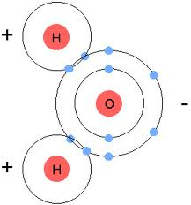

a) a charged molecule b) an ionic compound c) a polar molecule

14. Which of the following is NOT a special property of water based on hydrogen bonding?

a) cohesion

b) high specific heat

c) universal solvent

d) solid state is more dense than liquid state

15. Cells control pH level by using

a) buffers b) antacids c) enzymes