Contrast a scalar quantity from a vector quantity.

a. 17 m/s west

b. 17 m/s

c. -9.8 m/s2 which is the acceleration due to gravity

d. 600 Newtons downward

Net force produces ___

A paratrooper dives from a plane at 10,000 m. Which statement is NOT true?

a. The skydiver will continue to gain speed because of gravity all the way to the ground.

b. Air resistance will cause the skydiver to reach terminal velocity before touching the ground.

c. Gravity will remain the same the entire time the skydiver falls.

d. Terminal velocity means that eventually the skydiver will fall at constant speed.

An object that is accelerating may be ___

A ball is dropped from the top of a building. The speed the ball is moving at the moment it hits the ground is calculated using v = gt.

A basketball player runs forward down the court a distance of 3 m, reverses direction and runs a distance of 4 m, and then reverses direction once more for a distance of 8 m. What is the basketball player's displacement?

How far does a jet travel if it moves at an average speed of 500 km per hour for 2.5 hours? [v = d/t]

When baseball players hit the ball hard, their bats bend and recoil, increasing the force applied to the ball. Which one of Newton's Laws is best demonstrated by this phenomenon?

The property of matter that resists a change in motion is: ___

Which statement is NOT true regarding friction?

a. Static friction is usually greater than sliding friction for an object that was at rest and is now moving.

b. The greater the surface area over which an object moves, the greater the friction.

c. Heat energy is produced as a result of friction.

d. Friction increases as an object's mass decreases.

A man's motorcycle (mass = 76 kilograms) has broken down and he is pushing it to a gas station. Ignoring friction, what force (in units of Newton) must the man push with in order to make the motorcycle accelerate 0.50 m/s/s to the east?

A person sitting near the front of a jet moving at 600 km/h constant speed decides to walk to the back of the jet to use the restroom. Someone's foot is in the isle so they decide to jump straight up to get over the person's foot. Does this work?

Two cars, one is 1500 Kg and the other 3000 Kg, move down a hill at the same speed. Compared to the lighter car, the momentum of the heavier car is _____.

A child (mass = 20 kg) plops down on the floor in a grocery, refusing to move. The child resists the pull with a force of 20 Newtons. In addition, the static friction between the child and the ground is 20 Newtons, while the kinetic friction is 7 Newtons. What is the MINIMAL force necessary for the woman to get the child moving?

a. less than 40 N

b. greater than 40 N

c. exactly 40 N

Solar power, hydropower, and wind energy are all renewable energy sources because they

a. are cleaner.

b. are less expensive.

c. do less damage to the environment.

d. can be replenished by nature in a reasonable amount of time.

[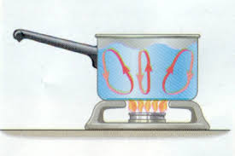](http://www.google.com/imgres?q=convection&hl=en&safe=active&sa=X&biw=792&bih=571&tbm=isch&tbnid=PHpWzJiZ2SEqDM:&imgrefurl=http://canyonridgeplatetectonics.weebly.com/convection.html&docid=_kdBBxdbYZLIiM&imgurl=http://canyonridgeplatetectonics.weebly.com/uploads/2/0/8/4/2084981/3254013.bmp&w=450&h=300&ei=EGhkUaWsJ4LQygGUsIDoCg&zoom=1&iact=hc&vpx=407&vpy=188&dur=172&hovh=183&hovw=275&tx=164&ty=96&page=1&tbnh=137&tbnw=221&start=0&ndsp=12&ved=1t:429,r:10,s:0,i:114)Which of the following is NOT true related to heat transfer?

a. Conduction is transfer of heat by direct touch.

b. Convection is movement produced based on a difference in density.

c. Radiation allows energy from the sun to travel to earth through empty space.

d. Conduction is observed in a boiling pot of water.

An iron skillet has a mass of 400.0 grams. The specific heat of iron is 0.449 J/g• ⁰C. How much heat must be absorbed to raise the skillet’s temperature from 20⁰C to 95 ⁰C?

[q = mc∆T PE = mgh *KE = 1/2 mv2]*

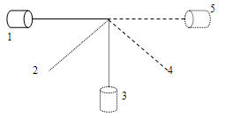

Describe the potential, kinetic energy at all positions.

19. Which is the MOST likely sequence of energy transformation realized when the light bulbs are lit?

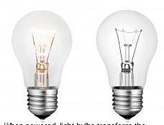

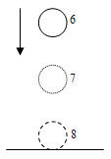

If the ball were held at rest in position “6” and let go, compare the work done by the ball dropping to position 8 versus the work done when rebounding upwards towards position 6. Assume "real life" conditions.

a. The work done dropping to position 8 is greater.

b. The work done rebounding to position 6 is greater.

c. The work done in both cases is approximately the same.

d. There is not enough information to compare the work done.

A 2 kg mass has 40 joules of potential energy with respect to the ground. It is dropped from a height and is travelling 6.3 m/s when it hits the ground. Approximately how far is it located above the ground?

[q = mc∆T PE = mgh *KE = 1/2 mv2]*

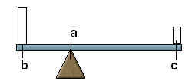

Define the fulcrum, resistance and effort.

The efficiency of a simple machine is ___

A student lifts a 300 N box using a pulley. She pulls the pulley rope 6 meters, exerting 100 N of force, to lift the box 2 meters. Which is the MA?

Understand equation for energy, work, and power.

Know the six simple machines and what they mean.

Understand output/input, resistance/effort, applied force/load.

A person pushes a 50 N box 20 m up a 4 m incline.

4 m

20 m

What is the work done and power exerted?

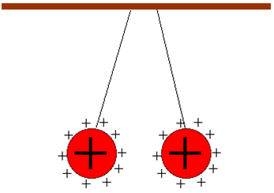

What influence will these two charges have on one another?

Define magnetism and compare with static electricity.

A person scuffs his feet on a carpet and while reaching for a door (knob), gets shocked without touching the door. This is most likely ___

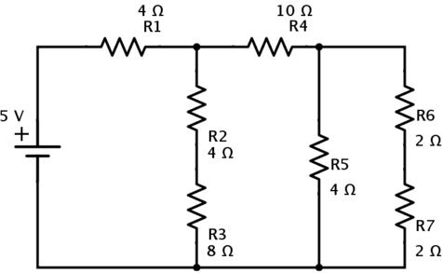

What type of circuit is shown by the image?

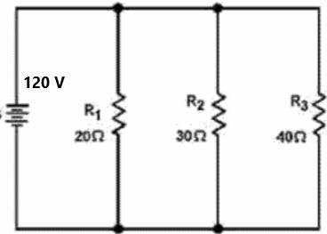

The current flowing through resistor R1 would be closest to (hint: V = IR)

Define major DIFFERENCES between magnetism and electricity is

Which of the following statements is TRUE?

a. Radio waves (electromagnetic radiation) can travel through space (vacuum) but sound waves cannot.

b. Sound waves travel through space (vacuum), although slowly, so there is a time lapse.

c. Sound waves and radio waves (electromagnetic radiation) are the same thing.

d. Sound waves and radio waves (electromagnetic radiation) are both transverse waves.

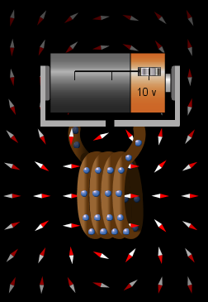

Based on the Electromagnetism Lab, if the lever on the battery was shifted to the left, what would happen?

a. The electric current and the tiny magnets speed up.

b. The electric current and the tiny magnets are not affected.

c. The circuit would shut down.

d. The electric current and the tiny magnets REVERSE direction.

Which statement is NOT true?

a. Sound waves changing pitch (frequency) while moving towards or away from the listener. This is an example of the Doppler Effect.

b. Sound waves travel faster through warm air and therefore, can be heard at greater distances. This is an example of refraction.

c. Animals use sonar or echo location to find their prey. This is an example of Reflection.

d. Sound waves interfere constructively or destructively. “Beats” in music. This is an example of diffraction.

e. All the choices are true.

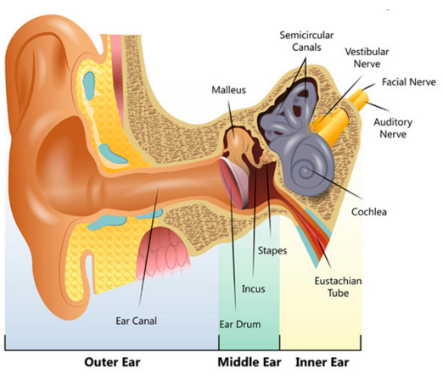

Understand the anatomy and function of each:

a. cochlea

b. hammer, anvil, and stirrup

c. tympanic membrane

d. semicircular canals

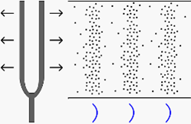

Recognize the parts of this wave. What type of wave is it?

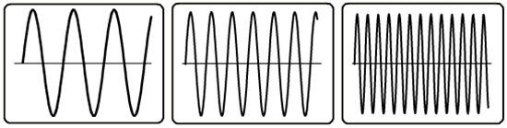

Distinguish wavelength, amplitude, and frequency and how they compare to one another.

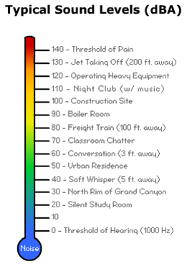

Students are chattering in a classroom. Outside the classroom is an active construction site. How much louder is the construction site than the classroom?

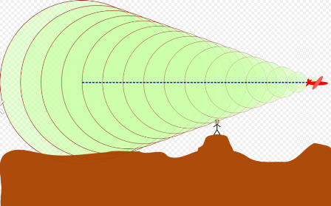

What wave behavior is shown by the image as the jet exceeds Mach 1?

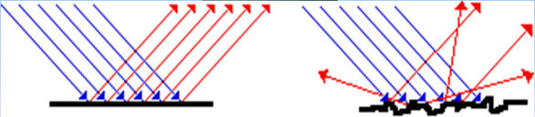

Distinguish between specular reflection and diffuse reflection and the type of image produced by each.

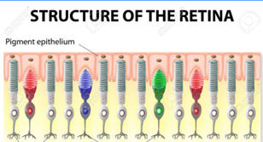

Understand the anatomy of the retina in the human eye. What cells are present and what is their function.

All of the following devices exhibit the same property of light EXCEPT a

a. digital clock.

b. digital scoreboard.

c. photocell.

d. 3D movie projection.

Question 46 refers to the following image

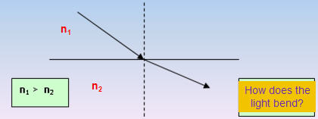

According to the image, light

a. refracts toward the normal.

b. refracts away from the normal.

c. reflects away from the normal.

d. reflects toward the normal.

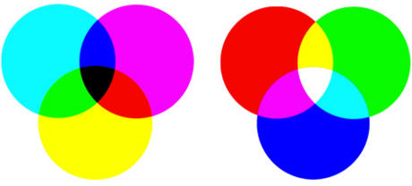

Based on light, which statement is true?

a. Green is made up of yellow and red.

b. Black contains all colors.

c. Yellow is a primary additive.

d. White contains all colors.

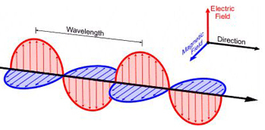

Which of the following is shown by the image?

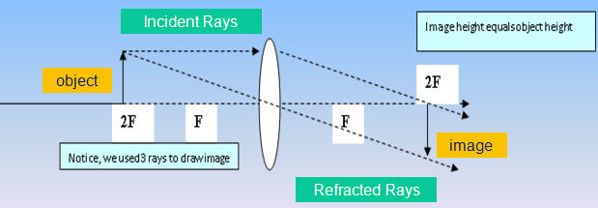

The lens in the image produces what kind of image?

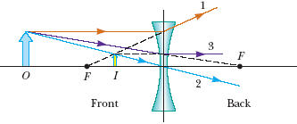

The lens in the image NEVER produces what kind of image?