Darwin's Theory

Darwin's theory of evolution has four main parts:

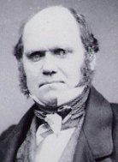

1. Organisms have changed over time, and the ones living today are different from those that lived in the past. Furthermore, many organisms that once lived are now extinct. The world is not constant, but changing.

* Speciation 🡪 The development of new species occurs as variations or adaptations accumulate in a population over many generations [*macroevolution*]

1. All organisms are derived from common ancestors by a process of branching.

* Populations are related because they are descended from a common ancestor. Over time, populations split into different species

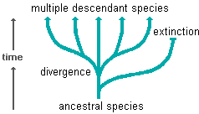

* Thus, if one goes far enough back in time, any pair of organisms has a common ancestor.
* This explained the similarities of organisms that were classified together -- they were similar because of shared traits inherited from their common ancestor.
* It also explained why similar species tended to occur in the same geographic region.

1. Change is gradual and slow, taking place over a long time.

* This was supported by the fossil and was consistent with the fact that no naturalist had observed the sudden appearance of a new species.
* Punctuated Equilibrium.

a) Darwin’s gradualism theory is now contested by many scientists (e.g. Stephen Gould)

b) Punctuated equilibrium uses a view of episodes of rapid change and long periods of no change as its base.

c) According to this understanding, the fossil record does not provide real “intermediates” between species.

1. The mechanism of evolutionary change was natural selection.

* The fundamental goal of all species is to reproduce and survive, passing on the genetic information of the species from generation to generation.

A. OVERPOPULATION

* Organisms produce more offspring than the environment can support … so that some will survive (e.g. a maple tree will put out thousands of seeds per year … maybe 1-2 trees will result)
* If all the offspring that organisms can produce were to survive and reproduce, they would soon overrun the earth.

# B. COMPETITION & ADAPTATION

1. This unbounded population growth resembles a simple geometric series (2 🡪 4 🡪 8 🡪 16 🡪 32 🡪 64 ... ) and quickly reaches infinity.
2. As a consequence, there is a "struggle" (metaphorically) to survive and reproduce, in which only a few individuals succeed in leaving progeny (offspring).
3. The lack of resources to nourish these individuals places pressure on the size of the species, and the lack of resources means increased competition and as a consequence, some organisms will not survive.
4. Darwin found that those organisms more suited to their environment were more likely to survive.
5. This 'weeding out' of less suited organisms and the reward of survival to those better suited *led Darwin to deduce that organisms had evolved over time*
6. survival of the fittest

* the organisms most suited to their environment had more chance of survival if the species falls upon hard times.
* the most desirable characteristics of a species are favored and those organisms who exhibit them survive to pass their genes on.

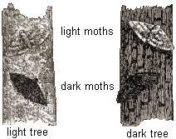

* The well-known example of camouflage coloration in an insect makes for a very powerful, logical argument for adaptation by natural selection.

C. VARIATION

1. Organisms show variation in characters that influence their success in this struggle for existence.
2. Individuals within a population vary from one another in many traits. (recognize every individual by its size, coloration, and distinctive markings)
3. Those organisms who are better suited to their environment exhibit desirable characteristics, which is a consequence of their genome being more suitable to begin with.
4. A changing environment would mean different characteristics would be favorable in a changing environment.
5. Darwin believed that organisms had 'evolved' to suit their environments, and occupy an ecological niche where they would be best suited to their environment and therefore have the best chance of survival.

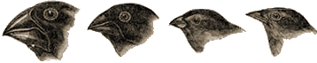

1. The Galápagos finches provide an excellent example of this process.

* Among the birds that ended up in arid environments, the ones with beaks better suited for eating cactus got more food. As a result, they were in better condition to mate.
* Similarly, those with beak shapes that were better suited to getting nectar from flowers or eating hard seeds in other environments were at an advantage there.
* In a very real sense, nature selected the best adapted varieties to survive and to reproduce.

D. REPRODUCTION & HEREDITY

1. The goal of all species is to survive and reproduce to keep their species going.
2. Darwin came to understand that any population consists of individuals that are all slightly different from one another. Those individuals having a variation that gives them an advantage in staying alive long enough to successfully reproduce are the ones that pass on their traits more frequently to the next generation.
3. Offspring tend to resemble parents, including characteristics that influence success in the struggle to survive and reproduce.
4. To the extent that offspring resemble their parents, the population in the next generation will consist of a higher proportion of individuals that possess whatever adaptation enabled their parents to survive and reproduce.

Natural Selection Example

Natural selection is one of the basic mechanisms of evolution, along with mutation, migration, and genetic drift.

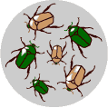

**1. There is variation in traits.**

* For example, some beetles are green and some are brown.

**2. There is differential reproduction.**

* Since the environment can't support unlimited population growth, not all individuals get to reproduce to their full potential.

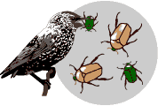

* In this example, green beetles tend to get eaten by birds and survive to reproduce less often than brown beetles do.

**3. There is heredity.**

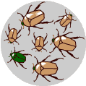

* The surviving brown beetles have brown baby beetles because this trait has a genetic basis.
* This is a form of “competition” related to the “survival of the fittest” since the green beetles were more easily eaten and did not survive.

**4. End result:**

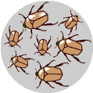

* The more advantageous trait, brown coloration, which allows the beetle to have more offspring, becomes more common in the population.
* If this process continues, eventually, all individuals in the population will be brown.

“What Darwin Never Knew”

video

1. Fossil Record

a. Some people deny the existence of fossils … not good science

b. We have listed 6 types of fossils: amber, cast, mold, petrified, trace, imprint.

c. Fossils can be dated using various techniques that are SPECIFIC to each type of fossil

1) Carbon dating only dates “organic” materials reliably up to 10,000 years

2) Lead Xenon (Pb-Xe) and Potassium-Argon (K-Ar) are used to date various rocks and minerals

3) Radioactive isotopes break down over time (half-life) … scientists compare the amount of a mineral or material remains and comes up with an “age”

2. Comparative Anatomy

a. Observing the body parts and organs of various organisms

b. HOMOLOGOUS structures 🡪 structures that look similar and have similar function

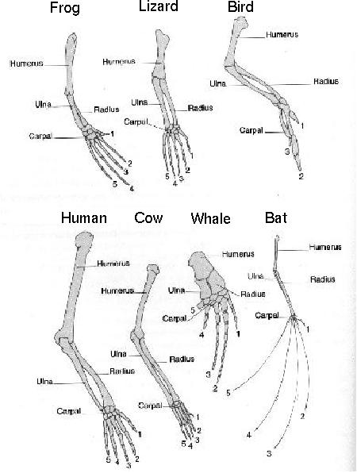

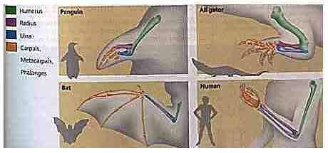

3. Comparative Cytology

a. Observing the cells and organelles of various organisms

b. All living things are made up of cells. Many of the cell structures are the same with the same function.

* Nucleus 🡪 cellular control, genetic code
* Cytoplasm
* endoplasmic reticulum 🡪 circulation and transport
* cell membrane 🡪 boundary of the cytoplasm; protection; “import”/”export”
* lysosomes 🡪 digestion
* ribosomes 🡪 protein synthesis
* golgi apparatus 🡪 “packaging centers”
* etc.

c. Cells can be Prokaryotic (no nucleus, unicellular) or Eukaryotic … yet there are many similar structures in each

* all living things are either unicellular or multi-cellular

d. Tissues of various organisms possess the same type of cells (e.g. *muscle (striated or smooth*), skin (*epidermis, endodermis*), digestive, cardiac, nervous (*dendrites, axons, synapses*), organs (*cells for* *liver, gall bladder, gonads, kidneys*), etc.)

4. Comparative Biochemistry

a. Observing the compounds/molecules of various organisms

b. CHNOPS, proteins, carbohydrates, DNA, RNA, lipids.

1) 98% of the DNA in chimpanzees and humans is the same …

a) macro-evolution states common ancestry

b) the 2% difference is still huge considering the amount of amino acid sequences that are produced from the DNA genetic code in the body (e.g. 1 billion amino acids still allows for over 2 million differences!)

2) plasma membrane (phospholipid layers, semi-permeable)

3) universal genetic code (mRNA codon sequence for amino acids) … there are millions of combinations for the amino acids, yet most organisms fit into the same basic genetic code sequences

c. DNA studies show relationships among organisms.

5. Comparative Embryology

a. Observing the development and developmental processes of various organisms

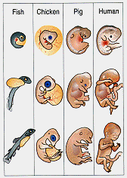

b. Embryos look similar among organisms.

c. Mammals seem to share the following:

1. fleshy, see-through skin

2. big head and large eyes

3. tail vertebrae

4. webbed hands and feet

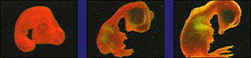

fish pig chick

EVIDENCE or PROOF?

1. Similarities among organisms cannot be ignored and should not be denied … they exist … so do fossils. We should not rationalize them away.

2. Advocates of an “Intelligent Design” or a “Supreme Creator” promote a common pattern by a single creator. This compares to “common ancestry” of the gradualism theory.

3. Micro-evolution (change over time … variation, mutation) exists. However, macro-evolution is just a theory and should be handled as such, not promoted as fact. As a theory, it has been and will continue to be modified (changed) over time.

a. There is a huge gap in gradualistic evidence due to the lack of “intermediates” … therefore, some evolutionists changed to Punctuated Equilibrium.

b. Darwin observed the beaks of finches on the Galapagos Islands. This, plus his theory of natural selection, caused him to extrapolate that all organisms came from a common ancestor over millions of years. Such an extrapolation is conjecture and not scientific.

c. Textbooks continue to print outdated research that is no longer valid (archeopteryx as the bird/reptile; Neanderthal man, Cro-Magnon man, Australopithecus as missing links of humankind; eohippus as a horse ancestor … all falsified by research)