**Trees 1**

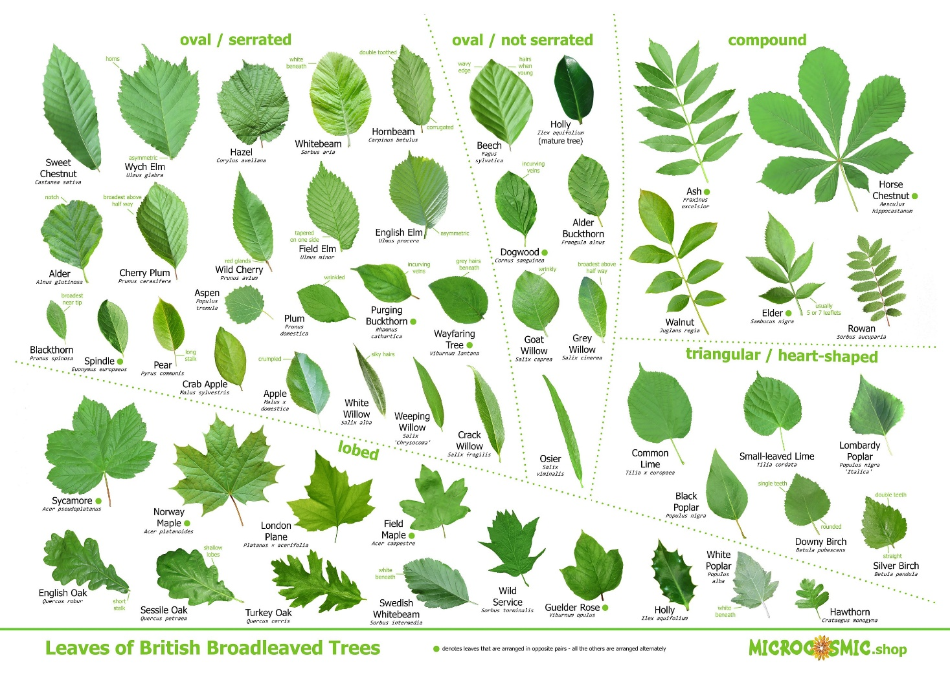

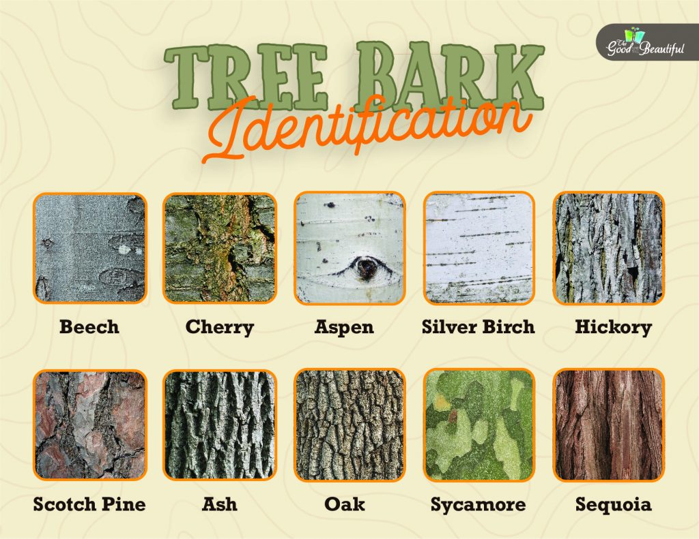

**See** [**https://www.learningctronline.com/courses**](https://www.learningctronline.com/courses) **for Materials and Resources.**

**Topics:**

1. Trees

**Objectives:**

* + Identify Trees Using Dichotomous Key
  + Continue Tree & Poisonous Plant Scrapbook Project

TAKE NOTE

1. Review Tree & Poison Plant Scrapbook [due in 3 weeks]
2. Activity Keying Out Trees & Poison Plants using PPT
3. In Class 🡪 Dichotomous Tree Key with PowerPoint (Evergreen, Armed, Opposites)
4. Outdoor Field Activity Trees – Identify and label
5. Week 5 Devotional (<https://www.learningctronline.com/devotional>)

**Text**: Peterson Field Guide to Trees & Dichotomous Key to Trees

**Reference Material: Dichotomous Tree Keey PowerPoint**

**Homework**:

* Work on Tree & Poisonous Plant Scrapbook (poison plants should be done)
* Become familiar with the Dichotomous Key to Trees.
* Field Guide Trees from Library

**Lab**: Key Out Trees & Poison Plants (worksheet with dichotomous key & Miscellaneous PPT)

* Use the PowerPoint “Miscellaneous Tree ID” and the worksheet provided.
* Save the document into your LAB folder in the Projects in Science folder on your desktop.

**Lab**: Outdoor Field Activity Trees – Identify and label

* Use the dichotomous key and / or phone app to identify 10 trees in your yard or nearby fields.
* Take a picture of the Tree and insert this into the Worksheet provided.
* Give the common name under the image of the tree.
* Save the document into your LAB folder in the Projects in Science folder on your desktop.

**TEST: none**

Supplemental Resources (Optional)

1. Websites Worksheet (Add new websites)
2. Field Guide to Trees