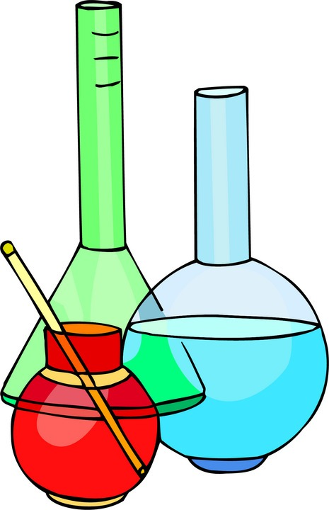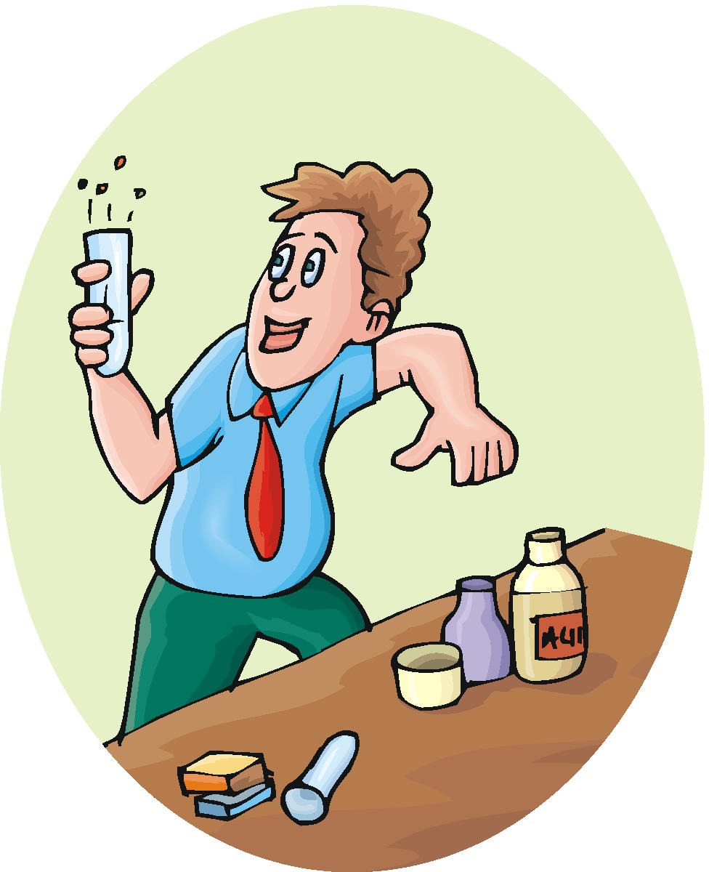

**Chapter 2:**

**The Chemistry of Biology**

**Life depends on Chemistry**. Living things are composed of chemical compounds. If order to understand biology, one must first understand the chemistry of life.

**I. Matter**

1. **Matter**: anything that _____ or has mas.
   1. Mass: quantity of _____ an object has.
   2. Matter can undergo both physical and chemical change
      1. Physical change: affects the _____, but the chemical make-up stays the same.
      2. Chemical Change: where the _____ is altered and a ____ substance is produced.
2. **Elements**:
   1. _____ that cannot be broken down chemically into simpler kinds of matter.
   2. Composed of only one type of _____.
   3. More than 100 elements (_____)

• **Essential elements** in living organisms include

a. **C:**

b. **H:**

c. **O:**

d. **N:**

A. **The Atom**

1. **Atoms** are the _____ that retains all the properties of that element.
   1. Smallest _____ of matter.
2. Properties of atoms:
   1. Determine the _____ and _____ of the matter they compose.

3. **Molecules** are groups of atoms _____ together.

4. **Subatomic Particles:** Atoms of each element are composed of even _____ called subatomic particles

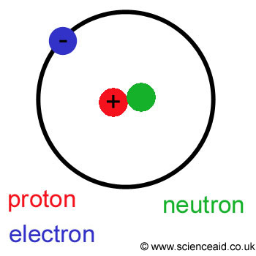a) **Neutrons**: have _____ electrical charge (located in the nucleus of the atom).

b) **Protons**: have a _____ (located in the nucleus of the atom)

c) **Electrons**: have a _____ (located around the nucleus in a “cloud”)

5. **Atomic number:** The _____ of an atom of a particular element.

6. **Atomic mass**: The number of _____ in an atom.

- The number of _____ is normally balanced by an equal number of negatively charged __________.

6. **Isotopes:**

1. Different forms of the same element
2. Have the _____ of protons, but _____ of neutrons.
3. May be _____ spontaneously giving off particles and energy.
4. May be used to _____ or as medical tracers.

**II. Chemical Bonds**

**A. COVALENT:**

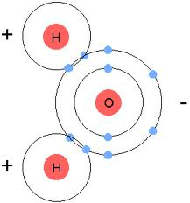1. A **Covalent Bond** is formed when two atoms _____ one or more pairs of _____.

2. _____ type of Chemical Bond.

3. Types:

a) _____

b) _____

4. **Nonpolar Covalent Bonds**

1. Sharing of _____ is _____.
2. The electrons are attracted to both atoms equally.

5. **Polar Covalent Bonds**

1. Sharing of _____ is _____.
2. The electrons are slightly more attracted to one atom of the bond than to the other.

b) Example:

1) _____ is a polar molecule.

2) _____ spend more time with _____ than with _____.

3) _____ become slightly **positive**, and _____ slightly **negative**.

**B. IONIC**

1.  **Ion:** an atom that has a _____ _____. Some atoms become stable by losing or gaining electrons

a) **Positive ions**: Atoms that _____

b) **Negative ions**: Atoms that _____

c) Because _____ and _____ electrical charges attract each other _____ bonds form.

d) Ionic bonds are _____ than covalent bonds.

2. **Example:**

* **Sodium** tends to _____ an electron and becomes a **Na+ ion**.
* **Chlorine** tends to _____ one electron and becomes a **Cl– ion**.
* These two ions are then attracted to one another because **they have** _____ **charges.**
* The compound **NaCl** (Sodium Chloride) is formed.

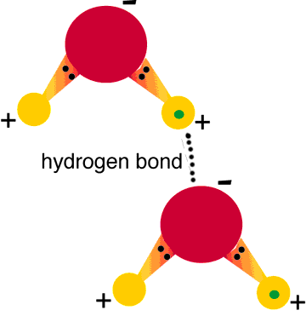

**III. Water – Can’t Have Life Without It!!**

**A. The Polarity of Water**

1) _____ is a polar molecule.

2) _____ spend more time with _____ than with _____.

3) _____ become slightly **positive**, and _____ slightly **negative**.

**B.** **Hydrogen Bonds**

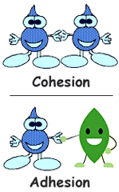1. The positive _________ _________ of water molecules are attracted to the negative _____ of other water molecules and form a _____. One hydrogen bond is weak, but many hydrogen bonds are strong.

2. Water molecules stick together because the _____ of the molecules attract one another.

3. This force of attraction forms _____.

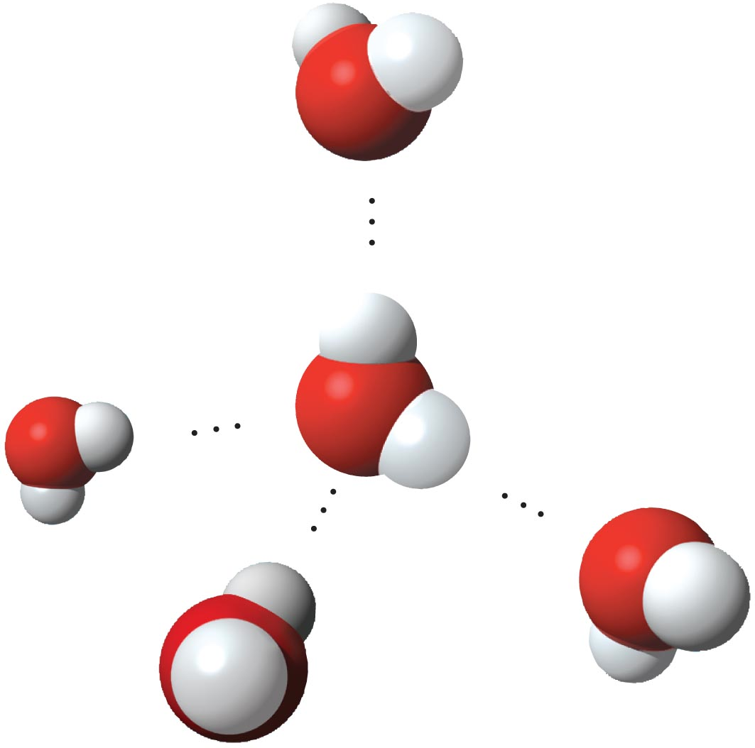4. In the picture to the right, the attraction between the _____ of one water molecule and the _____ of a different water molecule forms a _____.

5. A single water molecule can form up to _____ hydrogen bonds with other water molecules at the same time. **This is responsible or many of the unusual properties found in water.**

**C. Properties of Water:** _____ give water many unique properties, which makes it _____ to the functioning of all life forms.

**1)**

**2)**

**3)**

**4)**

**5)**

**1. Cohesion:** Attraction between water molecules

1. Results in _____, which is a measure of the strength of the water’s surface.
2. Produces a _____.

**2. Adhesion:** Attraction between water and _____.

* Water will make _____ with other surfaces such as glass, soil, plant tissue, and cotton.

**3. Temperature Moderation**

1. Heat 🡪 energy in transfer from a ______ to a ______ substance
2. Temperature measures the amount of heat energy — that is, the average _______ of molecules in a substance.
3. Heat must be _______ to break hydrogen bonds.
4. Heat is _______ when hydrogen bonds form.

**4. High Specific Heat**

a) Amount of _______ needed to raise or lower ______ of a substance _____.

b) Water has a _____ specific heat.

c) Metals generally have _____ specific heats.

d) When warming up, water absorbs large amounts of _____. When cooling, water _____ considerable amounts of heat.

e) Water resists _____ change both for heating and cooling.

f) Water’s resistance to temperature change also stabilizes _____ temperatures, creating a favorable environment for marine life.

**5. Water is less dense as a solid.**

a) Ice is less dense as a _____ than as a _____. (Ice floats)

b) This accounts for lakes and other bodies of water freezing on the top first (insulating the water and organisms below from harsh temperature changes).

**6. Water is the Universal Solvent**

**a) Solution:** is a homogeneous _____ combination of atoms in a liquid, solid, or gas.

**b) Solute:** is the substance _____ in the solution (lower quantity)

1. **Solvent:** is the substance in which the _____ (higher quantity)
2. **All metabolic processes of life occur in solution environments.**

**D. Acids, Bases, and pH**

**1.** **The pH scale**

a) The pH scale is a measurement system used to indicate the concentration of _____ ions in a solution.

b) The pH scales ranges from _____.

c) A pH of 7 is a _____ solution. This is neither acidic nor basic. Pure water has a pH of 7.

d) Solutions with a **pH below 7** are considered _____.

e) Solutions with a **pH above 7** are considered _____.

**2. Acids**

a) **Acid:** Any compound that forms _____ in a solution.

b) **Acidic solutions:** Have a greater H+ ion concentration than _____.

c) Acids have a pH _____.

d) **Examples** include: lemon juice, tomato juice, carbonated drinks, vinegar

**3. Bases**

a) **Base:** Any compound that _____ in a solution.

b) **Basic solutions:** Have a _____ concentration than pure water.

c) Bases have a pH _____.

d) **Examples** include: ammonia, soaps, bleach, sodium bicarbonate

**4. Buffers**

a) Buffers are substances produced by cells that prevent sharp, _____.

b) Example of where Buffers work:

1) The pH of most human cells should generally be between _____.

2) If the pH gets too high or too low, it affects the _____ that take place within cells.

3) Cells must be able to _____ their pH.

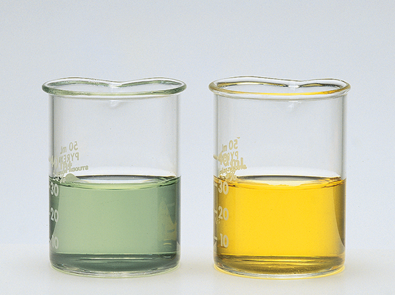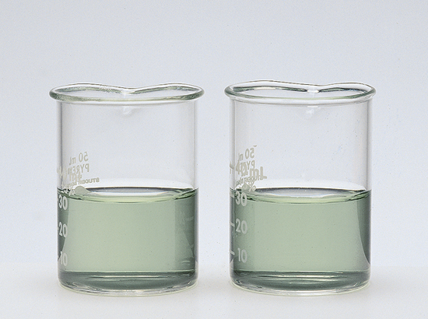

buffered

unbuffered

buffered

unbuffered

The color change in the unbuffered solution indicates a change in pH from 8 to about ___. Which is _________.

PRIOR to adding acid, the indicator shows that both solutions are _____ (pH of about 8).

The indicator shows no visible ____ change in the buffered solution.

c) Buffers cause _____ reactions that will not have much effect on the overall pH of the buffer solution.

* When hydrogen ions are added to a buffer, they will be neutralized by the _____ in the buffer.
* Hydroxide ions will be neutralized by the _____.