# Worksheet 1: Solubility Graphs

1. Which of the salts shown on the graph is the least soluble in water at 10ºC?

2. Which of the salts shown on the graph has the greatest increase in solubility as the temperature increases from 30º to 60º C?

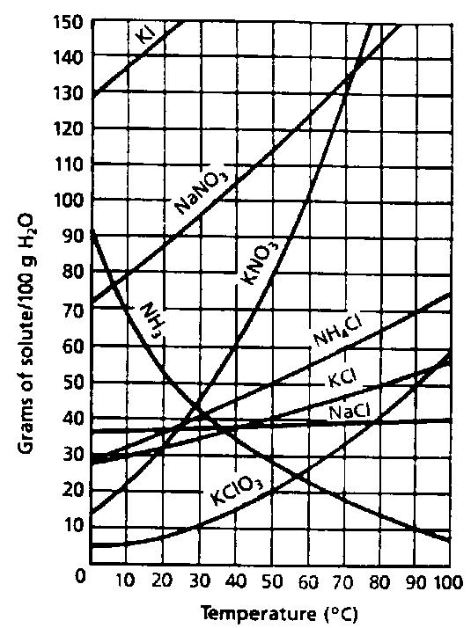

3. Which of the salts has its solubility affected the least by a change in temperature?

4. At what temperature do saturated solutions of potassium nitrate and sodium nitrate contain the same weight of solute per 100 ml H2O?

5. What two salts have the same degree of solubility at approximately 19º C?

6. How many grams of potassium chlorate must be added to1 liter of water to produce a saturated solution at 50º C?

7. A saturated solution of potassium nitrate is prepared at 60º C using 100 ml water. How many grams of KNO3 can be precipitated if the solution is suddenly cooled to 30º C?

8. What is the average rate of increase in solubility in grams per 100 ml of water per centigrade degree for potassium nitrate in the temperature range 60º C to 70º C?

9. If 50 ml H2O is saturated with KClO3 at 25º C and is slowly evaporated to dryness, how many grams of the dry salt would be recovered?



10. 30 grams of KCl are dissolved in 100 ml H2O at 10º C. How many additional grams of KCl are needed to make the solution saturated at 80º C?

11. What is the smallest volume of water (in ml) required to completely dissolve 40 g of KClO3 at 20º C?

12. What is the lowest temperature at which 50 g of NH4Cl can be dissolved in 100 ml water?

13. Are the following solutions saturated, unsaturated, or supersaturated (*assume that all 3 could form supersaturated solutions*)

a) 40 g KCl in 100 ml H2O at 80º C

b) 120 g KNO3 in 100 ml H2O at 60º C

c) 80 g NaNO3 in 100 ml H2O at 10º C

14. What does the saturation line for NH3 go in the opposite direction of all the other substances?

Answer Key

1. KClO3 … only ~6 g will dissolve at that temperature

2. KNO3 … increases from ~46 g to ~102 g /100 ml of water

3. NaCl … increases from ~36 g to ~41 g /100 ml of water from 0º C to 100º C

4. ~72º C … notice where the two lines intersect on the graph

5. KCl & KNO3 or

NH4Cl & NaCl … notice where the two lines intersect on the graph at 19º C

6. 210 g … KClO3 dissolves ~21 g/100 ml of H2O at 50º C … multiply by 10 to get a LITER of H2O

7. ~56 g … subtract ~102 g - ~46 g = 56 g/100 ml H2O

8. 2.8 g / 1 ºC … ~102 g to ~130 g/100 ml H2O / 10º C

9. 5 g … the graph shows solubility in 100 ml H2O … but the question asks for 50 ml H2O (half the amount)

10. 20 g … the solubilities are ~30 g at 10º C and ~50 g at 80º C

11. 500 ml … ~8 g KClO3 dissolve in 100 ml H2O … 40 / 8 = 5 times the amount of water

12. 50º C … notice where the saturation line dissolves 50 g on the graph

13. a. unsaturated … below the saturation line

b. supersaturated … above the saturation line

c. saturated … on the saturation line

14. NH3 (ammonia) is NOT a solid but a gas, so its solubility is inversely proportional to the temperature of the solvent.