**Student Projects**

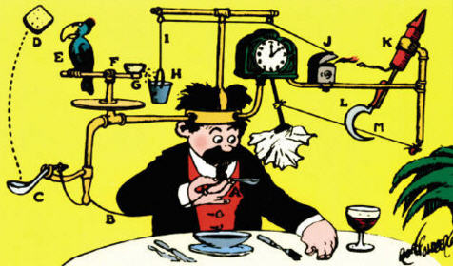

**See** [**https://www.learningctronline.com/courses**](https://www.learningctronline.com/courses) **for Materials and Resources.**

**Topics:**

1. Student Projects

**Objectives:**

* Participate in a project-based, independent study, learning unit as a review of one major concept from the year. The essential point is to learn something new.
* Use class notes, labs, homework, textbook, internet, and other resources to research ideas to create a lab experience based on Motion, Newton’s Laws, Momentum, Work, Power, Simple Machines, Efficiency, Heat Transfer, Electricity, Magnetism, Sound, or Light.
* Create a project that performs a task, solves a problem or assesses a Physics topic with TWO kinds of measurements and calculations.
* Submit a lab report of the project that includes all elements of a formal lab report as well as two calculations of physics principles related to the topic chosen.

TAKE NOTE

1. Project Ideas Rubric … the due date is 11 days after today’s class.
2. Test Corrections (Light and Optics)
3. Lab Revisions (Reflection and Refraction)
4. Final Project Ideas
5. Final Project Report Template
6. Study for Semester Exam by reviewing test corrections … due date is two weeks.
7. Week 31 Devotional (<https://www.learningctronline.com/devotional>)

**Text**: Hewitt

**Class Notes: Based on topic of project**

**Homework**:

* Work on Project … *plan to spend 8 – 10 hours minimum for the project*.
* Test Corrections (Light and Optics)
* Lab Revisions (Reflection and Refraction)

**Lab**: Final Project Report (use template worksheet)

* The final project report is written as a **lab report**, containing all formal lab report formatting and requirements.
* The project lab report is NOT the project itself, which is to perform a task, solve a problem or assess a Physics topic with TWO kinds of measurements and calculations.

**TEST:** Project Presentation (bonus) or submit project.

* **Project & Project Lab Report Due: 11 days from today’s class.**
* **Semester Exam due two weeks from today.**

Supplemental Resources (Optional)

1. Watch “Student Showcase” videos on Learning CTR Online.
   1. How Far We’ll Go – A Tribute to Mr. Riesen
   2. Rube Goldberg Machine
   3. Volleyball

<http://somup.com/c3602PvZGR> Household Items Machines Project (2:52)

<https://screencast-o-matic.com/watch/c0hbqRVATJO> The Physics of Tennis (Newton’s Laws of Motion) [2:13]

<http://somup.com/cFh3oGVHqy> Simple Machines Water Wheel & Such with permission from CG (1:28)

<http://somup.com/cFXD2ynjFm> Revenge of the Trebuchet RM Simple Machines (2:24)

<http://somup.com/cFXD2anjFH> Rube Goldberg Apparatus BF Simple Machines (2:02)

<https://screencast-o-matic.com/watch/cFhibFbOgb> Electric Circuits LR Electricity (3:09)

<http://somup.com/cFhjrZVGCT> Newton's Laws in Volleyball JS Newton's Laws (1:49)

<http://somup.com/cFXD2BnjFd> Rube Goldberg Apparatus - The Pressure Cooker AS Simple Machines (2:48)

<http://somup.com/cFXD2CnjF7> Clock Killer LB Simple Machines (3:15)

<http://somup.com/cFh2qrVmrp> Simple Machines AH (1:25)

<http://somup.com/cFXD2JnjFP> The Dog Ate My Homework - Simple Machines HH (1:21)

<http://somup.com/cFXD2KnjFR> Wonderful, Wonderful Grace BR Song Sound (3:17)

[**http://somup.com/cqeZVmnO1s**](http://somup.com/cqeZVmnO1s) **Parable of the Sower (3:04)**