**Test Correction Rationale**:

Test Corrections are part of the Physical Science curriculum and represent an important part of your learning in three major ways:

1) **Relearning**: concepts can be better understood after being assessed,

2) **Reflection**: you have the opportunity to adjust your thinking so it better aligns with scientific evidence; and

3) **Mastery** of concepts.

Test corrections apply to both the multiple choice and problem sections of your Chapter tests and may increase your test scores. *You could be given up to 1/3 of your points back IF you follow the directives given on this document*:

4) All students should correct their graded tests for relearning, reflection, and mastery.

5) Take the Chapter test (both multiple choice and problems). **Make sure a guardian is proctoring as directed on Learning CTR Online**.

6) Email the test to [learningctronline@gmail.com](mailto:learningctronline@gmail.com). The teacher will grade your test and return it to you via email after the due date has passed.

**Multiple Choice Corrections**

1) Start with the first question you answered **incorrectly** as indicated on the answer sheet.

2) Go to the original question (with choices) section and do the correction below the appropriate question.

3) **HIGHLIGHT** the entire correct answer response (NOT just the letter choice). Below that question:

(a) **Give an explanation** for why that answer is correct. You may use any feedback provided BUT YOU MUST TYPE IT IN YOUR OWN WORDS ... DO NOT COPY AND PASTE the feedback.

(b) DO NOT discuss incorrect responses. The point is to reinforce the correct concepts and realign one’s thinking.

(c) You must **explain your error** or why you answered incorrectly.

4) Repeat for all the questions you answered incorrectly.

**Problem Section Corrections**

1. Leave your original answers on the problem section. Insert your corrections below your original answer and teacher comments **IN A DIFFERENT COLOR FONT** (e.g. Blue, green), but **NOT RED**.
2. The teacher has supplied feedback with a scoring rubric for each question answered incorrectly or incompletely.

3) Use the feedback provided as a guideline and RETYPE (in your own typing and wording) the correct answers with explanation or feedback following your incorrect answer and the teacher comments.

a) **DO NOT copy and paste** the teacher-provided feedback nor just highlight it in a different color. You must retype.

b) You must **explain your error** or why you answered incorrectly.

4) Repeat for all the questions you answered incorrectly.

**Multiple Choice Correction SAMPLE:**

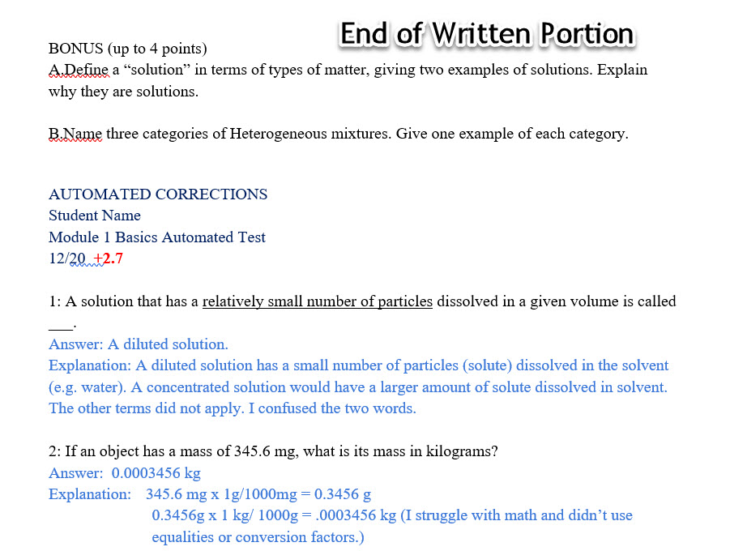

**Problem Section Correction SAMPLE:**

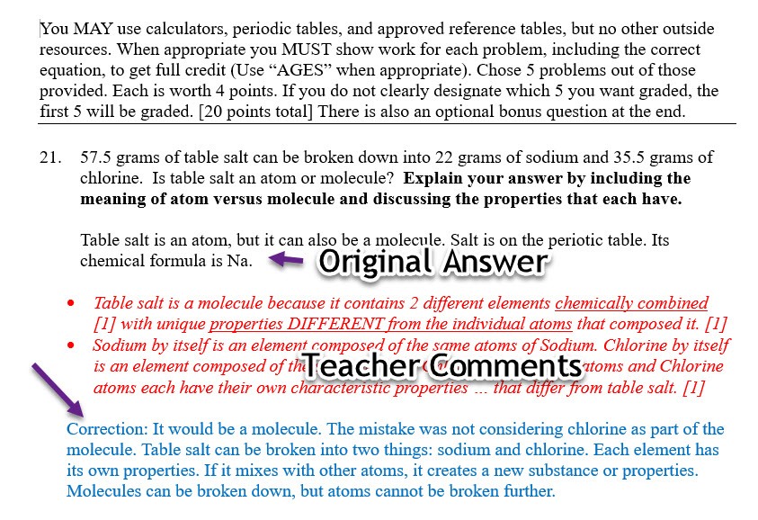

4) **Students who created a PDF for their test must be include corrections as directed.**

5) Email your test with the test corrections to [learningctronline@gmail.com](mailto:learningctronline@gmail.com).

6) Test corrections should be completed prior to the next Chapter test.

7) Tests taken after the due date or due to an approved extension will be given bonus points at the teacher’s discretion.