Genetic Variations

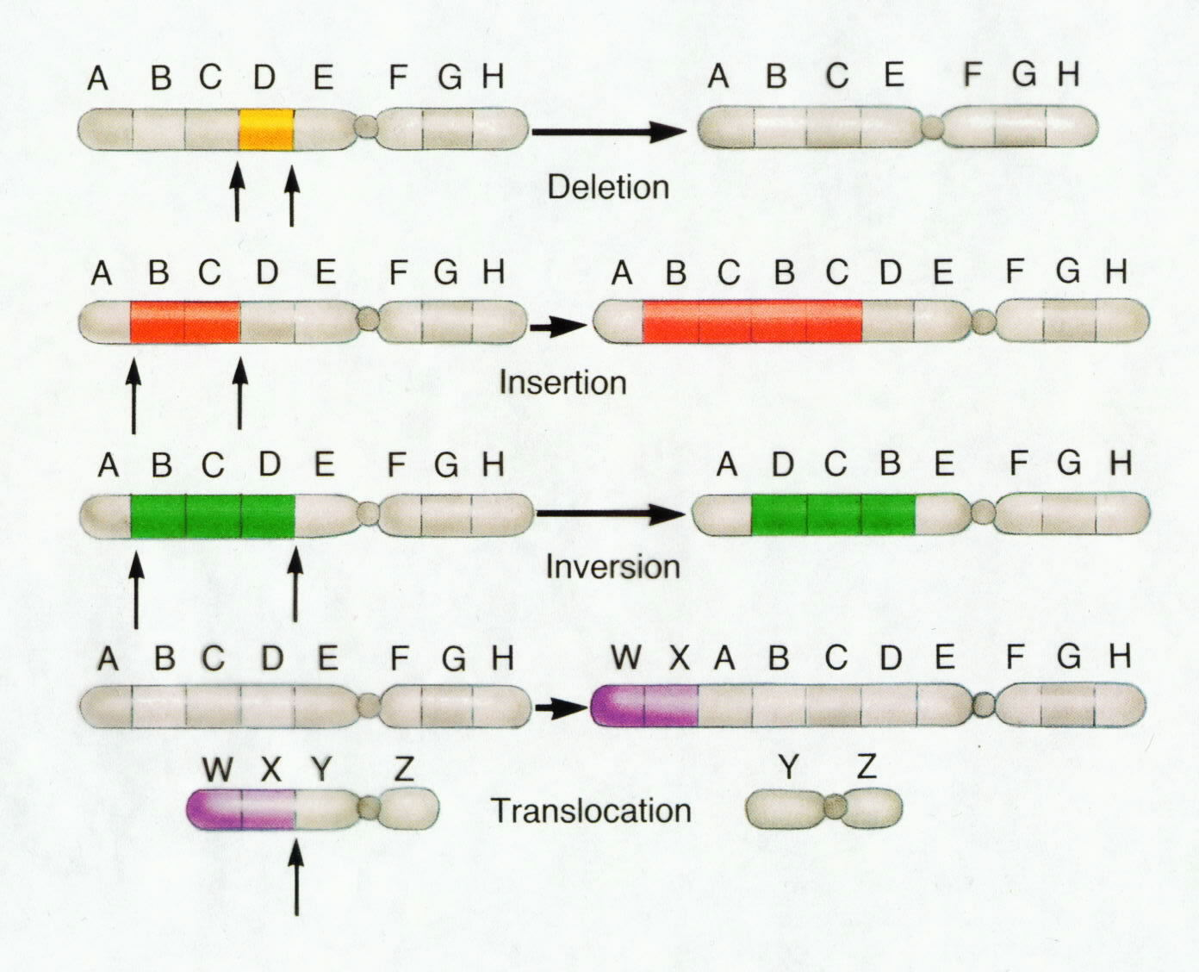

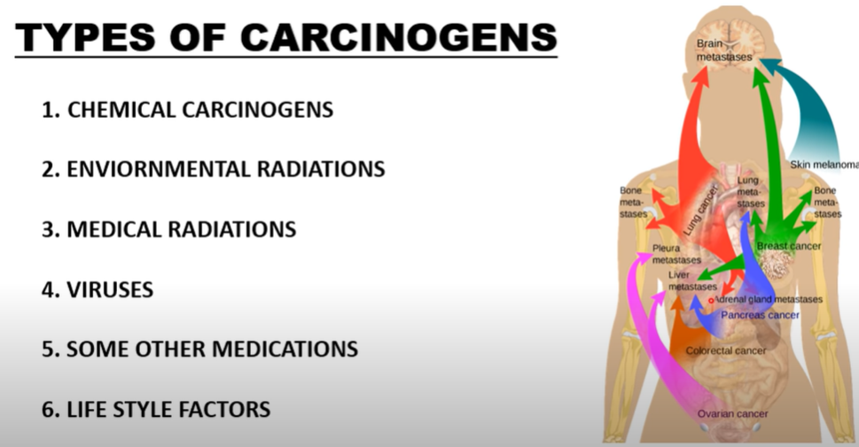

**See** [**https://www.learningctronline.com/courses**](https://www.learningctronline.com/courses) **for Materials and Resources.**

**Topics:**

1. Genetic Variations

**Objectives:**

1. Explain how traits are expressed and understand conditions that lead to mutations.
2. Define mutation and distinguish non-genetic mutations from gene mutations.
3. Define and identify mutations that involve chromosome number and structure.
4. Describe mutations in somatic cells versus sex cells.
5. Understand how genetics is used to produce desired traits in an organism (selective breeding; applied genetics).

TAKE NOTE

1. Notes/Study Guide (1 week)
2. Homework from Text (1 week)
3. Lab Bug Karyotype LAB REPORT (due in 9 days)
4. Human Traits Activity
5. Worksheet on Mutation
6. HONORS 🡪 Genetic Disorders Project (due next week)
7. HONORS 🡪 Personalized Study Guide (2 weeks)
8. Chapter 14 – 15 Test … Human Genetics & Genetic Variations
9. Week 18 Devotional (<https://www.learningctronline.com/devotional>)

**Text**: Chapter 14: Genetic Variations pp. 244 – 259

Read the assigned pages in the text.

**Class Notes: PowerPoint or PDF**

**Notes/Study Guide:** Fill in the Chapter 14 Study Guide worksheet to understand the class notes.

**Homework**: (1 week)

* Study Questions (end of the chapter in the text) #1-3, 5-11 (explain true/false), 14-16
* Use a Word document format as follows:
  + Start on a new page of your document
  + Heading: Your name, Chapter in Text, Study Questions
  + Number the appropriate questions you are to answer
  + Write the answer in a complete sentence use the question as the template (do not copy the question, but reword it into a statement that answers the question).
* Use the same document each week by starting a new “Study Question” for a different chapter on the next page.
* Assignments will be “spot checked” during class or submitted via email.

**Lab**: Bug Karyotype

* Complete the "Bug Karyotype Lab" using the lab worksheet provided. This is a LAB REPORT (due in 9 days).
* After completing the Lab Report, email it to [learningctronline@gmail.com](mailto:learningctronline@gmail.com) for grading.
* Save document into your LAB folder in the Biology folder on your desktop.

**Lab**: Human Traits Activity

* Complete the "Human Traits Activity" using the lab worksheet provided.
* After completing the Lab worksheet, email it to [learningctronline@gmail.com](mailto:learningctronline@gmail.com) for grading.
* Save document into your LAB folder in the Biology folder on your desktop.

**TEST:** Human Genetics & Genetic Variations

1) the academic integrity policy

* Tests must be completed **WITHOUT** referring to books, notes, the internet, people, or any outside resources.
* A guardian should be proctoring the test as per Learning CTR Online policy: <https://www.learningctronline.com/test-proctor-policy>

2) This test is composed of 27 multiple choice and 4 essay questions.

* The **test must be taken "in one sitting"**, meaning that once you start the test, you must complete it without interruption.
* Take a short break (5 minutes) during the test.

3) There is a **60-minute time limit** on this test. Please have the proctor write the time taken at the top of your answer sheet with their signature or initials.

4) Honors students have an additional 15 minutes to answer the additional questions.

5) Proctors should NOT be reading the test or engaging students during the test.

5) Do NOT use RED font. Black font is best.

Supplemental Resources (Optional)

1. Genetic Variations Vocabulary Crossword

<https://somup.com/c310FDtM3u> (6:12) **Cancer**

<https://youtu.be/vl6Vlf2thvI> (7:13) The Amoeba Sisters Channel – **Mutations**