*Work W = fnet x d Power P = W / t PE (mgh)*

*Mechanical Advantage MA = effort distance /resistance distance*

*MA = resistance force / effort force Efficiency = Wout / Win*

1. How much work (energy) is needed to lift an object that weighs 200 N to a height of 4 m?

2. What is the power output of an engine that does 60,000 J of work in 10 s?

3. How much power is needed to lift the 200 N object to a height of 4 m in 4 s?



4. A pile driver is used to drive stakes into the ground. While building a fence, Adam drops a 3000 N pile driver through a vertical distance of 0.8 m. How much work can the pile driver potentially do?

5. At target practice, Diana holds her bow and pulls the arrow back a distance of 0.30 m by exerting an average force of 40.0 N. Prior to letting go the potential energy stored in the bow the moment before the arrow is released equals the work it can do. Calculate this work.

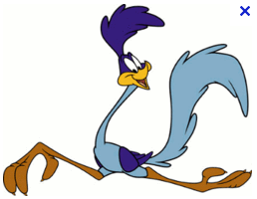

6. The coyote wants to push a 10,000 N rock off the edge of a cliff so that it falls on top of the roadrunner on the road below. If the coyote does 1,000 j of work, how far did he have to push the rock?



7. A nutcracker 16 cm long is used to crack open a Brazil nut that is placed 12 cm from where your hand is squeezing the nutcracker. What is the mechanical advantage of the nutcracker? (Hint: the length of the nutcracker relates to effort.)

8. Two clowns, of mass 50.0 kg and 70.0 kg respectively, are in a circus act performing a stunt with a trampoline and a seesaw. The smaller clown stands on the lower end of the seesaw while the larger clown jumps from the trampoline onto the raised side of the seesaw, propelling his friend into the air.

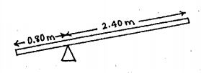

What is the mechanical advantage of the seesaw?

9. A crate of bananas is shipped from South America to New York, where it is unloaded by a dock worker who lifts the crate 2 m by pulling with a force of 200 N on the rope of a pulley system. He does 6,000 J of work. How much do the bananas weigh (force)?



b. What is the mechanical advantage of the pulley system?

c. Compare the distance the worker has to pull on the ropes to move the bananas.

10. A person pushes a 50 N box 20 m up a 4 m incline. How much work is accomplished by the person (ignore friction)?

4 m

20 m

b. What is the mechanical advantage of the inclined plane?

c. If it takes the person 40 seconds to push the box the entire distance of the inclined plane, how much power is exhibited?

11. The Ramseys are moving to a new town, so they have called in the ACME moving company to take care of their furniture. Debbie, one of the movers, exerts 500 N to slide the Ramsey’s 2200 N China Cabinet up a 6.0 m long ramp to the moving van, which stands 1.0 m off the ground. What it the ideal mechanical advantage of the incline?

What is the efficiency of the ramp?

12. Elben lifts an engine out of this Volkswagen with the help of a winch that allows him to raise the engine 0.20 m for every 10 m he pulls on the cable. Elben puts in 500 joules of work to lift the 800 N engine 0.50 m.

a. How much work is necessary to lift the engine?

a. What is the efficiency of the winch?

b. What is the mechanical advantage of the winch based on the distances?

13. The block of ice weighs 500 Newtons.

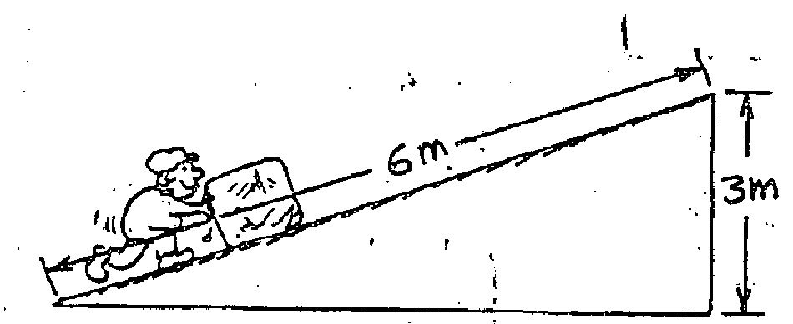

a. What is the mechanical advantage of the incline?

b. How much force is needed to push it up the incline? (neglect friction)

In problems 14-16, the Woman supports a 100 N load with the friction-free pulley systems shown below. Find the spring-scale readings that show how much force she must exert.

14. *___________* 15. *___________* 16. *___________*

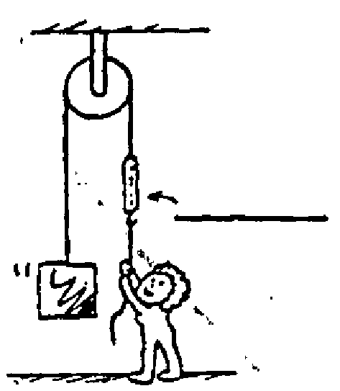 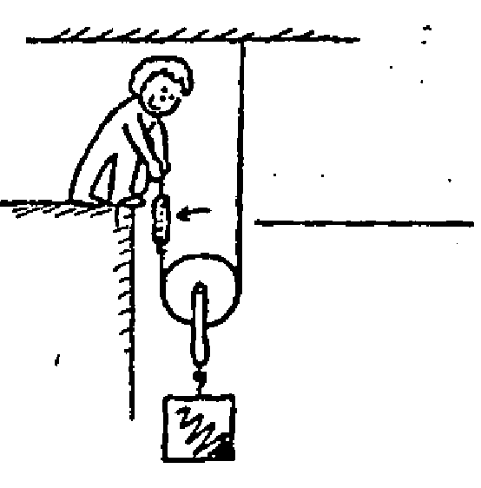 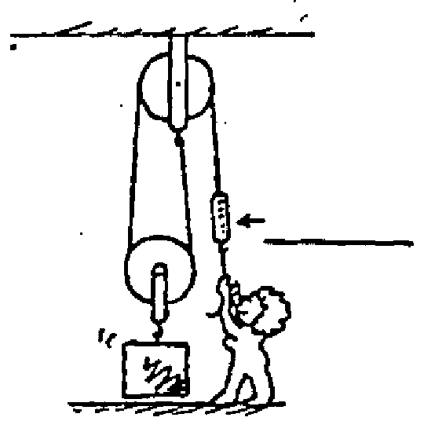

A 600 N block is lifted by the friction-free pulley system shown below.

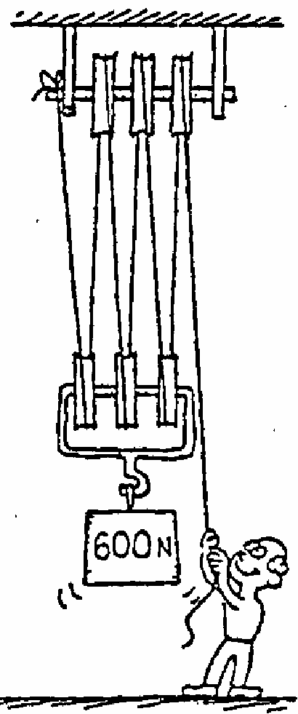

17. How many strands of rope support the 600 N weight?

18. What is the tension in each strand?

19. What is the tension in the end held by the man?

20. If the man pulls his end down 60 cm, how many cm will the weight rise?

21. What is the mechanical advantage of the pulley system?

22. Why don’t balls bounce as high during the second bounce as they do in the first?

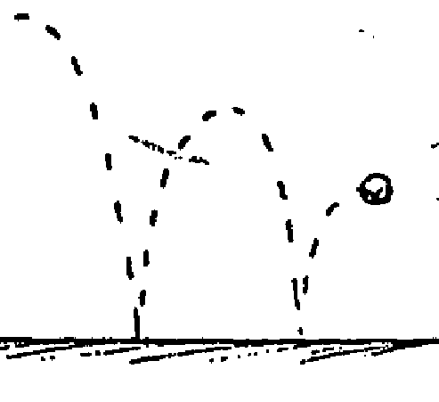

Answers

1. How much work (energy) is needed to lift an object that weighs 200 N to a height of 4 m?

*W = fnet x d = 200 N x 4 m = 800 J*

2. What is the power output of an engine that does 60,000 J of work in 10 s?

*P = W / t = 60,000 J / 10 s = 6,000 Watts*

3. How much power is needed to lift the 200 N object to a height of 4 m in 4 s?

*P = W / t = (fnet x d) / t = (200 N x 4 m) / 4 st = 200 Watts*



4. A pile driver is used to drive stakes into the ground. While building a fence, Adam drops a 3000 N pile driver through a vertical distance of 0.8 m. How much work can the pile driver potentially do?

*W = fx d = (3000 N)(0.8 m) = 2400 j = 2.4 x 103 j*

5. At target practice, Diana holds her bow and pulls the arrow back a distance of 0.30 m by exerting an average force of 40.0 N. Prior to letting go the potential energy stored in the bow the moment before the arrow is released equals the work it can do. Calculate this work.

*The work done by arrow is equal to the PE (mgh).*

*W = fnet x d = mgh = (40.0 N)(0.30 m) = 12 J*



6. The coyote wants to push a 10,000 N rock off the edge of a cliff so that it falls on top of the roadrunner on the road below. If the coyote does 1,000 j of work, how far did he have to push the rock?

*W = fx d Therefore, d = W / f*

*d = 1,000 j / 10,000 N = 0.1 m = 10 cm*



7. A nutcracker 16 cm long is used to crack open a Brazil nut that is placed 12 cm from where your hand is squeezing the nutcracker. What is the mechanical advantage of the nutcracker? (Hint: the length of the nutcracker relates to effort.)

*MA = deffort  / dresistance = 12cm / 4cm = 3*

8. Two clowns, of mass 50.0 kg and 70.0 kg respectively, are in a circus act performing a stunt with a trampoline and a seesaw. The smaller clown stands on the lower end of the seesaw while the larger clown jumps from the trampoline onto the raised side of the seesaw, propelling his friend into the air.



What is the mechanical advantage of the seesaw?

*MA = deffort / dresistance = 2.40 m / 0.80 m = 3*

9. A crate of bananas is shipped from South America to New York, where it is unloaded by a dock worker who lifts the crate 2 m by pulling with a force of 200 N on the rope of a pulley system. He does 6,000 J of work. How much do the bananas weigh (force)?



*W = fx d Therefore, f = W / d*

*f = 6,000 J / 2 m = 3,000 N = 3 x 103N*

b. What is the mechanical advantage of the pulley system?

*MA = fresistance / feffort or fout / fin*

*MA = 3000 N / 200 N = 15 Notice that mechanical advantage has no units.*

c. Compare the distance the worker has to pull on the ropes to move the bananas.

*The dock worker has to pull the rope 15 times farther 🡪 2 x 15 = 30 m since MA = 15.*

10. A person pushes a 50 N box 20 m up a 4 m incline. How much work is accomplished by the person (ignore friction)?

4 m

20 m

*W = fx d = 50 N x 20.0 m = 1,000 J*

b. What is the mechanical advantage of the inclined plane?

*MA = dE / dR = 20 m / 4 m = 5*

c. If it takes the person 40 seconds to push the box the entire distance of the inclined plane, how much power is exhibited?

*P = W / t = 1,000 J / 40 s = 25 Watts*

11. The Ramseys are moving to a new town, so they have called in the ACME moving company to take care of their furniture. Debbie, one of the movers, exerts 500 N to slide the Ramsey’s 2200 N China Cabinet up a 6.0 m long ramp to the moving van, which stands 1.0 m off the ground. What it the ideal mechanical advantage of the incline?

*MA = deffort / dresistance = length / height = 6.0 m / 1.0 m = 6*

What is the efficiency of the ramp?

*Eff = Wout / Win = 2200 N x 1.0 m / 500 N x 6.0 m = 73 %*

12. Elben lifts an engine out of this Volkswagen with the help of a winch that allows him to raise the engine 0.20 m for every 10 m he pulls on the cable. Elben puts in 500 joules of work to lift the 800 N engine 0.50 m.

a. How much work is necessary to lift the engine?

*W = fx d = 800 N x 0.50 m = 400 J*

a. What is the efficiency of the winch?

*Eff = Wout / Win= 400 J / 500 J = 0.80 = 80 %*

b. What is the mechanical advantage of the winch based on the distances?

*MA = deffort / dresistance = dE / dR = 10 m / 0.20 m = 50*

13. The block of ice weighs 500 Newtons.



a. What is the mechanical advantage of the incline?

*MA = deffort / dresistance = 6m / 3 m = 2*

b. How much force is needed to push it up the incline? (neglect friction)

*Using the mechanical advantage of 2, this would mean it takes ½ the force to lift the ice.*

*MA = fresistance / feffort* = Therefore, *feffort* = *fresistance / MA 🡪*  500 N / 2 = 250 N

*Notice that the effort required is half the resistance load, but the distance is twice as much.*

In problems 14-16, the Woman supports a 100 N load with the friction-free pulley systems shown below. Find the spring-scale readings that show how much force she must exert.

14. *100 N* 15. *100 N* 16. *50 N*

*14-15 1 supporting rope means MA = 1, so each rope support s the full weight.*

  

*2 supporting ropes means MA =2, so each rope support s ½ the weight.*

A 600 N block is lifted by the friction-free pulley system shown below.



17. How many strands of rope support the 600 N weight? *6*

*6 supporting ropes means that MA = 6 (do NOT include the rope*

*the man is pulling on)*

18. What is the tension in each strand? *100 N for each supporting rope*

*Since MA = 6, each rope supports 1/6 of the weight.*

19. What is the tension in the end held by the man? *100 N*

*Since MA = 6, the man only exerts 1/6 of the force of the weight.*

20. If the man pulls his end down 60 cm, how many cm will the weight rise?

*10 cm because MA = 6 so the weight only rises 1/6 of what the man pulls.*

21. What is the mechanical advantage of the pulley system?

*The mechanical advantage is 6. MA = resistance force / effort force*

*MA = # ropes supporting the load*

22. Why don’t balls bounce as high during the second bounce as they do in the first?

 *Friction (heat) reduces the efficiency of all work done.*