Radiometer

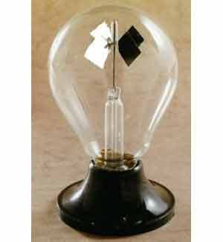

* The Radiometer **transfers** light energy into mechanical energy
* Vanes are white on one side and black on the other
* Light is **radiated** (*matter is not needed*) from the ceiling lights or the sun and strikes the dark vanes and light energy from an outside source is absorbed
* Light strikes the white vanes and very little light energy is absorbed from the outside source
* Free molecules in the air inside the radiometer are “energized” by the energy increase near the black vanes (**conduction**: *matter is needed*) and are, therefore, emitted … this “pushes” the vane in the opposite direction of the black side
* Free molecules in the air inside the radiometer are not “energized” by the lack of energy increase near the white vanes and so nothing much happens on the white side
* Since one side is black and the other side white, the energy differential causes the vanes to spin … there is **convection** (*matter is needed*) inside the radiometer
* The greater the light intensity, the greater the spinning of the vanes
* Radiometers also show the wave-particle nature of light

Convection, Conduction & Radiation

**Convection** is the transfer of heat by the actual movement of the warmed matter*. Heat leaves the coffee cup as the currents of steam and air rise*.

Convection is the transfer of heat energy in a gas or liquid by movement of currents. (*It can also happen in some solids, like sand*.) The heat moves with the fluid.

Consider this: convection is responsible for making macaroni rise and fall in a pot of heated water. The warmer portions of the water are less dense and therefore, they rise. Meanwhile, the cooler portions of the water fall because they are denser.

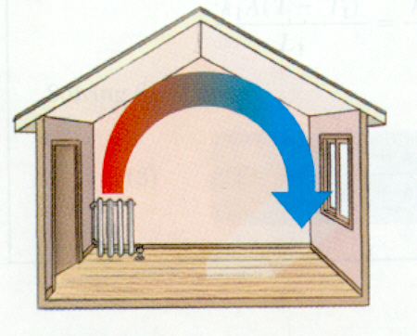 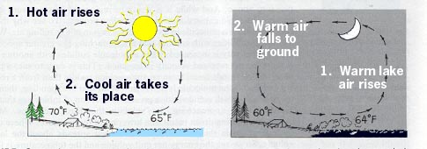

**Conduction** is the transfer of energy through matter from particle to particle. It is the transfer and distribution of heat energy from atom to atom within a substance.

*For example, a spoon in a cup of hot soup becomes warmer because the heat from the soup is conducted along the spoon*.

Conduction is most effective in solids-but it can happen in fluids. Fun fact: Have you ever noticed that metals tend to feel cold? Believe it or not, they are not colder! They only feel colder because they conduct heat away from your hand. You perceive the heat that is leaving your hand as cold.

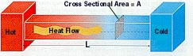

**Radiation** is Electromagnetic Waves that directly transport ENERGY through space.

Sunlight is a form of radiation that is radiated through space to our planet without the aid of fluids or solids (the vacuum of space). The energy travels through nothingness! Just think of it!



The sun transfers heat through 93 million miles of space. Because there are no solids (like a huge spoon) touching the sun and our planet, conduction is not responsible for bringing heat to Earth.

Since there are no fluids (like air and water) in space, convection is not responsible for transferring the heat. Thus, **radiation brings heat to our planet**.

**e.g. radiometer**

* Heat excites the molecules near the black surface of the vanes more than it heats the molecules near the white surface.
* Black is a good absorber and a good radiator. Think of black as a large doorway that allows heat to pass through easily.
* In contrast, white is a poor absorber and a poor radiator of energy. White is like a small doorway and will not allow heat to pass easily.