**Student Projects Chapter 11-21**

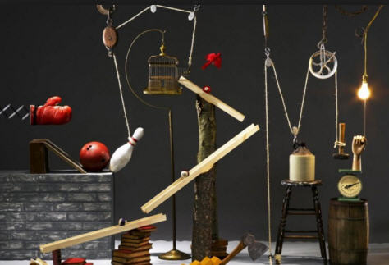

**See** [**https://www.learningctronline.com/courses**](https://www.learningctronline.com/courses) **for Materials and Resources.**

**Topics:**

1. Student Projects

**Objectives:**

* Participate in a project-based, independent study, learning unit as a review of one major concept from 2nd semester.
* Use class notes, labs, homework, textbook, internet, and other resources to research ideas to create a lab experience based on Motion, Newton’s Laws, Simple Machines, Electricity, Sound, or Light.
* Submit a report of the project that includes all elements of a formal lab report.

TAKE NOTE

1. Project Ideas Rubric
2. Final Project Ideas
3. Final Project Report is due in 7 days
4. Baseball Song (John Riesen)
5. SEMESTER EXAM – due 10 days after class.
6. Class Song: We Don’t Say “I Don’t Know”!
7. Week 32 Devotional (<https://www.learningctronline.com/devotional>)

**Text**: Chapters 11 – 21 (excluding Chapter 13)

**Guided Reading Note-Taking Worksheet: None**

**Class Notes: none**

**Homework**:

* Work on Project … due in 7 days
* Study for Semester Exam by completing the Review Guide

**Lab**: Final Project Report (use template worksheet)

**TEST:** Submit project within 7 days

Supplemental Resources (Optional)

[**http://somup.com/c3hnqeOGA8**](http://somup.com/c3hnqeOGA8) **Johnathan Riesen "Baseball Song" Music Video (4:25)**

<http://somup.com/cYhlqQjqZi> 2 Peter 3:18; Be Still & Know (4:07)



**SEMESTER EXAM**

1. **Use the Review (Study Guide) document below to study for the Final Exam. Then, take the Final Exam in the assignments tab.**
2. **A guardian should be proctoring your test. Proctoring means to monitor the following:  
     
   1) the academic integrity policy,  
   2) taking the entire test "in one sitting", and  
   3) keeping the time limit of 90 minutes.  
     
   Proctors should NOT be reading the test or engaging students during the test.**
3. **For the semester exam you MAY use the review study guide during the exam according to the exam strategy shown below. Do NOT use the study guide until you have gone through the exam twice as directed below.**
4. **The test must be completed WITHOUT referring to the textbook, the class notes, the internet, people, or any other outside resources on this test.**
5. **Students MAY use the approved Periodic Tables, approved Reference Tables, or approved equation (formula) sheet (provided by the teacher) along with calculators and scratch paper throughout the exam.**
6. **The semester exam must be taken in one sitting, meaning that once you open the test, you must complete it without interruption. There is NO written portion for this exam, only automated (multiple choice).**
7. **You have 90 minutes maximum to complete the semester exam. If you take more than 90 minutes, your score will be reduced UNLESS you have a documented, pre-approved accommodation.**

**STRATEGY:**

1. **Go through all the questions and answer the "easier" ones for you first ... to build confidence.**
2. **Then, go back and carefully consider the ones you did not answer initially. Skip the ones you feel are too hard, you don't understand, or you will look up using the review study guide.**
3. **Lastly, go to the questions you skipped and make them make sense based on your knowledge of Physical Science. Look up some answers using the review study guide if you have time.**

**The semester exam is automated (50 multiple choice questions) with NO written portion.**

The semester exam should be taken within 10 days.