### Heading

### Title

### Introduction This lab deals with two properties of light waves.

### Purpose To investigate reflection off a surface and refraction when light passes through two different media.

Background Information

Hypothesis (Reflection and Refraction)

### Materials Simulation or Light: Reflection & Refraction Video (3:35) on Study Place

*List Materials if done at home*

### Procedures for Reflection

1. Click on the link below:

<http://www.physicsclassroom.com/Physics-Interactives/Refraction-and-Lenses/Refraction/Refraction-Interactive>

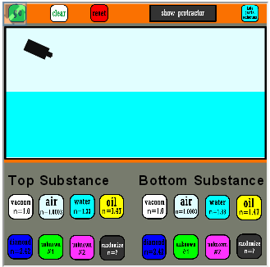

**If the above link does not work, use:**

[**http://somup.com/cYfDFUi1N0**](http://somup.com/cYfDFUi1N0)



2. Click on the word “GO” of the “Interactive” picture

3. Click “Show Protractor” (upper right of center).

4. Click “Hide Partial Reflection” in upper right corner.

5. For “Top Surface” click on “air” (white). For bottom surface click on “diamond” (dark blue).

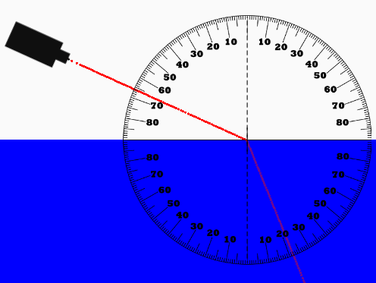

6. Click on “GO” and let the simulation run. You may have to run it again … make sure the light “bends” as it enters the diamond (lower part). Click “air” again and keep trying until the light ray bends.

7. Move the protractor to the center of the interface between air and diamond so that the cross hairs are on the point where the light enters the diamond.

8. Move the light source INTO THE DIAMOND region (dark blue) until it reads 60 degrees on the protractor. Click “GO”. It should look like this:

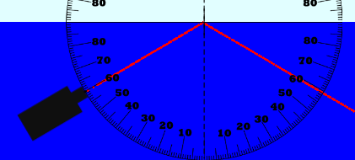

9. Record the reflected angle in the data chart below.

10. Move the light source to make an incident angle of 45**°** and run the simulation. Record the reflected angle.

11. Move the light source to make an incident angle of 30**°** and run the simulation. Record the reflected angle.

**Calculations & Data for Reflection**

1. Record the reflected angles for each of the incident angles.

|  |  |  |  |
| --- | --- | --- | --- |
| **Incident Angle** | **60°** | **45°** | **30°** |
| **Reflected Angle** |  |  |  |

2. Make a drawing or take a screen shot of the 45**°** OR 30**°** incident angle reflection. Label the following: incident ray, incident angle, normal, reflective surface, reflected ray, reflected angle. Use the items provided at the right:

I

600

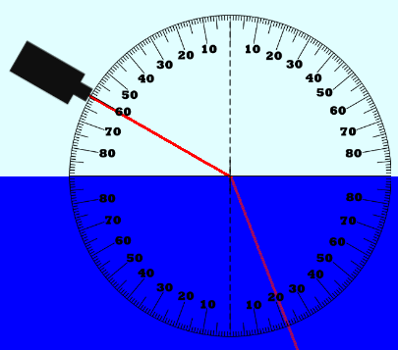

**Procedures for Refraction**

1. Move the light source INTO THE AIR region (white) until it reads 60**°** on the protractor. Click “GO”. It should look like this 🡪

2. Record the refracted angle in the data chart below.

3. Move the light source to make an incident angle of 45**°** & run the simulation. Record the refracted angle.

4. Move the light source to make an incident angle of 30**°** & run the simulation. Record the refracted angle.

**Calculations & Data for Refraction**

1. Record the refracted angles for each of the incident angles.

|  |  |  |  |
| --- | --- | --- | --- |
| **Incident Angle** | **60°** | **45°** | **30°** |
| **Refracted Angle** |  |  |  |

2. Make a drawing or take a screen shot of the 45**°** or 30**°** incident angle refraction. Label the following: incident ray, incident angle, normal, the two media (air, diamond), refracted ray, refracted angle.

I

600

### Conclusions

Address your hypothesis:

Analysis

(*Change the questions into statements* *that convey a complete thought including supporting evidence from the lab*.)

1. How did the angles of incidence compare with the angles of reflection? Support your answer with evidence from the lab.

2. What general type of reflection did you observe in this lab? Contrast this with diffuse reflection.

3. How did the angles of incidence from air compare with the angles of refraction going into diamond? Give examples from the lab.

4. Why would the light refract from air into diamond the way it did (What must be true of the two different media)?

Give some sources of error in this laboratory:

**Resources** (*APA format*)