Your Name Physical Science

Date Teacher, Section #

Density

**Introduction** This lab deals with a property of matter called density.

**Purpose**

To utilize an intensive property (density) in order to identify various materials and to investigate the difference between physical and chemical changes.

**Background Information**

Physical properties of substances are characteristics that can be observed or measured without changing the composition of the substances in the material. Some physical properties only deal with amounts. These are called extensive properties because they measure quantities like volume, mass, and weight. Other physical properties are useful in identifying a substance. These are called intensive properties (e.g. melting point, boiling point, solubility and density) and to distinguish different elements or compounds.

Density is the ratio of the mass of a substance to its volume and can be expressed mathematically as: d = m/v, where “d” is density, “m” is mass, and “v” is volume.

Density can be used to test the purity of a substance as well as distinguish one material or substance from another. In other words, density is an important intensive property used to identify materials or substances. Water has a density of 1.0 g/ml while vegetable oil has a density of 0.9 g/ml. This means one will float on the other due to a difference in their densities.

In this lab, you will determine the density of 4 substances and predict the order these substances will take on if mixed together.

|  |
| --- |
|  |
|  |
|  |

**Hypothesis**

If water, vegetable oil, and copper coins are mixed together, they will separate out according to their densities as follows:

**Materials**

Metric ruler 100 ml Graduated Cylinder Mass Balance

Water Vegetable Oil (yellow) 10 pennies / copper coins

Small wood block (regularly shaped to measure LWH) Food Coloring

###### **Procedures**

A. Finding Volumes

You will use THREE (3) different techniques to determine volume.

1. **Direct Measurement** of a **liquid** using the 100 ml graduated cylinder (ml).

Read the volume **measurement** shown on the graduated cylinder (*see sketch to the right*) by looking at the **meniscus** (*bottom of the “bubble”*).

20 ml

The reading to the right is ~22.5 ml. The last number (“.5”) is an estimate and may vary within reason.

2. **Regularly Shaped Solids**: Measure the Length (longest side) and the width (opposite length) and the height of a regularly shaped solid like the small block of wood. Then, multiply length (L) times width (W) times height (H) to get the cubic volume (cm3). cm3 = ml.

**L** (cm) **x W** (cm) **x H** (cm)= ____ cm3

**3. Water Displacement for NON-regularly shaped solids.**

a. Add a known amount of water to the graduated cylinder.

b. Read the volume to the nearest 0.1 ml (e.g. 4.0 ml to the left).

c. Gently add the copper coins to the graduated cylinder (to avoid water splashing out).

d. Read the meniscus of the water in the graduated cylinder (e.g. 6.0 ml).

e. Subtract the original volume of water in the cylinder to determine the volume of the substance.

(6.0 ml – 4.0 ml = **2.0 ml**)

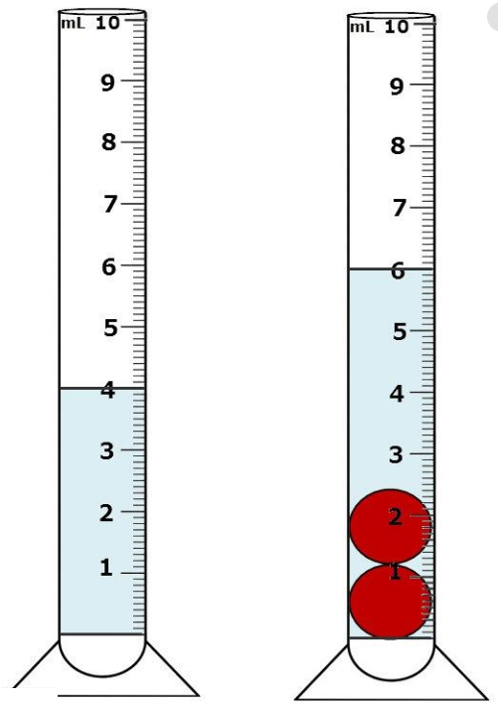

B. Finding Mass

You will use TWO (2) different techniques to determine the mass of a substance.

1. **Direct Measurement** of a **solid** using the mass balance (grams).

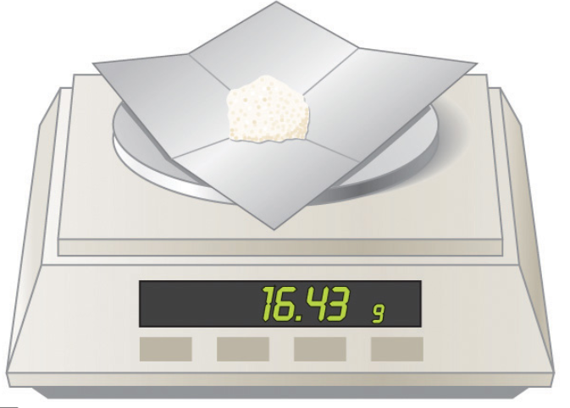

a. To protect your mass balance, add a filter paper or something to keep the surface clean. Then, “zero” the balance so as NOT to include the mass of the paper with the mass of the substance.

b. Read the mass of the **solid** shown on the balance to the nearest TENTH of a gram (e.g. 16.4 g).

2. **NON-Direct Measurement** of a **liquid** using the 100 ml graduated cylinder and the mass balance (grams).

a. Find the mass of the graduated cylinder ALONE.

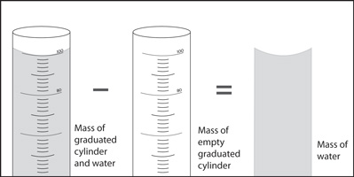

b. Find the mass of the graduated cylinder AND the liquid (water or vegetable oil) combined.

Mass of liquid ALONE.

Mass of graduated cylinder & liquid.

c. Subtract the mass of the EMPTY graduated cylinder FROM the mass of the graduated cylinder AND liquid (water or vegetable oil) combined.

d. Express the mass of the liquid ALONE to the nearest TENTH of a milliliter.

C. Procedures for the Density Lab

1. Determine the mass of the DRY, EMPTY Graduated Cylinder before doing any other measurements. Record this mass in the Calculations and Data section above the data table.

2. Find the mass of the 10 **copper coins** using the mass balance. Record this mass in the Calculations and Data section in the data table.

3. Find the mass of the **wood block** using the mass balance. Record this mass in the Calculations and Data section in the data table.

4. Measure the length (longest side), the width (opposite longest side), and the height of the **wood block**. Record these measurements in the Calculations and Data section below the data table.

5. Add a specific amount of **water** to the graduated cylinder that is an exact multiple of 10 ml (e.g. 20.0 ml, 30.0 ml, 40.0 ml).

a. Read and record this volume in the Calculations and Data section in the data table.

b. Place the graduated cylinder with the water on the mass balance. Record this mass in the Calculations and Data section in the data table.

6. Carefully/Slowly add the 10 **copper coins** (*to avoid water splashing out of the graduated cylinder*) and read the NEW volume to the nearest 0.1 ml. Record this volume in the Calculations and Data section in the data table.

7. Dry out the graduated cylinder as best as possible.

8. Add an amount of **vegetable oil** to the graduated cylinder between 10.0 and 20.0 ml. Read and record this volume in the Calculations and Data section in the data table.

9. Place the graduated cylinder with the vegetable oil on the mass balance. Record this mass in the Calculations and Data section in the data table.

10. Add a drop of food coloring to a small glass of water (at least 20 ml). SLOWLY / CAREFULLY pour the colored water into the graduated cylinder that contains the vegetable oil.

a. The amount of water added does not have to be exact or recorded, but should occupy at least 20 ml in the graduated cylinder.

b. SLOWLY add ONE of the copper coins to the graduated cylinder.

c. Record your observations in the Calculation and Data section.

11. Take a picture or draw a sketch of what is in the graduated cylinder. Especially note the layers of the substances.

**Calculations and Data**

Mass of the EMPTY Graduated Cylinder:  **____ g**

**Density Data Table**

|  |  |  |  |  |  |  |  |
| --- | --- | --- | --- | --- | --- | --- | --- |
|  | Mass of  grad cyl | Mass of cyl + substance | Mass of substance | Volume (grad cyl) | Volume  (L x W x H) | Density | Identity of Substance |
| 1 | g | g | g | ml |  | g/ml | Vegetable Oil |
| 2 |  |  | g |  | cm3 | g/cm3 | Wood Block |
| 3 | g | g | g | ml |  | g/ml | Tap  Water |
| 4 |  |  | g |  | ml | g/ ml | 10 copper coins |

1. For the wood block #2 … show work for calculating the volume

length x width x height = ____ cm3

2. For 10 copper coins … show work for calculating the volume

(Volume of grad cyl, water, coins) - (Volume of grad cyl with water) = ____ ml

3. Show Work for Calculating the Density of each substance (to the nearest tenth):

1. Vegetable Oil #1

g / ml = g/ml

1. Wood Block #2

g / cm3 = g/ cm3

1. Water #3

g / ml = g/ml

1. Copper Coins #4

g / ml = g/ml

The following Density Table gives densities as guidance for the substances in this lab.

|  |  |  |  |  |
| --- | --- | --- | --- | --- |
| Substance | Vegetable Oil | Wood Block | Water | Penny |
| Density | 0.9 g/ml | 0.6 g/ cm3 | 1.0 g/ml | 7.0 g/ml |

**Calculate the Percent Error for ONE of the substances based on your results:**

% Error = │(Accepted – Your Results)│ x 100% =

Accepted

Be sure to include images of the lab experiment (e.g. taking the mass and volume of an object).

## Conclusions

Layers of Substances

|  |
| --- |
|  |
|  |
|  |

Address Hypothesis

(*Did the experiment confirm or disprove the hypothesis? What did the experiment show?)*

Analysis

(*Use evidence from the lab to discuss the background information in the introductory section).*

Questions

(*Write statements in complete sentences that convey a complete thought using evidence from the lab to support your statements*).

1. What kind of quantifying properties are mass, weight and volume?

2. What kind of quantifying property is density? How is this kind of property different than those in question #1?

3. Name the three techniques used to determine volume and give the metric unit for each.

4. Explain why the “layers” occurred when the copper coins, water, and vegetable oil were combined.

**Error**

**Bibliography**