*Use the class notes (and/or textbook) to complete this study guide.*

**Covalent Bonding**

A covalent bond is a relatively **________** (weak/strong) bond when two atoms **_______** (transfer/share) a pair of electrons. Covalent bonds occur most between **_______** (metallic/non-metallic) elements. Electrons are shared in the outermost **___** and **___** sublevels (**_______** energy level). Covalently bonded substances consist of small **_______** (compounds/molecules), which are a group of two or more atoms joined together by sharing their **_______**. Substances that are made up of ions do not form molecules, but only **_______** (**_______** bonds).

Since covalent bonds are **_______** (weak/strong); a lot of **_______** is needed to break them apart. Substances with covalent bonds are usually **_______** or **_______** (states of matter), molecules with **_______** (low/moderate/high) melting and boiling points, such as hydrogen, H2 (g), and water, H2O (l).

Atoms generally exist in their lowest energy state (Aufbau principle) in order to become **_______**. Two conditions of atomic stability are **_______ _______** and a **_______ _______**. Stability drives atoms to bond.

Covalent bonds are often represented by a Lewis Structure or electron dot diagram. Draw the end product of the covalent bond for HCl:

After bonding, the chlorine atom, as most atoms, is now in contact with **_______** electrons in its highest energy level orbitals (3s, 3p) or **_______**; so, it is **_______**. The hydrogen atom is now in contact with **_______** electrons in its highest energy level orbital (1s) or valence; so, the hydrogen atom is also **_______**. Hydrogen and Chlorine share a single **_______** of electrons.

Most **_______** (metallic/non-metallic) atoms can form multiple covalent bonds; that is, share not just one pair of electrons but two or more pairs. Atoms of different elements will form either one bond (one **_______** of shared electrons, two bonds (**_______** pairs of shared electrons), three bonds (three pairs of **_______** electrons), or four covalent bonds (**_______** pairs of shared electrons) with other atoms. *Fill in the table below:*

|  |  |  |  |
| --- | --- | --- | --- |
| Group | Example | Valence | # of Covalent Bonds to Complete the Valence |
| IVA (14) |  |  |  |
| VA (15) |  |  |  |
| VIA (16) |  |  |  |
| VIIA (17) |  |  |  |

When Hydrogen behaves as a non-metal, it forms **_______** covalent bond (**_______** pair of shared electrons). The noble gases (also considered non-metallic) in Group **_______ (**18**)** or 0normallydo not form any bonds because their valence is full.

Covalent bonds can be polar, non-polar, or coordinate covalent. This is based on how electrons are shared. **_______** bonds mean that electrons are shared **_______** between atoms of **_______** electronegativity (the same element). E.g., Professor HOFBrINCl elements.

Bonding elements: A ↔ ___ or B ↔ ____

**_______** bonds mean that Electrons are shared **_______** between atoms of unequal **________**. One atom (higher electronegativity) draws the electrons more. An END below **1.7** indicates **_______** covalent character. An END of 0 indicates a **_____**-polar bond.

Bonding elements: A ↔ ___

**_______** Covalent Bonds form when the electrons being shared between two atoms are both donated by the **_______** atom. This is commonly found in **_______** ions which are held together by **_______** bonds, but overall bond **_______** as charged ions.

E.g., **_______**, **_______**

Covalent **_______** may be polar or non-polar depending on the distribution of electrons. Non-polar molecules share electrons **_______** throughout the molecule and have geometrically **_______** (balanced) shapes. E.g., **_______**, **_______**, **_______**, **_______**. Examples:

BF3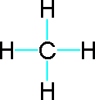

F−Be−F

All **_______** diatomic elements are non-polar molecules as well as molecules whose overall polarity cancels out.

**_______** molecules share electrons unequally throughout the molecule. Binary molecules composed of 2 different elements must be polar (END does not equal **_______**). A **_______** pole exists closer to one atom(s) and a **_______** pole exists closer to the other atom(s). Polar molecules are **_______**. Examples: **_______**, **_______**.

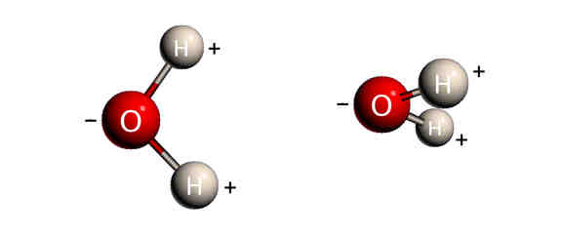 

It is important to distinguish valence electrons that are bonded with those which are not bonded. Label the following electron pairs as bonded or “lone” (unbonded) pairs:

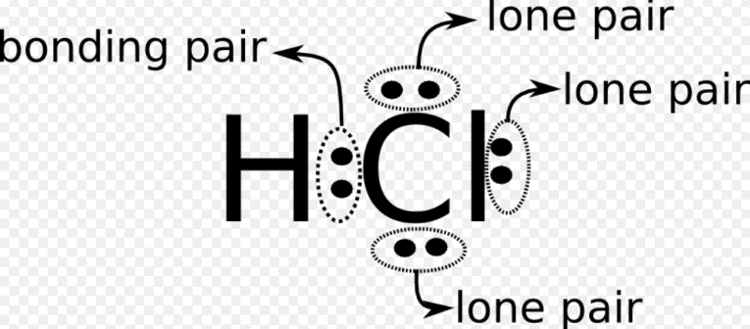

**Structural Formulas**

A structural formula shows the bonds between atoms in a molecule. Straight **_______** or dashes are the most common way to represent **_______** bonds, with each line representing a shared **_______** of **_______.**

Using the Lewis Structure:  the shared pair becomes **_______** dash or straight line. Draw or type it: **_______.** Usually, the other “lone” valence electron pairs are omitted, but can remain in the structural formula: 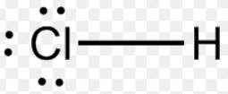.

Write the Lewis Structure (bottom box) and the structural formula (SF) for each molecule shown, given the molecular formula (MF):

|  |  |  |  |  |  |  |  |
| --- | --- | --- | --- | --- | --- | --- | --- |
| **Hydrogen** | | **Water** | | **Ammonia** | | **Methane** | |
| MF | SF | MF | SF | MF | SF | MF | SF |
| H2 |  | H2O |  | NH3 |  | CH4 |  |
|  | |  | |  | |  | |

All the bonds shown are called single covalent bonds because only **_______**   **_______** of electrons is shared between two atoms. Notice that hydrogen only form **_______** covalent bond, oxygen can form **_______** bonds, nitrogen can form **_______** bonds, and carbon can form **_______** bonds.

**Some Molecules contain more than one pair of shared electrons between two atoms. For instance,** a molecule of oxygen (**O2**) consists of **_______** oxygen atoms held together by a double bond which contains **_______** _**______** of shared electrons and is represented by **_______** dashes between the two atoms. A molecule of nitrogen (**N2**) consists of **_______** nitrogen atoms held together by a triple bond which contains **_______** _**______** of shared electrons and is represented by **_______** dashes between the two atoms.

Give the Molecular Formulas (in the left box) & draw the Lewis Structure (middle box) and Structural Formula for each molecule.

|  |  |  |
| --- | --- | --- |
| Hydrogen atoms  in a **single** bond |  | Write the  “Structural Formula” |
| Oxygen atoms  in a **double** bond |  | Write the  “Structural Formula” |
| Nitrogen atoms  in a **triple** bond |  | Write the  “Structural Formula” |

Note that molecules with a double **covalent bond possess** **_____** shared **_______** of electrons. A double covalent bond is shown by **____** dashes in the structural formula between two atoms.

Molecules with a triple **covalent bond possess** **_______** shared **_______** of electrons. A triple covalent bond is shown by **_______** dashes in the structural formula between two atoms.

Bonding Exceptions

1. **_______** Orbitals

Simple covalent bonding relates to electrons shared between two individual atoms. However, modern atomic theory deals with bonds in which electrons are NOT assigned to individual atoms (*as shown in Lewis structures or structural formulas*), but are treated as **_______** by nuclei of the **_______** molecule (*similar thinking as metallic bonding in the electron sea model*).

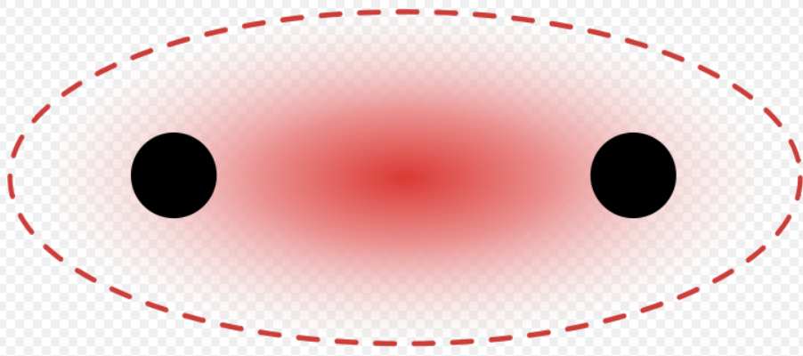 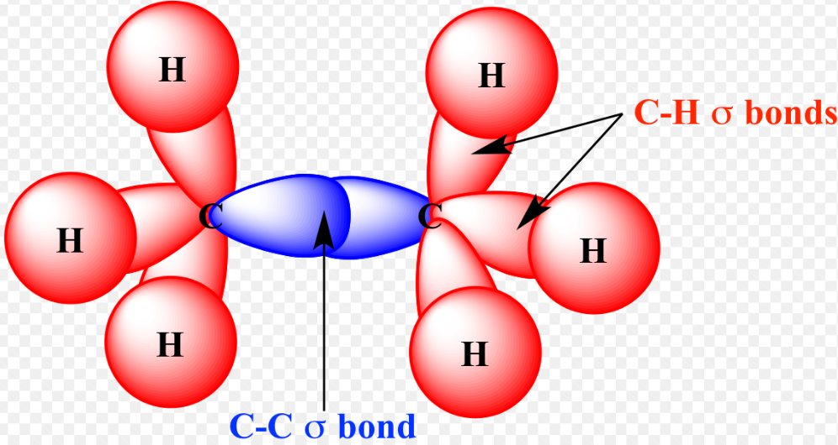

**_______** bonds, signified by the Greek letter, **σ**, are the **_______** (weakest/strongest) type of covalent bond and are formed by the overlap of atomic orbitals along the **_______** (outer/central) bond axis of atoms.

**_______**  bonds, signified by the Greek letter **π,** refers to **___** orbitals, since the orbital symmetry of the pi bond is the same as that of the p orbital when seen down the bond axis. Pi bonds are orbitals that overlap **_____** and below the central bond axis. Pi bonds are usually **_______** (weaker/stronger) than sigma. Pi bonds are commonly associated with **_______** and triple bonds. *Label the bonds on the diagram to the right*.

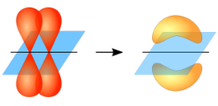 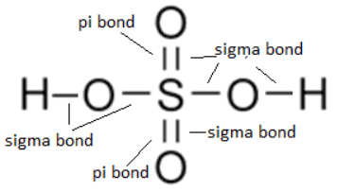

2. Exceptions to the Octet Rule

Sometimes molecules form covalent bonds that have less than or exceed the **_______** valence. This is best recognized by looking at the **_______** atom of the molecule.

What is Berrylium’s valence in BeCl2?

**___** e- (represented by **___** dashes or 2 **_______** pairs of electrons).

What is Boron’s valence in BCl3?

**___** e- (represented by **___** dashes or 3 bonded pairs of electrons).

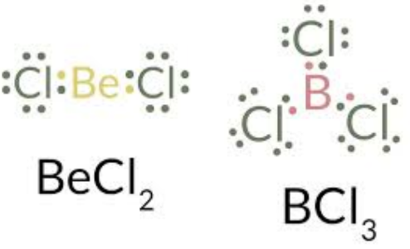

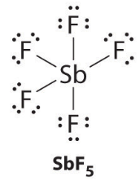

What is Antimony’s (Sb) valence in SbF5?

**___** e- (represented by **___** dashes or 5 **_______** pairs of electrons).

3. Resonance Structures

Resonance occurs when more than **____** Lewis’s structure can be drawn for a molecule or polyatomic ion. These structures are indicated by a double arrow (↔). Often, the actual structures possess bond lengths that are **_______** between single and double bonds. Draw an example of a resonance structure:

4. **_______** Theory

Valence-Shell Electron-Pair Repulsion Theory states that the **_______** between electron pairs causes molecular shapes to adjust so that the valence-electron pairs stay as far apart as possible. This helps explain the various **_______** of molecules.

a. **_______**  🡪 diatomic molecules; CO2; BeH2. 180◦ bond angle. ____ atoms bond on each side of a **_______** atom. Give an example:

b. **_______**  🡪 water, H2S, SO2. 105◦ bond angle. Two **_______** pairs of electrons **_______** so the geometry changes. (e.g., Central atom from group ____A) Give an example:

c. **_______** Planar 🡪 BF3; BCl3. 120◦ bond angle. **_______** electron pairs surround the **_______** atom. (e.g., Central atom from group ____A) Give an example:

d. **_______**  🡪 PCl3. 107◦ bond angle. **_______** unbonded electron pair repels the bonded electron pairs. (e.g., Central atom from group ____A) Give an example:

e. **_______**  🡪 CH4; CCl4. 109◦ bond angle. **_______** equidistant bonded electron pairs around a **_______** atom. (e.g., Central atom from group ____A) Give an example:

5. **_______** Orbitals: sp, sp2, sp3

Simple atomic theory or VSEPR theory does not explain actual bond angles of many molecules. The diagrams below show the

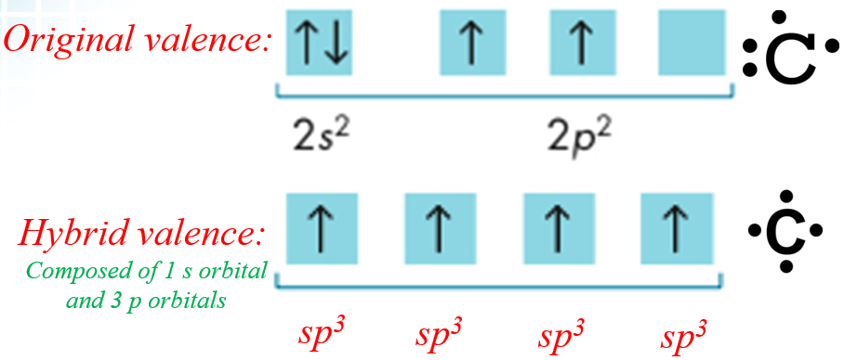

**sp3 Hybrid Orbitals**

Carbon often bonds with a tetrahedral geometry (4 equidistant points from the center atom). The top electron dot diagram cannot justify such a bond, so the hybrid orbitals were proposed. One of the ___ electrons jump to the ___ unoccupied orbital, forming ___ hybrid sp3 orbitals.

**sp2 Hybrid Orbitals**

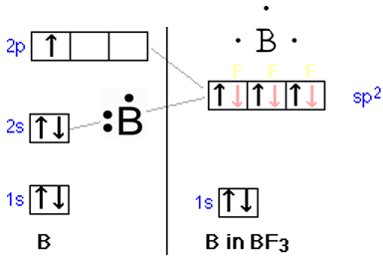

Explains the _______ planar shape (*equilateral triangle*) for single bonded atoms like Boron & for double bonded molecules like Ethene. One of the 2s electrons jumps to the 2p unoccupied orbital, forming ___ hybrid sp2 orbitals.

*Draw electron dot diagrams (in box provided) for B before & after hybridization.*

**spHybrid Orbitals**

Explains the _______ shape for single bonded atoms like Beryllium difluoride (e.g., F-Be-F) & for double bonded molecules like carbon dioxide, and for triple bonded molecules like Ethyne (C2H2). One of the 2s electrons jumps to the 2p unoccupied orbital, forming ___ hybrid sp orbitals.

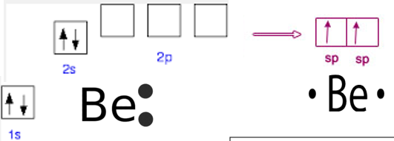

*Draw electron dot diagrams (in box provided) for Be before & after hybridization.*

INTERmolecular Attractions

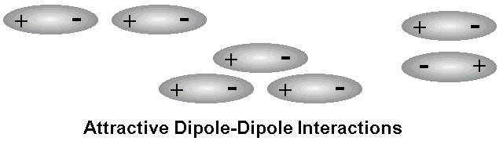

MOLECULES can be attracted to each other by a variety of different forces called intermolecular attractions.

These are _______ (weaker/stronger) than either ionic or covalent bonds that hold the individual ATOMS together.

Dispersion Forces are present between ALL molecules whether they are polar or nonpolar. They represent _______ “_______” to “dipole” attractions).

**1.** _______ _______ _______ **Forces**

VDW forces consist of dipole interactions and dispersion forces. The slightly _______ region of a polar molecule is weakly attracted to the slightly _______ region of another _______ molecule.

F2, Cl2, Br2, or I2 molecules are diatomic _______ (same family/group), and have similar chemical properties and behaviors. Yet, F2 and Cl2 are _______, Br2 is a _______, and I2 is a _______.

**2.** _______ **Bonds**

A dipole – dipole attraction when hydrogen (*a very small atom)* bonds with a highly _______ atom (e.g., O, F).

For water each O—H bond in the water molecule is highly _______ (END 3.5 – 2.2 = 1.3), and the oxygen “end” acquires a slightly _______ charge because of its greater electronegativity while the hydrogen “ends” acquire a slightly _______ charge.

This explains water’s many special (unique) properties: a) _______ dense as a solid (ice floats); b) high _______ tension, high specific _______.

**3.** _______ **Solids**

_______, stable molecules forming a “network” of _______ bonds that extends throughout the solid. Also called network crystals.

_______ melting points (> 1000 C) due to a high strength of covalent bonds throughout the huge molecule. _______ conductors of heat and electricity. _______ crystals.

_______ (paint, lubricants, pencils) and _______ (jewelry, cutting tools) are “allotropes” of Carbon (same element with different forms). _______ dioxide is found in sand, used in glass (optical instruments). Allotropes of Phosphorus are used for fireworks, water softening.

Answers

*Use the class notes (and/or textbook) to complete this study guide.*

**Covalent Bonding**

A covalent bond is a relatively **STRONG** (weak/strong) bond when two atoms **SHARE** (transfer/share) a pair of electrons. Covalent bonds occur most between **NON-METALLIC** (metallic/non-metallic) elements. Electrons are shared in the outermost **s** and **p** sublevels (**HIGHEST** energy level). Covalently bonded substances consist of small **MOLECULES** (compounds/molecules), which are a group of two or more atoms joined together by sharing their **VALENCE**. Substances that are made up of ions do not form molecules, but only **COMPOUNDS** (**IONIC** bonds).

Since covalent bonds are **STRONG** (weak/strong); a lot of **ENERGY** is needed to break them apart. Substances with covalent bonds are usually **GASES** or **LIQUIDS** (states of matter), molecules with **LOW** (low/moderate/high) melting and boiling points, such as hydrogen, H2 (g), and water, H2O (l).

Atoms generally exist in their lowest energy state (Aufbau principle) in order to become **STABLE**. Two conditions of atomic stability are **ELECTRICAL NEUTRALITY** and a **FULL VALENCE**. Stability drives atoms to bond.

Covalent bonds are often represented by a Lewis Structure or electron dot diagram. Draw the end product of the covalent bond for HCl:

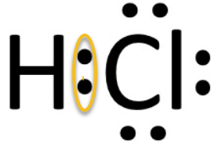

After bonding, the chlorine atom, as most atoms, is now in contact with **EIGHT** electrons in its highest energy level orbitals (3s, 3p) or **VALENCE**; so, it is STABLE. The hydrogen atom is now in contact with **TWO** electrons in its highest energy level orbital (1s) or valence; so, the hydrogen atom is also **STABLE**. Hydrogen and Chlorine share a single **PAIR** of electrons.

Most **NON-METALLIC** (metallic/non-metallic) atoms can form multiple covalent bonds; that is, share not just one pair of electrons but two or more pairs. Atoms of different elements will form either one bond (one **PAIR** of shared electrons, two bonds (**TWO** pairs of shared electrons), three bonds (three pairs of **SHARED** electrons), or four covalent bonds (**FOUR** pairs of shared electrons) with other atoms.

*Fill in the table below:*

|  |  |  |  |
| --- | --- | --- | --- |
| Group | Example | Valence | # of Covalent Bonds to Complete the Valence |
| IVA (14) | **Carbon, C** | **4 e-** | 8 - 4 = **4** |
| VA (15) | **Nitrogen, N** | **5 e-** | 8 - 5 = **3** |
| VIA (16) | **Oxygen, O** | **6 e-** | 8 - 6 = **2** |
| VIIA (17) | **Chlorine, Cl** | **7 e-** | 8 - 7 = **1** |

When Hydrogen behaves as a non-metal, it forms **1** covalent bond (**ONE** pair of shared electrons). The noble gases (also considered non-metallic) in Group **VIIIA (18)** or 0normallydo not form any bonds because their valence is full.

Covalent bonds can be polar, non-polar, or coordinate covalent. This is based on how electrons are shared. **NON-POLAR** bonds mean that electrons are shared **EQUALLY** between atoms of **EQUAL** electronegativity (the same element). E.g., Professor HOFBrINCl elements.

Bonding elements: A ↔ A or B ↔ B

**POLAR** bonds mean that Electrons are shared **UNEQUALLY** between atoms of unequal **ELECTRONEGATIVITY**. One atom (higher electronegativity) draws the electrons more. An END below **1.7** indicates **POLAR** covalent character. An END of 0 indicates a **NON**-polar bond. Bonding elements: A ↔ B

**COORDINATE** Covalent Bonds form when the electrons being shared between two atoms are both donated by the **SAME** atom. This is commonly found in **POLYATOMIC** ions which are held together by **COVALENT** bonds, but overall bond **IONICALLY** as charged ions.

E.g., NH4+, H3O+

Covalent **MOLECULES** may be polar or non-polar depending on the distribution of electrons. Non-polar molecules share electrons **EQUALLY** throughout the molecule and have geometrically **SYMMETRICAL** (balanced) shapes. E.g., CO2, CH4, BF3, BeF2. Examples:

BF3

F−Be−F

All **HOFBrINCl** diatomic elements are non-polar molecules as well as molecules whose overall polarity cancels out.

**POLAR** molecules share electrons unequally throughout the molecule. Binary molecules composed of 2 different elements must be polar (END does not equal **ZERO**). A **NEGATIVE** pole exists closer to one atom(s) and a **POSITIVE** pole exists closer to the other atom(s). Polar molecules are **DIPOLES**. Examples: HF, H2O.

 

It is important to distinguish valence electrons that are bonded with those which are not bonded. Label the following electron pairs as bonded or “lone” (unbonded) pairs:



**Structural Formulas**

A structural formula shows the bonds between atoms in a molecule. Straight **LINES** or dashes are the most common way to represent **COVALENT** bonds, with each line representing a shared **PAIR** of **ELECTRONS**.

Using the Lewis Structure:  the shared pair becomes **ONE** dash or straight line. Draw or type it: **H–Cl**. Usually, the other “lone” valence electron pairs are omitted, but can remain in the structural formula: .

Write the Lewis Structure (bottom box) and the structural formula (SF) for each molecule shown, given the molecular formula (MF):

|  |  |  |  |  |  |  |  |
| --- | --- | --- | --- | --- | --- | --- | --- |
| **Hydrogen** | | **Water** | | **Ammonia** | | **Methane** | |
| MF | SF | MF | SF | MF | SF | MF | SF |
| H2 |  | H2O |  | NH3 |  | CH4 |  |
|  | |  | |  | |  | |

All the bonds shown are called single covalent bonds because only **ONE PAIR** of electrons is shared between two atoms. Notice that hydrogen only form **ONE** covalent bond, oxygen can form **TWO** bonds, nitrogen can form **THREE** bonds, and carbon can form **FOUR** bonds.

**Some Molecules contain more than one pair of shared electrons between two atoms. For instance,** a molecule of oxygen (**O2**) consists of **TWO** oxygen atoms held together by a double bond which contains **TWO PAIRS** of shared electrons and is represented by **TWO** dashes between the two atoms. A molecule of nitrogen (**N2**) consists of **TWO** nitrogen atoms held together by a triple bond which contains **THREE PAIRS** of shared electrons and is represented by **THREE** dashes between the two atoms.

Give the Molecular Formulas (in the left box) & draw the Lewis Structure (middle box) and Structural Formula for each molecule.

|  |  |  |
| --- | --- | --- |
| Hydrogen atoms  in a **single** bond  H2 |  | Write the  “Structural Formula” |
| Oxygen atoms  in a **double** bond  O2 |  | Write the  “Structural Formula”  **0 = 0** |
| Nitrogen atoms  in a **triple** bond  N2 |  | Write the  “Structural Formula” |

Note that molecules with a double **covalent bond possess** **TWO** shared **PAIRS** of electrons. A double covalent bond is shown by **TWO** dashes in the structural formula between two atoms.

Molecules with a triple **covalent bond possess** **THREE** shared **PAIRS** of electrons. A triple covalent bond is shown by **THREE** dashes in the structural formula between two atoms.

Bonding Exceptions

1. Molecular Orbitals

Simple covalent bonding relates to electrons shared between two individual atoms. However, modern atomic theory deals with bonds in which electrons are NOT assigned to individual atoms (*as shown in Lewis structures or structural formulas*), but are treated as shared by nuclei of the entire molecule (*similar thinking as metallic bonding in the electron sea model*).

Sigma bonds, signified by the Greek letter, **σ**, are the **STRONGEST** type of covalent bond and are formed by the overlap of atomic orbitals along the **CENTRAL** (outer/central) bond axis of atoms.

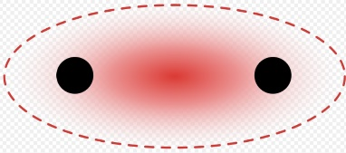 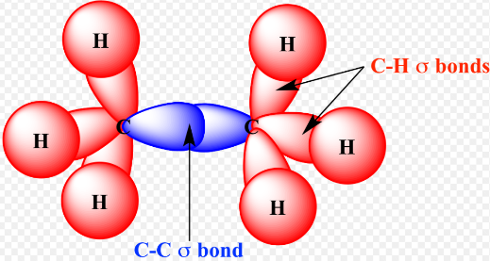

Pi bonds, signified by the Greek letter **π,** refers to **p** orbitals, since the orbital symmetry of the pi bond is the same as that of the p orbital when seen down the bond axis. Pi bonds are orbitals that overlap **ABOVE** and below the central bond axis and are usually **WEAKER** than sigma. Pi bonds are commonly associated with **DOUBLE** and triple bonds.

 

2. Exceptions to the Octet Rule

Sometimes molecules form covalent bonds that have less than or exceed the octet valence. This is best recognized by looking at the central atom of the molecule.

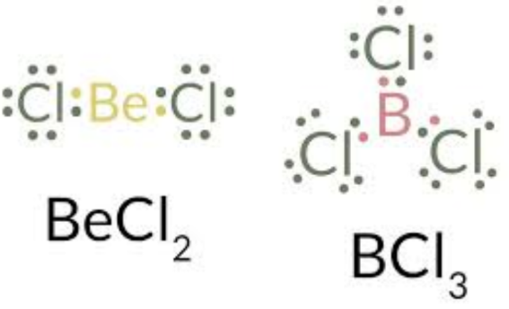

What is Berrylium’s valence in BeCl2?

**4** e- (represented by **2** dashes or 2 **bonded** pairs of electrons).

What is Boron’s valence in BCl3?

**6** e- (represented by **3** dashes or 2 bonded pairs of electrons).



What is Antimony’s (Sb) valence in SbF5?

**10** e- (represented by **5** dashes or 5 **bonded** pairs of electrons).

3. Resonance Structures

Resonance occurs when more than one Lewis structure can be drawn for a molecule or polyatomic ion. These structures are indicated by a double arrow (↔). Often, the actual structures possess bond lengths that are **INTERMEDIATE** between single and double bonds. Draw an example of a resonance structure:

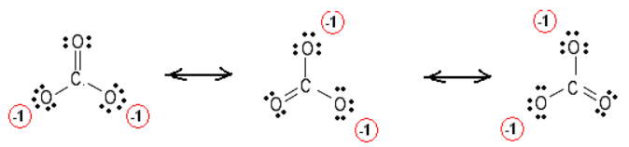

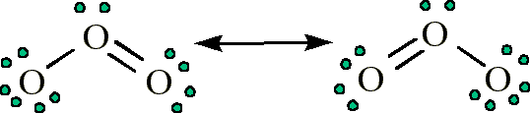

4. VSEPR Theory

Valence-Shell Electron-Pair Repulsion Theory states that the **repulsion** between electron pairs causes molecular shapes to adjust so that the **valence**-**electron** pairs stay as far apart as possible. This helps explain the various **geometry** of molecules.

a. **Linear** 🡪 diatomic molecules; CO2; BeH2. 180◦ bond angle. **Two** atoms bond on each side of a **central** atom. Give an example:

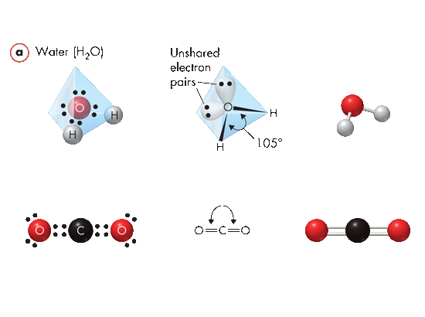

b. **Bent** 🡪 water, H2S, SO2. 105◦ bond angle. Two **unbonded** pairs of electrons repel so the geometry changes. (e.g., Central atom from group VIA) Give an example:

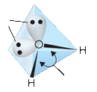

Unbonded pairs (repel)

c. **Trigonal Planar** 🡪 BF3; BCl3. 120◦ bond angle. **Three** electron pairs surround the **central** atom. (e.g., Central atom from group IIIA) Give an example:

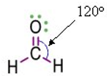

d. **Pyramidal** 🡪 PCl3. 107◦ bond angle. **One** unbonded electron pair repels the bonded electron pairs. (e.g., Central atom from group VA) Give an example:

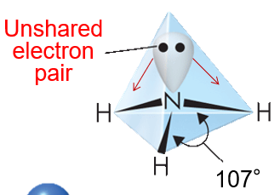

e. **Tetrahedral** 🡪 CH4; CCl4. 109◦ bond angle. **Four** equidistant bonded electron pairs around a **central** atom. (e.g., Central atom from group IVA) Give an example:

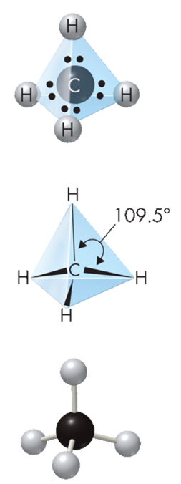

5. **Hybrid** Orbitals: sp, sp2, sp3

Simple atomic theory or VSEPR theory does not explain actual bond angles of many molecules. The diagrams below show the



**sp3 Hybrid Orbitals**

Carbon often bonds with a tetrahedral geometry (4 equidistant points from the center atom). The top electron dot diagram cannot justify such a bond, so the hybrid orbitals were proposed. One of the 2s electrons jumps to the 2p unoccupied orbital, forming 4 hybrid sp3 orbitals.

**sp2 Hybrid Orbitals**



Explains the trigonal planar shape (*equilateral triangle*) for single bonded atoms like Boron & for double bonded molecules like Ethene. One of the 2s electrons jumps to the 2p unoccupied orbital, forming 3 hybrid sp2 orbitals.

*Draw electron dot diagrams (in box provided) for B before & after hybridization.*

**spHybrid Orbitals**

Explains the linear shape for single bonded atoms like Beryllium difluoride (e.g., F-Be-F) & for double bonded molecules like carbon dioxide, and for triple bonded molecules like Ethyne (C2H2). One of the 2s electrons jumps to the 2p unoccupied orbital, forming 2 hybrid sp orbitals.



*Draw electron dot diagrams (in box provided) for Be before & after hybridization.*

INTERmolecular Attractions



MOLECULES can be attracted to each other by a variety of different forces called intermolecular attractions.

These are weaker than either ionic or covalent bonds that hold the individual ATOMS together.

Dispersion Forces are present between ALL molecules whether they are polar or nonpolar. They represent **TEMPORARY** “**dipole**” to “dipole” attractions).

**1. Van der Waals Forces**

VDW forces consist of dipole interactions and dispersion forces. The slightly **negative** region of a polar molecule is weakly attracted to the slightly **positive** region of another **polar** molecule.

F2, Cl2, Br2, or I2 molecules are diatomic **halogens** (same family/group), and have similar chemical properties and behaviors. Yet, F2 and Cl2 are **gases**, Br2 is a **liquid**, and I2 is a **solid**.

**2. Hydrogen Bonds**

A dipole – dipole attraction when hydrogen (*a very small atom)* bonds with a highly **electronegative** atom (e.g., O, F).

For water each O—H bond in the water molecule is highly **polar** (END 3.5 – 2.2 = 1.3), and the oxygen “end” acquires a slightly **negative** charge because of its greater electronegativity while the hydrogen “ends” acquire a slightly **positive** charge.

This explains water’s many special (unique) properties: a) **less** dense as a solid (ice floats); b) high **surface** tension, high specific **heat**.

**3. Network Solids**

**Large**, stable molecules forming a “network” of **covalent** bonds that extends throughout the solid. Also called network crystals.

**High** melting points (> 1000 C) due to a high strength of covalent bonds throughout the huge molecule. **Poor** conductors of heat and electricity. **Hard** crystals.

**Graphite** (paint, lubricants, pencils) and **diamonds** (jewelry, cutting tools) are “allotropes” of Carbon (same element with different forms). **Silicon** dioxide is found in sand, used in glass (optical instruments). Allotropes of Phosphorus are used for fireworks, water softening.