*This test should be taken WITHOUT notes, without textbook or any other outside resources. Approved Reference Materials may be used. Choose the best answer for each question*.

Multiple Choice:

Use the Answer Section below to place your answers. Suggestion: print out this page to write your answers while you take the test. You can scan or take a phone pic of the Answer page and insert it back into the test for grading (along with the problem section).

1.

2.

3.

4.

5.

6.

7.

8.

9.

10.

11.

12.

13.

14.

15.

16.

17.

18.

19.

20.

1. Identify the oxidizing agent in the following reaction: Mg(s) + S(s) → MgS(s)

a. Mg

b. S

c. This is a synthesis reaction, but not a redox reaction.

d. MgS

Questions 2 and 3 refer to the following image.

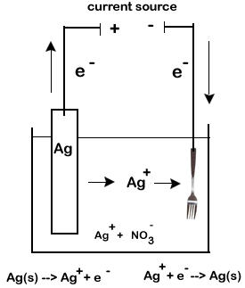

2. Which specific type of electrochemical cell is shown in the image?

a. voltaic cell

b. electroplating

c. electrolysis to split a compound into its elements

d. alkaline battery

3. What half-reaction is occuring on the "fork" side of the cell?

a. oxidation of Ag

b. reduction of Ag

c. oxidation of Ag+

d. reduction of Ag+

4. Which metal will react spontaneously with Cu2+(aq) at 25°C?

a. Ag

b. Au

c. Mg

d. Hg

5. Which of the following is TRUE for an electrolytic cell?

a. It changes electrical energy into chemical energy.

b. It is the type of cell used in electroplating.

c. It uses an electric current from an outside power source to make a nonspontaneous reaction go.

d. All of the above are true.

Question 6 refers to the following image.

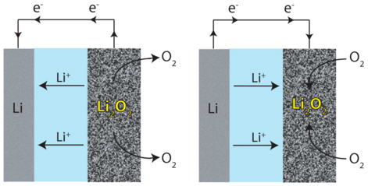

6. The image shows a reversible electrochemical reaction. Which specific electrochemical process is operating?

a. discharging and recharging battery

b. electrolysis to split a compound into its elements

c. half cell reactions of a typical voltaic cell

d. electroplating

7. Which is a redox reaction?

a. CaCO3 → CaO + CO2

b. NaOH + HCl → NaCl + H2O

c. 2NH4Cl + Ca(OH)2 → 2NH3 + 2H2O + CaCl2

d. 2H2O → 2H2 + O2

8. Nitrogen has the same oxidation number in all of the following except

a. NO3-

b. N2O5

c. NH4Cl

d. Ca(NO3)2

9. Determine what happens in this reaction: S(s) + Cl2(g) → SCl2(s) (Hint: Chlorine is the more electronegative element.)

a. Sulfur is reduced.

b. Chlorine is reduced.

c. Chlorine is oxidized.

d. Sulfur is the oxidizing agent.

Questions 10, 11 and 12 refer to the following image.

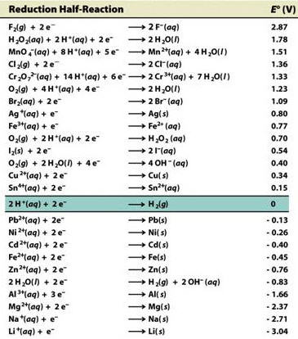

10. According to the SRP chart, which element will oxidize the others?

a. F2

b. Li

c. Zn

d. Mg

11. Does aluminum react with copper? What is the E0cell potential of these two metals?

a. yes ... 2.00 V

b. no ... -2.00 V

c. no ... 1.32 V

d. yes ... -1.32 V

12. Which of the following elements is the strongest reducing agent?



a. Fe

b. Na

c. Cl2

d. Ag

13. All of the following describe a salt bridge or porous barrier in an electrochemical cell EXCEPT that it:

a. contains electrolyte solution.

b. allows ions to flow between half-cells.

c. prevents buildup of charge on the electrodes.

d. recharges the voltaic cell after extended usage.

14. Fe(OH)2(s) + O2(g) + H2O(l) → Fe(OH)3(s) represents a corrosion reaction of iron. Which statement is NOT true?

a. Salts, acids, temperature, exposure all accelerate corrosion.

b. Coating the metal, reducing exposure, and replacing metal with plastic or alloys decreases corrosion.

c. The metal gets reduced and the oxidizing agent (often oxygen) is oxidized.

d. The metal gets oxidized and the oxidizing agent (often oxygen) is reduced.

15. Assuming that electrochemical cells are categorized into TWO groups, which of the following represents a different type of electrochemical cell than the others?

a. A dry cell that uses a paste, but has a short shelf life.

b. Fuel cells that do not need recharging.

c. Alkaline battery that shows no significant drop in voltage when used.

d. A lead storage battery that contains multiple cells.

e. Electroplating silver onto a piece of jewelry.

Questions 16 – 18 refer to the following image.

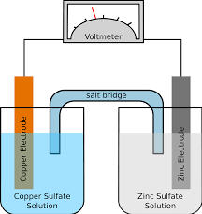

16. What kind of electrochemical cell is shown in the image?

a. A voltaic cell that has a spontaneous redox reaction.

b. A voltaic cell that has a nonspontaneous redox reaction.

c. An electrolytic cell that has a spontaneous redox reaction.

d. An electrolytic cell that has a nonspontaneous redox reaction.

17. Which electrode represents the anode and what is its sign?

a. copper, -

b. zinc, -

c. copper, +

d. zinc, +

18. Which way do the electrons flow in this redox reaction?

a. ... from copper to the voltmeter to zinc.

b. ... from zinc to the voltmeter to copper.

c. ... from zinc through the salt bridge to copper.

d. There is no way of knowing without further information.

Questions 19 – 20 refer to the following image.

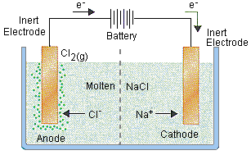

19. What type of electrochemical cell is shown in the image?

a. voltaic cell

b. electroplating

c. electrolysis to split a compound into its elements

d. alkaline battery

20. What is the half reaction at the anode?

a. 2Cl- → Cl2 + 2 e-

b. Cl2 + 2 e- → 2Cl-

c. Na+ + e- → Na

d. Na → Na+ + e-

Problems:

You MAY use calculators, periodic tables and approved reference tables. You MUST write the appropriate equation for each problem. You MUST show work for each problem to get full credit. Each question is assigned a specific number of points. You need to do 20 points total. If you do more than 20 points worth of questions, we will grade the first 20 points. [There is also an optional bonus question at the end.]

21. Based on the diagram:

a. write the half reactions at the appropriate electrodes

b. label which electrode is the anode, and which is the cathode

c. give the sign (+ or -) of the anode and cathode.

d. show the voltage potential of each half reaction

e. determine the total voltage potential of this redox reaction. [10 points]

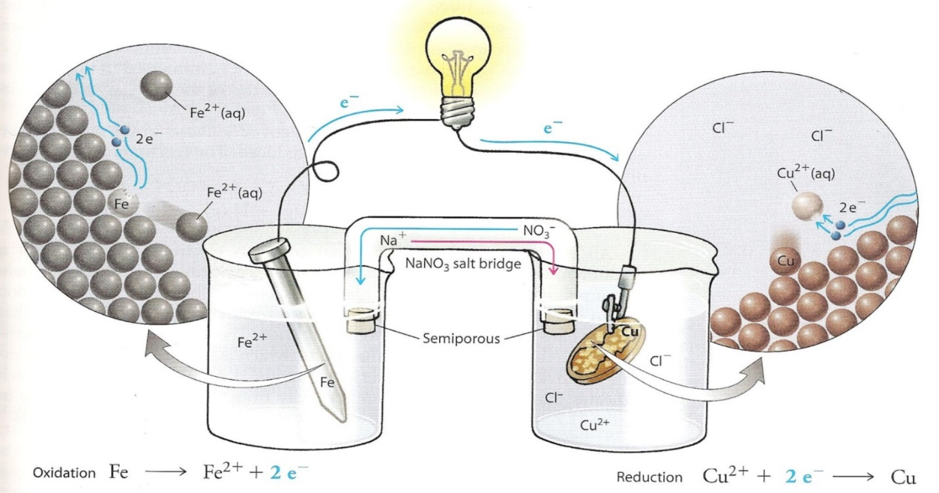

22. Balance the following redox equation, using either the oxidation-number-change method or the half-reaction method. You must show all your work, especially the total number of electrons transferred in the reaction. (*In using the half-reaction method, assume that the reaction occurs in an aqueous acid solution*.)

Fe2O3 + CO → Fe + CO2 (acid solution) [5 points]

23. Determine whether the following redox reactions are spontaneous as written? (Use the information in the table below. Show the half reactions and the potentials for each half reaction.)

a. 2Ag(*s*) + Mg2+(*aq*) → 2Ag+ (*aq*) + Mg(*s*) [5 points]

b. 2Al(*s*) + 3Zn2+(*aq*) → 2Al3+(*aq*) + 3Zn(*s*) [5 points]

|  |  |  |
| --- | --- | --- |
| Reduction Potentials at 25°C | | |
| Electrode | Half-Reaction | E0(V) |
| Mg2+/Mg | Mg2+ + 2*e*– → Mg | –2.37 |
| Al3+/Al | Al3+ + 3*e*– → Al | –1.66 |
| Zn2+/Zn | Zn2+ + 2*e*– → Zn | –0.76 |
| Ag2+/Ag | Ag+ + *e*– → Ag | +0.80 |

24. Based on the diagram:

a. write the half reactions at the appropriate electrodes

b. show the voltage potential of each half reaction

c. determine the total voltage potential of this redox reaction. [5 points]

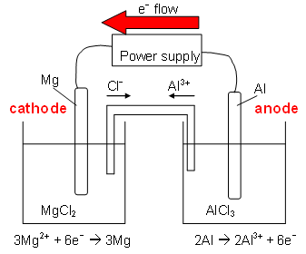

BONUS QUESTION (up to 4 pts):

Complete the chart and the paragraph below, stating the sign of the electrodes and the half reaction that occurs at each electrode for both voltaic and electrolytic cells.

|  |  |  |  |  |
| --- | --- | --- | --- | --- |
|  | Anode | Anode Sign | Cathode | Cathode Sign |
| Voltaic Cell |  |  |  |  |
| Electrolytic Cell |  |  |  |  |

In both voltaic and electrolytic cells, electrons flow from the _____ to the _____

through the external circuit. While the flow of electrons in a voltaic cell is caused by a spontaneous chemical reaction, in an electrolytic cell the flow of electrons is being pushed by an _____ _____ such as a _____.

|  |  |
| --- | --- |
| Oxidation Reaction | Eo (V) |
| Li → Li+ + e- | 3.04 |
| K → K+ + e- | 2.92 |
| Ba → Ba2+ + 2e- | 2.90 |
| Ca → Ca2+ + 2e- | 2.87 |
| Na → Na+ + e- | 2.71 |
| Mg → Mg2+ + 2e- | 2.37 |
| Al → Al3+ + 3e- | 1.66 |
| Mn → Mn2+ + 2e- | 1.18 |
| H2 + 2 OH- → 2H2O + 2e- | 0.83 |
| Zn → Zn2+ + 2e- | 0.76 |
| Cr → Cr2+ + 2e- | 0.74 |
| Fe → Fe2+ + 2e- | 0.44 |