Introduction to Biology!



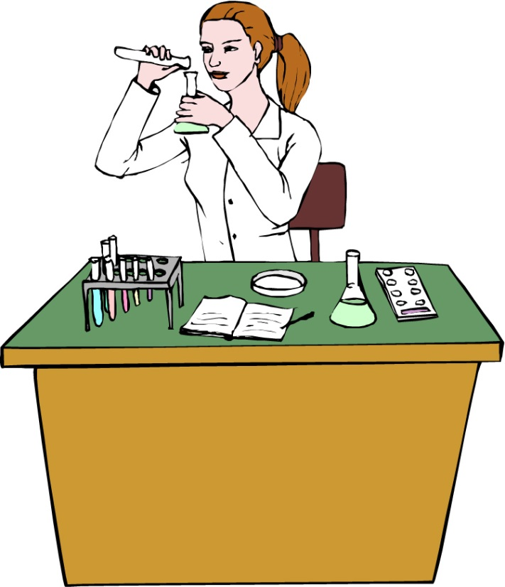

**See** [**https://www.learningctronline.com/courses**](https://www.learningctronline.com/courses) **for Materials and Resources.**

**Topics:**

1. Biology Introduction

**Objectives:**

1. Have a great start to Biology!
2. *Go over practical and technical issues to navigating course related issues.*
3. *Discuss the Characteristics of all Living Organisms.*
4. Explore the principles and practices of the Scientific Method.
5. Identify, label, and explain the parts and functions of a compound light microscope.

TAKE NOTE – expect to spend 8-10 hours/week on Biology (Honors 10-12 hours/week)

1. Review Policies
   1. Late Policy
   2. Grading & Pedagogy – expect to spend 8-10 hrs/week on Biology; Honors: 10-12 hrs/wk
   3. Test Corrections
2. Create a Biology folder on your Desktop with the following SUBfolders:
   1. Class Notes
   2. Homework
   3. Lab
   4. Test
   5. Reference Tables / Resources
3. Technology
   1. Zoom
   2. Tablet
   3. Lab Supplies
   4. Microsoft Word, PowerPoint, Excel compatibility (especially MAC users)
   5. Text
4. Review Conduct, Integrity, Plagiarism policy (<https://www.learningctronline.com/policies-conduct-integrity-plagiari>)
5. Notes/Study Guide
6. Homework from Text
7. Lab Microscopic Field
8. Chapter 1 Test Biology and Compound Light Microscope
9. Week 2 Devotional (<https://www.learningctronline.com/devotional>)

**Text**: Chapter 1: Introduction to Biology pp. 1-31

Read the assigned pages in the text.

**Class Notes: PowerPoint or PDF**

**Notes/Study Guide:** Fill in the Chapter 1 Study Guide worksheet to understand the class notes.

**Homework**: (2 weeks)

* Study Questions (at the end of the chapter in the text) #1-2, 6-8, 10-13, 15
* Use a Word document format as follows:
  + Start on a new page of your document
  + Heading: Your name, Chapter in Text, Study Questions
  + Number the appropriate questions you are to answer
  + Write the answer in a complete sentence use the question as the template (do not copy the question, but reword it into a statement that answers the question).
* Use the same document each week by starting a new “Study Question” for a different chapter on the next page.
* Assignments will be “spot checked” during class or submitted via email.

**Lab**: Microscope Field

* Complete the "Microscopic Field Lab" using the lab worksheet provided.
* After completing the Lab worksheet, email it to [learningctronline@gmail.com](mailto:learningctronline@gmail.com) for grading.
* Save document into your LAB folder in the Biology folder on your desktop.

**TEST:** Biology & Compound Microscope

1) the academic integrity policy

* Tests must be completed **WITHOUT** referring to books, notes, the internet, people, or any outside resources.
* A guardian should be proctoring the test as per Learning CTR Online policy: <https://www.learningctronline.com/test-proctor-policy>

2) This test is composed of 40 multiple choice questions.

* The **multiple-choice test must be taken "in one sitting"**, meaning that once you start the test, you must complete it without interruption. (50 minutes)
* Take a short break (5 minutes)
* There is no written portion of this test.

3) There is a **60-minute time limit** on this test. Please have the proctor write the time taken at the top of your answer sheet with their signature or initials.

4) Honors students have an additional 5 minutes to answer the additional questions.

5) Proctors should NOT be reading the test or engaging students during the test.

6) Do NOT use RED font. Black font is best.

Supplemental Resources (Optional)

1. Introduction to Biology Vocabulary Crossword

<https://youtu.be/3nAETHZTObk?list=PLwL0Myd7Dk1F0iQPGrjehze3eDpco1eVz> The Amoeba Sisters Channel – **Nature of Science** (9:51)

<https://youtu.be/cQPVXrV0GNA> The Amoeba Sisters Channel – **Characteristics of Life** (7:56)

<https://youtu.be/P30QlwSsUic?list=PLwL0Myd7Dk1F0iQPGrjehze3eDpco1eVz> The Amoeba Sisters Channel – **Casual and Scientific Use of “Theory” and “Law”** (5:00)