Problem Set: Nuclear Energy

1. Will brighter light eject more electrons from a photosensitive surface than dimmer light of the same frequency?

2. Will high-frequency light eject more electrons than low-frequency light?

3. When the tritium nucleus, 1H3, undergoes beta decay, what is the resulting nucleus?

4. The nucleus of beryllium-8, 4Be8, undergoes a special kind of radioactive decay, splitting into two equal nuclei. What are the products of this decay? What type of isotope is formed?

5. If 80 g of a sample of medicinal radioisotope has a half-life of 1.5 hours, how much of the original sample will be left after 4.5 hours?

6. A 2.4 kg sample of a C-14 radioisotope was reduced to 0.6 kg. The half-life of C-14 is 5,730 years. How old is the sample?

7. If two equal amounts of radioactive materials are tested with a Geiger counter, one has a short half-life and the other longer, which will get a higher reading?

8. Complete the following transmutations based on the decay involved:

a. 88Ra228 beta decay …

a. 84Po209 alpha decay …

9. What finally becomes of all the uranium-238 that undergoes radioactive decay?

10. An archeologist extracts a gram of carbon from an ancient bone and measures between 7 and 8 beta emissions per minute from the sample. A gram of carbon extracted from a fresh piece of bone gives off 15 betas per minute. Estimate the age of the bone.

11. Suppose the carbon sample from the ancient bone (question 10) were found to contain ¼ the radioactive carbon as the fresh bone. Estimate the age of the ancient bone.

12. Distinguish the types of radioactive decay. Which is most dangerous?

13. Compare the penetrating power of each type of radioactive decay. Which is most dangerous?

14. Distinguish an ion from an isotope.

15. How does the number of protons and electrons compare in a neutral atom?

16. Compare the protons, electrons, and neutrons between U-235 and U-238.

17. Why is less C-14 found in new bones than in ancient bones?

18. Why can one use carbon dating for the Dead Sea Scrolls, but not stone tablets?

19. Why are there deposits of lead in all uranium ore mines?

20. Why is radiation more intense at high altitudes and near the Earth’s poles?

21. What experimental evidence indicates that radioactivity is a process that occurs in the atomic nucleus?

22. What do different isotopes of the same element have in common?

23. What happens to alpha, beta, and gamma particles when streamed into an electric field?

24. Give the number of protons, electrons, and neutrons in each neutral element.

3Li6 6C14 26Fe56 80Hg201 94Pu239

p+

e-

n

25. Distinguish fission from fusion.

26. What is a chain reaction related to nuclear energy? Why is it significant?

27. What is the function of control rods in nuclear reactors?

28. What is involved in a breeder reactor?

29. What is the fundamental premise of E = mc2? Where does the energy originate from?

30. What particle initiates nuclear fission? Why are these particles better than others?

31. List and describe the subatomic particles that comprise protons and neutrons.

32. List the types of quarks and give their electric charge.

33. List the types of quarks and electric charge related to protons, neutrons, and mesons.

ANSWERS

1. Will brighter light eject more electrons from a photosensitive surface than dimmer light of the same frequency?

**Frequency is related to the energy of the light. The number of ejected electrons depends on the number of incident photons that hit the surface. Most likely, brighter light will eject more electrons as long as the frequency is beyond the threshold.**

2. Will high-frequency light eject more electrons than low-frequency light?

**Frequency is related to the energy of the light. The number of ejected electrons depends on the number of incident photons that hit the surface. The frequency must be greater than the threshold frequency whether it is high or low frequency incident light.**

3. When the tritium nucleus, 1H3, undergoes beta decay, what is the resulting nucleus?

**Beta decay involves the loss of an electron and an antineutrino and the gain of a proton. The result is an isotope of helium: 1H3 🡪 2He3 + -1e0.**

4. The nucleus of beryllium-8, 4Be8, undergoes a special kind of radioactive decay, splitting into two equal nuclei. What are the products of this decay? What type of isotope is formed?

**Both nuclei would be alpha particles: 4Be8 🡪 2He4 + 2He4.**

5. If 80 g of a sample of medicinal radioisotope has a half-life of 1.5 hours, how much of the original sample will be left after 4.5 hours?

**4.5 hours / 1.5 hours/half-life = 3 half-lives. 80 g 🡪 40 g 🡪 20 g 🡪 10 g**

6. A 2.4 kg sample of a C-14 radioisotope was reduced to 0.6 kg. The half-life of C-14 is 5,730 years. How old is the sample?

**2.4 kg 🡪 1.2 kg 🡪 0.6 kg = 2 half-lives. 2 x 5730 = 11, 460 years**

7. If two equal amounts of radioactive materials are tested with a Geiger counter, one has a short half-life and the other longer, which will get a higher reading?

**The shorter the half-life, the more radioactive the material.**

8. Complete the following transmutations based on the decay involved:

a. 88Ra228 beta decay … 88Ra228 **🡪 89Ac228 + + -1e-0**

a. 84Po209 alpha decay … **84Po209 🡪 82Pb205 + 2He4**

9. What finally becomes of all the uranium-238 that undergoes radioactive decay?

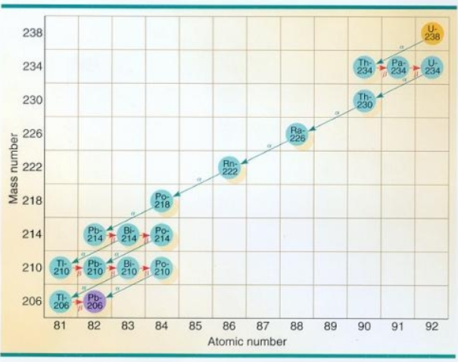

**All the U-238 will eventually become stable lead, Pb. On the way to becoming lead, it will exist as a series of other elements.**

10. An archeologist extracts a gram of carbon from an ancient bone and measures between 7 and 8 beta emissions per minute from the sample. A gram of carbon extracted from a fresh piece of bone gives off 15 betas per minute. Estimate the age of the bone.

**Since beta emissions for the old sample is one-half that of the fresh sample, about one half-life has passed. The half-life of carbon-14 is 5730 years.**

11. Suppose the carbon sample from the ancient bone (question 10) were found to contain ¼ the radioactive carbon as the fresh bone. Estimate the age of the ancient bone.

**The ancient bone is two half-lives of C-14. The half-life of carbon-14 is 5730 years x 2 = 11,460 years.**

12. Distinguish the types of radioactive decay. Which is most dangerous?

**Alpha decay is a helium nucleus. Beta decay is an electron. Gamma decay is an electromagnetic ray of high energy.**

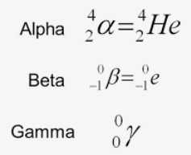

13. Compare the penetrating power of each type of radioactive decay. Which is most dangerous?

**Alpha decay cannot penetrate paper. Beta decay can penetrate paper and implant into thin sheets of metal (e.g. aluminum). Gamma decay penetrates the most and is therefore, the most dangerous.**

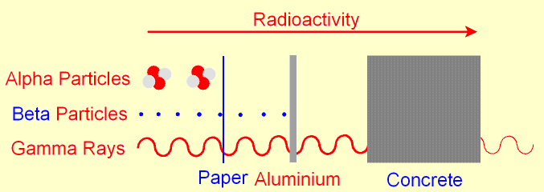

14. Distinguish and ion from an isotope.

**Ions are charged particles or atom containing an unequal number of protons and electrons. Isotope are the same element (with the same number of protons and electrons), but different number of neutrons.**

15. How does the number of protons and electrons compare in a neutral atom?

**Neutral atoms contain an equal number of protons and electrons.**

16. Compare the protons, electrons, and neutrons between U-235 and U-238.

**Uranium’s atomic number (protons) is 92. A neutral atom of U-235 or U-238 has 92 protons and 92 electrons. U-235 has 143 neutrons, while U-238 has 146 neutrons. Neutrons are determined by atomic mass – atomic number.**

17. Why is more C-14 found in new bones than in ancient bones?

**C-14 is radioactive and decays away over time.**

18. Why can one use carbon dating for the Dead Sea Scrolls, but not stone tablets?

**The scrolls contain carbon from formerly living things, but stone does not.**

19. Why are there deposits of lead in all uranium ore mines?

**Lead is a byproduct of uranium decay.**

20. Why is radiation more intense at high altitudes and near the Earth’s poles?

**Radiation (including sunlight that yields sunburns) increases at high altitudes and the poles because there is less shielding.**

21. What experimental evidence indicates that radioactivity is a process that occurs in the atomic nucleus?

**Atoms can release huge amounts of energy when the nuclei splits or fuses. Atomic mass and charge vary even to create different elements from the original (transmutation).**

22. What do different isotopes of the same element have in common?

**Elements have characteristic properties, both physical and chemical. Isotopes of the same elements have the same number of protons and electrons.**

23. What happens to alpha, beta, and gamma particles when streamed into an electric field?

**Alpha particles (+) and beta particles (-) would be deflected in opposite directions, but gamma particles (no charge) would be undeflected and pass through.**

24. Give the number of protons, electrons, and neutrons in each neutral element.

3Li6 6C14 26Fe56 80Hg201 94Pu239

p+ 3 6 26 80 94

e- 3 6 26 80 94

n 3 8 30 121 145

**Neutral elements** **have the same number of protons and electrons.**

25. Distinguish fission from fusion.

**Fission is the splitting of an atom’s nucleus, releasing huge amounts of energy. Fusion is the joining of nuclei of at least two atoms, also yielding huge amounts of energy.**

26. What is a chain reaction related to nuclear energy? Why is it significant?

**Chain reactions are self-sustaining, meaning that once started, it continues indefinitely because one reaction event triggers another. When atoms split, neutrons are released and bombard other atoms.**

27. What is the function of control rods in nuclear reactors?

**Control rods absorb neutrons which trigger nuclear reactions. They control the number of neutrons that can participate in chain reactions. Inside the reactor, controls rods absorb a lot of neutrons.**

28. What is involved in a breeder reactor?

**Plutonium (Pu-239) is fissionable and is mixed with uranium-238. Since Pu-239 is fissionable, it releases neutrons that convert U-238 to Pu-239. These reactors “breed” more fuel than what was originally present.**

29. What is the fundamental premise of E = mc2? Where does the energy originate from?

**According to the law of conservation of mass and energy, mass or energy cannot be created or destroyed. However, Einstein understood that nuclear reactions seemingly “lost” mass. In reality the “lost” mass was actually converted into a specific amount of energy that is always the same.**

**When atoms are split, energy goes into Kinetic Energy of the moving fragments.**

30. What particle initiates nuclear fission? Why are these particles better than others?

**Neutrons are most used in nuclear fission because they have no charge and so are undeflected in charged electric fields (protons, electrons would be deflected). Electrons will be attracted to a nucleus, while protons will be repelled from a nucleus, but neutrons will be unaffected.**

31. List and describe the subatomic particles that comprise protons and neutrons.

* **Hadrons are particles that experience the strong nuclear force.**
* **Baryon implied a heavy subatomic particle.**
* **Meson implies particles with much lower masses.**

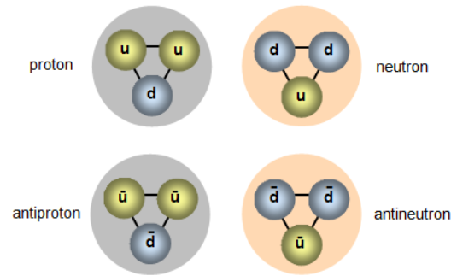

32. List the types of quarks and give their electric charge.

There are six quarks with anti-quarks (same magnitude, but opposite sign): **up quark**, **down quark, strange quark**, **charm quark**, **top quark**, and **bottom quark**.

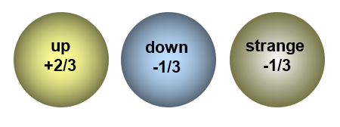



**bottom**

**charm**

**top**

**+2/3**

33. List the types of quarks and electric charge related to protons, neutrons, baryons, & mesons.

* Baryons are composed of 3 quarks so their charges are +1/3 e.
* Mesons are composed of a quark and an antiquark so their charges are +1 e, 0, or -1 e.

