**Static Electricity & Magnetism (Week 1)**

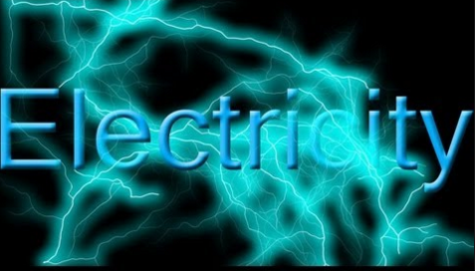



**See** [**https://www.learningctronline.com/courses**](https://www.learningctronline.com/courses) **for Materials and Resources.**

**Topics:**

1. Static Electricity & Magnetism (week 1 of 3)

**Objectives:**

* Which particle is involved in transfer of charge between objects?
* Compare and contrast Static Electricity and Magnetism (similarities, differences).
* Explain the source of electrostatics and how objects are affected by it.
* Identify properties of magnetic objects.
* Explain friction, induction and conduction related to electrostatics and magnetism.

TAKE NOTE

1. Reading (Hewitt Text)

1. Notes Static Electricity
2. Lab Movement of Charge

1. Problem Set 1: Static Electricity (2 weeks)
2. Elicitation of Static Electricity & Magnetism
3. Lab: Torsion Apparatus & Static Electricity – Rub / UnRub
4. Lab: Magnetism Properties
5. Class Song: Work Hard
6. Week 21 Devotional (<https://www.learningctronline.com/devotional>)

**Text**: Chapters 32 – 33, 36 Static Electricity & Magnetism (Hewitt)

**Class Notes: Use the Document provided**

**Homework**:

* Problem Set 1: Static Electricity (2 weeks)
* Build Torsion Apparatus for labs (before recitation)

**Lab**: Movement of Charge Activity

* Perform the lab as directed using the worksheet provided.
* Complete all calculations and data, showing work whenever appropriate.
* Conclusions should be answered in complete sentences that convey a complete thought.
* Save the documents into your LAB folder in the Physics folder on your desktop.

**Lab**: Torsion Apparatus & Static Electricity – Rub / Unrub

* Perform the lab as directed using the worksheet provided.
* Complete all calculations and data, showing work whenever appropriate.
* Conclusions should be answered in complete sentences that convey a complete thought.
* Save the documents into your LAB folder in the Physics folder on your desktop.

**Lab**: Magnetism Properties

* Perform the lab as directed using the worksheet provided.
* Complete all calculations and data, showing work whenever appropriate.
* Conclusions should be answered in complete sentences that convey a complete thought.
* Save the documents into your LAB folder in the Physics folder on your desktop.

**TEST:** No Quiz this week.

Supplemental Resources (Optional)

1. Static Charges on Material (Reference)
2. Demagnetizing Materials (Reference)

<http://somup.com/cr1ro0qJdH> Demagnetizing Objects (1:50)

<http://somup.com/cFX2YDnjcj> Beaker’s Ode to Joy (1:41)

<http://somup.com/cFX2YInjch> Electric Force (Cows) (0:18)

<http://somup.com/cr10Dfqslf> Electric Forces Attraction & Repulsion (1:24)

<https://phet.colorado.edu/en/simulation/balloons>