**Newton’s Laws of Motion Chapter 12.2**

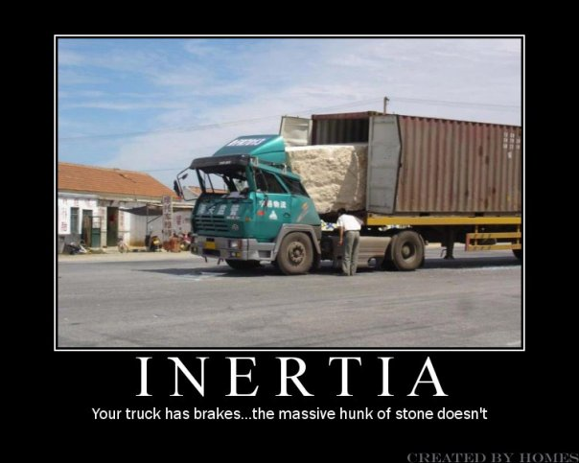

**See** [**https://www.learningctronline.com/courses**](https://www.learningctronline.com/courses) **for Materials and Resources.**

**Topics:**

1. Newton’s Laws of Motion

**Objectives:**

* Explain & recognize Newton’s First Law of Motion, Inertia, as the tendency of matter to resist change in motion.
* Understand projectile motion as a combination of an initial forward velocity and the downward vertical force of gravity resulting in a curved path.
* Understand and explain friction [recognizing four kinds of friction] as a force that opposes motion, producing negative acceleration or “deceleration”.
* Explain & calculate variables of Newton’s Second Law of Motion, f = ma, describing how force, acceleration, and mass are related. Force equals mass times acceleration.

TAKE NOTE

1. Guided Reading Note-Taking Worksheet (Pearson Text)
2. Pearson Concepts in Action Worksheets
3. Newton’s 1st & 2nd Laws of Motion Activities Worksheet (12 WS)
4. Lab Speed (Formal Lab Report) … due in TWO days
5. Lab Quiz: Newton’s 1st Law and Friction Activities
6. Class Song: The Minute You Came to This Class
7. Week 19 Devotional (<https://www.learningctronline.com/devotional>)

**Text**: Chapter 12.2: Newton’s Laws of Motion pp. 363-369

**Guided Reading Note-Taking Worksheet:**

Complete the worksheet for Chapter 12.2: Forces & Motion.

**Class Notes: PowerPoint or PDF**

**Homework**:

* 12.2 Newton’s 1st & 2nd laws of Motion Worksheet (Pearson Concepts in Action)
* 12 WS Newton’s 1st & 2nd Laws of Motion Activities Worksheet
* Assignments will be “spot checked” during class or submitted via email.

**Lab**: Newton’s 1st Law of Motion & Friction Activities (12aL)

* Complete the activities using the worksheet provided.
* Save the documents into your LAB folder in the Physical Science folder on your desktop.
* *Assignments will be “spot checked” during class or submitted via email.*

**TEST:** The test will be given after next week’s lesson.

Supplemental Resources (Optional)

1. Friction Lab
2. Newton’s 2nd Law Lab

[**http://somup.com/cFXh00n1kH**](http://somup.com/cFXh00n1kH) **Projectile Motion (0:15)**

* **Showing the cart and ball BOTH moving with constant velocity**
* **Showing the ball moving in a curved path (projectile motion: trajectory)**
* **Newton's 1st Law (inertia**

[**http://somup.com/cFXh0bn1kE**](http://somup.com/cFXh0bn1kE) **Projectile Motion 2 (0:27) similar experiment to above.**

<http://somup.com/cFXh0Un1k7> Newton's Laws of Motion Overview Sports (3:12)

<http://somup.com/cFXh04n1kN> Newton's Laws of Motion Overview Hockey (5:22)

<http://somup.com/cFXh0gn1kP> Newton's 1st Law of Motion: Inertia (3:37) Football

<http://somup.com/cFXh05n1kR> Newton's 2nd Law of Motion (3:37) Football Place Kicker

<http://somup.com/crhT28qX2y> Friction Lab (2:35)

<http://somup.com/cYVZDwfWoH> Car Racing (1:15)

<http://somup.com/cYhFoTjyjP> Knowledge Puffs Up Love Builds Up 1 Corinthians 8:1-2; Basin and the Towel (3:41)