Static Electricity Electron Movement

## PART 1 Which Particle Is Transferred in Electrostatics?

# **Introduction**

# **Purpose** To observe evidence for which atomic particle is transferred during electrostatic interactions between materials.

**Discussion**

It is difficult to prove which direction “charges” flow without some kind of convention. We will use the terminals of a battery to define the positive and negative charge flow in order to determine which charge moves during normal electrostatic and current interactions.

**Materials** LED diode Pie Tin Apparatus 2 Alligator clips

Wool Cloth Ten 9 V batteries One 330 -1 K-Ohm Resistor

Styrofoam Acrylic

**Procedures** [**http://somup.com/cZn2YXprgV**](http://somup.com/cZn2YXprgV) **(2:11) Particle Transfer**

**Part 1** The best is for you to do this experiment yourself. However, answers are provided if you cannot. Set up the system as shown below:

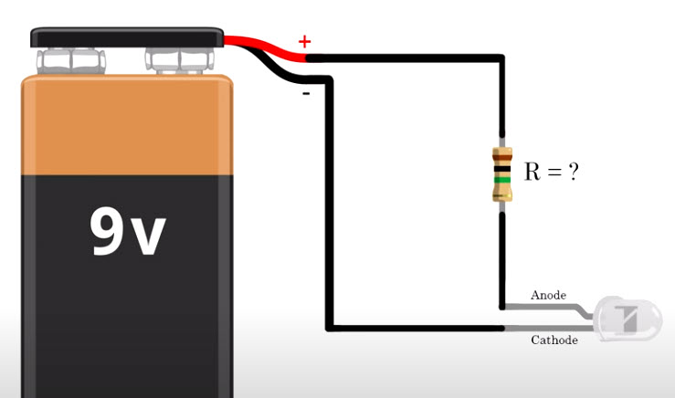

*330 - 1 K-Ohm resistor*

*Two filament LED diode*

*2 double ended Alligator clips*

*9-10 9V batteries in series*

resistor

-

+

9V

a. Observe which side of the diode lights up (both, - end, or + end).

b. Switch the alligator clips (at the terminals) so they are connected to the opposite terminal as before. Observe which side of the diode lights up (both, - end, or + end).

**Part 2** Watch the following video: <http://somup.com/cr10oOqsjp> Transfer of Charge & Charge by Induction (1:44)

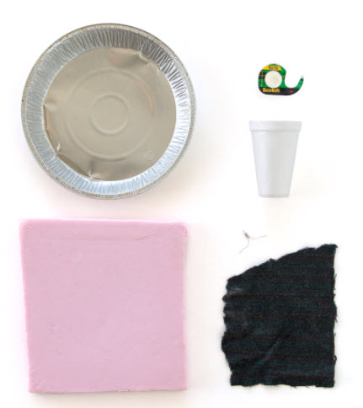

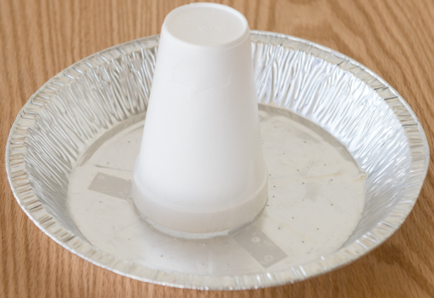

Pie Tin Apparatus

* Tape an inverted Styrofoam cup to an aluminum pie tin as shown.

a. Obtain a piece of Styrofoam (plate or square), a piece of acrylic (plastic or Saran Wrap), a LED diode and a pie tin apparatus. If you can’t obtain a diode, you can use the Torsion Test stand with a rubbed coffee stirrer.

* Rub the Styrofoam and Acrylic together to produce charged surfaces.
* Lay the unrubbed surface of the Styrofoam on the table so that the rubbed surface faces upwards.
* Place the pie tin apparatus directly on top of the RUBBED surface as shown.
* Hold the LED diode by the outside wire and bring the other wire near the pie tin. The diode should light up.
* Observe which diode lights up (nearest the pie tin or away from the pie tin) … record this observation.

b. Rub the Styrofoam and Acrylic together again to produce charged surfaces.

* Lay the unrubbed surface of the Acrylic on the table and place the pie tin apparatus directly on top of the RUBBED surface of the Acrylic.
* Hold the LED diode by the outside wire and bring the other wire near the pie tin. The diode should light up.
* Observe which filament lights up (nearest the pie tin or away from the pie tin) … record this observation.

## Part 3 Transfer of Electrons

# **Purpose** To perform several activities in order to see evidence for which atomic particle is transferred during electrostatic interactions between materials.

**Materials** LED diode Pie Tin Apparatus Styrofoam Plate

Wool Cloth Piece of Tinsel Clear Tape

**Procedures**

tinsel

Styrofoam Square

Pie Tin Apparatus

1. If you can’t obtain a diode, you can use the Torsion Test stand with a rubbed coffee stirrer.

2. Place the Pie Tin Apparatus up-side-down so that the Styrofoam cup is pointing upwards.

3. Tape a 2-3” long piece a tinsel to the Pie Tin Apparatus.

4. Remove the pie tin apparatus in order to vigorous rub the Styrofoam square with a wool cloth for 20-30 seconds. Set the wool cloth down on the desk or lab table, and place the Pie Tin Apparatus against (*on top of*) the Styrofoam square as shown. What happens to the tinsel piece?

5. Hold one of the wires of the LED diode with your thumb and index finger only. Bring the other wire (*the one you are not holding*) of the LED diode near the Pie Tin Apparatus until you see the LED diode light up. *Be sure to notice which filament of the LED diode lights up for each procedure and relate this to the previous demonstration.* Which filament lit up?

6. Pull the Pie Tin Apparatus off the Styrofoam square. Rub the Styrofoam square with the wool cloth. Place the Pie Tin Apparatus on the Styrofoam and touch the pie tin with your index finger. What happened to the tinsel?

7. Hold one of the wires of the LED diode with your thumb and index finger only. Bring the other wire (*the one you are not holding*) of the LED diode near the Pie Tin Apparatus until you see the diode light up. Which filament lit up?

8. Repeat the procedures again, but this time pull the pie tin off the Styrofoam square before bringing the LED diode near. Describe the tinsel and diode.

## Conclusions and Questions

1. Does Part II of this lab give evidence that negative charges flow rather than positive? If so, explain.

2. Which charge is on the rubbed Styrofoam plate based on your observations? Give evidence to support your answer.

3. Which charge is on the Pie Tin Apparatus when brought in contact with the rubbed Styrofoam square?

4. Based on previous labs, which charge would be on the acrylic plate after rubbing it with Styrofoam? Give evidence to support your answer.

5. Were you able to see the LED diode light up before it actually touched the pie tin or was it necessary to touch the pie tin? Suppose it would light up without touching the pie tin. What would account for this?

6. Was there a difference when you tested the pie tin without touching it versus after touching it. If there was a difference, what might account for this?

7. Based on your observations and deductions due to conventions we have defined, which atomic charge is moving during electrostatic interactions?

8. Assume that the size of an atom is approximately 10-10 m in diameter and the size of that atom’s nucleus is 10-15 m. Using your knowledge of atomic structure, explain how these measurements give some evidence supporting the movement of negative particles rather than positive particles in electrostatic interactions.

## Answers

**Procedures**

**Part 1** The best is for you to do this experiment yourself. However, answers are provided if you cannot. Set up the system as shown below:

a. Observe which side of the diode lights up (both, - end, or + end).

resistor

-

+

9V

**The light shines on the negative terminal side of the battery. Notice the right side is lit up.**

b. Switch the alligator clips (at the terminals) so they are connected to the opposite terminal as before. Observe which side of the diode lights up (both, - end, or + end).

-

+

9V

resistor

**The battery was reversed. The light still shines on the negative terminal side of the battery. Notice the left side is lit up.**

**Part 2**

* Rub the Styrofoam and Acrylic together to produce charged surfaces.
* Lay the unrubbed surface of the Styrofoam on the table so that the rubbed surface faces upwards.
* Place the pie tin apparatus directly on top of the RUBBED surface as shown.
* Hold the LED diode by the outside wire and bring the other wire near the pie tin. The diode should light up.
* Observe which diode lights up (nearest the pie tin or away from the pie tin) … record this observation.

**The Styrofoam takes on a NEGATIVE charge and the LEFT filament lights up in the diode.**

b. Rub the Styrofoam and Acrylic together again to produce charged surfaces.

* Lay the unrubbed surface of the Acrylic on the table and place the pie tin apparatus directly on top of the RUBBED surface of the Acrylic.
* Hold the LED diode by the outside wire and bring the other wire near the pie tin. The diode should light up.
* Observe which filament lights up (nearest the pie tin or away from the pie tin) … record this observation.

**The acrylic takes on a POSITIVE charge and the RIGHT filament lights up in the diode (opposite side of the Styrofoam procedure).**

**Part 3**

tinsel

Styrofoam Square

Pie Tin Apparatus

4. Remove the pie tin apparatus in order to vigorous rub the Styrofoam square with a wool cloth for 20-30 seconds. Set the wool cloth down on the desk or lab table, and place the Pie Tin Apparatus against (*on top of*) the Styrofoam square as shown. What happens to the tinsel piece?

**The tinsel should repel straight out because it shares the charge of the pie tin (metal to metal conduction).**

5. Hold one of the wires of the LED diode with your thumb and index finger only. Bring the other wire (*the one you are not holding*) of the LED diode near the Pie Tin Apparatus until you see the LED diode light up. *Be sure to notice which filament of the LED diode lights up for each procedure and relate this to the previous demonstration.* Which filament lit up?

**The filament nearest the Styrofoam lit up because the electrons flowed from the NEGATIVELY charged Styrofoam to the diode to your finger.**

6. Pull the Pie Tin Apparatus off the Styrofoam square. Rub the Styrofoam square with the wool cloth. Place the Pie Tin Apparatus on the Styrofoam and touch the pie tin with your index finger. What happened to the tinsel?

**The tinsel should repel straight out because it shares the charge of the pie tin (metal to metal conduction).**

7. Hold one of the wires of the LED diode with your thumb and index finger only. Bring the other wire (*the one you are not holding*) of the LED diode near the Pie Tin Apparatus until you see the diode light up. Which filament lit up?

**The filament away from the Styrofoam/pie tin lit up because the electrons flowed from your finger to the diode to the NEGATIVELY charged Styrofoam. The pie tin became POSITIVELY charged.**

8. Repeat the procedures again, but this time pull the pie tin off the Styrofoam square before bringing the LED diode near. Describe the tinsel and diode.

**The pie tin and Styrofoam had opposite charges. The pie tin was POSITIVELY charged and the Styrofoam was NEGATIVELY charge.**

## Conclusions and Questions

1. Based on this lab which particle flows related to electrostatics and current? Explain and/or give evidence to support your answer.

**The negative charges flow rather than positive. When using the LED diode, the filament nearest the NEGATIVE terminal of the battery lit up and the other filament did not light up. If we assume that electrons flow from the anode (negative terminal of the battery) towards the cathode (positive terminal of the battery) in the OUTSIDE circuit, then electrons flowed from the negative terminal to the LED diode and then to the positive terminal of the battery.**

2. Which charge is on the rubbed Styrofoam plate based on your observations? Give evidence to support your answer.

**The Styrofoam takes on a NEGATIVE charge (after being rubbed with acrylic). The LED diode filament closest to the pie tin lit up, indicating the electrons were flowing from the pie tin towards the diode and your finger.**

3. Which charge is on the Pie Tin Apparatus when brought in contact with the rubbed Styrofoam square?

**The pie tin was NEUTRAL because it was not rubbed. The Styrofoam is an insulator so the charges are “stuck” or do not flow easily unless there is grounding.**

4. Based on previous labs, which charge would be on the acrylic plate after rubbing it with Styrofoam? Give evidence to support your answer.

**The acrylic takes on a POSITIVE charge (after being rubbed with Styrofoam). The LED diode filament closest to your finger (opposite the pie tin), indicating the electrons were flowing from your finger towards the diode and the pie tin.**

5. Were you able to see the LED diode light up before it actually touched the pie tin or was it necessary to touch the pie tin? Suppose it would light up without touching the pie tin. What would account for this?

**The LED diode did light up (not that brightly) because charges were induced (rearranging without objects touching).**

6. Was there a difference when you tested the pie tin without touching it versus after touching it. If there was a difference, what might account for this?

**There is a significant difference when touching the pie tin versus not touching it. This is due to GROUNDING. Induction rearranges the charges but does not transfer charges UNTIL grounding occurs. Charging by induction requires GROUNDING which causes charges to transfer between objects. Our finger represented the grounding agent in this experiment because the charges would transfer to the finger, through the body, to the ground. This is how we get shocked when rubbing our feet on a carpet during the dry, cool, winter days. When our finger gets close to a metal object, charges jump the gap into our finger to the ground, shocking us.**

7. Based on your observations and deductions due to conventions we have defined, which atomic charge is moving during electrostatic interactions?

**The electron is the particle of the atom that moves during electrostatic interactions. Excess electrons produce a NEGATIVELY charged surface. When electrons leave a surface, it becomes POSITIVELY charged.**

8. Assume that the size of an atom is approximately 10-10 m in diameter and the size of that atom’s nucleus is 10-15 m. Using your knowledge of atomic structure, explain how these measurements give some evidence supporting the movement of negative particles rather than positive particles in electrostatic interactions.

**The size of the nucleus is 1/10,000th the size of the average atom, meaning that the atom is mostly empty space occupied by electrons which are constantly moving. Therefore, it is easy for electrons to flow or transfer compared to the protons in the nucleus.**