Creation / Evolution

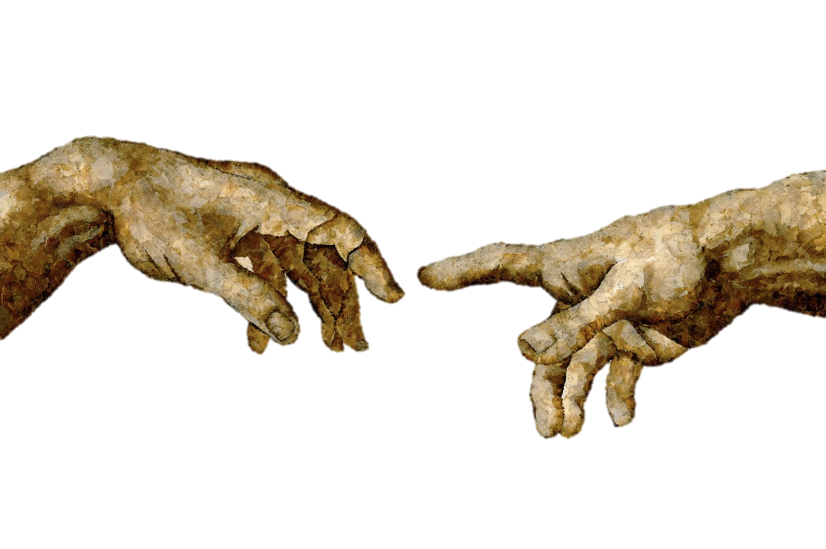

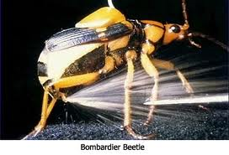 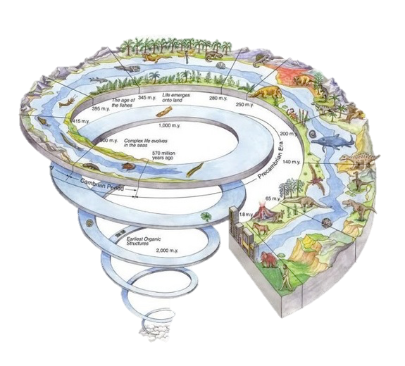

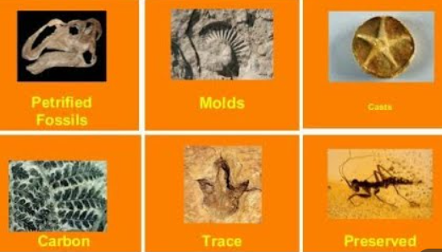

**See** [**https://www.learningctronline.com/courses**](https://www.learningctronline.com/courses) **for Materials and Resources.**

**Topics:**

1. Creation / Evolution / Fossils

**Objectives:**

1. Establish the best way to deal with a potentially controversial and contentious issue.
2. Identify and dismantle misconceptions related to creation / evolution.
3. Learn and practice the appropriate questions to ask in a discussion of creation / evolution.
4. Understand the fossil record, its place in earth’s history, and the use of radioactive dating.

TAKE NOTE (most assignments due before next class)

1. Test Corrections (due before next week’s class)
2. Lab Bug Karyotype LAB REPORT (due in 2 days)
3. Notes/Study Guide (1 week)
4. Lab Fossil Identification
5. Lab Radioactivity Simulation
6. Worksheet Fossils
7. Honors 🡪 Radioactive Dating Worksheet
8. Week 19 Devotional (<https://www.learningctronline.com/devotional>)

**Text**: Chapters 17 & 19: Creation / Evolution pp. 292 – 337; 380 – 441

Read the assigned pages in the text. This is optional.

**Class Notes: PowerPoint or PDF**

**Notes/Study Guide:** Fill in the Study Guide worksheet to understand the class notes.

**Homework**: (1 week)

* Worksheet Fossils
* Assignments will be “spot checked” during class or submitted via email.

**Lab**: Fossil Identification

* Complete the "Fossil Identification" lab using the lab worksheet provided.
* After completing the Lab worksheet, email it to [learningctronline@gmail.com](mailto:learningctronline@gmail.com) for grading.
* Save document into your LAB folder in the Biology folder on your desktop.

**Lab**: Radioactivity Simulation

* Complete the Radioactivity Simulation using the lab worksheet provided.
* After completing the Lab worksheet, email it to [learningctronline@gmail.com](mailto:learningctronline@gmail.com) for grading.
* Save document into your LAB folder in the Biology folder on your desktop.

**TEST:** No Quiz this week

Supplemental Resources (Optional)

1. Practice Quiz (Fossils & Dating)
2. Text Outline

***<https://somup.com/c31vDmuc3J> Incredible Creatures that Defy Evolution 1 (9:04) Dr. Jobe Martin, former evolutionist, Bombardier Beetle and Giraffe***

[***https://somup.com/c31vbiucZy***](https://somup.com/c31vbiucZy) ***Incredible Creatures that Defy Evolution 2 (11:23) Woodpecker, Golden Plover***

<http://somup.com/cZVbFDkpHP> (6:58) Young Earth or Old Earth? [by Christians]