Static Electricity – Transfer of Charge, Insulators, Conductors

**Part 1 Can Electrical Effects Transfer Through a Material?**

**Discussion** Are all objects that can be made to attract or repel other objects electrically alike? (*For instance, in a lightning storm, is it safer to hold an aluminum baseball bat or a wooden one*?)

# **Materials** Styrofoam Cup Tinsel Coffee Stirrer Acrylic Piece

Wool cloth if needed Styrofoam Piece Aluminum Strip Clear Tape

Piece of Metal Hanger 3” Finish Nail Glass Rod

**Procedures**

1. Prepare an electrostatic indicator using tinsel on clear acrylic tape. Stick 3-4 pieces of tinsel (*about 5-6 cm in length each*) to a piece of clear tape so that they can hang freely below the tape and the taped ends are TOGETHER. This is your “tinsel indicator.” *It’s a cheap way to get pretty sensitive electrostatic results*.

tape

2. You will be attaching this “tinsel indicator” to various objects in order to observe the effect of electrostatics on different kinds of materials. Discharge the tinsel by lightly brushing it with your fingers BEFORE bringing any objects near it.

3. Stick the tinsel indicator to the edge of your desk or table so that it hangs freely over the edge without touching the desk. “Discharge the tinsel indicator” by brushing it lightly. Rub a plastic straw with wool and bring it close to the tinsel indicator. RECORD your observations.

4. Repeat procedure #3, except this time rub the plastic straw in your hair and bring it close to the tinsel indicator. RECORD your observations. COMPARE the results when using wool versus hair to “rub” the plastic straw.

5. Obtain a Styrofoam cup and place it upside down on your table or desk. Place piece of metal hanger on top of the cup. Then, attach the tinsel indicator to one end of the hanger piece.

Metal hanger

Tinsel Indicator

Inverted

Styrofoam Cup

Coffee Stirrer

6. IMAGINE bringing a wool rubbed plastic coffee stirrer near the end of the hanger piece OPPOSITE the tinsel indicator and rubbing the coffee stirrer against the non-tinsel end of the piece of hanger. PREDICT what would happen, if anything, to the tinsel indicator.

7. Likewise, IMAGINE replacing the piece of metal hanger with other materials as listed in the prediction table below. PREDICT what would happen, if anything, to the tinsel indicator in each case. Complete the prediction table for each of the objects listed.

PREDICTION TABLE

|  |  |  |  |  |  |  |
| --- | --- | --- | --- | --- | --- | --- |
| **MATERIAL** | Metal Hanger | Strip of Styrofoam | Strip of Acrylic | Aluminum Strip | 3” Finish Nail | Glass Rod |
| **Observation** |  |  |  |  |  |  |

8. TEST your predictions by placing each material, one by one, on top of the Styrofoam cup. Attach the tinsel indicator to one end of the material. Vigorously rub a coffee stirrer with wool and rubbing the coffee stirrer against the non-tinsel end of the material.

* BE SURE THAT the tinsel is actually touching the material that you place on top of the Styrofoam.
* “Discharge the tinsel” each time before bringing the rubbed coffee stirrer near the opposite end of the material.
* RECORD all your observations in the chart below.

OBSERVATION TABLE

|  |  |  |  |  |  |  |
| --- | --- | --- | --- | --- | --- | --- |
| **MATERIAL** | Metal Hanger | Strip of Styrofoam | Strip of Acrylic | Aluminum Strip | 3” Finish Nail | Glass Rod |
| **Observation** |  |  |  |  |  |  |

## Part 2 What Parts of Insulators Are Affected When Rubbed?

# **Introduction**

# **Purpose** To investigate some of the different properties of insulators and conductors.

**Discussion**

Electrostatic effects occur by a transfer of charge from one end of a conductor to another. Without direct contact of the conductor, there is no electrostatic effect. Basically, metal objects are the best conductors since they allow “charges” to flow easily compared to non-metal objects (insulators).

# **Materials** Wool Cloth 2 Styrofoam Pieces Torsion Apparatus

Coffee Stirrer Tape

**Procedures**

1. Obtain the TORSION APPARATUS from earlier labs. Use the coffee stirrer or plastic straw in the test stand.

2. When an insulator material is rubbed by another to produce static electric effects, what part(s) of the insulator do you think are affected [just the surface that is rubbed, all the surfaces of the material, or all the surfaces and the entire inside region]?

3. Previously you have observed that when a rubbed coffee stirrer is brought near an unrubbed coffee stirrer in a test stand, the two ends attract each other. Touching the rubbed coffee stirrer all over with moist fingers and then bringing it near the end of the unrubbed coffee stirrer. Record your observations.

4. Why do you suppose that moistening the electrified coffee stirrer causes it to no longer exhibit a static electric effect?

5. Obtain two, small Styrofoam blocks and tape them together. The two OUTSIDE surfaces of the block are numbered, #1 and #2. With the Styrofoam sheet block held tightly together, rub the wool cloth against surface #1 vigorously and then bringing the rubbed surface #1 near the unrubbed coffee stirrer in the test stand.

Styrofoam Block

Surface #2

Outside

Surface #1

5. Remove the tape that held the Styrofoam block together and separate the two Styrofoam pieces, trying not to rub them together. Surface #3 and #4 are the inside surfaces of the former Styrofoam block.

Surface #1

rubbed

Surface #2

unrubbed

Surface #3

unrubbed

Surface #4

unrubbed

6. Complete the OBSERVATION TABLE below based on what happened when each surface of the Styrofoam is separately brought near the unrubbed coffee stirrer. Does it repel, attract or have no effect?

|  |  |  |  |  |
| --- | --- | --- | --- | --- |
| **OBSERVATION TABLE** | | | | |
| **SURFACE** | #1  rubbed | #2  unrubbed | #3  unrubbed | #4  unrubbed |
| **Observations** |  |  |  |  |

7. Based on your observations, when an insulator material is rubbed to produce static electric effects, what part(s) of the insulator is (are) affected?

**Part 3** **What Happens When Insulators Are Rubbed?**

# **Introduction**

# **Purpose**

# To investigate the changes that take place during static electricity.

**Discussion**

Exploring electrical effects with different materials allows development of a model of what is actually happening WITHIN materials. Convention using plus (+) and minus (-) symbols to represent two types of “charge.”

# **Materials** Piece of Acrylic / Saran Wrap Piece of Styrofoam (insulation works good)

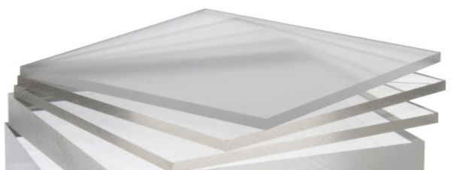 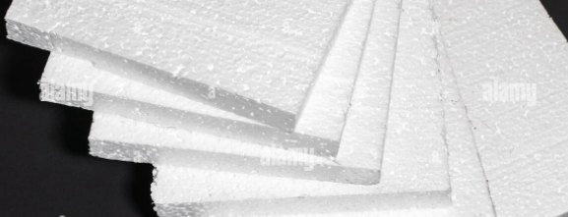

<http://somup.com/cr10omqs6t> Charging an Insulator (Styrofoam) 1:12)

<http://somup.com/cr10oOqsjp> Transfer of Charge & Charge by Induction (1:44)

<http://somup.com/cr10DGqso6> Acrylic & Metal Transferring Charge (1:08)

**Procedures**

1. Obtain the TORSION APPARATUS from earlier labs. Use the coffee stirrer or plastic straw in the test stand. Rub the straw or stirrer with wool and place it in the Torsion Test stand. What charge does the straw or stirrer take on?

2. Rub a piece of acrylic and Styrofoam together. Bring each piece close to the straw or stirrer and record your observations.

3. Based on your observations, what charge did the Styrofoam and acrylic take on when rubbed?

4. Below are drawings representing cross-sections of the foam plate and acrylic sheet, before they are rubbed and afterwards. The black lines represent the **surfaces** of the materials. The white area inside the rectangles represents the **inside** (interior) of the foam or acrylic material. Which drawings represent what the materials look like BEFORE rubbing them together?

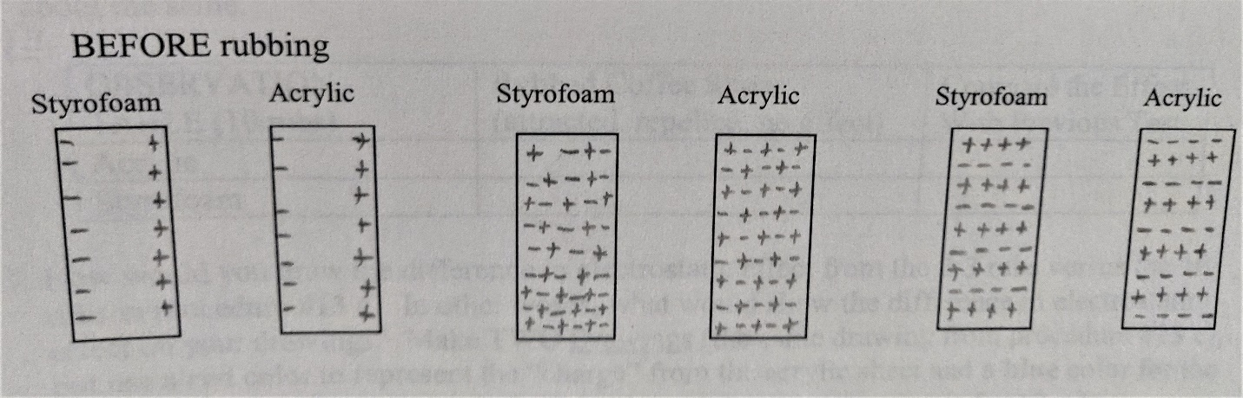

5. Which drawings represent what the materials look like AFTER rubbing them together?

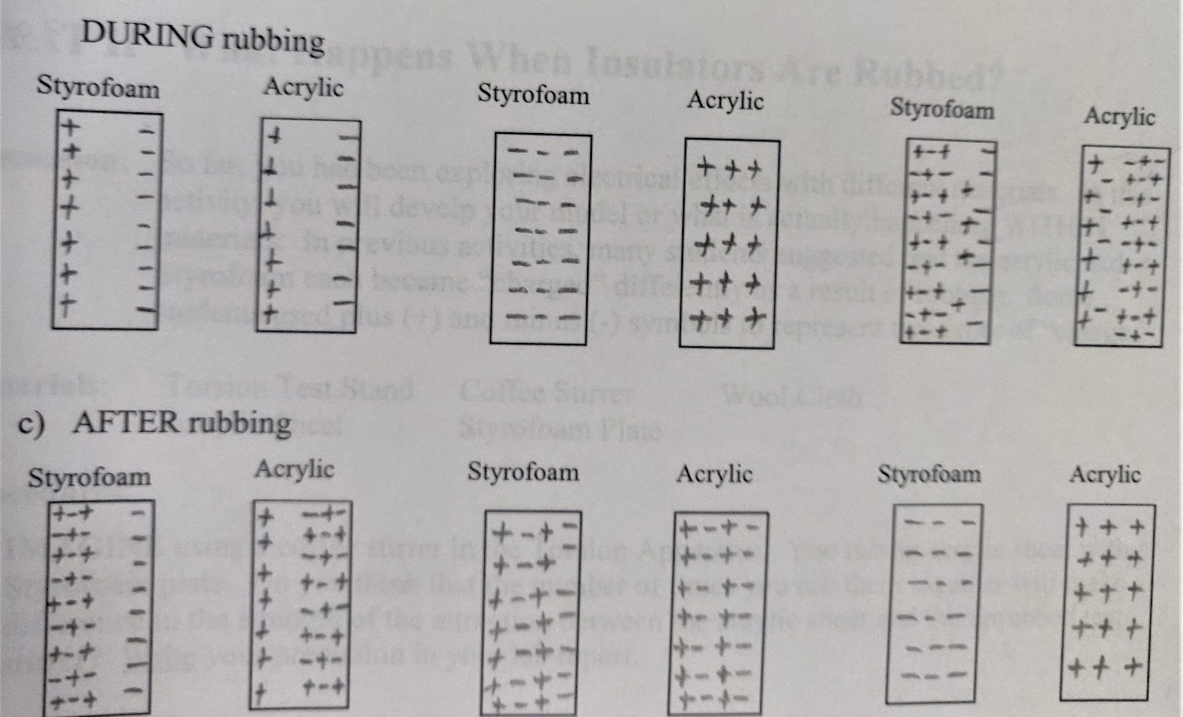

**CONCLUSIONS AND QUESTIONS**

1. What can you conclude about the observations you made in relation to the rubbed coffee stirrer and the tinsel indicator? In other words, what caused the results you saw?

2. Develop a general statement about what types of materials seem to transfer electrical effects easily (from one end to the other), and what types of materials do not.

3. What do we call materials that transfer electrical effects easily? What do we call materials that do not transfer electrical effects easily?

4. What was necessary for a transfer of electrical effects to occur?

5. What is the charge on Styrofoam and acrylic when rubbed together?

6. Where is electrostatic charge located?

7. How do charges exist in materials (e.g. positively charged, negatively charged, neutral)?

**ANSWERS**

**PART 1 Can Electrical Effects Transfer Through a Material?**

**Procedures**

3. Stick the tinsel indicator to the edge of your desk or table so that it hangs freely over the edge without touching the desk. “Discharge the tinsel indicator” by brushing it lightly. Rub a plastic straw with wool and bring it close to the tinsel indicator. RECORD your observations.

tape

**The tinsel was attracted to the plastic stirrer.**

4. Repeat procedure #3, except this time rub the plastic straw in your hair and bring it close to the tinsel indicator. RECORD your observations. COMPARE the results when using wool versus hair to “rub” the plastic straw.

**The tinsel was attracted to the plastic straw, but weakly.**

OBSERVATION TABLE

|  |  |  |  |  |  |  |
| --- | --- | --- | --- | --- | --- | --- |
| **MATERIAL** | Metal Hanger | Strip of Styrofoam | Strip of Acrylic | Aluminum Strip | 3” Finish Nail | Glass Rod |
| **Observation** | Conductor | Insulator | Insulator | Conductor | Conductor | Insulator |

**The conductors showed an electric transfer from the rubbed coffee stirrer to the tinsel.**

**The insulators did not show any electric transfer or effect from the rubbed coffee stirrer to the tinsel.**

## Part 2 What Parts of Insulators Are Affected When Rubbed?

**Procedures**

3. Previously you have observed that when a rubbed coffee stirrer is brought near an unrubbed coffee stirrer in a test stand, the two ends attract each other. Touching the rubbed coffee stirrer all over with moist fingers and then bringing it near the end of the unrubbed coffee stirrer. Record your observations.

**There was no attraction or repulsion.**

4. Why do you suppose that moistening the electrified coffee stirrer causes it to no longer exhibit a static electric effect?

**Humidity absorbs static charges.**

5. Obtain two, small Styrofoam blocks and tape them together. The two OUTSIDE surfaces of the block are numbered, #1 and #2. With the Styrofoam sheet block held tightly together, rub the wool cloth against surface #1 vigorously and then bringing the rubbed surface #1 near the unrubbed coffee stirrer in the test stand.

Styrofoam Block

You should notice that the coffee stirrer is attracted to the rubbed surface #1.

Surface #2

Outside

Surface #1

5. Remove the tape that held the Styrofoam block together and separate the two Styrofoam pieces, trying not to rub them together. Surface #3 and #4 are the inside surfaces of the former Styrofoam block.

Surface #1

rubbed

Surface #2

unrubbed

Surface #3

unrubbed

Surface #4

unrubbed

6. Complete the OBSERVATION TABLE below based on what happened when each surface of the Styrofoam is separately brought near the unrubbed coffee stirrer. Does it repel, attract or have no effect?

|  |  |  |  |  |
| --- | --- | --- | --- | --- |
| **OBSERVATION TABLE** | | | | |
| **SURFACE** | #1  rubbed | #2  unrubbed | #3  unrubbed | #4  unrubbed |
| **Observations** | **Attracted** | **Nothing** | **Nothing** | **Nothing** |

7. Based on your observations, when an insulator material is rubbed to produce static electric effects, what part(s) of the insulator is (are) affected?

**Electrostatic charges exist on the rubbed surfaces only.**

**Part 3 What Happens When Insulators Are Rubbed?**

1. Obtain the TORSION APPARATUS from earlier labs. Use the coffee stirrer or plastic straw in the test stand. Rub the straw or stirrer with wool and place it in the Torsion Test stand. What charge does the straw or stirrer take on?

**The straw/stirrer becomes negatively charged when rubbed with the wool because wool has excess electrons that rub off onto the plastic.**

2. Rub a piece of acrylic and Styrofoam together. Bring each piece close to the straw or stirrer and record your observations.

**The Styrofoam repelled the straw/stirrer, meaning that the Styrofoam becomes NEGATIVELY charged. The acrylic attracted the straw/stirrer, meaning that the acrylic becomes POSITIVELY charge. The two insulators became oppositely charged.**

3. Based on your observations, what charge did the Styrofoam and acrylic take on when rubbed?

**The Styrofoam repelled the straw/stirrer, meaning that the Styrofoam becomes NEGATIVELY charged. The acrylic attracted the straw/stirrer, meaning that the acrylic becomes POSITIVELY charge. The two insulators became oppositely charged.**

4. Below are drawings representing cross-sections of the foam plate and acrylic sheet, before they are rubbed and afterwards. The black lines represent the **surfaces** of the materials. The white area inside the rectangles represents the **inside** (interior) of the foam or acrylic material. Which drawings represent what the materials look like BEFORE rubbing them together?



5. Which drawings represent what the materials look like AFTER rubbing them together?



**CONCLUSIONS AND QUESTIONS**

1. What can you conclude about the observations you made in relation to the rubbed coffee stirrer and the tinsel indicator? In other words, what caused the results you saw?

**Something transferred from one end of the apparatus to the other. The coffee stirrer needed to be rubbed (friction) to have any influence.**

2. Develop a general statement about what types of materials seem to transfer electrical effects easily (from one end to the other), and what types of materials do not.

**Metals seem to transfer electric effects while other materials did not.**

3. What do we call materials that transfer electrical effects easily? What do we call materials that do not transfer electrical effects easily?

**Materials that transfer electric effects easily are called conductors and materials that do not transfer electric effects easily are called insulators.**

4. What was necessary for a transfer of electrical effects to occur?

**When materials were tested on the Styrofoam cup, all materials had to be touching or there was no effect (conduction). Initially, the tinsel was attracted to the rubbed coffee stirrer without touching (induction).**

5. What is the charge on Styrofoam and acrylic when rubbed together?

**Styrofoam takes on a negative charge (wool) and acrylic a positive charge (silk).**

6. Where is electrostatic charge located?

**Charges are located on the surface of materials.**

7. How do charges exist in materials (e.g. positively charged, negatively charged, neutral)?

**The intrinsic (inside) charges tend to be randomly aligned (neutral). Positively charged materials have protons on the surface and electrons deeper within the material. Negatively charged materials have electrons on the surface and protons deeper within the material.**

**Neutral materials tend to have charges randomly aligned so the positives (protons) equal the negatives (electrons).**