Heating & Cooling Curves

**Introduction**

**Purpose** To investigate the states of matter changes which occur when heating a substance.

**Background Information**

When energy (e.g. heat) is added to a solid substance (e.g. ice), its temperature increases until its melting point is reached. Upon the addition of more energy, the substance begins to melt, becoming a mixture of solid and liquid (e.g. ice and water at 0.0◦C). As energy continues to increase (the s 🡪 l mixture is heated), the temperature of the mixture does not immediately increase, but remains constant until all the substance has melted. This represents the phase change from solid to liquid, the melting point. At the actual melting point, the added energy changes the positions of the particles, meaning that the potential energy of the particles is increased as the physical state changes. Therefore, the average kinetic energy (temperature) of the particles is constant during the phase change.

After the substance melts, added energy increases the kinetic energy of the molecules; that is, the temperature is raised until the boiling point is reached. Potential energy remains constant during this state (liquid).

Upon the addition of more energy, the substance begins to boil. The temperature while boiling, however, remains constant until all the substance has vaporized. . This represents the phase change from liquid to vapor, the boiling point. At the actual boiling point, the added energy changes the positions of the particles, meaning that the potential energy of the particles is increased as the physical state changes. Therefore, the average kinetic energy (temperature) of the particles is constant during the phase change.

**Hypothesis**

If ice is melted, the temperature will not change until most of the ice becomes liquid, then the temperature will increase until the water boils. Water boils at constant temperature.

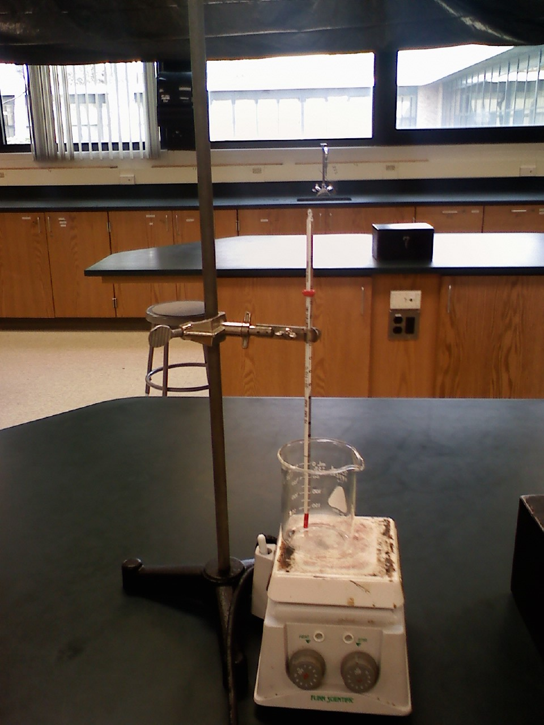

**Equipment (***If you want to try the lab yourself***)**

* Celsius thermometer
* A small glass container (250 ml). Make sure it is safe for boiling water.
* Water
* Ice (preferably crushed)
* Hot plate or stove or heat source to heat the ice and water
* Plastic stirring rod
* Safety goggles

**Procedures**

1. You may watch the video links provided to collect the data OR do your own lab.

2. Add a minimum of one cup of crushed ice cubes to the glass.

3. CAREFULLY place a thermometer in the crushed ice along with a plastic stirring rod (e.g. a thick straw will suffice). Begin to stir the crushed ice slowly and consistently. DO NOT USE THE THERMOMETER to stir. The ice is melting so there will be an ice-water mixture.

4. Stir until the temperature of the ice-water mixture reads ~0º C. The thermometer was previously at room temperature. [*Record this initial temperature, and all the following temperatures in the “Temperature of Ice & Water” table, p. 6*]

5. Place the ice-water mixture on a heat source, heating the mixture on MEDIUM to HIGH heat and CONTINUING TO STIR SLOWLY & CONSISTENTLY. [The overall process should take ~15 to 20 minutes optimally.] Record the temperature of the ice-water mixture every 30 seconds. It is best to not let the tip of the thermometer rest on the bottom of the glass cup.

7. Continue to record the temperature of the water until the water has boiled for at least 3 minutes at the same temperature.

**Calculations and Data**

1. Refer to the Calculations and Data sheet provided to record all your data and observations.

2. Label the graph of the experimental results showing the overall heat of ice going to water vapor.

a. Label time (minutes) as the independent variable (x-axis).

b. Label temperature (C) as the dependent variable (y-axis).

c. Title the graph “Heating Curve” for water” …. Endothermic or exothermic?

d. Label the three “Best Fit”, STRAIGHT-line slopes of the the plotted points. (O*ne line for ice melting, one line for water heating up, and one line for water boiling*.)

g. Label states of matter (include phase changes), melting point, and boiling point.

3. Label the Phases of Matter from the chart below:

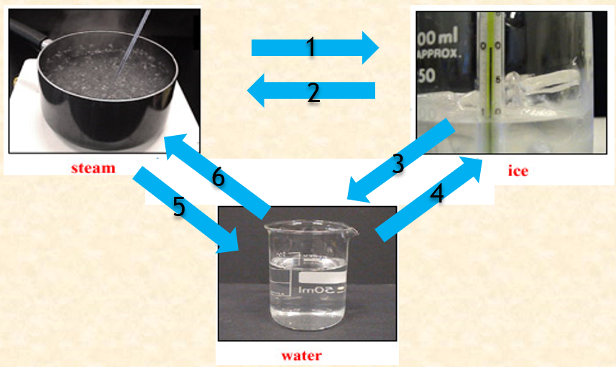

1.

2.

3.

4.

5.

6.

**Heating Curve of Water Data**

**Data collected from Videos on Study Place:**

<https://screencast-o-matic.com/watch/cFX6DlYWTH>

<https://screencast-o-matic.com/watch/cFX6D4YWOH>

Initial Temperature (melting point) ________________

Record the thermometer reading **every 30 seconds** for the remainder of this experiment.

|  |  |  |  |  |  |  |  |
| --- | --- | --- | --- | --- | --- | --- | --- |
| **Time** | **Degrees** |  | **Time** | **Degrees** |  | **Time** | **Degrees** |
| 0:30 min |  |  | 10:30 min |  |  | 20:30 min |  |
| 1:00 min |  |  | 11:00 min |  |  | 21:00 min |  |
| 1:30 min |  |  | 11:30 min |  |  | 21:30 min |  |
| 2:00 min |  |  | 12:00 min |  |  | 22:00 min |  |
| 2:30 min |  |  | 12:30 min |  |  | 22:30 min |  |
| 3:00 min |  |  | 13:00 min |  |  | 23:00 min |  |
| 3:30 min |  |  | 13:30 min |  |  | 23:30 min |  |
| 4:00 min |  |  | 14:00 min |  |  | 24:00 min |  |
| 4:30 min |  |  | 14:30 min |  |  | 24:30 min |  |
| 5:00 min |  |  | 15:00 min |  |  | 25:00 min |  |
| 5:30 min |  |  | 15:30 min |  |  | 25:30 min |  |
| 6:00 min |  |  | 16:00 min |  |  | 26:00 min |  |
| 6:30 min |  |  | 16:30 min |  |  | 26:30 min |  |
| 7:00 min |  |  | 17:00 min |  |  | 27:00 min |  |
| 7:30 min |  |  | 17:30 min |  |  | 27:30 min |  |
| 8:00 min |  |  | 18:00 min |  |  | 28:00 min |  |
| 8:30 min |  |  | 18:30 min |  |  | 28:30 min |  |
| 9:00 min |  |  | 19:00 min |  |  | 29:00 min |  |
| 9:30 min |  |  | 19:30 min |  |  | 29:30 min |  |
| 10:00 min |  |  | 20:00 min |  |  | 30:00 min |  |

Title:

®

®

®

®

®

|  |  |  |  |  |  |  |  |  |  |  |  |  |  |  |  |  |  |  |  |  |
| --- | --- | --- | --- | --- | --- | --- | --- | --- | --- | --- | --- | --- | --- | --- | --- | --- | --- | --- | --- | --- |
| 100˚ C |  |  |  |  |  |  |  |  |  |  | ® | ® |  |  |  |  |  |  |  |  |
|  |  |  |  |  |  |  |  |  |  | ® |  |  | ® |  |  |  |  |  |  |  |
| 90 |  |  |  |  |  |  |  |  |  | ® |  |  |  |  |  |  |  |  |  |  |
|  |  |  |  |  |  |  |  |  |  |  |  |  |  |  |  |  |  |  |  |  |
| 80 |  |  |  |  |  |  |  |  | ® |  |  |  |  |  |  |  |  |  |  |  |
|  |  |  |  |  |  |  |  |  |  |  |  |  |  |  | Label Each Slope Line  Line 1: melting point of the ice/water (phase change)  Line 2: water’s temperature rises  Line 3: boiling point of water/steam (phase change) |  |  |  |  |  |
| 70 |  |  |  |  |  |  |  |  | ® |  |  |  |  |  |  |  |  |  |  |  |
|  |  |  |  |  |  |  |  |  |  |  |  |  |  |  |  |  |  |  |  |  |
| 60 |  |  |  |  |  |  |  | ® |  |  |  |  |  |  |  |  |  |  |  |  |
|  |  |  |  |  |  |  |  |  |  |  |  |  |  |  |  |  |  |  |  |  |
| 50 |  |  |  |  |  |  |  |  |  |  |  |  |  |  |  |  |  |  |  |  |
|  |  |  |  |  |  |  |  | ® |  |  |  |  |  |  |  |  |  |  |  |  |
| 40 |  |  |  |  |  |  |  |  |  |  |  |  |  |  |  |  |  |  |  |  |
|  |  |  |  |  |  |  | ® |  |  |  |  |  |  |  |  |  |  |  |  |  |
| 30 |  |  |  |  |  |  |  |  |  |  |  |  |  |  |  |  |  |  |  |  |
|  |  |  |  |  |  |  |  |  |  |  |  |  |  |  |  |  |  |  |  |  |
| 20 |  |  |  |  |  |  | ® |  |  |  |  |  |  |  |  |  |  |  |  |  |
|  |  |  |  |  |  | ® |  |  |  |  |  |  |  |  |  |  |  |  |  |  |
| ®  10 |  |  |  |  |  |  |  |  |  |  |  |  |  |  |  |  |  |  |  |  |
|  |  |  |  |  | ® | ® |  |  |  |  |  |  |  |  |  |  |  |  |  |  |
| ®  0˚ C |  | ® |  | ®  ® | ® |  |  |  |  |  |  |  |  |  |  |  |  |  |  |  |

10 min

30 min

20 min

# Conclusions and Questions

Address hypothesis

Questions

1. What kind of heat flow (endothermic or exothermic) is the heating curve of water?

2. What happened to temperature at the melting point and boiling points in this lab?

3. Use the graph below to answer “a” and “b”:

a. Label states of matter [gas (g); liquid (l), solid (s)], condensation point [CP] and Freezing point [FP].

b. What kind of heat flow (endothermic or exothermic) is the cooling curve of water?

Heat

🡪

🡪

Temperature

°C

**ANSWERS**

**Data collected from Videos on Study Place:**

<https://screencast-o-matic.com/watch/cFX6DlYWTH>

<https://screencast-o-matic.com/watch/cFX6D4YWOH>

6. Record the thermometer reading every 30 seconds:

|  |  |  |  |  |  |  |  |
| --- | --- | --- | --- | --- | --- | --- | --- |
| **Time** | **Degrees** |  | **Time** | **Degrees** |  | **Time** | **Degrees** |
| 0:30 min | -1.1 °C |  | 10:30 min | 11.4 °C |  | 20:30 min | 100.7 °C |
| 1:00 min | -1.1 °C |  | 11:00 min | 11.4 °C |  | 21:00 min | 100.8 °C |
| 1:30 min | -0.9 °C |  | 11:30 min | 16.6 °C |  | 21:30 min | 100.8 °C |
| 2:00 min | -0.8 °C |  | 12:00 min | 19.4 °C |  | 22:00 min | 100.8 °C |
| 2:30 min | -0.6 °C |  | 12:30 min | 15.9 °C |  | 22:30 min | 100.8 °C |
| 3:00 min | -0.4 °C |  | 13:00 min | 25.3 °C |  | 23:00 min | 100.8 °C |
| 3:30 min | -0.3 °C |  | 13:30 min | 31.7 °C |  | 23:30 min | 100.8 °C |
| 4:00 min | -0.1 °C |  | 14:00 min | 37.9 °C |  | 24:00 min | 100.8 °C |
| 4:30 min | 0.1 °C |  | 14:30 min | 43.7 °C |  | 24:30 min | 100.8 °C |
| 5:00 min | 0.2 °C |  | 15:00 min | 49.9 °C |  | 25:00 min | 100.8 °C |
| 5:30 min | 0.4 °C |  | 15:30 min | 55.9 °C |  | 25:30 min | 100.8 °C |
| 6:00 min | 1.6 °C |  | 16:00 min | 61.9 °C |  | 26:00 min | 100.8 °C |
| 6:30 min | 5.8 °C |  | 16:30 min | 67.8 °C |  | 26:30 min | 100.8 °C |
| 7:00 min | 7.2 °C |  | 17:00 min | 73.6 °C |  | 27:00 min | 100.8 °C |
| 7:30 min | 5.7 °C |  | 17:30 min | 79.4 °C |  | 27:30 min | 100.8 °C |
| 8:00 min | 6.2 °C |  | 18:00 min | 85.1 °C |  | 28:00 min | 100.8 °C |
| 8:30 min | 4.9 °C |  | 18:30 min | 90.3 °C |  | 28:30 min | 100.8 °C |
| 9:00 min | 7.1 °C |  | 19:00 min | 95.4 °C |  | 29:00 min | 100.8 °C |
| 9:30 min | 8.8 °C |  | 19:30 min | 99.6 °C |  | 29:30 min | 100.8 °C |
| 10:00 min | 11.6 °C |  | 20:00 min | 100.5 °C |  | 30:00 min | 100.8 °C |

ice ice-water water boiling water



Heat is added

“Heating Curve of Water – an Endothermic Reaction”

10˚ C

100˚ C

PE

**BP**

®

®

®

®

®

|  |  |  |  |  |  |  |  |  |  |  |  |  |  |  |  |  |  |  |  |  |
| --- | --- | --- | --- | --- | --- | --- | --- | --- | --- | --- | --- | --- | --- | --- | --- | --- | --- | --- | --- | --- |
|  |  |  |  |  |  |  |  |  |  |  | ® | ® |  |  |  |  |  |  |  |  |
|  |  |  |  |  |  |  |  |  |  | ® |  |  | ® | l → g |  |  |  |  |  |  |
| 90 |  |  |  |  |  |  |  |  |  | ® |  |  |  |  |  |  |  |  |  |  |
|  |  |  |  |  |  |  |  |  |  |  |  |  |  |  |  |  |  |  |  |  |
| 80 |  |  |  |  |  |  |  |  | ® |  |  |  |  |  |  |  |  |  |  |  |
| Temperature C |  |  |  |  |  |  |  |  |  |  |  |  |  |  | Use three straight lines:  Line 1: melting point of the ice/water (phase change)  Line 2: water’s temperature rises  Line 3: boiling point of water/steam (phase change) |  |  |  |  |  |
| 70 |  |  |  |  |  |  |  |  | ® |  |  |  |  |  |  |  |  |  |  |  |
|  |  |  |  |  |  |  |  |  |  |  |  |  |  |  |  |  |  |  |  |  |
| 60 |  |  |  |  |  |  |  | ® |  |  |  |  |  |  |  |  |  |  |  |  |
|  |  |  | KE |  |  |  |  |  |  |  |  |  |  |  |  |  |  |  |  |  |
| 50 |  |  |  |  |  |  |  |  |  |  |  |  |  |  |  |  |  |  |  |  |
|  |  |  |  |  |  |  |  | ® |  |  |  |  |  |  |  |  |  |  |  |  |
| 40 |  |  |  |  |  | liquid |  |  |  |  |  |  |  |  |  |  |  |  |  |  |
|  |  |  |  |  |  |  | ® |  |  |  |  |  |  |  |  |  |  |  |  |  |
| 30 |  |  |  |  |  |  |  |  |  |  |  |  |  |  |  |  |  |  |  |  |
|  |  |  |  |  |  |  |  |  |  |  |  |  |  |  |  |  |  |  |  |  |
| 20 |  |  |  |  |  |  | ® |  |  |  |  |  |  |  |  |  |  |  |  |  |
|  |  |  |  |  |  | ® |  |  |  |  |  |  |  |  |  |  |  |  |  |  |
|  |  | PE  **MP** |  |  |  |  |  |  |  |  |  |  |  |  |  |  |  |  |  |  |
|  |  | S → l |  |  | ® | ® |  |  |  |  |  |  |  |  |  |  |  |  |  |  |
| ®  ®  0˚ C |  | ® |  | ®  ® | ® |  |  |  |  |  |  |  |  |  |  |  |  |  |  |  |

10 min

30 min

20 min

Time (minutes)

**Calculations**

3.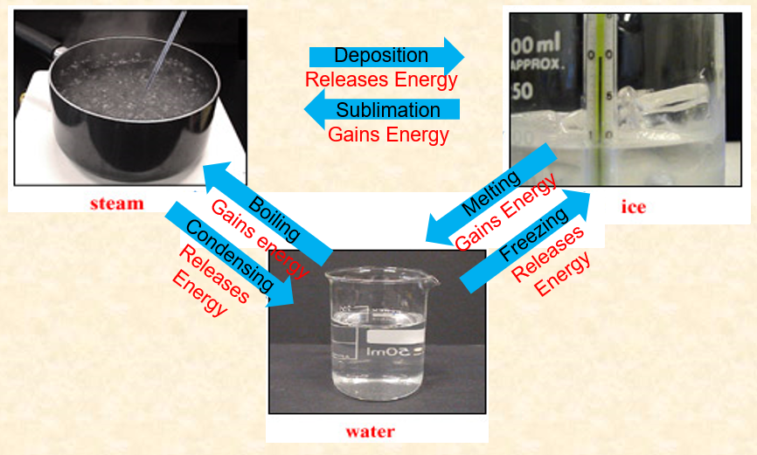

**Conclusions**

**Hypothesis**

When ice is heated, a phase change into liquid occurred with little temperature change at approximately 0 ºC, implying that potential energy increased while kinetic energy remained constant.

When liquid water is heated, the temperature increased from ~0 ºC to ~100 ºC, implying that kinetic energy increased while potential energy remained constant.

When water reached the boiling point, a phase change into vapor occured with no temperature change at ~100 ºC, implying that potential energy increased while kinetic energy remained constant.

**Questions**

1. What kind of heat flow (endothermic or exothermic) is the heating curve of water?

*The heating curve of water represents an endothermic heat flow. Heat needed to be added for ice to melt, water to increase in temperature, and to boil.*

2. What happened to temperature at the melting point and boiling points in this lab?

*Temperature remains constant during phase changes (melting and boiling). This means that potential energy is increasing while kinetic energy remains constant.*

3. Use the graph below to answer “a” and “b”:

a. Label states of matter [gas (g); liquid (l), solid (s)], condensation point [CP] and Freezing point [FP].

b. What kind of heat flow (endothermic or exothermic) is the cooling curve of water?

*The cooling curve of water represents an exothermic heat flow. Heat is released so that gas can condense, water decreases in temperature, and freezes.*

g

Heat

l 🡪 s

g 🡪 l

l

s

Temperature

°C

CP

FP