**Molar Quantities Chapter 10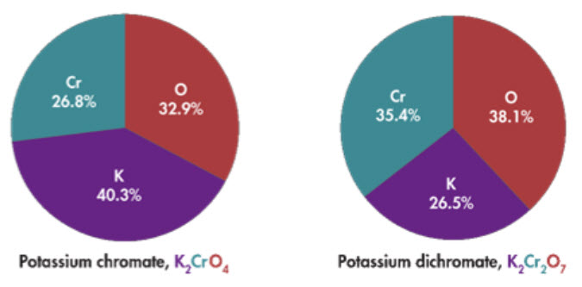B**

**See** [**https://www.learningctronline.com/courses**](https://www.learningctronline.com/courses) **for Materials and Resources.**

**Topics:**

1. Molar Quantities

**Objectives:**

1. Calculate Percent Composition (Percent by Mass of elements in a compound) using mass, formulas, and percentages.
2. Determine mole ratios of elements within a formula.
3. Understand and calculate Empirical Formulas using mass, percentages, and moles.
4. Determine Molecular Formula from Empirical Formulas.
5. Understand and utilize the mole in mathematical computations according to the mole concept (Avogadro's Number).
6. Calculate Molar Mass of Elements and Compounds. Interconvert moles and mass.
7. Calculate Molar Volume at STP. Interconvert moles and liters, molar mass and density.

TAKE NOTE

1. Notes / Study Guide
2. Lesson Check/Sample problems or Alternative Worksheets
3. Revise the Lab Definite Proportions (over break) … due before 2nd Semester begins.
4. Molar Quantities Test (due within ONE week). Submit Test for grading and feedback BEFORE taking the semester exam.
5. Semester Exam (Chapters 1-10, 13) … (due within 10 days after week 16’s class) … review document provided.
6. Class Song: Christ in You Will Succeed (Joyful, Joyful)
7. Week 16 Devotional (<https://www.learningctronline.com/devotional>)

**Text**: Chapter 10: Molar Quantities pp. 325-345

Read the assigned pages in the text.

**Class Notes: PowerPoint or PDF**

**Notes/Study Guide:** Fill in the Chapter 10 worksheet to understand the class notes.

**Homework**: TEXT

(1) Answer the KEYED **"Lesson Check"** questions at the end of each of the chapter.

(2) Answer the **"Sample problems"** found in the "Sample Problem" boxes throughout the chapter. An answer KEY is provided for you to use to self-correct your homework problems.

* Put your answers into complete thoughts in a Word document. Do NOT just put the answer, but write a phrase or sentence that you can study from for your tests. Save your work in a WORD document and SAVE into your HOMEWORK folder in the Chemistry folder on the desktop.
* Assignments will be “spot checked” during class or submitted via email.

**Alternate Homework**:

1. Molar Quantities Review Worksheet

**Lab**: none

**TEST:** Molar Quantities

1) the academic integrity policy

* Tests must be completed **WITHOUT** referring to books, notes, the internet, people, or any outside resources.
* Students **MAY** use the approved Periodic Tables, approved Reference Tables, or approved equation (formula) sheet (provided by the teacher) along with calculators and scratch paper.
* A guardian should be proctoring the test. Proctoring means to monitor the following:

2) The test is composed of 20 multiple choice questions and some written problems.

* The **multiple-choice test must be taken "in one sitting"**, meaning that once you start the test, you must complete it without interruption. (40 minutes)
* Take a short break (5-10 minutes)
* The **written portion of the test must be taken "in one sitting"**, meaning that once you start the test, you must complete it without interruption. (40 minutes)

3) There is a **80-minute time limit** on this test. Please have the proctor write the time taken at the top of your answer sheet with their signature or initials.

4) Proctors should NOT be reading the test or engaging students during the test.

5) Do NOT use RED font. Black font is best.

Supplemental Resources (Optional)

1. Chapter 10 Study Guide Pearson
2. Molar Quantities Review Test

[Hear and Obey Matthew 7:24-27](http://somup.com/cYhbq9jwVF) (3:05)

**TEST:** Semester Exam

1. Use the Review (Study Guide) document to study for the Final Exam. Then, take the Final Exam in the assignments tab.
2. **A guardian should be proctoring your test.** Proctoring means to monitor the following:  
     
   1) the academic integrity policy,  
   2) taking the entire test "in one sitting", and  
   3) keeping the time limit of 100 minutes.  
     
   Proctors should NOT be reading the test or engaging students during the test.
3. For the semester exam you **MAY** use the review study guide during the exam according to the exam strategy shown below. **Do NOT use the study guide until you have gone through the exam twice as directed below.**
4. The test must be completed **WITHOUT** referring to the textbook, the class notes, the internet, people, or any other outside resources on this test.
5. Students **MAY** use the approved Periodic Tables, approved Reference Tables, or approved equation (formula) sheet (provided by the teacher) along with calculators and scratch paper throughout the exam.
6. **The semester exam must be taken in one sitting, meaning that once you open the test, you must complete it without interruption.** There is NO written portion for this exam, only automated (multiple choice).
7. You have **100 minutes** **maximum** to complete the semester exam. You will be penalized for going over the time limit, even 1 minute. Students who have an accommodation should email the teacher regarding the time limit.

**STRATEGY: Take the test "three times".**

1. Go through all the questions and answer the "easier" ones for you first ... to build confidence.
2. Then, go back and carefully consider the ones you did not answer initially. Skip the ones you feel are too hard, you don't understand, or you will look up using the review study guide.
3. Lastly, go to the questions you skipped and make them make sense based on your knowledge of Chemistry. Look up some answers using the review study guide if you have time.

If you take more than 100 minutes, your score will be reduced UNLESS you have a documented, pre-approved accommodation.

**The semester exam has 65 multiple choice questions with NO written portion.**