**Earth’s History & Climate**

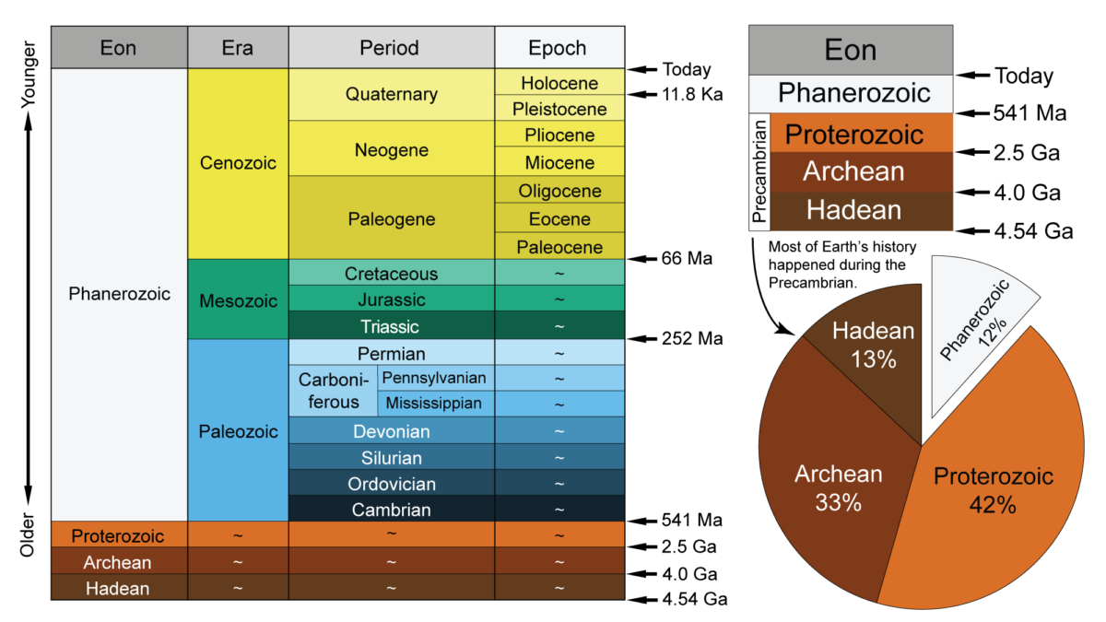

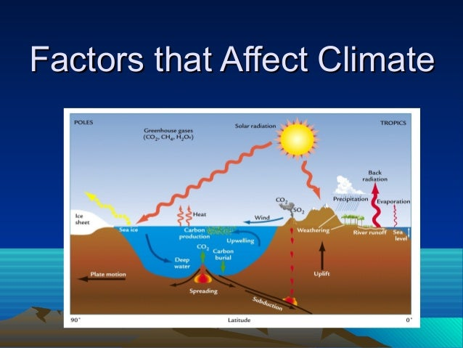

**See** [**https://www.learningctronline.com/courses**](https://www.learningctronline.com/courses) **for Materials and Resources.**

**Topics:**

1. Earth’s History & Climate

**Objectives:**

**Earth’s History**

1. Understand and frame Geologic time & the geologic time scale.

2. Explain how geologic time was derived and potential problems with the time scale.

3. Define radioactive dating and elements that contribute to it (index fossils, marker beds)

4. Explain variables involved with relative dating.

5. Distinguish relative dating from absolute dating.

6. List some radioactive dating “clocks”.

**Factors Affecting Climate**

1. Understand 5 major factors that influence global climate.

2. Explain the relationship between Carbon Dioxide levels in the atmosphere, and global temperature.

3. Describe how ocean currents and global wind patterns are created?

4. Explain thermohaline circulation.

5. Define El Niño. How does it affect climate. (optional)

6. Understand the difference between a maritime and a continental climate.

7. Define and expound global warming.

8. List the most significant greenhouse gases.

9. Distinguish between a “good” & “bad” greenhouse gas.

10. Define the major function of ozone. Explain negative issues related to ozone.

TAKE NOTE (1 week)

1. Earth’s History & Factors Affecting Climate PowerPoint (class notes)
2. Lab: Geologic Time Line
3. Lab: Climate Graphing Inquiry
4. Flawed Climate Models WS
5. Quiz Earth’s History
6. Week 27 Devotional (<https://www.learningctronline.com/devotional>)

**Text**:

**Reference Material: Earth’s History & Factors Affecting Climate PowerPoint**

**Homework**:

* Earth’s History & Factors Affecting Climate PowerPoint Notes Worksheet
* Flawed Climate Models WS

**Lab**: Geologic Time Line

* Perform the Geologic Time Line lab using the worksheet provided.
* Save the document into your LAB folder in the Projects in Science folder on your desktop.

**Lab**: Climate Graphing Inquiry.

* Complete the Climate Graphing Inquiry using the worksheet provided.
* Save the document into your LAB folder in the Projects in Science folder on your desktop.

**TEST:** Quiz Earth’s History

1) the academic integrity policy

* Tests must be completed **WITHOUT** referring to books, notes, the internet, people, or any outside resources.
* Students **MAY** use the approved Periodic Tables, approved Reference Tables, or approved equation (formula) sheet (provided by the teacher) along with calculators and scratch paper.

2) Take the **"in one sitting"**, meaning that once you start the test, you must complete it without interruption.

3) There is a **25-minute time limit** on this test.

4) Do NOT use RED font. Black font is best.

Supplemental Resources (Optional)

Global Warming Fear Factor <https://screenpal.com/watch/cq6VIEu6JC> (2:24)

Greenhouse Gases Trapping Heat <https://screenpal.com/watch/cFQ6q6qGeF> (0:17)

Carbon Dioxide Greenhouse Effect Explained <https://screenpal.com/watch/cFQr2HqRaT> (2:04)