## Periodic Table of Foods

* Look at the items in all 24 squares below in terms of similar characteristics
* You will arrange the squares into columns and rows based on a recognizable pattern of the items
* Fill in the bottom table showing your “Periodic Table of Foods” as follows:
* Give a name to each “Group” or “Family”
* The order of the foods should follow the order for the electromagnetic spectrum from lowest frequency (left side) to highest frequency (right side) as indicated in each square

|  |  |  |  |  |  |  |  |
| --- | --- | --- | --- | --- | --- | --- | --- |
| Pork 0.5 lb  radio | Salmon  steak  microwave | Beans  5 pods  ultraviolet | Milk  1 gallon  visible ROY | Grapes  1 twig  gamma | Beef  0.25 lb  radio | Tomato Soup  8 oz  infrared | Rye  1 loaf  visible GBIV |
| Stew  32 oz  infrared | Spaghetti  1 pot  x-rays | Bananas  1 bunch  gamma | Clams  1 bushel  microwave | Cheese  1 slice  visible ROY | Celery  1 stalk  ultraviolet | Eggs  1 dozen  visible ROY | Barley  1 stalk  visible GBIV |
| Chicken Noodle 16 oz  infrared | Wheat flour  2 lbs  visible GBIV | Shrimp  Cocktail  microwave | Rigatoni  1 bite  x-rays | Chicken   1. lb   radio | Apple  1 bushel  gamma | Cucumber  1 plant  ultraviolet | Macaroni  1 bowl  x-rays |

### Periodic Table of Foods

|  |  |  |  |  |  |  |  |
| --- | --- | --- | --- | --- | --- | --- | --- |
|  |  |  |  |  |  |  |  |
|  |  |  |  |  |  |  |  |
|  |  |  |  |  |  |  |  |
|  |  |  |  |  |  |  |  |

**Use section 5.1-2 in your textbook for guidance:**

**1.** How did Dmitri Mendeleev arrange the elements in his periodic table?

2. How did he come up with this system?

3. Why couldn’t he come up with a complete periodic table?

4. How is the modern periodic table arranged?

5. Define “periods”. How many does the modern table have?

6. Define “groups”. How many does the modern periodic table have?

7. Why do all the elements in a group have similar chemical properties?

8. What does periodic law refer to?

**Practice Quiz**

1. Which element is an example of a noble gas?

a) Krypton b) Chlorine c) Iridium d) Nitrogen

2. Valence electrons are electrons in the

a) nucleus b) outer energy level c) inner energy level d) ionization level

3. Which of these is the most stable number of electrons to have in an outer energy level (valence)?

a) 5 b) 6 c) 7 d) 8

4. Non-metals are found in what area of the periodic table?

a) top b) bottom c) left side d) right side

5. An alkali metal has one valence electron, while an alkaline earth metal has

a) none b) two c) three d) four

6. Which list of elements contains only metals?

a) helium, carbon, gold c) iodine, iron, nickel

b) sodium, chromium, copper d) phosphorus, nitrogen, oxygen

7. As you move left to right across a period, the number of valence electrons

a) decreases b) stays the same c) increases

8. Which elements are the “staircase elements, sharing metallic and non-metallic properties?

a) metalloids b) halogens c) chalcogens d) transition elements

9. The scientist who proposed the modern periodic table be arranged by atomic mass was

a) Galileo b) Mendeleev c) Moseley d) Newton

10. Neutral elements which have complete outer electron energy levels are in the group called

a) alkali metals b) transition metals c) halogens d) noble gases

11. A column on the periodic table is known as a

a) row b) period c) class d) group or family

12. Atoms are arranged in order on the modern periodic table, based on

a) mass b) atomic number c) number of neutrons d) atomic radius

13. Which of these elements should have properties most similar to those of Beryllium?

a) Calcium b) Carbon c) Boron d) Lithium

14. Groups possess elements with

a) the same number of electrons c) similar properties

b) the same number of protons d) the same number of neutrons

15. The scientist who discovered atomic number that was used to arrange the modern periodic table was

a) Galileo b) Mendeleev c) Moseley d) Newton

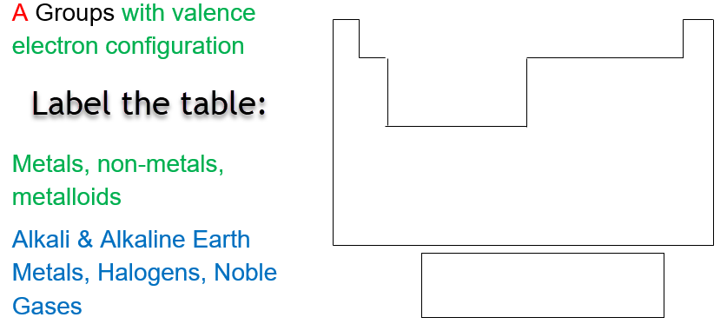

|  |  |  |  |  |  |  |  |
| --- | --- | --- | --- | --- | --- | --- | --- |
| Meat  radio | Seafood  microwave | Soup  infrared | Dairy  Visible ROY | Breads  Visible GBIV | Vegetables  ultraviolet | Pasta  x-rays | Fruit  gamma |
| Beef  0.25 lb | Shrimp  cocktail | Tomato Soup  8 oz | Cheese  1 slice | Rye  1 loaf | Beans  5 pods | Rigatoni  1 bite | Grapes  1 twig |
| Pork 0.5 lb | Salmon  steak | Chicken Noodle 16 oz | Eggs  1 dozen | Barley  1 stalk | Cucumber  1 plant | Macaroni  1 bowl | Bananas  1 bunch |
| Chicken  1.0 lb | Clams  1 bushel | Stew  32 oz | Milk  1 gallon | Wheat flour  2 lbs | Celery  1 stalk | Spaghetti  1 pot | Apple  1 bushel |

What guidelines did you use to make your Periodic Table of Foods?

* How did you determine “Groups”?

Food groups

* How did you determine “Periods” or “Rows”?

Amounts within each food group

**1.** How did Dmitri Mendeleev arrange the elements in his periodic table?

*Mendeleev arranged the elements into rows (periods) in order of increasing atomic mass so that elements with similar properties were in the same column.*

2. How did he come up with this system?

*While Mendeleev was playing “Solitaire” (the card game), he realized that the cards could be arranged by suits in columns and rows.*

3. Why couldn’t he come up with a complete periodic table?

*Many elements had not been discovered yet. He left “spaces” in his periodic table for future discoveries, and several proved that his table was suitable (e.g. Scandium, Germanium).*

4. How is the modern periodic table arranged?

*The modern periodic table is arranged in rows of increasing atomic number and columns of similar chemical properties.*

5. Define “periods”. How many does the modern table have?

*Each row on the periodic table is a “period”, meaning a repeating cycle corresponding to energy levels related to electrons. There are 7 possible periods.*

6. Define “groups”. How many does the modern periodic table have?

*Each column on the periodic table is called a group or family because they have similar properties.*

7. Why do all the elements in a group have similar chemical properties?

*Elements in each group have the same electron configuration. Elements in a group have similar properties because they have the same number of valence electrons (p. 139).*

8. What does periodic law refer to?

*Periodic law is the pattern of repeating properties on the periodic table.*

Practice Quiz

1. **a** krypton

2. **b** outer energy level

3. **d** 8 (except for hydrogen and helium which only need 2 valence electrons)

4. **d** non-metals are found on theright side of the Periodic table

5. **b** two valence electrons for alkaline earth metals

6. **b** sodium, chromium, copper are all metals

7. **c** # of valence electronsincreases across periodic table

8. **a** metalloids are the “staircase” elements

9. **b** Mendeleev … arranged Periodic table by atomic mass

10. **d** noble gases have complete outer electron shells (valence)

11. **d** groups or family = columns

12. **b** periodic table is arranged byatomic number

13. **a** Calcium is most similar to beryllium because they are in the same group

14. **c** groups contain elements with similar properties

15. **c** Moseley discovered atomic number that was used to arrange the modern periodic table.

